Seacombe St Paul’s
Parish profile
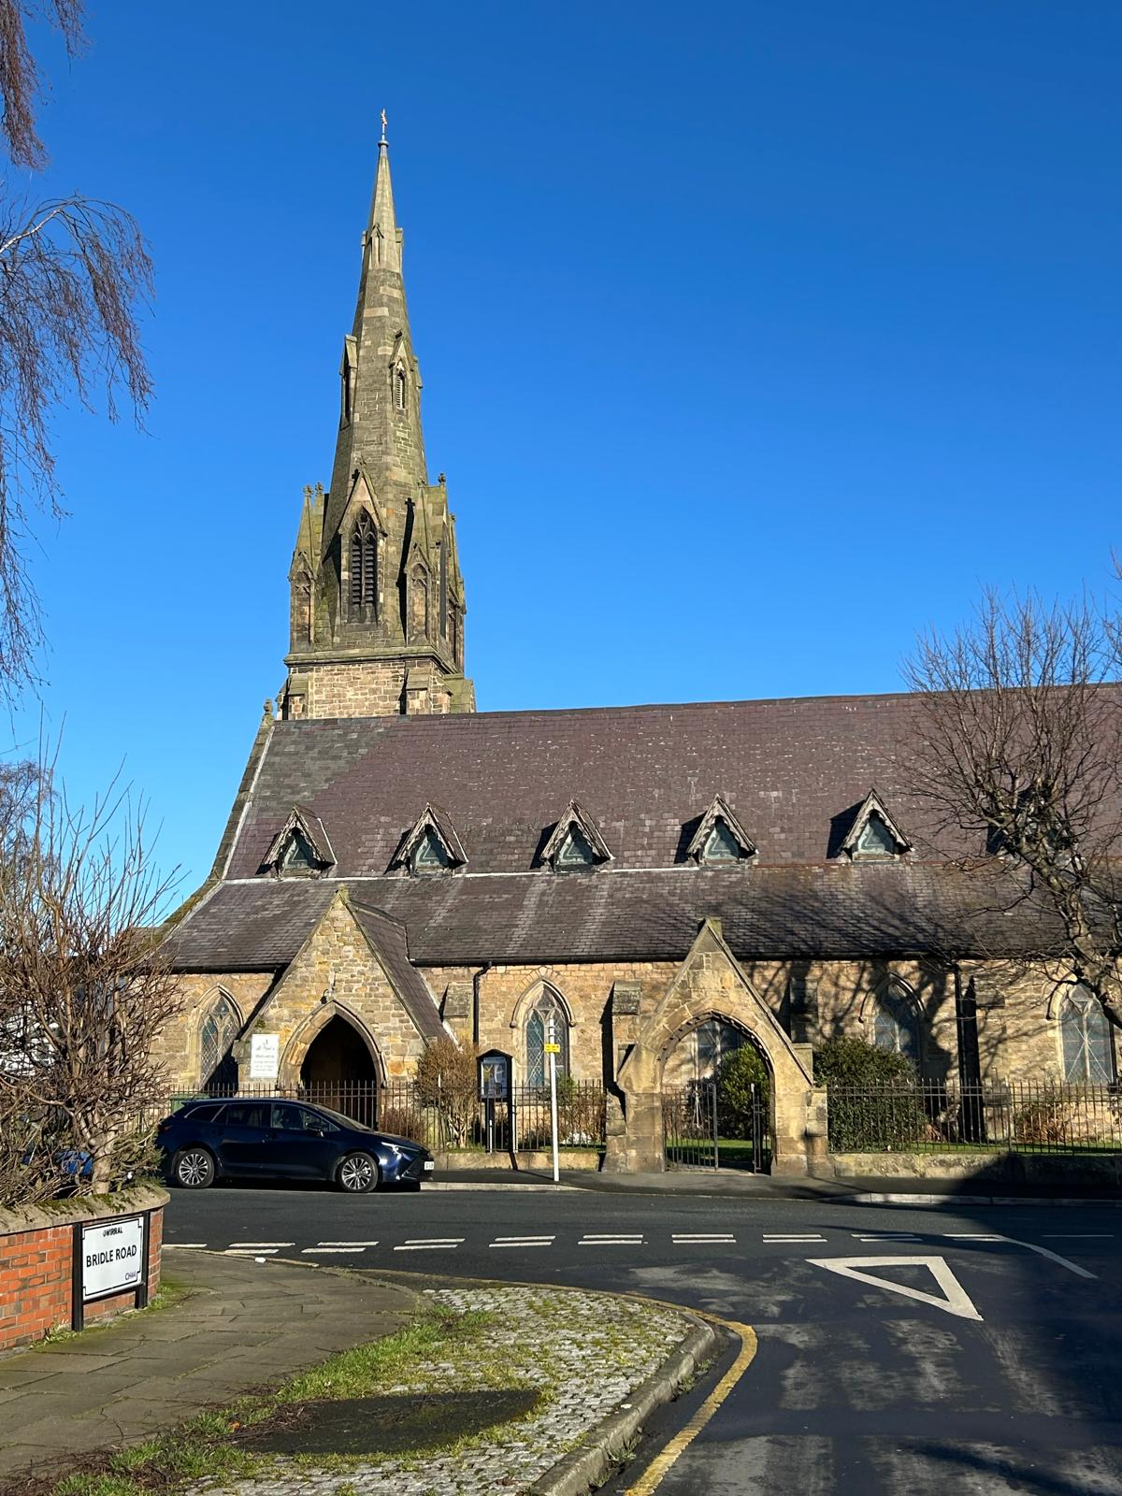

Parish.

Our future incumbent
We are looking for a compassionate and dynamic leader to guide our parish through a time of renewal and growth and can inspire and deepen our faith through thoughtful preaching, meaningful worship and pastoral care.
Somone who -
- Will continue to encourage the congregation to live out their faith in daily life Monday to Saturday and not just on a Sunday.
- Enjoys leading different styles of worship and relates well to all age groups.
- Provides confident leadership to all three churches, to enable growth in numbers and faith.
- Will be a good pastoral vicar who is responsive to the needs of all three churches and their communities.
- Is a motivating and inspiring leader who is forward-thinking and proactive and is also sympathetic to each church’s history and the makeup of the current congregations.
- Will continue to foster a strong safeguarding culture in the parish, that is currently a strong focus in our church.

Vision
Our strengths at St Paul’s are our community and building good relationships with people. Our goal is to eventually have our church be a central hub for the community of Seacombe, offering more groups and providing different services. A significant area for our new incumbent to develop would be children and young people back into our church, as we have lost this since Covid, due to our Rainbows group moving location.

Our Parish
St Paul’s Church is a United Benefice with Poulton St Luke’s, and we also share a priest with St Mary’s Liscard. Our Electoral Roll stands at 35.
If you ask people in Seacombe, they will tell you St Paul’s is their church and speak of it with affection. We are a very welcoming and friendly church to all people. The population of St Paul’s parish is 5900. The area faces many challenges: there are many single parent families and old age pensioners. Over the past couple of years a large number of refugees have arrived, and they rely on benefits as their only means of income. While most do not come to church services, a large number come into our church to use our Social Supermarket.
St Paul’s is situated 100 yds from the ferry which travels from Seacombe to Birkenhead across to Liverpool in a triangle service. The bus services are reliable, which can take you into Liscard shopping or New Brighton for shopping or entertainment. Locally we have a supermarket and many shops all within walking distance. There is train service from New Brighton that takes you to Liverpool passing through Birkenhead and from Hamilton Square Birkenhead you can join the train to Chester. We are very well connected with local transport in the area. We have 3 housing associations within the parish, Churchlands, Maritime Grange and Reay court. We have many industries and businesses on the Dock Road.

Wirral Waters
Wirral Waters is a huge new business and residential development in the docklands between Wallasey and Birkenhead.
The Diocese of Chester has established a Bishop Mission Order in Wirral Waters. It is known as ‘The Well’, led by Rev Debbie Wilkinson. The mission area encompasses parts of the parishes of Birkenhead Priory; St James Birkenhead; St Oswald Bidston; St Luke’s Poulton; and St Paul’s, Seacombe.
‘The Well’ is situated on the edge of the Wirral Waters Development and has made good progress to engage with the local community so far. The objectives are to create a worshipping community within the Wirral Waters Development, which engages with residents and commerce and the voluntary sector. The local churches mentioned above support the Bishops Order and help where able to encourage and develop a supporting relationship with The Well. We would hope our new Incumbent would do the same.

The Social Supermarket
We are an integral part of our local community, offering a Social Supermarket to reach the marginalised in society and those struggling with issues of poverty in Seacombe. Our Supermarket attracts people who sometimes come to our weekly service and engage with church. We have a diverse multicultural society that lives in our area, which brings in an interesting mix of people into our church.
We support our local community with a Social Supermarket to help marginalised individuals and those facing poverty in Seacombe.

The Social Supermarket brings in approx 60-100 people into our church per week. Social Supermarket is open Thursday 2-3pm, Friday 2-3pm and Sunday at 12:15. The Social Supermarket is a Community Interest Company (CIC) with 4 directors and several volunteers who help.

Building
Our Church became a grade 2 listed building in 2010. Not long after our steeple was repaired and rebuilt to its former height then the cross was restored and placed on top, which can be seen from a great distance. The spire is a point of reference to ships coming up the Mersey to local docks and entrance to the Manchester ship canal. Also, the west wall of our church was rebuilt and restored in 2015.
Our kitchen is on the west wall which has had a refresh, we are in need of a new kitchen, new toilets to be put in and eventually a new roof. We are going to need accepted grant applications to achieve this.
We have screens in church that are useful for most services and a good sound system. In 2020 we had a new heating system put throughout the church, which has made a lot of difference in the Winter. At the same time some of our pews have been removed to make room for our community outreach. We have a Choir Vestry and Vicars Vestry and volunteers who clean the church weekly.
The church is surrounded by lawns and borders with flowers and bushes. We have a remembrance garden for the burial of ashes, with a place for memorial plaques on the wall. The garden is maintained by members of the congregation and volunteers.

Churchmanship
Our tradition is low church. We have 1 reader, and 2 members of the congregation are licensed to assist in communion. The PCC is supportive of the Ministry of Women at all levels in the church. Our congregation is on average a mixed age group of friendly people who meet every week.

Church Groups
St Paul’s is used most days for our groups. We have a Charity Shop which runs alongside our Social Supermarket 3 times a week. We have tea and toast on every week, also a dog training group that uses the grounds every Saturday morning. We hold a craft group once a month called “Crafty Natters” a fairly new group, we are hoping to hold it every 2 weeks once our attendance increases. We have a parish meal every year, were we all get together socially, and we also have visited places of interest, transport permitted. Any social events or functions we hold at the back of church.

Choir
We currently have a choir of 7 members ranging in age from 18 to nearly 90, led by a fully trained organist and choir mistress. We raise all our own funds for music, robes and trips etc. We run the R.S.C.M award scheme and many members are successful in attaining national R.S.C.M awards and we also present ‘Chorister of the year’ awards annually. We sing at all the weekend services, leading hymns/worship songs, chanting/singing setting of psalms and canticles and regularly sing an anthem, the choice of which is made in conjunction with the theme of the service and can be from any era of music - renaissance through to modern day unison through to occasionally 4-part harmony. Outside of church services we enjoy time together raising funds through car- washes, cake sales, sponsored events and also spend time socialising together through activities such as bowling, rock climbing, day trips out and going on camp. Our deputy organist is undertaking lessons from the current organist and has completed her foundation certificate for royal college of organists. We have begun the process of leaflet distribution to the local schools in our community.

Sunday School
We do not have one at present, since Covid. Our goal is to have Sunday School and Messy Church, as we hope to develop children’s work in the church.

Education
We have 3 Primary schools within our parish: Riverside, Kingsway and St Joseph’s, and have made contact with other schools on occasions. Our secondary schools are not in our area, being at the far end of the borough. Riverside Primary use our church every year for their Christmas Concert.

Other Churches
St Paul’s is part of ‘Wallasey Churches Together’ along with 19 other churches across the borough. During the year, the events that are held are, Week of prayer for Christian Unity in January, The Good Friday Walk of Witness, The Easter Day Sunrise Service. They also support the World Day of Prayer every March. There is a Mental Health drop in each week and a prayer meeting that takes place every week at St Albans Parish Centre.
The churches near us are Our Lady of St Joseph’s Catholic Church, Seacombe United Reformed Church, Liscard St Mary’s Church, and Serpentine Road Church. The five of our churches used to be in a covenant together, but this disbanded in January 2024. The support between us is particularly good and we attend each other’s functions.

Safeguarding
At St Paul’s we work hard to maintain a safe environment for all. We are committed to implementing the House of Bishops Safeguarding Policies and Practice Guide. All PCC Members, Choir Members, Social Supermarket directors and volunteers are all DBS checked and have completed all Safeguarding training.

Pastoral
We have two retired ministers, who are members of our congregation. One of our ministers along with our lay reader takes care of our services with occasional help from outside clergy. Intercessions are led by the congregation, as are the Old and New Testament readings which our retired Minister puts on a quarterly rota. We have pew sheets every week for our Sunday Services. We have a Verger for weddings and funerals.
After Sunday morning service we have a meal or light lunch, with cakes/biscuits, tea, and coffee, were we chat with members of the church. Currently, we also have a surplus of free food for the community to come and pick what they need, while our Social Supermarket is open. Some even stop for food, a cuppa, and a chat.
Last year we completed an Alpha course bible study, which was well attended.
Financial
We are in a planned giving scheme. We hold a Summer Fair in the church grounds and a Christmas fair held in church. We have other events to raise money for our church, one of the largest being a charity shop we hold for a week either in May or September. These events bring in a lot of people from our community who continually support us and new people, especially in the Charity Shop and Supermarket.
Services

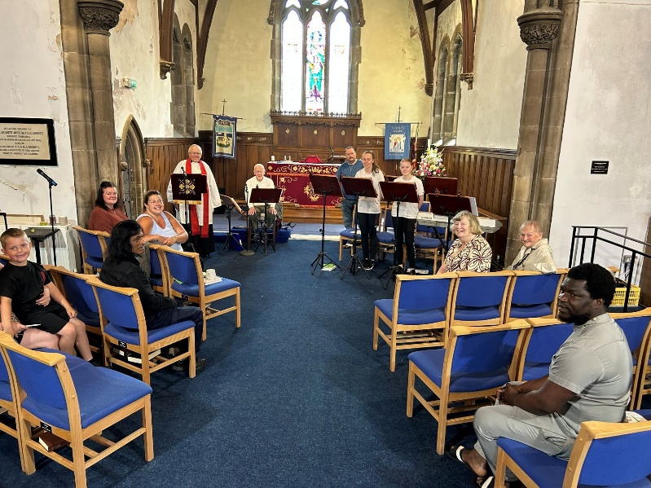
Sunday 11am - Morning Prayer on 1st and 3rd Sun of Month
Sunday 11am - Holy Communion on 2nd and 4th Sun of Month
Sunday 11am - Cafe Church on 5th Sun of Month
Wednesday 12 Noon - B.C.P Communion, not taking place now as we have no incumbent.
Other Services
Christingle Sunday morning service
Ash Wednesday 7:30pm
Palm Sunday 11am Communion
Maundy Thursday 7:30pm communion & stripping of the alter.
Good Friday last hour of the cross
Easter Sunday 11am Communion
Remembrance Sunday/Time to Remember 10:45 around war memorial.
Christmas Eve 11:30 pm Communion
Christmas Morning 11am
Our services range in age at present from 18 to 89.
The Vicarage
Where our new incumbent will live.
5, Brougham Road, Wallasey, Wirral. CH44 6PN.
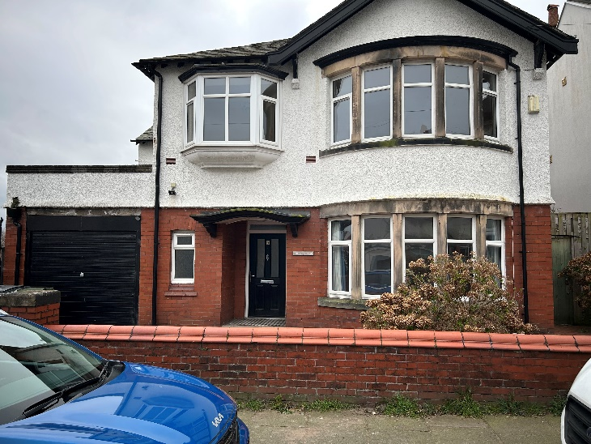
This is a 4-bedroom detached house, with a garage, small drive and the garden is to the rear. The ground floor has a lounge, cloak room, study, dining room, kitchen and WC. Also, there is an internal door to the garage.
The first floor there is a master bedroom with an en suite, 3 bedrooms and a large bathroom with lots of storage space.

