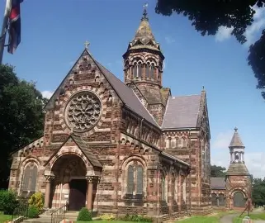
St Paul’s Hooton Parish Profile

Welcome to St Paul’s

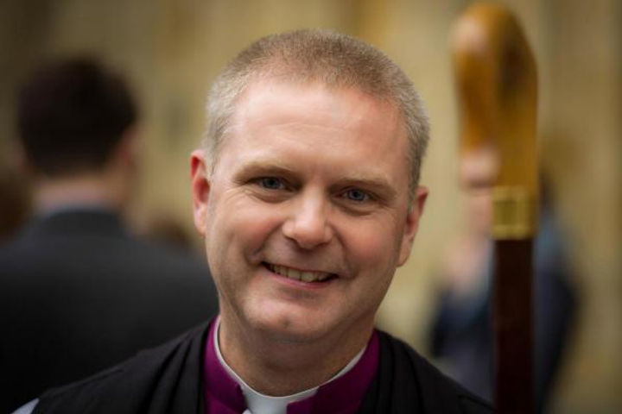
A message from
the Bishop of Chester

Thank you for looking at this post in Chester Diocese. Whatever the Lord has for you, I want to assure you of my own prayers and a deep gratitude that we might get to partner together in this part of the Lord’s work.
I have spent ages trying to capture the enormity of the privilege I feel in getting to serve the people of this diocese, and my words cannot bear the weight of that calling. This community of communities ranging from the very richest to the very poorest and the deepest rural to the most industrialised and urban is amazing. The diocese holds together in a shared sense of call to be ‘Together in Christ Sharing Hope’. We have a deeply held vocation to serve the 1.5 million inhabitants who have no meaningful connection with a community of faith, and share the feast which has been shared with us in Jesus.
In Chester Diocese this is always going to be worked out locally first and foremost: no-one met Jesus through a Diocese! Lives are changed in parishes, chaplaincies, and new expressions of Christian community, when people are invited in kindness and grace into transformative encounter with the love of the God who made them. Together we focus on our broad strategic aims so that those who know they are the people of God can serve all the people God calls in their everyday living.
We are utterly committed to safeguarding, because every person matters to our God and Saviour more than we know how to express. This is also why we welcome applications from every background for posts in this diocese. We are learning how to do all of this as guest rather than always as host, as we partner to serve the world to which we are sent.
If God is calling you to serve with us, I rejoice! Come, roll up your sleeves, and get stuck in! If the call is elsewhere then be assured of our gratitude and earnest prayer that the Lord will lead and provide in all things.
Please do pray for us, too – the harvest is plentiful, but the workers are few.
+Mark
Introduction
Hooton is a welcoming suburban community at the southern end of the Wirral Peninsula, and close to the town of Ellesmere Port. The parish encompasses the villages of Hooton, Childer Thornton, and Little Sutton. St Paul's church, prominently situated on the A41 is close to the vibrant city of Liverpool and the historic city of Chester. The beautiful North Wales Coastline and Wirral peninsular offers many attractions including seaside resorts, coastal paths and country parks. The church is an impressive Italian-style building, set back from the main road amid well-kept lawns, and is recognised in the National Heritage List for England as a Grade II* listed building. The church was built in 1862 by Richard Naylor, a member of a prominent local family, and generously bequeathed to the people of Hooton.
We are a lively and welcoming church community, seeking to share Christ’s love through worship, service, and fellowship. We offer opportunities for people to mark important milestones in their lives and encourage wider participation through a varied and flexible weekly programme. Our modern Church Hall is a well-used resource for parish and community activities, hosting social groups, fundraising events, and community gatherings
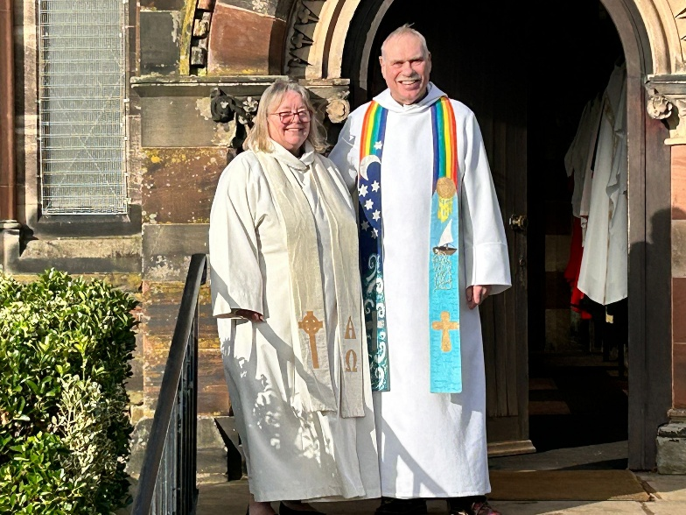

The Broader Picture
Our parish brings together a vibrant mix of people, from young families to retired residents, representing a range of professional and practical backgrounds. Over the past decade, three major housing developments have brought growth and new energy to the area, enriching parish life and boosting numbers in our local schools. We maintain close and supportive relationships with these schools, inviting their participation in major festivals such as Harvest Thanksgiving and the Summer Fair, as well as hosting special services including Leavers’ Services and teaching opportunities where children are introduced to the sacraments and Christian traditions. We are especially proud of our strong and enduring link with our church school.
We are blessed with a faithful and steady congregation. Our two Sunday services at 8:30 a.m. and 10:30 a.m. cater for differing worship styles and preferences.
Like many parishes, we face financial challenges. Regular giving is currently lower than we would like, but is supplemented by occasional offices, hall hire, and well-supported fundraising activities. We are actively working to strengthen our stewardship through a new giving campaign, supported by the Diocese.
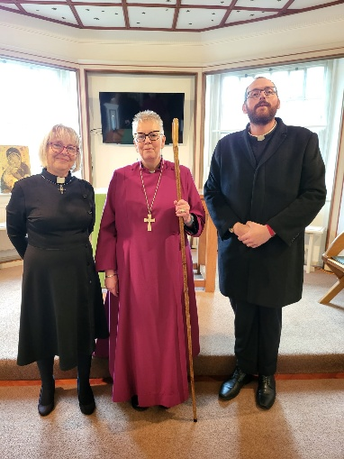
What we lack in financial resources, we make up for in enthusiasm and commitment. Our congregation is generous with their time and talents, and we are blessed with volunteers who give willingly and joyfully in many areas of parish life.

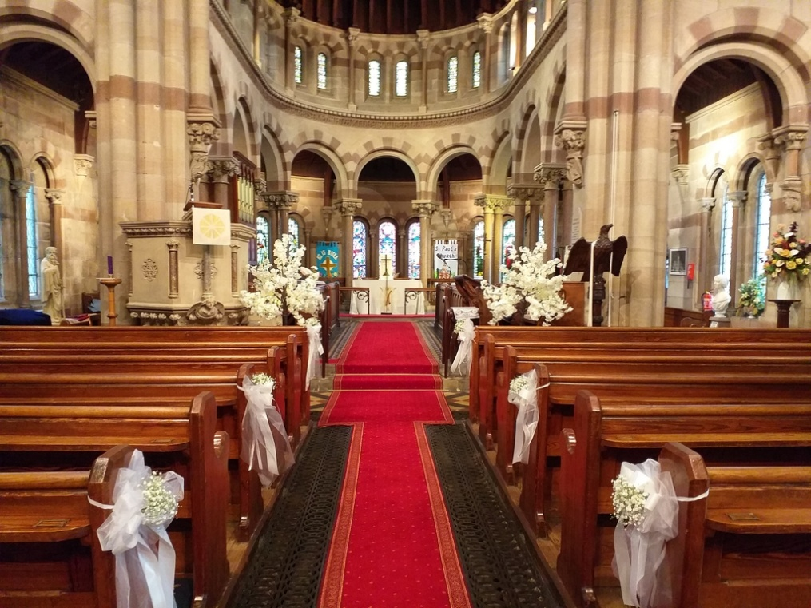

Our New Vicar
What We Are Looking For
We are prayerfully seeking a vicar who will build on our strengths, help us to grow in faith and service, and lead us forward with vision and renewed energy. Someone who has a deep, genuine and compelling faith in Jesus and is as comfortable visiting the elderly and housebound as they are welcoming young families, nurturing faith through baptism and beyond.
Our Vicar would be Christ centred, scripture based and spirit led, someone with a strong, living faith, who can inspire and guide us as we grow in discipleship and mission within our local communities. Someone who will encourage the congregation to live out their Christian faith in daily life, Monday to Saturday, not just on a Sunday.
We would also love our new vicar to be keen to explore new outreach opportunities, helping to ensure that those who may not otherwise have the chance to worship feel welcomed and valued within our community
We hope for a minister who is as comfortable engaging with pre-school children in our Parent/Carer Toddler Group as they are sharing fellowship with the retired and elderly at our monthly drop-in lunches. Someone who delights in encouraging faith, inspiring and enabling lay leadership, and nurturing and expanding our close links with local schools. Our vicar would also need to foster a strong safeguarding culture in the parish.
Above all, we seek someone enthusiastic and inspiring, who will lead St Paul’s forward with faith and imagination, while honouring the traditions that many of our older congregation hold dear. We hope that as you read this profile, you will see the potential that we see — and add your own gifts, ideas, and energy to our shared future. A charismatic person, who with a sense of humour is able to roll with the unconventional absurdities that make up the wonderful mix of God's people.

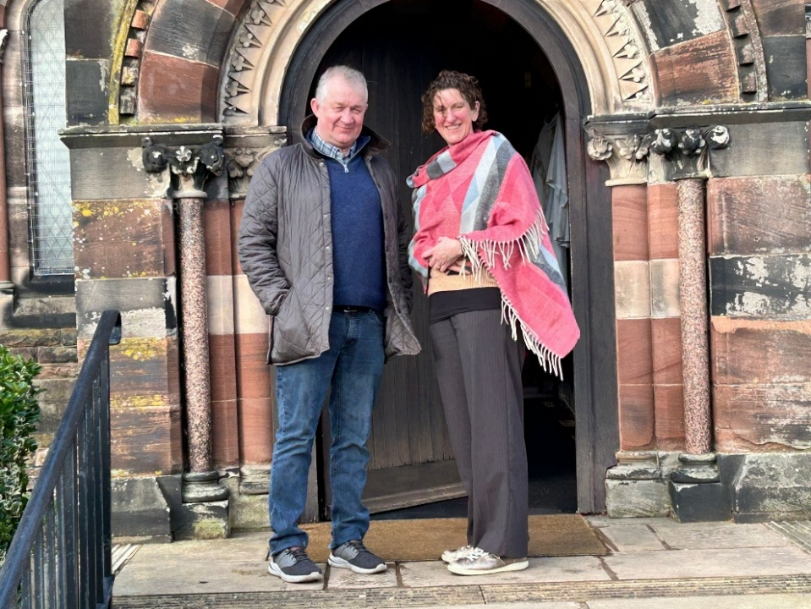

Alex and Mark - Our Church Wardens

PCC and safeguarding
The enthusiastic Parochial Church Council (PCC) team plays a vital role in the life of the church, ensuring it runs smoothly and meets all its safeguarding responsibilities.

About the Parish
According to the most recent census, the parish has a population of around 10,800 people, with 146 currently on the electoral roll. While St Paul’s stands proudly on a main through-route rather than in a densely built-up area, our congregation draws from across the wider community, with most worshippers travelling by car. Alongside the two recent housing developments mentioned earlier, a third is now underway. With excellent transport links — including the nearby M53 motorway and two local railway stations — the parish increasingly attracts professionals and families who commute to Liverpool, Chester, and beyond.
The Vauxhall car plant lies just beyond our parish boundary, and the neighbouring area of Ellesmere Port remains a hub for manufacturing and industry, situated near the outer reaches of the Manchester Ship Canal.
Our population is diverse but predominantly made up of working parents with children in local schools, and it continues to grow as new housing becomes available. The nearby village of Little Sutton, also situated along the A41, has a friendly, welcoming atmosphere and an active local economy. Recent investment has brought new life to the village, with a microbrewery, bakery, and coffee shop opening recently. These join a range of established local businesses including hairdressers, chemists, a post office, charity shops, and barbers. The introduction of on-street parking has further enhanced access to these amenities, helping to foster a sense of community and vibrancy in the area.

What Parishioners say about St Paul’s

‘Everyone is so friendly and caring, people are genuinely interested in each other and what they can do for others.’

‘Being part of St Paul's is like having an extension of your family, the care and support is exceptional.’

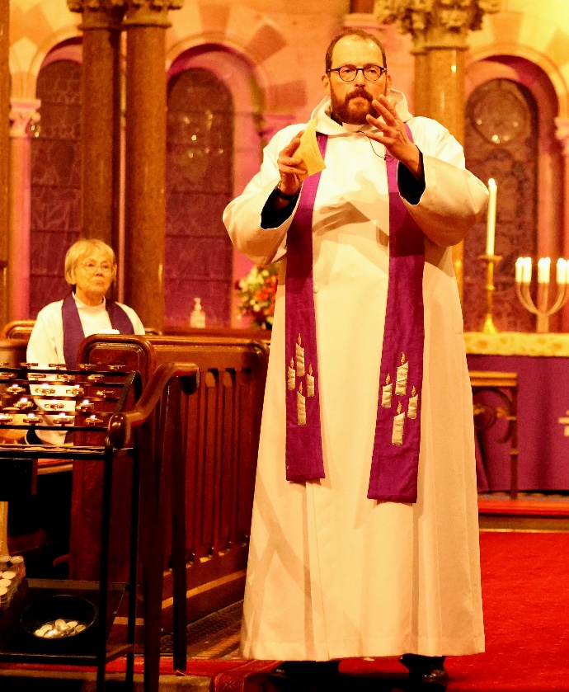
‘Being a member of St. Paul’s family is to witness God’s love in action – to feel God’s joy, to hear His laughter, to be strengthened by His grace and enveloped by His love and acceptance. It is to be part of something incredibly special.’

About the Church
The Worshipping Community
St Paul’s offers a variety of Sunday services designed to meet the spiritual needs of our diverse congregation:
We are blessed with a faithful and steady congregation. Our two Sunday services at 8:30 a.m. and 10:30 a.m. cater for differing worship styles and preferences, and we also hold a midweek Communion on Wednesday mornings, held in the lady chapel of the Church Hall. We also have a dedicated robed choir at the 10.30am service.

- 8:30 a.m. Holy Communion – held every Sunday; a quieter, traditional service, following Common Worship, without music.
- 10:30 a.m. Holy Communion – on the 1st, 3rd, and 5th Sundays of the month; a more traditional service with hymns and music.
- 10:30 a.m. Family Service – on the 2nd Sunday; an inclusive service that actively involves children and young families.
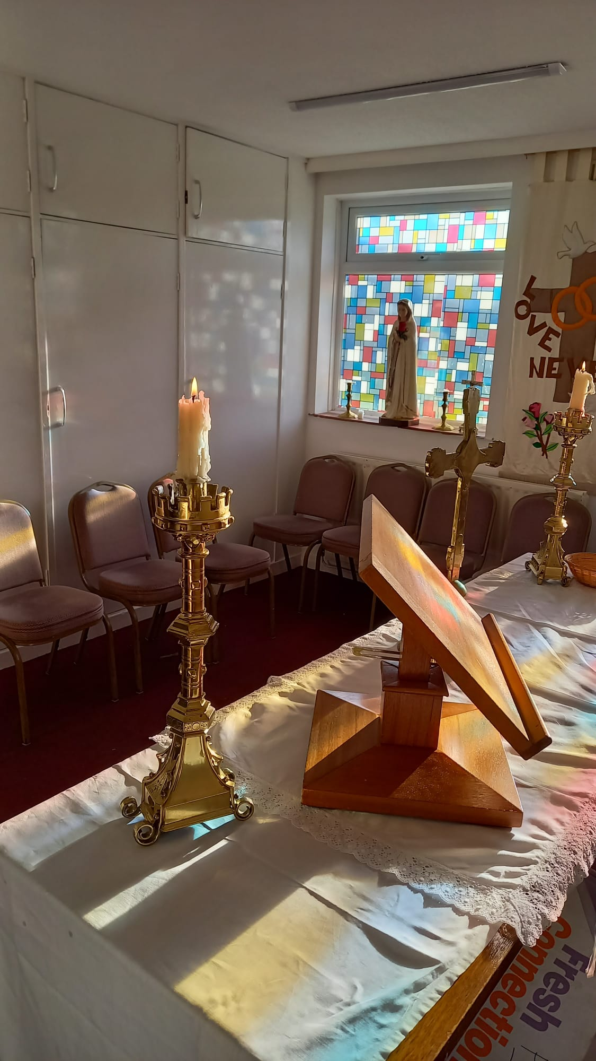
- 10:30 a.m. Café Church – on the 4th Sunday; an informal, contemporary service with a relaxed atmosphere, designed to engage people of all ages and backgrounds.
All our 10:30 a.m. services are supported by a dedicated choir and organist.
10:30 a.m. Holy Communion follows our standard service book, hymns and a sung Gloria, and readings and intercessions delivered by the laity and are followed by refreshments and fellowship in the church hall.
Family and All age Service is planned around contributions from the congregation and Sunday club, including, Bible readings, intercessions, and occasionally short Bible-themed plays performed by the children. While numbers are currently low, we are committed to nurturing and encouraging young participation.

The Lady Chapel in within the Church hall
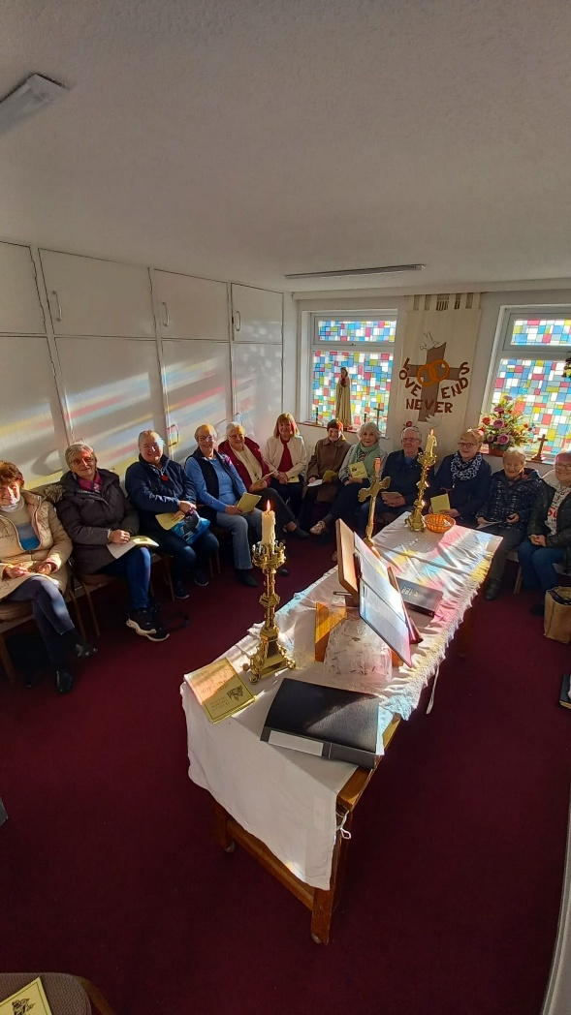
Café Church is a more informal service held in the Church Hall currently using The Service of the Word. Leading, reading, intercessions, and preaching are shared by members of the worship team.
Sunday Club meets at 10:20 a.m. during term time for children aged 5–15. Older children are encouraged to assist and attend confirmation classes, fostering their ongoing participation in worship.
Attendance has fluctuated in recent years, but we maintain strong links with the local Church School on Berwick Road, Little Sutton Primary school.
Midweek Worship 10am, mirrors the 8:30 a.m. Sunday service and is attended by a mix of 8:30 a.m. and 10:30 a.m. congregants, as well as others unable to attend Sunday services. This service is attended by an average of 15 communicants held in the chapel room of the Church Hall. This is also followed by refreshments and fellowship.
Through this varied pattern of worship, we aim to provide something for everyone — from traditional services for long-standing members to creative and accessible formats that welcome families and newcomers.
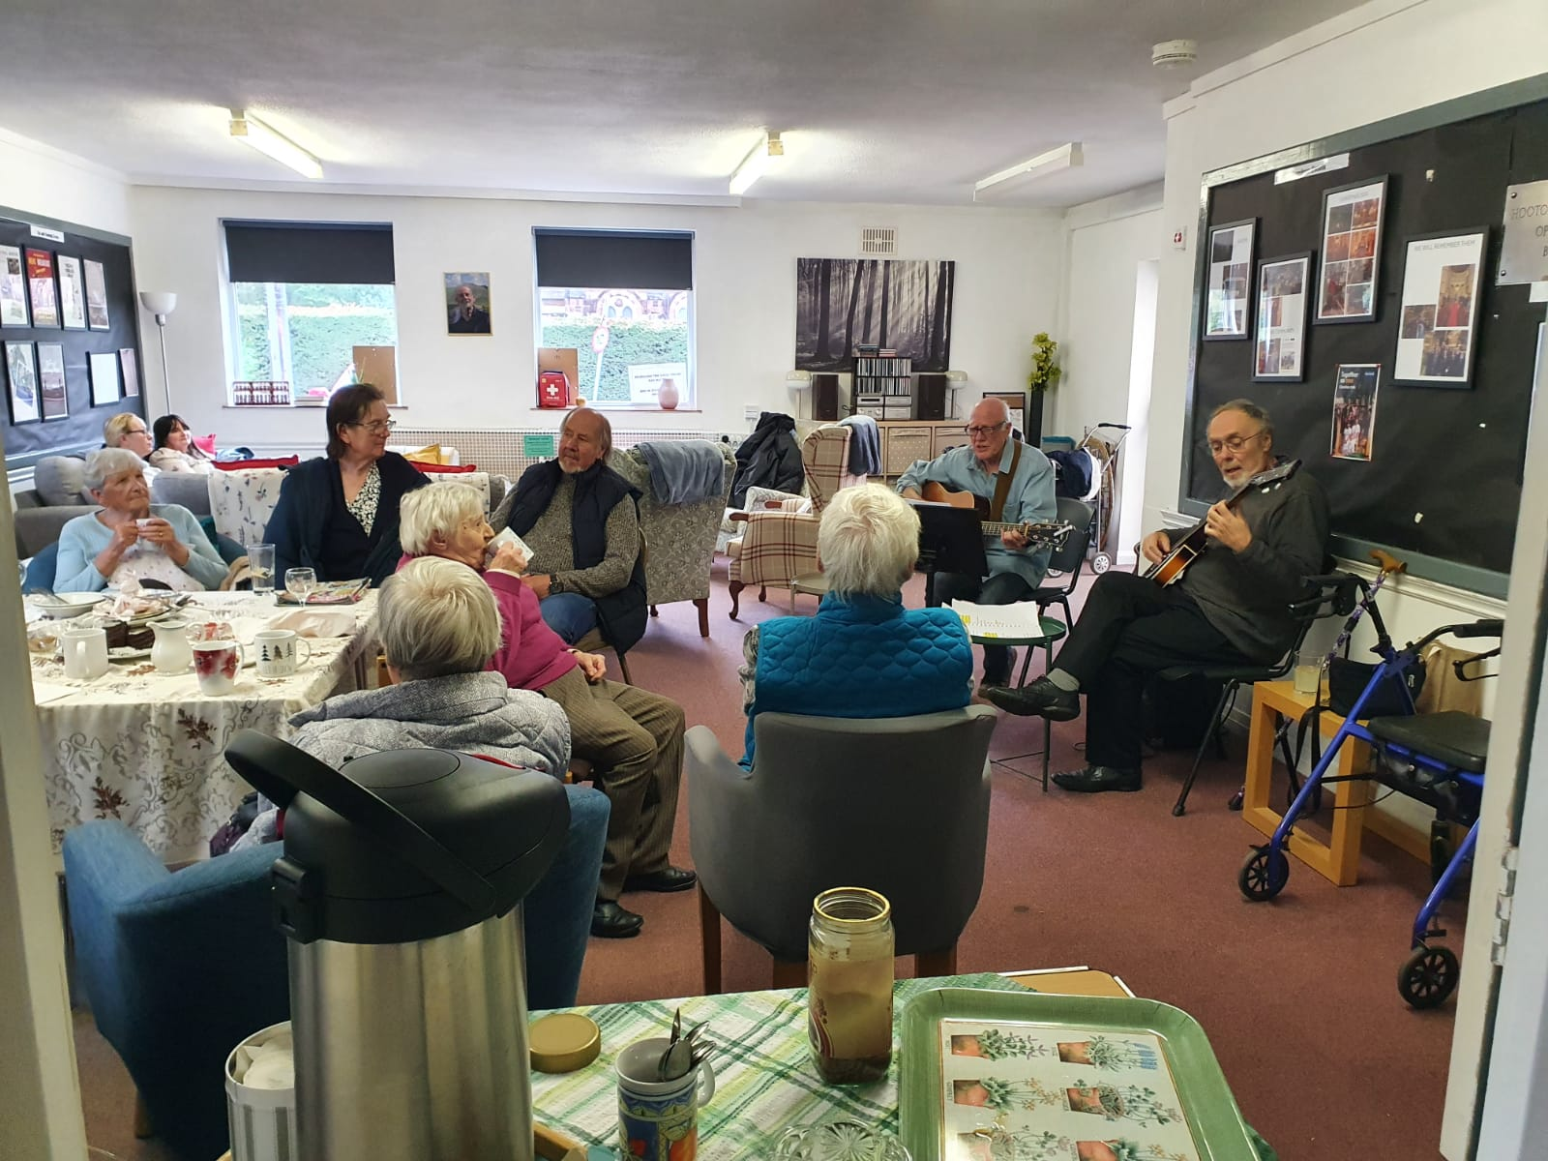

The warm hub

Worship and Ministry

In recent years, ministry at St Paul’s has been led by the vicar, supported by our self-supporting curate, Revd Joanna Pemberton, licensed reader, Sheena Wilson, and Occasional Worship Leaders.
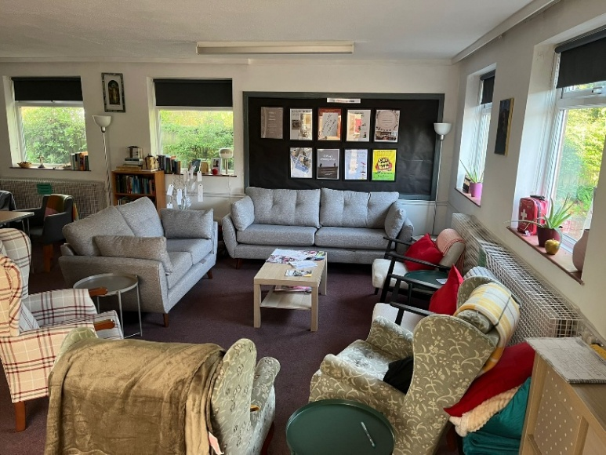
Prayer and Bible meetings/ groups:
- Bible Study Group:
The Bible study group which meets regularly and is growing in numbers.
- Bible in a Year:
This group meets weekly for reflection.
- The prayer group regularly meet for devotional reading and open intersessions.

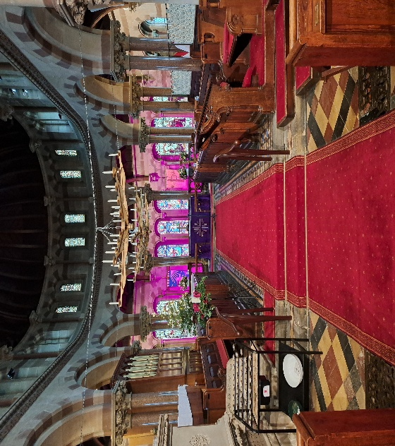
Special Services and Festivals:
- In 2025 we have been lucky enough to host two confirmation services with 14 candidates blessed by Bishops Mark and Sam.
- We hold an annual Remembrance Service, as well as memorial services organised by local funeral directors.
- Holy Communion is celebrated on key calendar days, including Ash Wednesday, Maundy Thursday, and Ascension Day.
- Major festivals are a highlight of parish life. During Advent and Christmas, the church is decorated with large chandeliers, enabling a candlelit Lessons and Carols service and a Crib Service on Christmas Eve, both of which are well-attended by the local community. During Easter Holy week activities include agape supper, good Friday meditation/ stations of the Cross and sunrise services.
Our worship reflects both traditional and modern, providing opportunities for all ages to engage meaningfully in the life of the church.
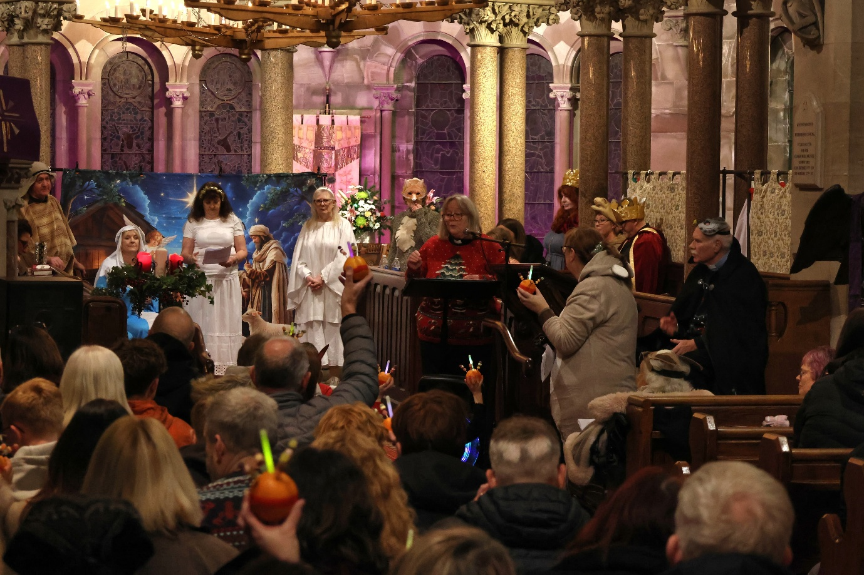
The Community We Serve
St Paul’s Church is widely admired for its striking Italian-style architecture and is a popular choice for weddings and baptisms. Over the past year, we have celebrated 32 baptisms, 7 weddings, and 40 funerals, reflecting the church’s important role in marking life’s milestones.
We maintain a home visitation list for the sick, elderly, and those unable to attend church, ensuring they can receive communion and pastoral care. Our worship team also conducts hospital visits and supports parishioners in nursing and care homes.
The parish includes a Church School and four other primary schools. The vicar regularly leads assemblies at the Church School, and all the schools are welcomed to use the church for special services such as leaving assemblies and teaching sessions. Students are invited to create displays in the church at key times of the year, which parents are encouraged to view. We are eager to further develop these school links, strengthening connections between families, children, and the wider parish community.
Parents are actively encouraged to attend Family Services, particularly when their children are participating, fostering engagement across all ages.
This is what Little Sutton C of E Primary School say:
‘My aspiration for our partnership with St Paul’s is that it continues to be a meaningful, supportive and serves a visible presence in the life of our school. I hope we can further develop opportunities for shared worship, reflection and community engagement, ensuring that our children continue to grow in confidence, compassion and understanding of Christian values in action. A strong partnership with St Paul’s enriches not only the spiritual life of our school, but also our wider school community, and I look forward to seeing this relationship continue to flourish and enhance our pupils’ sense of belonging and understanding of their place in the world.’
Emily Philip - Headteacher of Little Sutton C of E Primary School

‘I like to work with St Paul’s church so we can learn more about God and be kind to others. We like listening to Bible stories and singing songs together. I hope we can help people and make our school a happy place.’ Year 1
‘I am hoping to learn more about Christianity in church and grow in our spirituality. Learning Bible stories helps me think about God, myself and other people. I hope working with the church will help us make good choices, feel calm, and care for our community.’ Year 3
‘I would like our school and church to feel more like one community. I think it would be nice to invite people from the church into our school and to meet new people too. I would like people of different ages and backgrounds to come together, get to know each other and celebrate what makes us all special, while showing kindness and respect to one another.’ Year 5



Summer display by students from our local Church School

Buildings and Resources and Stewardship
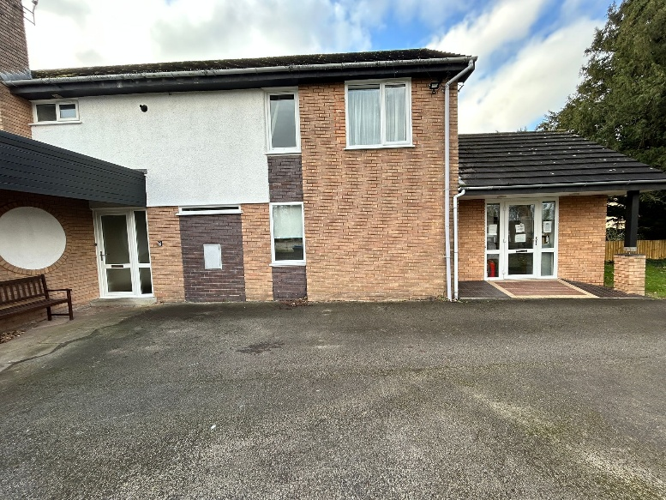
The parish is blessed with excellent buildings and facilities, though, like many churches, we face some financial challenges. Over the past decade, we have consistently met our commitments to the Diocese in Parish Share and Assigned Fees, covering all other expenses. Recently, we experienced a temporary pause in paying the full Parish Share, but full payments have now resumed. We have had a presentation from the diocese stewardship advisor, a talk last Sunday to encourage people to increase their giving in terms of time and money and letters have been sent to all the congregation asking that they prayerfully consider their giving. We are hoping for a positive response.
The parish continues to cover all expenses submitted by the incumbent, and a proportion of gas and electricity for the vicarage, which adjoins the Church Office.
The Vicarage
The vicarage is a modern, four-bedroom detached house and garage, with a large enclosed garden, it is situated next to the Church Hall on site. It has recently been painted and the kitchen extended and refitted.
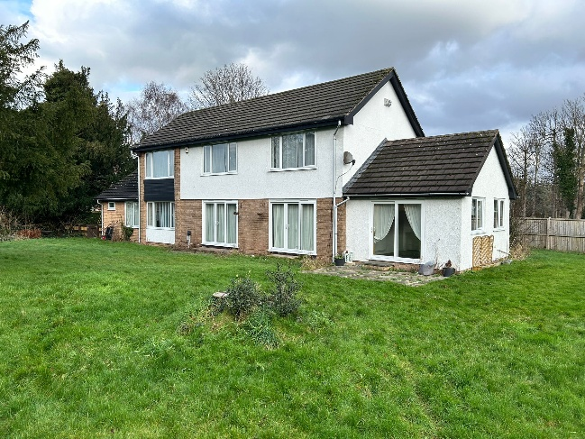
Church Buildings
The parish includes St Paul’s Church, the Church Hall, and the Church Office (adjoining the vicarage), which is maintained by the Diocese. We currently employ two office administrators four mornings a week to assist with administration and phone coverage.
Currently, the church dome requires repair, and we have recently installed a temporary netting to reopen the space fully while a grant application is submitted for the necessary repairs. Routine maintenance is managed by a committed volunteer team, though, as with many historic buildings, occasional costly repairs are unavoidable. The church is open daily for prayer, reflection or just a space for to be still in God’s presence.
Graveyard
Our graveyard, mainly located to the east of the church, is full apart from additional family plot spaces. There are still spaces for ashes burials, including a memorial lawn with plaques on an adjacent wall. It is regularly tended by volunteers and the Community Payback Team.
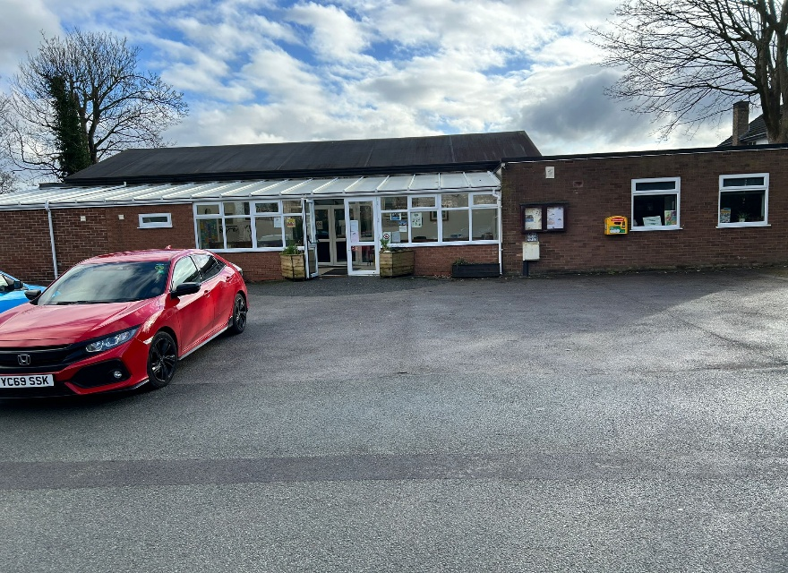
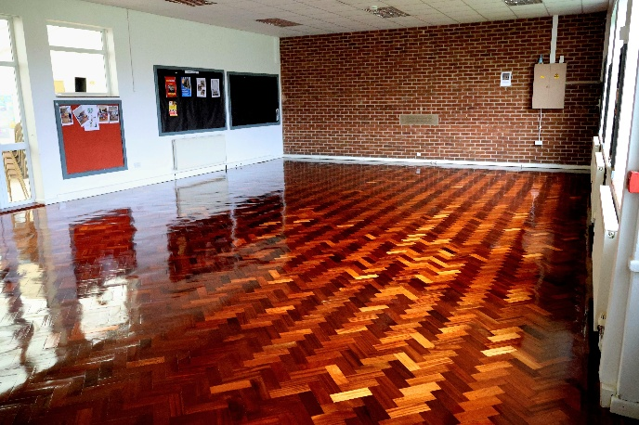
Church Hall
The modern Church Hall was extended in 2012 and has recently been refurbished. It consists of a large multi-functional hall, a modern fitted kitchen with full catering facilities, a smaller hall, furnished with comfortable settees and chairs, used as a warm hub / public living room.
A separate room that has been converted into a lady chapel. It has ample parking and outdoor space and is used daily for a wide variety of activities, including:
- Parent and toddler groups, Art classes, Brownies & Guides, Karate Academy, Slimming World, luncheon clubs, Spanish classes
- Community events, including a recently launched Artisan fair

The hall also supports church activities, hosting the warm hub, a ‘it’s good to talk’ lunch, men’s breakfast, PCC meetings, toddlers’ group, fundraising events and refreshments after Sunday services. Through these activities and rentals, the hall now successfully covers its own costs. These activities also attract people that would otherwise not attend church, helping us to connect and serve the local community.
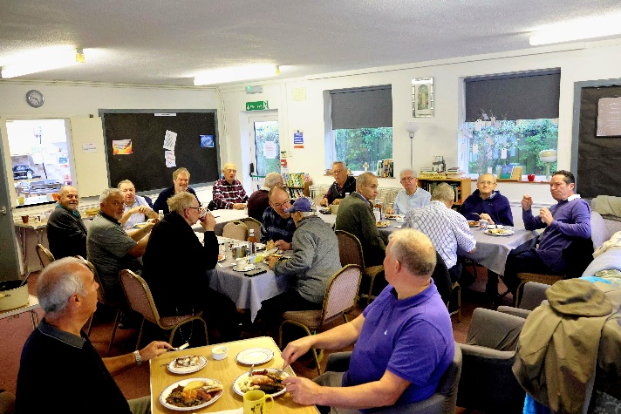

The popular Men’s breakfast
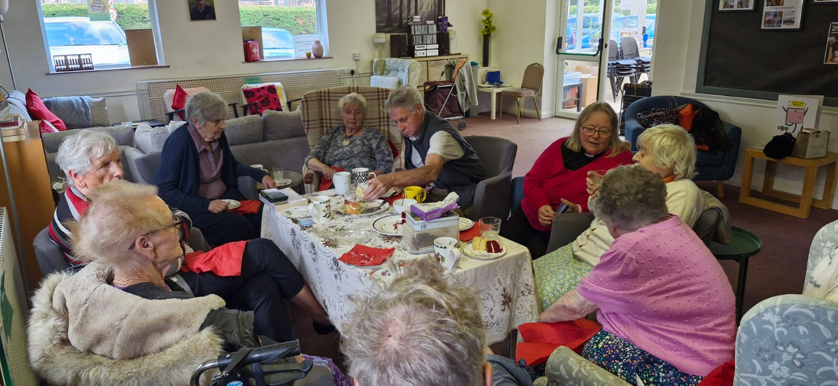
Other activities
We are also an active church away from St Pauls. We run a monthly walking group, an annual barge trip, a fish and chip walk and a parish picnic. Our Monthly magazine is delivered to over 70 people in the local community

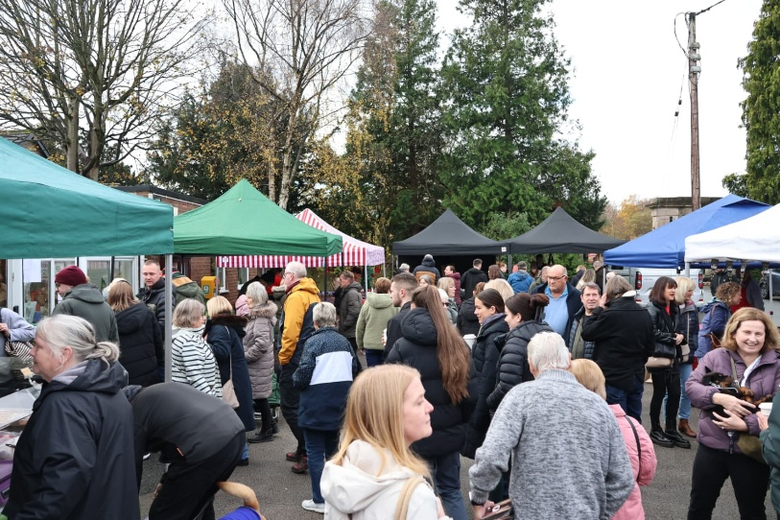

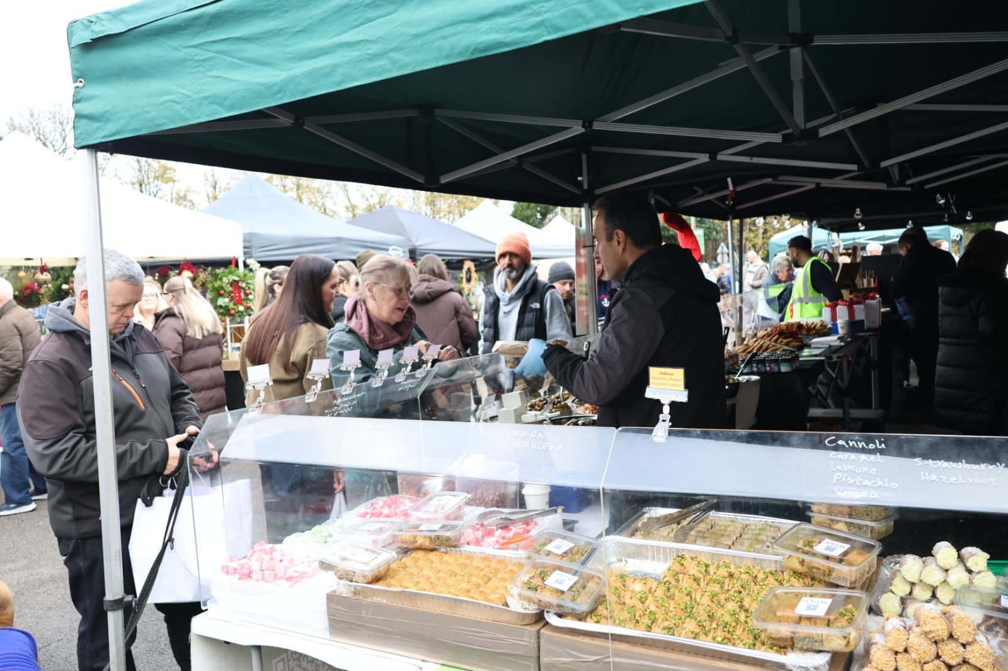
The Monthly Artisan market

In summary
We prayerfully trust that as you read this profile, you will clearly hear God speaking to you, leading you here as the next step of your ministry.
Our arms are open, ready to welcome and support you in Christ's love.

"Be completely humble and gentle; be patient, bearing with one another in love. Make every effort to keep the unity of the Spirit through the bond of peace."
Ephesians 4:2-3 NIV

