Introduction from the Bishop of Chichester

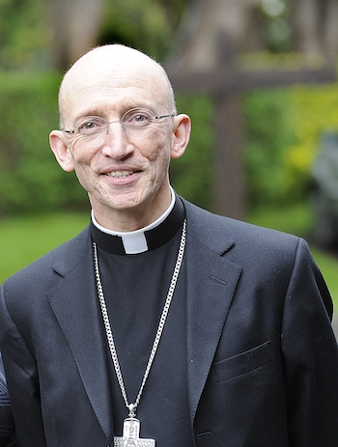
The anniversary of moving our mission centre from Selsey to Chichester in 1075 has been a catalyst for renewal, by living the mystery of faith that has been handed on to us.
This means being endlessly curious about how the Holy Scriptures and the sacraments of the New Covenant enable us to know, love and follow Jesus Christ in today’s noisy and distracted world.
It also invites us to address how to be more fully what we say we are: the body of Christ, his radiant Bride, the flock for which he laid down his life.
We seek to understand the qualities of being the Church: one, holy, catholic, and apostolic, as challenging marks of mission shared by all Christians. We believe that this will bring us closer to Jesus Christ and present a more compelling account of his compassion and joy to the people of Sussex, young and old alike.
If God is calling you to join us in living the mystery of faith in some part of this diocese, we pray that the contribution of your gifts and experience will enrich our witness and deepen your own discipleship.
We take very seriously the call to diversity and radical inclusion as characteristic of the Church’s mission. For this reason, we welcome applications from ordained women and Global Majority Heritage clergy, who are under-represented in those who serve this diocese.

+Martin

