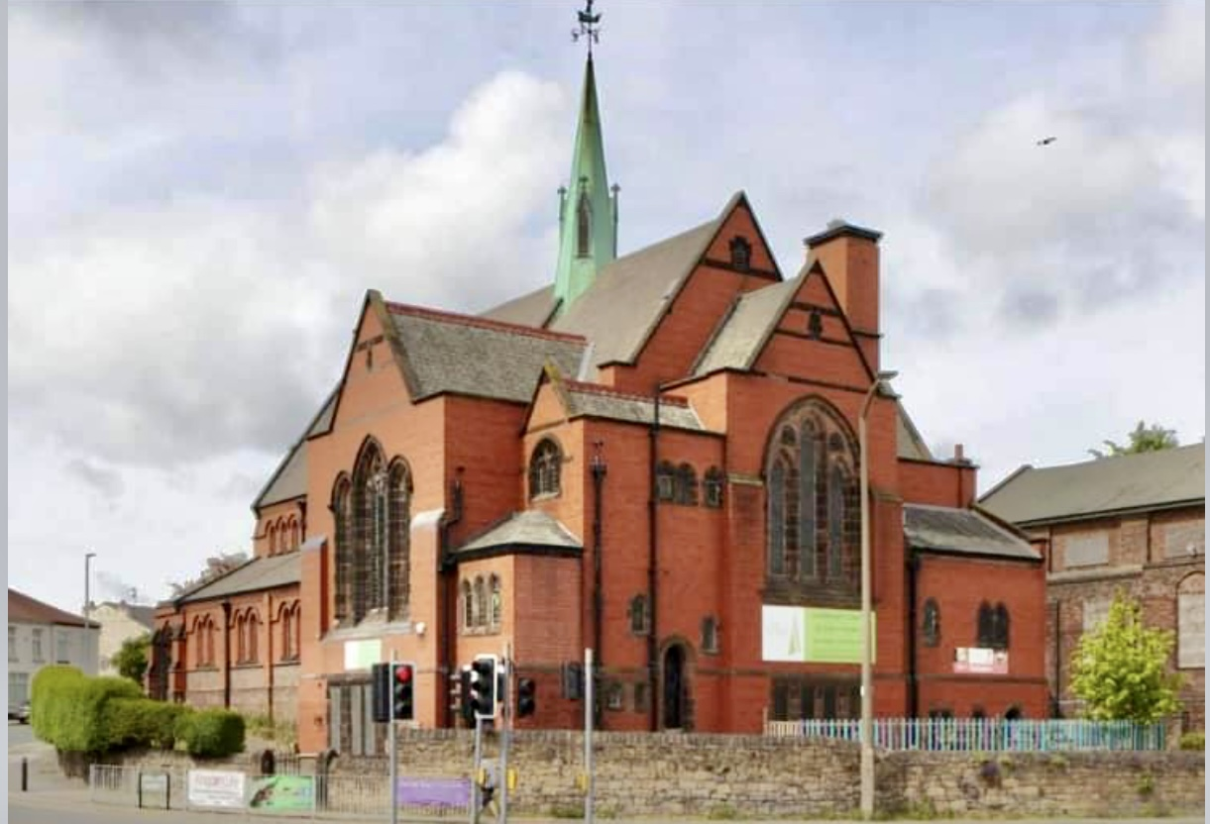
Parish Profile

St. Luke’s Church

Poulton
INTRODUCTION
St Luke’s parish is situated in an urban area of Wallasey, on the Wirral. The parish borders the dockland area of Wallasey and the M53 motorway link. There is one school in the parish, Park Primary school, which is local authority controlled. There are 2 GP practices and a minor injuries and clinic unit.
Along the dockside area of our parish there is a new housing development called Wirral Waters. The area also encompasses parts of neighbouring parishes. The Bishop has put a Mission Order in place and a new initiative called “The Well@WirralWaters is set up there. Meetings and services are held weekly led by Rev Debbie Wilkinson.
Wallasey is situated on the River Mersey, across from the famous Liverpool waterfront. Liverpool city centre is just a short bus, train, ferry or car journey away. There are also transport links to the wider Liverpool region and cheshire. Nearby is the coastal resort of New Brighton which has beaches, a fort, parks and entertainment venues, restaurants and shopping areas.
St Luke’s is in a united benefice with St Paul’s Seacombe. St Mary’s also shares our priest

OUR CONGREGATION
We are a small friendly, loyal congregation. Many members have been attending St Lukes for many years. We have a small, loyal, tuneful choir. We have one reader and two churchwardens. Members of the congregation read lessons and lead prayers during the services. We have two communion services and two morning praise services each month. If there is a fifth Sunday we have a Café Church service. We follow simple, easy to follow services presented in booklets. We have been using a projector and screen for our songs and we sometimes use CDs. We enjoy a drink together and some social time after our services.

OUR AIM
To reach out to the local community and share the word and teachings of Christ to enable our church to grow and flourish.

OUR MISSION STATEMENT
“Taking steps Towards Christ”
We feel that we are all on a journey working our way nearer to Christ. We need to continue to take forward steps and develop our understanding of Christianity and make our journeys more meaningful. During our worship and at home, we aim to take steps to become nearer to Christ. We believe that faith is foremost, and our church and home family and our friendships play an important part in all our lives.

OUR BUILDINGS
Although we worship in St Luke’s church, the building has a rather unusual status. Some years ago we sadly had to leave our building due to falling numbers and increasing maintenance costs and we moved into our local primary school for Sunday services. At that point St Luke’s was closed to public worship and sold to a Christian charity called The Aspiration Trust. It was renamed “the Spire” because of its prominent green spire. Some tears later we were happily able to return to the church building on Sundays for our services. So this is something of a resurrection story. The net result is that we are now renting space in what used to be the parish church, without responsibility for maintaining the fabric of the building.
We have a community café in the church basement, owned by the Aspiration Trust, which is well used and holds weekly events such as music groups and craft clubs. The café also provides free meals for those in need in the community. We have previously used the café area as a venue for Alpha and Bible study groups. St Luke’s sometimes supports the café financially as part of our mission to the local community. The adjoining derelict memorial hall, which is owned by the Aspiration Trust, and empty land area are both for sale by the Aspiration Trust, for redevelopment.
The Vicarage is situated in St Paul’s parish, close to the long promenade linking Seacombe to New Brighton along the River Mersey. It is a traditional 4 bedroomed detached house. A gym, primary school and swimming pool are across the road and convenience shops are nearby.

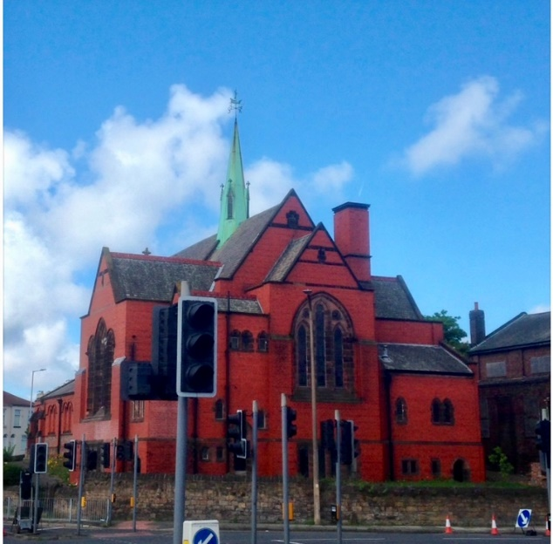

CHURCH ACTIVITIES
We enjoy our Café church, which is held on fifth Sundays in the month. This is a more informal gathering including songs, prayers, a reading, a talk and group activities and discussions. We enjoy hot drinks and cakes during this gathering.
We hold a midweek communion at “Willowbank”, a supported living community within the parish.
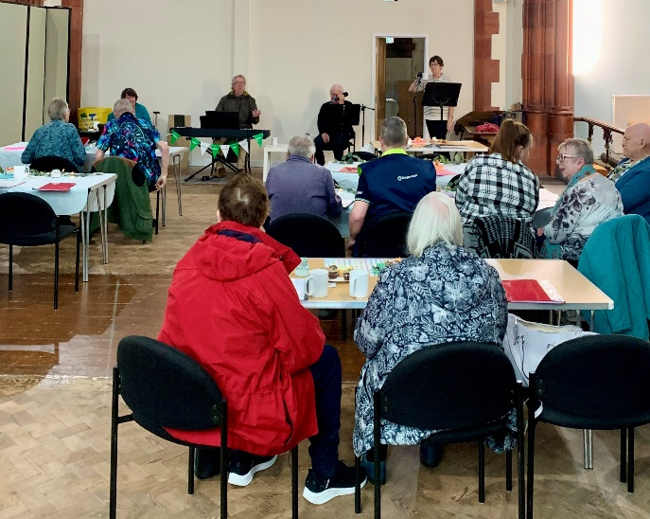
We link with our local primary school to do talks and we have also presented assemblies.
We hold a singing café each Tuesday morning in the church. This is run by Singing Café Wirral. Church members set up the area and provide refreshments and friendly chat. There are musicians and singers and everyone is encouraged to join in, with lyric books provided.

We enjoy having lunch out together a few times during the year at a local garden centre and we have a picnic every summer in a local park. We have also been up the tower at Liverpool cathedral and tried some bellringing.

We have previously walked through our shopping centre, or along the prom, with a real donkey on Palm Sunday, with our friends from St Paul’s, handing out palm crosses to people and singing songs.
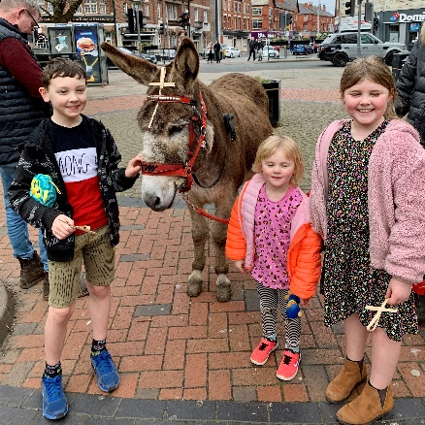

Our reader attends ecumenical events in the area and weekly prayer meetings. He also attends a dawn service on Easter Sunday held in differing parts of Wallasey. He has also formed links with other churches in the area.
We recently took part in a Wirral wide Christian event where churches walked the whole coast of Wirral and prayed for the area. There was a marquee on the prom for worship services and information.
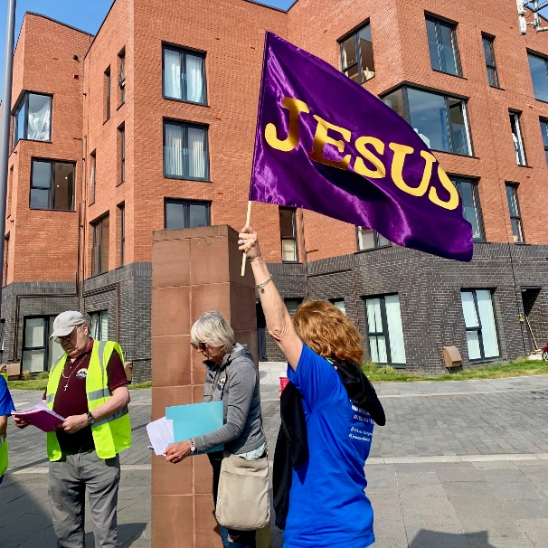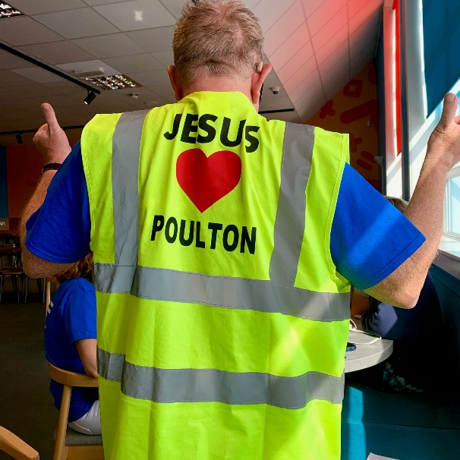

We held a Macmillan coffee morning at our Singing Café and we collect non-perishable foods for the foodbank at our morning services. Members of our church help at the nearby foodbank in Seacombe.
We have a Facebook page which we try and keep updated with photos and information.

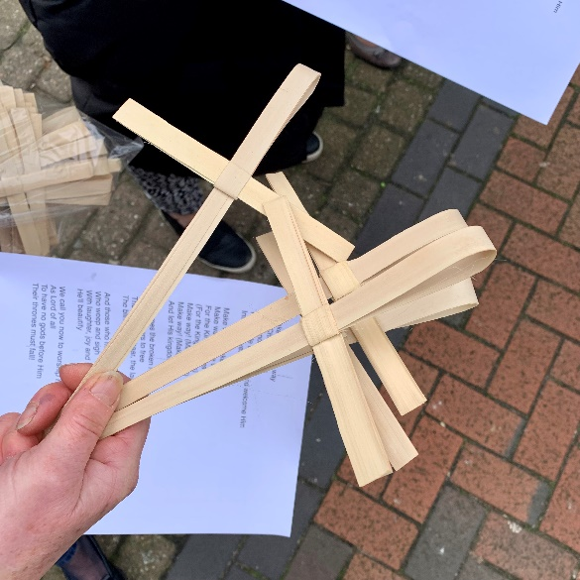
OUR FUTURE HOPES
We would love to increase our numbers and attract new people to the church. We have tried to develop links with the local community through leaflets and personal contact, but have had very little positive response so far. We would like to rebuild our links with the local school community as well. We would love St Lukes to be a growing uplifting part of the community in Poulton. We always have positive feedback from our baptism families, who say we are friendly and helpful.
EQUALITY AND INCLUSION
We are welcoming and friendly to all people.
We are committed to value all people
The church leaders and PCC members have undertaken Safeguarding training.
We have ramp access to the building and the worship area and we have accessible toilets and baby change facilities.
We can provide large print service booklets and hymn books.
The PCC has started to discuss the national church’s “Living in love and faith” initiative
We have a sound system.

WE SEEK AN INCUMBENT WHO:
- Enjoys leading different styles of worship and relates well to all age groups.
- Provides confident leadership to the churches, to enable growth in numbers and faith.
- Will be a good pastoral vicar who is responsive to the needs of the three churches and their communities.
- Is a motivating and inspiring leader who is forward thinking and pro-active and is also sympathetic to each church’s history and the make up of the current congregations.
- Will encourage our congregation to live out their faith in daily life, Monday to Saturday and not just on a Sunday.
- Will foster a strong safeguarding culture in the parish.

