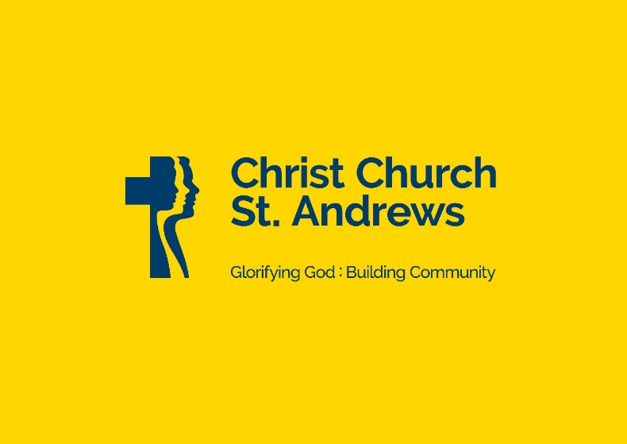

The new post of
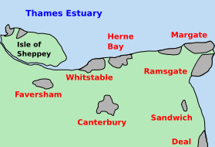Youth and Children’s Minister

About Us
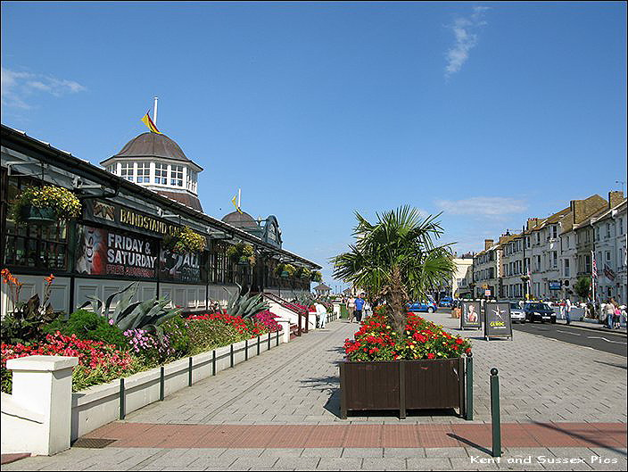Christ Church St Andrews is a welcoming and growing church based in the heart of Herne Bay. In recent years, we have been encouraged to see significant growth in the number of children, young people, and families connecting with church life through our Sunday services, children’s and youth ministries, and schools ministry. We believe God is creating exciting opportunities to deepen and expand this work now and, in the years, ahead.
As a seaside town, Herne Bay presents both unique opportunities and challenges for ministry, with a diverse and changing community shaped by tourism, local families, and varying social needs. We are passionate about sharing the love of Jesus in ways that are relevant, welcoming, and grounded in the truth of Scripture and the life of Jesus Christ.
 We are now seeking an enthusiastic and compassionate Youth and Children’s Minister who can build upon the strong foundations already in place and help further establish, grow, and develop ministry among children, young people, and families. We currently have five years funding for this post. This is an exciting opportunity for someone who is passionate about discipleship, outreach, and helping young people flourish in faith and belonging within the life of the church.

Vision
We have a clear vision statement which allows us to assess all we do in the light of our vision, values, and mission. This has been particularly useful for us as we continue to seek the Lord’s leading and have seen growth, numerically and spiritually, in the ministries we are involved in.

Our aim is to glorify God by building a Christ centered community through the power of the Holy Spirit. We do this by making and growing followers of Jesus.

Christ Church St Andrews is looking for someone who will

~ enable us to grow the kingdom of God in Herne Bay.
~ take responsibility for leading our youth and children’s ministry.
~ be involved in developing what we currently do among youth and children. (See below for our current activities/ministries.)
~ pioneer new ministries which are sustainable.
~ recognise that the church family has great community links and use those to reach wider numbers of young people and
children.

The gifts and experience we are looking for
Essential
~ a mature and active Christian faith, with in sympathy with the evangelical ethos of Christ Church St Andrews.
~ a clear commitment to discipleship, outreach, and helping children and young people grow in faith and belonging.
~ experience of working with children and/or young people in a church or ministry context.
~ the ability to teach the Bible clearly, faithfully, and engagingly in age-appropriate ways.
~ the ability to build positive relationships with children, young people, families, and volunteers.
~ experience of encouraging, supporting, and equipping volunteers for ministry.
~ the ability to work well as part of a team, while also taking initiative and leading areas of ministry responsibly.
~ experience of developing or growing children’s and youth ministry.
~ good communication and organisational skills.
~ commitment to safeguarding and willingness to comply with all safeguarding training and requirements.

Desirable
~ experience of outreach among children, young people, and families not yet connected with church.
~ experience of schools ministry.
~ experience of running evangelistic courses or nurture opportunities for young people.
~ relevant theological training or ministry qualification.
~ experience of working within a similar evangelical church context.

The current provision for youth and children

~ Sunday during our 11am service we have a weekly creche, a weekly Junior Church (age 5-11) and a monthly youth group (age 11-16).
These serve between 20-30 children and young people. The role would mean developing the youth provision to weekly and leading the Junior Church team.
~ on Tuesday a weekly alternative service which serves around 50 adults, children and youth. Being part of the leadership team would be
part of the role.
~ on Wednesday there is a small youth group for churched young people. The role would include leading this team.
~ we have an extensive schools ministry where we serve four non-church schools with assemblies and services especially at Christmas
and Easter. The role would involves supporting the other staff who have built good relationship with these schools.
~ annual holiday club for 5-11’s (at present three days) in the summer holiday.

The development of the youth and children’s ministry

We see this as an important ministry role so would hope that in time the person appointed would develop

~ open youth work with those not yet engaged with church at all.
~ better discipleship opportunities especially for the teenagers.
~ a broader age range in the team of volunteers including training newer Christians to join in the ministry.
~ the involvement of young people in Sunday worship.
~ the provision of possible one-off events for children and youth.
~ in the longer term a youth service in the Parish.
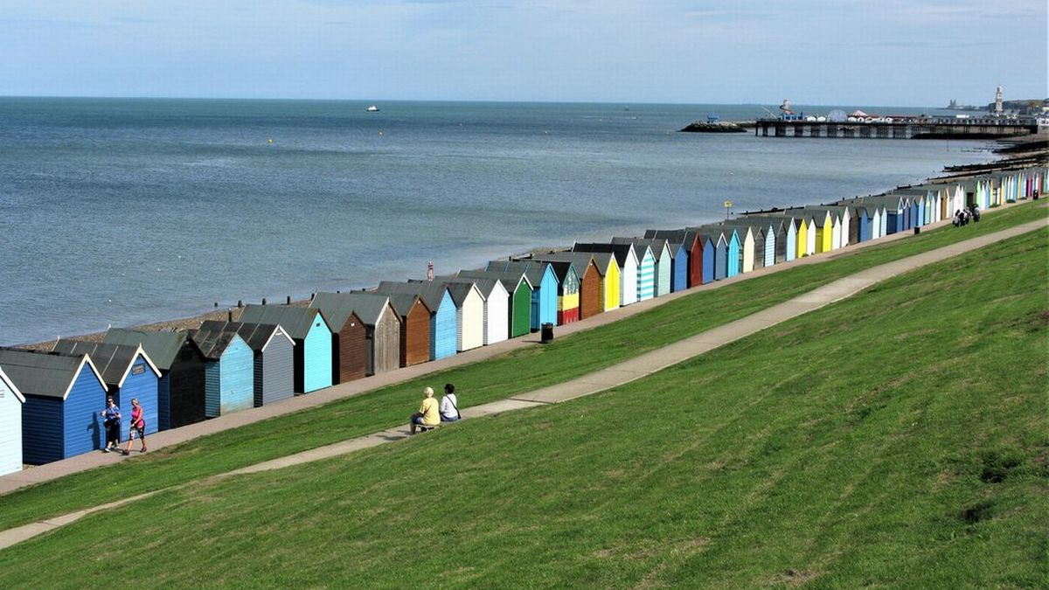Herne Bay is a great place to live and work
Herne Bay has been reported to be a great place for people to live. It has all the many advantages of living by the sea including walks by the sea, glorious sunrises and sunsets,
you can swim safely in the sea. The town is surrounded by woods where walking is a treat.

The Staff Team
The church has a strong staff team which is -

Anthony Everett has been vicar since September 2002. Anthony was before ordination an Accountant and Pastoral Assistant at a large London city church. He trained at Oak Hill and served curacies at Hailsham, East Sussex and New Malden, Surrey. He was incumbent at St Alban’s, Streatham Park before moving to Herne Bay. He has helped at an interdenominational Bible College and while in Canterbury has been an Assistant Diocesan Director of Ordinands, Area Dean and on Archbishop’s Council. Anthony is married to Anne, and they have three grown-up children and six grandchildren.The growth of the church has meant that we have appointed an associate vicar.

Simon Fellows was appointed our associate vicar over 2 years ago and is funded by the congregation. He trained for the ministry at St John’s, Nottingham before serving in a curacy in that Diocese. Before ordination he travelled with Operation Mobilization and worked on the team at Lee Abbey where he met his wife, Julia. Prior to coming to Herne Bay, he and Julia moved to work in the Faroe Islands which is where Julia was born and raised. They have two young children. Simon runs two of our congregations as well as being involved in many ministries, especially supporting Anthony.
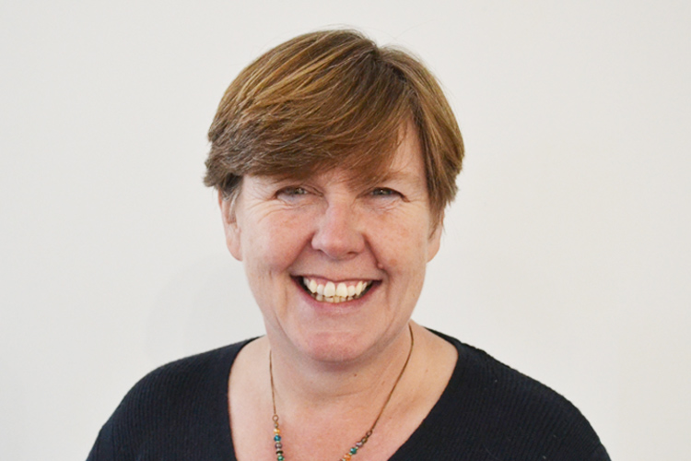
Denise Parrett is our self- supporting curate and part-time paid staff worker with her major responsibility being for music. As curate she runs a Sunday afternoon service, looks after one of our schools, runs our Ladies ministry, leads our care home ministry and is involved in Bay Ignite. Denise will complete her curacy in a year. Denise is married to Stephen, and they have two grown-up sons.

In addition to these staff, we have both a part-time administrator and a part-time cleaner. The staff team meets regularly together for prayer, Bible Study, encouragement and to plan the practical aspects of the ministry. There are a number of people who are beginning to investigate their own ministries and are being given experience in various areas of ministry. As well as many lay volunteers there are five PTO clergy.

The Services/Prayer Gatherings
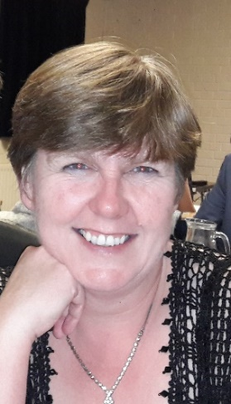Christ Church St Andrews are evangelical Anglican churches which function as one unit and attract congregations of a broader churchmanship. The staff team takes their role of teaching the Bible very seriously and we seek to present the gospel clearly and relevantly through all our activities. On Sunday we have around 170-200 people attending its main service and we have two smaller services. The numbers will increase substantially for major festivals and for civic services. We also have our two Bay Ignite congregations and a monthly Sunday afternoon service (Teatime) aimed older people which has started in 2026. The current pattern of a normal week is -

Christ Church St Andrew’s
Sunday Sunday
9.00a.m. Holy Communion
[Common Worship with music]

11.00a.m Morning Service [3 times a month]
Communion Service [once a month]

3.30pm Teatime [monthly]

7.00p.m. Evening Service [weekly]
[Café style teaching events]

Tuesday Tuesday
9.00a.m. Tuesday Prayer (weekly on zoom)

3.45pm Bay Ignite (families)

7.00p.m. Tuesday Prayer Gathering (monthly)

Thursday
6.15pm Bay Ignite (adults)
Church Life
We are privileged to have a number of ministries which enable us to make an authentic link between what we believe and what we do.

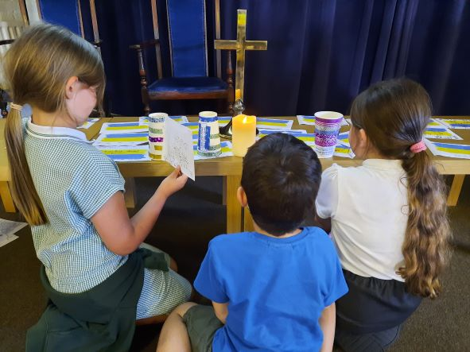Children and Young People
We have excellent links with a number of local state primary schools and with the town’s only secondary school which means we celebrate Christmas and Easter with them and run end-of-year-leavers services as well as taking regular assemblies and helping with RE lessons. The detail of the current church children’s and youth work is shown above.

Bay Ignite
The church commissioners have funded Ignite projects throughout the Diocese and we have been privileged to see two congregations become established. We are now completely responsible for these congregations. On Tuesday we have a family Ignite congregation which aims to reach young families we would not normally connect with. This congregation has families with special needs and many single parent families and has become a destination for some and a journey to involvement in other aspects of church life for others.
The adult Bay Ignite on Thursdays has again been able to reach people we would not normally have contact with. Seeing some of them come to faith and be baptized and confirmed has been an absolute delight. The setting up of a homegroup from this congregation has been an amazing experience.

South Room and Food Larder
When the local job centre closed, we set up our South Room with computers to help people who needed to apply for benefits, jobs or had other needs. It took time but now we are now seeing it well used and we are able to talk to people about what they believe. During the pandemic we took the decision to set up a food larder which we still run although we have adapted how it runs. The original purpose was to help people through the pandemic but now we are thinking about how we can continue to serve the community through the current economic challenges many face. This work has led to people joining our Bay Ignite and Sunday congregations.

Homegroups
We are privileged to have seventeen groups which study the same material most of the time. These groups are often full and so we need to add more when we can. The groups have emerged well from the pandemic and are overseen by two members of the church family.

Other ministries
In addition to these we run Christianity Explained courses, Growing in Faith courses, a mid-week teaching break for older people, a teaching day at home, social events including restaurant nights, prayer walking, men’s and women’s ministry with various activities and training events for leaders and those involved in ministry, to name some not all! We are committed to looking at how all these ministries and events
fit into the life of our church and especially how they help us both to reach out to our community and build up our church family.

Time Off, Holidays and Practicalities
Life outside the parish is important and so the staff team is committed to encouraging each other to take a proper day off a week, five weeks holiday and to have time off during the working week. Time will also be given for one conference a year to allow growth and encouragement from outside the parish. Reasonable expenses will be refunded.

Accommodation
The person appointed will need to find their own accommodation. Where possible we will help with local knowledge.

Website and Facebook https://www.facebook.com/ChristChurchStAndrews/ https://www.parishofhernebay.org.uk/
We continue to work on our social media. On the website the best place to see current material is under latest news and our Facebook page always carries up to date material. Under resources you will find our recent sermons.

Conclusion
This is an exciting time to come to Christ Church St Andrews. The person who comes as Youth and Children’s minister (contract details and application process is overleaf) will have the advantage of seeing a growing church and with people growing in commitment to Christ and one another - this growth and development will involve the whole staff team seeing God at work in peoples’ lives. The parish loves its staff and offers a supportive environment to be loved, learn skills in ministry and deepen faith.

Contract details and Application Process

Job Title: Youth and Children’s Minister (CYFM)

Employer: Parochial Church Council (PCC) of Christ Church St Andrews Herne Bay

Line Manager: The Associate Vicar of Christ Church St Andrews Herne Bay

Contract: Full time (37.5 hours/week) but we recognise the need for flexible working and so will work to ensure that time off in lieu is rightly and properly provided.

Salary: £30,000-£34,000 per annum

Locations: Christ Church and St Andrews Herne Bay

Church Attendance: Weekly Sunday morning Worship at Christ Church St Andrews Herne Bay is expected as part of the contracted hours.
Annual Leave: 5 weeks plus time off between Christmas and New Year.
Pension Scheme: Eligible for occupational pension scheme.
Safeguarding Requirement: The post is subject to an enhanced DBS check and subject to the Church of England Safer Recruitment and People Management guidance; references and background safeguarding checks will be required; and
the successful applicant must comply with safeguarding training requirements and policies.
Occupational Requirement: This post carries an occupational requirement under Schedule 9 of the Equality Act 2010 for the postholder to be a practicing Christian. The successful applicant will be expected to demonstrate a commitment to and willingness to work within the doctrinal basis and evangelical Anglican ethos of Christ Church St Andrews Herne Bay.
Right to work The appointment is subject to the right to work in the UK.
Equal opportunities There is a commitment to equality of opportunity and to following lawful recruitment practices.

To apply, please submit:
A covering letter detailing your suitability for the role and your CV.
For more information or for an informal conversation please contact: The Reverend Simon Fellows on 07472696609
Closing Date for applications is June 30th 2026

