THE MULGRAVE BENEFICE - PROFILE 2025

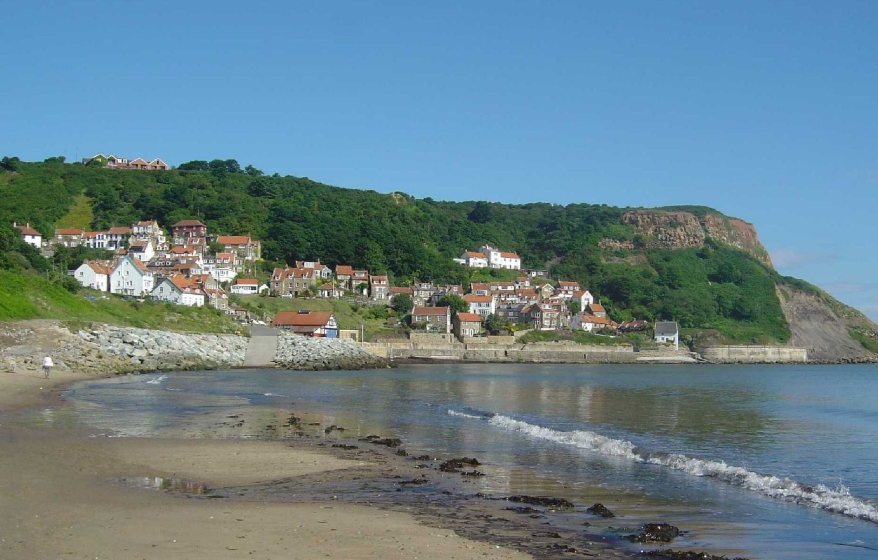
Photo: Runswick Bay by Richard Cole

We are fortunate to live in a beautiful part of the world where moors meet beach and sea. The above photograph is Runswick Bay which is a few moments away from where the Vicarage is situated.
The Mulgrave Benefice is made up of:
The Parish of Hinderwell: St Hilda’s, Hinderwell; St Peter’s, Staithes; St Nicholas, Roxby
The Parish of Ugthorpe: Christchurch, Ugthorpe
The Parish of Lythe and Sandsend: St Oswald’s, Lythe; St Mary’s Sandsend
The three parishes are actively working with the Archdeacon of Cleveland and the Bishop of Whitby to become a single Mulgrave Parish. On completion the Parish would have a single PCC with representatives from the six churches. While this has obvious benefits in reducing the number of officers needed, simplifying procedures and reducing the number of meetings needed, we feel that, more importantly, it would allow us to use our churches’ individuality and styles to offer more options to the wider community that we don’t currently reach, from modern forms of service to the traditional, as well as family-orientated services.

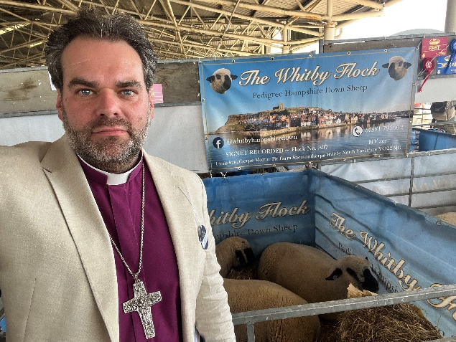
An introduction from Barry, the Bishop of Whitby

I am delighted you are exploring applying to be Rector of the Mulgrave Benefice in a beautiful area close to both the coast and the moors, and including some of the most picturesque villages in the UK. Be assured of my prayers and those of Archdeacon Amanda and our colleagues as you do.

The profile which the Benefice has compiled I found inspiringly honest and realistic for what is an attractive post with huge potential. In God’s leading, the trio of a team of very capable and collaborative lay and ordained leaders, the history of deeply storied places, and a desire to reach beyond the walls of the church buildings in new and creative ways, offers a seedbed rich for mission and ministry.

The role combines a lovely balance of space to be and to discern how God is calling, with colleagues who are keen to support and partner. The opportunities across the Mulgrave benefice are also echoed in different ways across Whitby deanery – a deanery of considerable creativity and lightly held missional energy - meaning there is space to share ideas, resources and challenges with clergy colleagues in similar places too.

Recognising the potential, this is deliberately a short vacancy (I write this letter just a few weeks after the previous Rector has retired) as The Mulgrave Benefice joins with the parishes of the Diocese in seeking to invite the 1.5 million parishioners we serve to know the joy of Living Christ’s Story. This means each church focusing on what it means to:
- Become more like Christ – knowing we are God’s beloved children, that Jesus came to seek, serve and save, and actively participating in worship and witness Monday to Sunday;
- Reach people we currently don’t - living and telling the story of God with cultural humility and faith-filled confidence, inviting our classmates and colleagues, neighbours and friends to know the love, purpose and hope which has blessed us;
- Grow as churches of missionary disciples which are younger and more diverse – knowing we are sent to every place and person to which we go, but being a ‘community of the sent’ is most effective and best reflects the Kingdom of God when everyone is known and needed, honoured and participating.

May you know the surrounding and upholding of the Spirit of God as you discern,


For an informal conversation about this post, contact the Bishop of Whitby, Barry Hill (bishopofwhitby@yorkdiocese.org or 01642 593273) or the Archdeacon of Cleveland, Amanda Bloor (adcl@yorkdiocese.org or 01642 706095).

This post is open to Anglican priests who are eligible to work in the UK, subject to satisfactory episcopal reference and enhanced DBS.
Applications to Jacqui Gunter, Jacqui.Gunter@yorkdiocese.org

Mulgrave Benefice – our aspirations
Where are we going and what do we need? We feel that we are at an important juncture in our mission, as we seek to become a united parish and build our congregation. We are elderly, but very young at heart, and keen to welcome new people into our churches. We are open to new ideas and new ways of worship. We seek new people with new ideas, energy and drive to enthuse us. There are relatively few children in the Benefice and we feel the lack of them in church, though we do have good links with two of the three schools in the Benefice.
Our current pattern of services
Our present pattern of services tends to be a single Benefice service on the first Sunday of the month; three services on the remaining Sundays, although sometimes only two. The Benefice service is always a Eucharist; the other services will be a mixture of Eucharistic and non-Eucharistic. Generally, the only midweek services we have are Ash Wednesday, Maundy Thursday, Good Friday and Ascension Day, as well as occasional school services.
Our Helpers
There are two self-supporting ministers in the Benefice. Our curate is a former teacher and teacher educator who is keen to develop more study group work; she also assists with pastoral visiting and pastoral offices. The other is an academic and psychoanalyst, with permission to officiate. There is also an authorised lay minister (mission, worship and pastoral visiting) in the Benefice. Three of the churchwardens are comfortable taking non-Eucharistic services when required. Eleven parishioners have the Bishop’s authorisation to be Eucharistic Ministers, and three of the churchwardens in the Benefice have received training to enable them to take home communions to those unable to get to church.
Living Christ’s Story
As part of the Diocese of York and Whitby Deanery, our parishes share the vision of Living Christ’s Story made a reality. We are trying to become more like Christ, and by becoming more involved in the communities we live and the community work we do, are trying to reach people we currently don’t. Through our clergy and indeed ourselves we are trying to grow in discipleship and become more missionary disciples. We have actively looked at our structures and finances and have committed to giving more in our free will offerings to support our clergy. We have looked at our structure hence becoming one parish. We believe that this vision will inspire new vocations both lay and ordained and encourage more younger people into the church.
We want to do these things, and are looking for someone to help us achieve them. Someone who can:
- Drive and build commitment to mission
- Develop strong leadership skills and allow others to develop theirs
- Build communications with people of all ages
- Be creative and innovative
- Develop and plan our vision for the future
- Work collaboratively
- Inspire young people and families to come to church
- Have an open baptism and marriage policy
- Be a visible presence in the community

Where we are
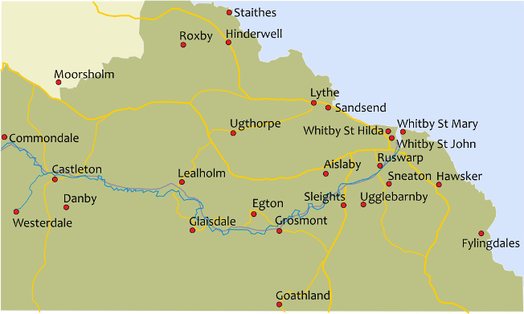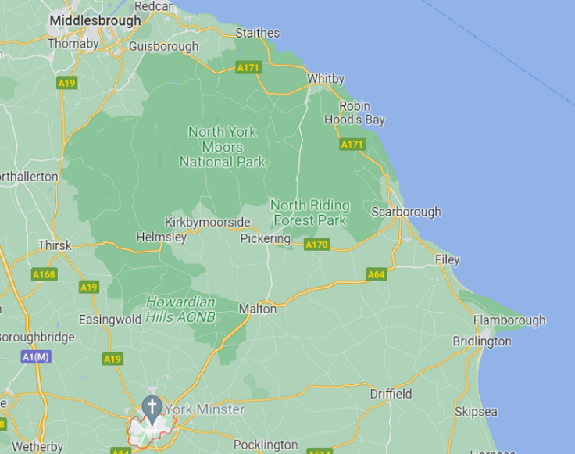

Character, Area, & Transport links
The Benefice lies within the North York Moors National Park, along the coast at its Eastern edge. The area is mainly farmland, beaches and woodland. Farming is a mix of arable, sheep and cattle.
Tourism is very important to the area and supports many families. Pilgrims often walk the 43-mile long St Hilda’s Way, inaugurated by Archbishop Sentamu in 2015, from Hinderwell to Whitby Abbey.
Roads are good along the coastal stretch with narrower roads inland. A half hour bus service links Whitby through Sandsend, Lythe and Hinderwell to Middlesbrough, and from Whitby to Scarborough.
Whitby, Middlesbrough, Scarborough, Saltburn and Malton are the nearest rail stations, served by Grand Central and TransPennine. York and Darlington LNER stations have services direct to London or Scotland. Durham Tees Valley is the nearest airport.
There are doctors’ surgeries in Staithes and Sandsend. Staithes has a Co-op supermarket whilst Lythe has a volunteer-run and well-supplied village shop with post office and tea room. There are pubs, restaurants and cafés in many of the villages. St Hilda’s church owns the old village school, the Hub, which has a café and hall for the local community.
Schools
Lythe CEVC School is a small primary school with approximately 86 children age 3 to 11. They welcome families of all faiths or none and there is a good working relationship between school and parish. Children regularly attend St Oswald’s Church, Lythe.
From the Headteacher of Lythe School
At Lythe CE Primary School, our strong link with St Oswald’s Church is an important part of our school life. The church is not just a building to us—it’s where we come together as a school family and community to celebrate, reflect, and grow.
We visit the church regularly for services at key points in the year: Harvest, Christmas, Easter and other points in the year. These moments are special for our pupils and families, offering space to pause and to celebrate together. Members of the church also come into school to lead assemblies, share stories, and help us learn more about our Christian values in everyday life.
Our children love being part of these traditions—singing in the church, presenting prayers and readings, and learning about the Christian faith in a way that feels alive and connected to their own lives. The presence of a welcoming incumbent makes all the difference in helping our children see that faith is about relationships, kindness, and belonging.
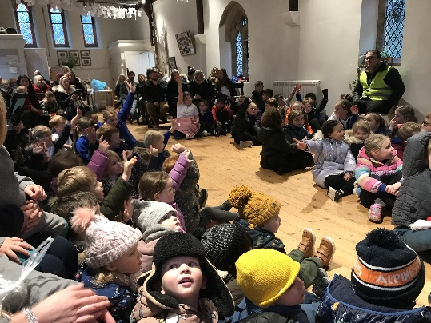 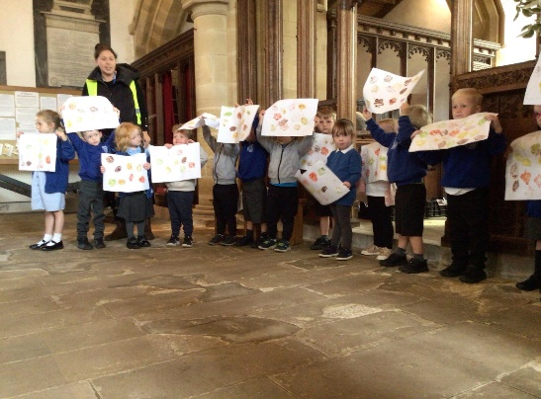 Lythe School at St Mary’s, Sandsend Lythe School at St Oswald’s, Lythe

As we look ahead, we would be delighted to welcome a new incumbent who will continue and strengthen this partnership. We hope for someone who:
- Enjoys working with children and young people, making faith accessible and engaging.
- Is visible and approachable in school and at community events.
- Helps us explore the Christian values that shape our school ethos—respect, hope, friendship, forgiveness, and perseverance.
- Supports our staff and families as part of the wider parish family.
We believe the role of the church in our school is not only to teach, but to inspire. With the right incumbent, the bond between St Oswald’s and Lythe CE Primary will continue to grow, ensuring that our children see the church as a place of joy, welcome, and community.

Andrew Wood, Headteacher

There are also primary schools in Hinderwell and Staithes. There are secondary schools in Whitby and Guisborough. There is an ‘outstanding’ children’s nursery in Lythe, next door to the school. Messy Church runs regularly at Lythe school and Oakridge school, Hinderwell.

The Churches
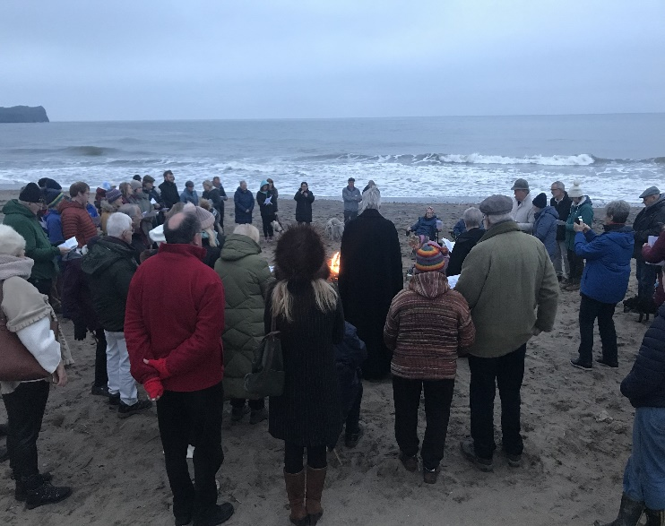
The churches and villages have their own very distinct identity. We are flexible in our approach to worship and forward thinking. We do have some traditions that we would hope to preserve; Plough Sunday at Lythe, a sunrise service on the beach at Sandsend on Easter morning (pictured), a Rogation service at Roxby where we can see the sea, farming and industry, and a Well service and a Crib service at Hinderwell on the afternoon of Christmas Eve. Each church has volunteers and active helpers. We have a monthly Parish Magazine with both church and village news.
The buildings themselves range from the Grade One-listed St Oswald’s with its roots going back to the Vikings, the charming but remote St Nicholas with no power or water but so much atmosphere, the ‘upper room’ of St Peter’s, St Hilda’s with its well, the present building built in the late 18th century but with a church on the site since the Saxons, to the Victorian churches of Ugthorpe and Sandsend both having had modern restorations.

St Hilda’s, Hinderwell.
Hinderwell’s Church is dedicated to St. Hilda, but the Holy Well in the churchyard has much earlier origins and gave its name to the village. Hinderwell is mentioned in the Doomsday Book as Hildrewell, a corruption of, “Hilda’s Well.”
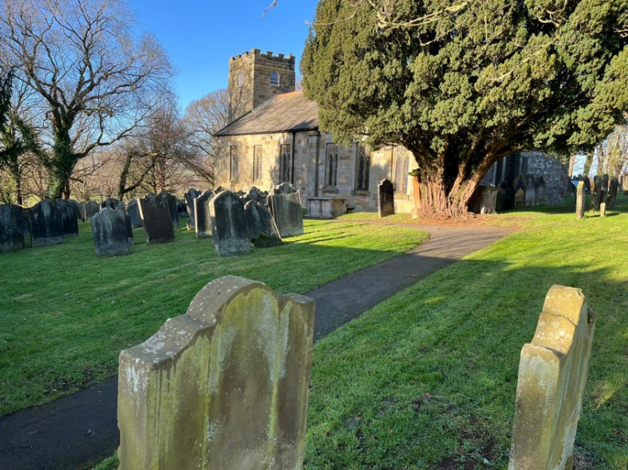
Hilda’s Well in the Churchyard is the only Scheduled Ancient Monument in the parish, and was once the only water supply for the village. According to legend, St.Hilda was asked to intercede in a drought whilst travelling through the parish. Her prayers were answered and the spring which appeared has continued to bubble from the hillside to this day. We have a well service on the first Sunday of July to celebrate St Hilda.
We have a tremendous team of helpers who work hard to raise money for our Free Will offer and church maintenance.
Since opening the church on a daily basis, there has been tremendous footfall with visitors from all over the world. Many wish to find out more about relatives buried in the closed churchyard. St Hilda’s helpers, around 20 volunteers, regularly attend to the grounds around the church. They have gradually tidied up by removing scrub and making pathways for visitors to enjoy. A local nursery often comes to the woodland and also into church.
Staithes and the Church of St Peter the Fisherman
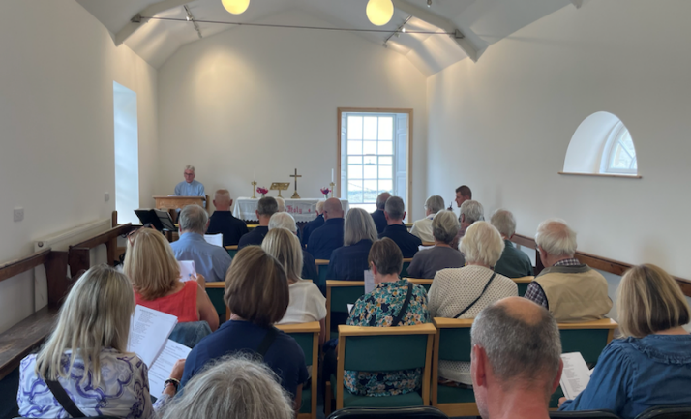
Staithes is a substantial village separate and distinct from Hinderwell, and comprises “top Staithes” and “old Staithes
We have monthly church services – some eucharist, some evening praise -- which attract a small and welcoming congregation and a packed church for Christmas Carols. Mothering Sunday, Easter and Harvest draw larger congregations and in 2024 a successful Harvest Show was inaugurated prior to the thanksgiving service. Renovation work has just been completed in the church.
Today the Church building is leased by the Diocese to St Peter’s Centre CIC. During the summer months the ground floor hosts Staithes Arts and Crafts stalls. The CIC is committed to building up community events: currently workshops of many different sorts and a monthly café, and occasional cinema, concerts, theatre and exhibitions. The St Peter’s Centre is the only community space in old Staithes. In recent times some twenty-five thousand people each year have visited St Peter’s Centre.

St Nicholas, Roxby
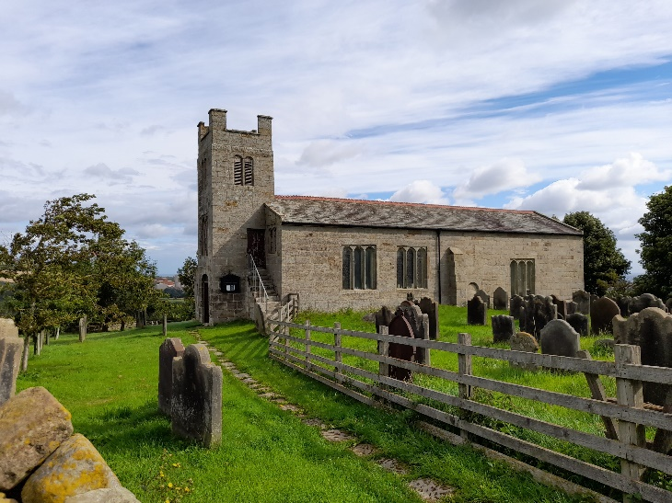
St Nicholas is a daughter church of St Hilda’s, Hinderwell. Roxby is a very small village; we try to maintain regular worship there, but there are obviously difficulties in a building with no power or water on site. It is a well-established tradition to hold Benefice services there at certain times, for example on Rogation Sunday and the Feast of St Nicholas, and it makes a beautiful and atmospheric setting for the candle-lit Christmas service.

Christchurch, Ugthorpe
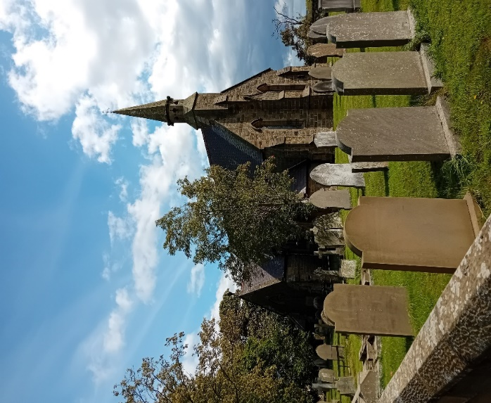
Ugthorpe parish incorporates the villages of Ugthorpe, Ellerby and Mickleby, and comprises some 125 dwellings, many of which are farms. There are also several second homes in the parish, and one or two of the owners attend church when they are in residence. There are no shops in the villages, and no public transport to Ugthorpe, though Mickleby and Ellerby are served by a bus which runs along the nearby A174 every half hour.
Ugthorpe has a strong Roman Catholic presence, with whom we have had a good relationship in the past. However the new RC priest is not inclined to have any relationship at all.
Christchurch was refurbished in 2015 and now has a kitchenette and toilet. The church is open daily and our Visitor Book and prayer net show that people do visit. Our congregation has dwindled significantly in the last year or so, as several of our regular worshippers have died. However, good attendance at our coffee mornings and fundraising activities suggest that the church is still important to villagers. There is clearly room for missional work here.

St Oswald’s, Lythe
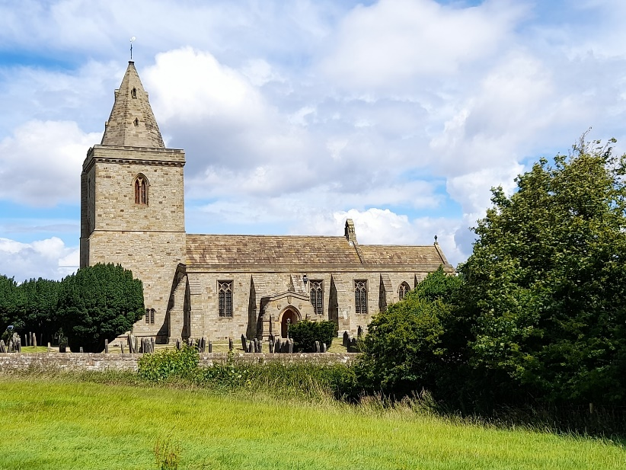
St Oswald’s has a small but faithful worshipping community, often swelled by visitors to the area. Services tend to be fairly traditional in form with Common Worship Eucharist being the most frequent. There are also regular BCP evening services led by one of the churchwardens. There is a good connection between St Oswald’s and Lythe CEVC school, and the children, staff and parents are welcomed to several services during the year.
The building lends itself beautifully to other uses such as a venue for musical events both classical and contemporary, local history exhibitions and art festivals.
Looking after a Grade One listed building has its challenges, but there is an enthusiastic and hard-working Restoration Committee which has already overseen considerable repointing to the building, the replacement of four pairs of churchyard gates and a new heating system, with more work being planned.
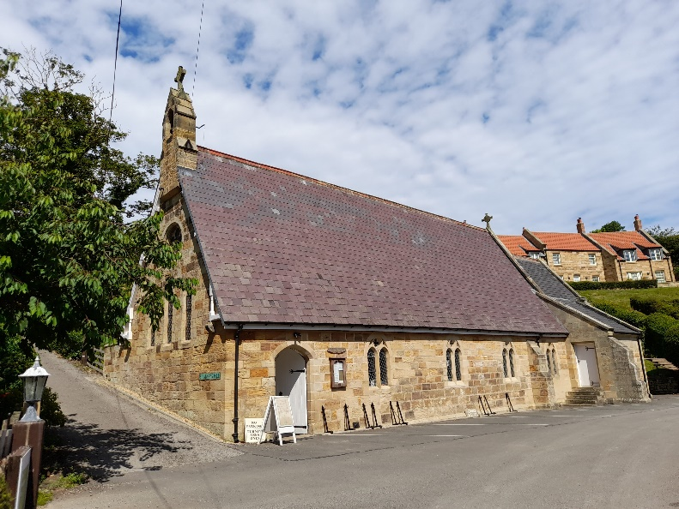
St Mary’s, Sandsend St Mary's church is located at the end of the old valley in Sandsend. In 2019 Sandsend residents and 2nd homeowners raised over £240K to restore the church, insulating the roof, installing new central heating and lighting and adding a kitchen and disabled toilet.
Primarily a church it has now become a community building offering a weekly coffee club, yoga, craft days and various activities. Slowly some of those attending the community activities are coming to services. Service attendance is rising. The services at St Mary's are more modern than others in the area, using a computer and screen rather than books and more modern liturgy. St Mary's has a Facebook page and over 200 emails are sent out twice monthly as to ‘What’s On’ at St Mary's. There is also a ‘Church near you’ page.
There is a St Mary’s community committee which organises the letting of the building (rent going to the PCC) and community activities. Some members of the PCC and the vicar are an integral part of this committee. This committee fund frequently pays for items/repairs at St Mary's although the responsibility remains with the PCC.
St Mary's is open 24/7 for all to call in and being a popular tourist resort we have many visitors.

Whitby Deanery

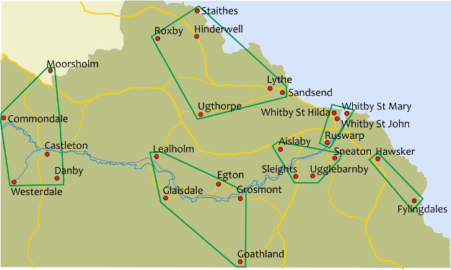

Whitby Deanery covers part of the North Yorkshire coast, from Staithes to Robin Hood’s Bay, part of the North Yorkshire moors and the Esk Valley. There are 25 churches in the town and the surrounding villages within five Ministry Units – about half the population in the Deanery is to be found in the town of Whitby and the other churches are in villages of varying sizes
Mulgrave: Staithes, Roxby, Hinderwell, Ugthorpe, Lythe and Sandsend
Whitby with Ruswarp : St Mary’s, St Hilda’s , St John’s (Incumbent and Area Dean : Michael Gobbett)
Hawsker and Fylingdales (Robin Hood’s Bay) and Lower Esk (Sleights, Ugglebarnby, Aislaby, Sneaton ) (interim Priest in Charge until 2029 and post potentially could be long term): Jo Parker
Middle Esk : Egton, Goathland, Grosmont, Lealholm, Glaisdale (Interim Priest-in charge soon to become permanent post): Anthony Bennett
Moorland: Danby, Moorsholm, Castleton, Westerdale, Commondale (in Vacancy)
There a number of very active SSM curates, clergy with PTO, Licensed Lay ministers (Readers) and Authorised Lay Ministers who play a vital part in enabling ministry across the deanery. The parishes in the Mulgrave benefice have provided three of our Lay deans in recent years including Helen Lloyd who took up the post in Autumn 2025

Pastoral re-organisation has been a feature of life in the deanery in the past 25 years and more, with some churches moving between benefices and teams. Current Diocesan plans and expectations of Free Will Offer mean that each Ministry Unit should be offering at least £57,000 if it is to have a full-time permanent priest. Realistically this is not possible for the Moorland parishes and reaching the expectation of £77,000 by 2031 will be a considerable challenge for all Ministry Units. So, the Deanery will be considering various possibilities for Pastoral re-organisation and the ways in which we work together in the coming years. Our expectation of the person appointed to the Mulgrave post is that they will be a strong Deanery player with an openness to supporting ministry across the Deanery, involvement in the ongoing discussions as part of the Deanery Leadership Team, and a willingness to accept that their role may change over the years as plans develop towards 2031. We look forward to welcoming someone into a team where people are committed to working together and the current incumbents all have significant deanery roles.

The Rev’d Canon Michael Gobbett Area Dean

Accommodation
The Rectory is located in Hinderwell, half a mile from the church and a 20-minute walk from the sea at Runswick Bay. It is a four-bedroomed family home which has been much improved. There is a sensibly-sized back garden, backing onto fields, and there is off-street parking. The property has an EPC rating of E (certificate number 8201-9895-7029-4477-2733)

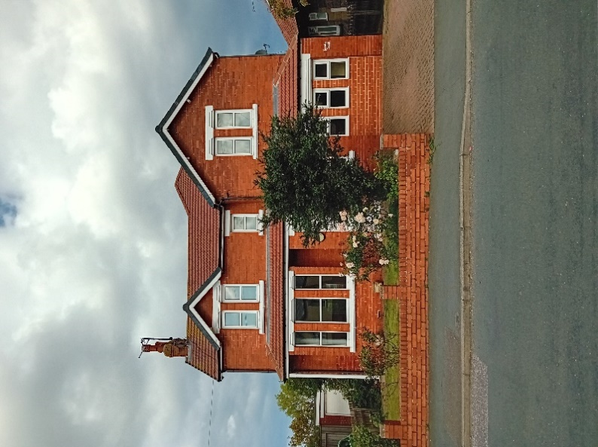
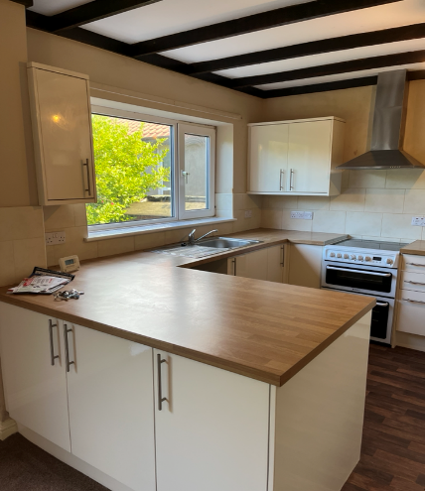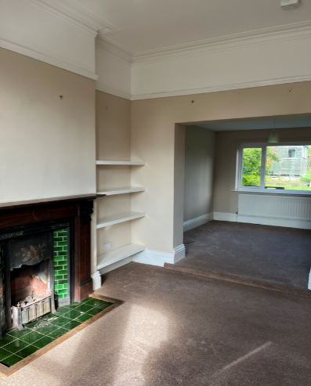
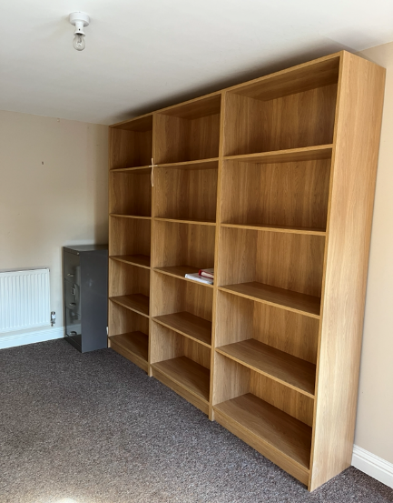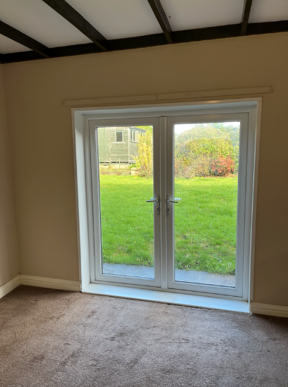

Statistics
Present three Parishes | Hinderwell, Roxby and Staithes | Lythe and Sandsend | Ugthorpe | As a Single Parish
Populations  2022  (approx.) | 1800 | 340 | 250 | 2390
Average weekly attendance | 15 | 15 | 10 | 40
Baptisms  2024 | 2 | 4
Weddings  2024 | 3 | 2
Funerals 2024 | 8 | 6
Free Will  Offer  2025 | £22000 | £22000 | £10000 | £54000

Thank you for taking the time to read our profile. We are very happy to be contacted for further details, or to welcome you for a visit.
Mr Ian Dobson 07377 412287 (Churchwarden, Hinderwell Parish)
Mrs Sue Mason 01947 893308 (Churchwarden, Lythe & Sandsend Parish)
Mr Tony Mason 07518 659777 (Churchwarden, Lythe & Sandsend Parish)
Mr Joe Jefferson 01947 840692 (Churchwarden, Ugthorpe Parish)

