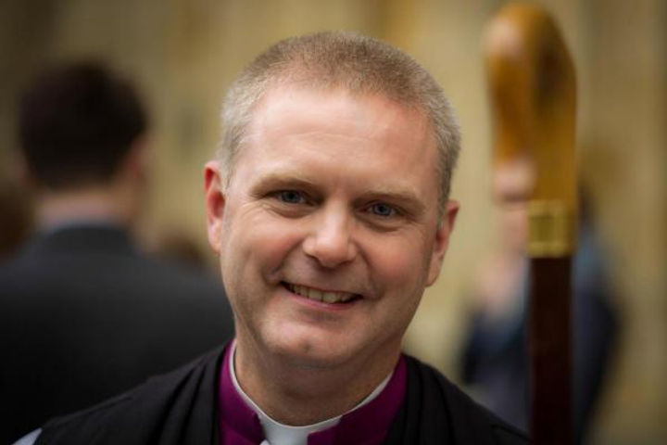
A message from
the Bishop of Chester

Thank you for looking at this post in Chester Diocese. Whatever the Lord has for you, I want to assure you of my own prayers and a deep gratitude that we might get to partner together in this part of the Lord’s work.
I have spent ages trying to capture the enormity of the privilege I feel in getting to serve the people of this diocese, and my words cannot bear the weight of that calling. This community of communities ranging from the very richest to the very poorest and the deepest rural to the most industrialised and urban is amazing. The diocese holds together in a shared sense of call to be ‘Together in Christ Sharing Hope’. We have a deeply held vocation to serve the 1.5 million inhabitants who have no meaningful connection with a community of faith, and share the feast which has been shared with us in Jesus.
In Chester Diocese this is always going to be worked out locally first and foremost: no-one met Jesus through a Diocese! Lives are changed in parishes, chaplaincies, and new expressions of Christian community, when people are invited in kindness and grace into transformative encounter with the love of the God who made them. Together we focus on our broad strategic aims so that those who know they are the people of God can serve all the people God calls in their everyday living.
We are utterly committed to safeguarding, because every person matters to our God and Saviour more than we know how to express. This is also why we welcome applications from every background for posts in this diocese. We are learning how to do all of this as guest rather than always as host, as we partner to serve the world to which we are sent.
If God is calling you to serve with us, I rejoice! Come, roll up your sleeves, and get stuck in! If the call is elsewhere then be assured of our gratitude and earnest prayer that the Lord will lead and provide in all things.
Please do pray for us, too – the harvest is plentiful, but the workers are few.
+Mark

