St John’s Church, Polegate and St Wilfrid’s, Lower Willingdon

Parish Profile 2026

Section Page

Welcome to St John’s Church 1

Our Parish 1
Demographics 2

WHO WE ARE 3

Our Purpose 3

Our Church Family 3

OUR MINISTRY 4

Sundays 4

Discipleship & Outreach 5

Pastoral Care 6

Local Community 6

Mission Activities 7

OUR BUILDINGS 7

Finance 9

Our new Vicar – Person Specification 11

St Wilfrid’s 13



Welcome to our Parish Profile. We are delighted that you are considering the role of Vicar of St John’s, Polegate (please see * below). We hope this profile will give you a flavour of us as a church family, our needs; our hopes for the future and what the post has to offer. We are praying for the Holy Spirit to lead you in considering this exciting opportunity.

St John’s is part of the Rural Deanery of Eastbourne and as a church we are committed to the authority of the God’s Word as set out in the Bible; our aim is to honour the Lord Jesus; our mission is ‘Making Disciples of Jesus Christ’.

We are looking for a Vicar who has a central focus on:

Expository preaching, teaching and obeying God’s Word as set out in the Bible

Prayer

Loving one another as a church family

Nurturing individual and collective growth as Disciples of Jesus Christ

Sharing the gospel and leading the church in making a difference to our local community.

As you read on, you will discover that the life of St John’s includes a variety of activities, some well-established, some which are relatively new and still others which are ripe for development. We would welcome ideas to nurture our growth, whilst remaining steadfastly committed to living according to biblical truths.
Please also read the information later in this document about St Wilfrid’s, Lower Willingdon which was originally a church plant within the Parish of St John’s in 1962. St Wilfrid’s was made a Conventional District in 2003 with a view that it would itself become a Parish. To date this has not happened and whilst supportive links exist between both churches and we share the same aim of making disciples of Jesus Christ, in practice we function independently and there is limited interaction between the two. **The Diocese endorse our intention for the current Conventional District arrangement to cease at the point the new incumbent takes up post. It is, however expected that the Curate in Charge at St Wilfrid’s will remain in post for a few years as Associate Minister as we transition to a point at which the new incumbent will be the sole paid member of clergy in the Parish**.
- Future Priority - to end the Conventional District arrangement and to work towards a position over time whereby there is one full-time paid incumbent for both St John’s and St Wilfrid’s.

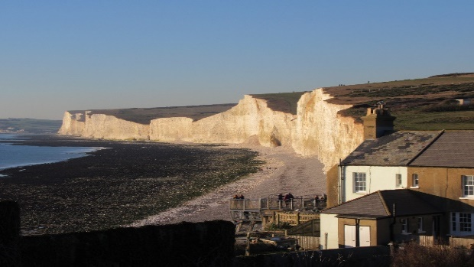

Our Parish
Polegate is a busy, friendly little town situated near to the popular coastal resort of Eastbourne and the South Downs National Park, an Area of Outstanding Natural Beauty. It has excellent public transport links to Eastbourne, London, Brighton and Gatwick Airport. By train it is possible to reach Brighton in 35 minutes, Gatwick in 45 minutes and London in 85 minutes. Eastbourne can be reached in 10 minutes by train or 15 minutes by car. There is also a regular bus service to Eastbourne. According to the 2021 Census, the Parish had a population of about 13,000 but since then there has been new housing and commercial development, with more underway and planned, while currently still maintaining its small-town character.
There are two primary schools and a community college within the Parish; two have ‘Good’ Ofsted ratings and Polegate Primary is rated as ‘Outstanding’. There are also several residential care homes, some sheltered accommodation and two medical practices, with plans to build a new one as part of the local housing developments.
The town offers a typical blend of small retail outlets offering essential supplies; coffee and charity shops, cafés, (even a tattoo parlour!) and other services located in a single high street running through its centre. All in all, it’s a great place to live!

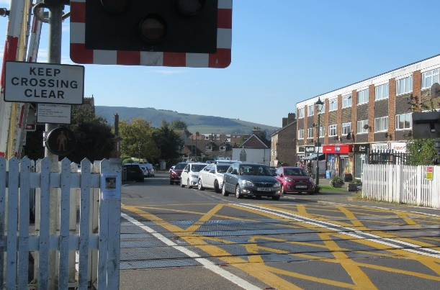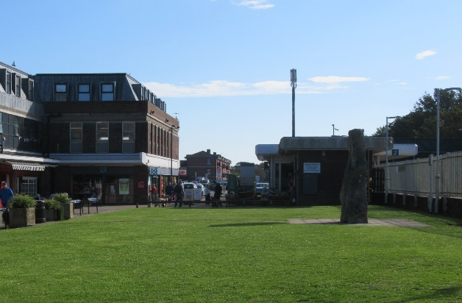
Misc demographic data
Deprivation rank (1=most deprived, 12,178=least deprived) | 6,994
Parish population (2021 census) | 12,843
% aged 0-4 | 5.0
% aged 5-19 | 14.5
% aged 20-29 | 8.6
% aged 30-44 | 16.6
% aged 45-69 | 33.8
% aged 70 and over | 21.6
% White ethnicity | 95.8
% Other ethnicity | 4.2
% Christian | 47.3
% No/Other religion | 52.7

WHO WE ARE

Our Purpose

St John’s is an established evangelical church. Together we are seeking to grow closer to Jesus Christ, to hold fast to the truths of God’s Holy word as stated in the Bible and to reach out to others with the good news of the Gospel.

In our life and witness, we seek to be:
- A prayerful church – dependent and led by God, Father, Son and Holy Spirit.
- A faithful church – obedient to God’s Word, the Bible.
- A family church – a Christ-centred community of all ages, which welcomes everyone.
- A loving church – reaching out with Christ’s love locally, nationally and globally.
- A generous church – in the way we use our time, money and skills to serve Christ and others.
Our Church Family
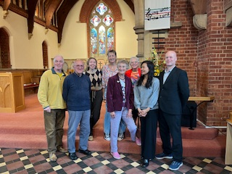
In 2024 there were 103 people on the St John’s electoral roll, including 10 per cent who live outside the Parish. This has remained steady in recent years, as some have died or moved away and others have joined. St John’s is a warm and friendly church and we seek to ensure everyone feels welcome and that Christ’s love is made evident to all. Whilst we are a family which is predominantly white British and mature in years, we have been encouraged in more recent times to welcome new members from other ethnic backgrounds, and a wider range of nationalities. We encourage everyone to play an active part in church life.
We are blessed by having people who are keen to use their gifts and experience in God’s service. The Parish team includes three long established and knowledgeable Readers who are a great blessing in leading and supporting our worship at St John’s. Each of the Readers serves by permission to officiate (PTO) and therefore we need to be actively planning for when they need to retire. We also employ an experienced part-time church administrator who works 15 hours a week (part home, part church office) and who ensures routine business is dealt with efficiently and effectively.

In addition, we have others who faithfully support other aspects of church life and operation, including:

Two Churchwardens

PCC (9 members, including the mandatory postholders e.g. Churchwardens)

Parish Safeguarding Officer

Treasurer

PCC Secretary

Five House Group Leaders
- A pool of people to lead Prayer Meetings (including our Readers)
- Audio Visual team

- Future Priority - like any church we are dependent on volunteers for much of our ministry. We need to encourage others to step up and to widen the range of roles currently undertaken.

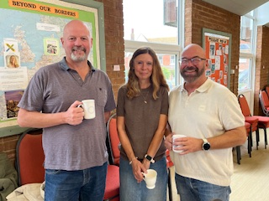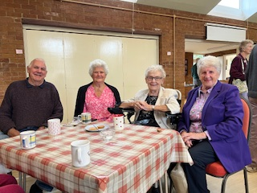
OUR MINISTRY
Sundays
Sunday mornings are when we come together at 10.30am for worship, hearing God’s Word preached and prayer. On the first Sunday of each month Holy Communion is also celebrated. At 6.30pm on each Sunday we hold a prayer meeting; a small team of people, including the Readers take it in turns to lead these. The average attendance on Sunday mornings in 2024 was 70, including children and 12 at the evening prayer meetings. Dedicated members ensure there are always hand stitched banners and beautifully arranged fresh flowers on display in the church.

For those with difficulties in getting to church, a transport service is available.
Children can attend ‘Sunday Club’ which runs in parallel to the 10.30 services and provides an opportunity for them to come to know and love our Lord Jesus and learn more about the Bible in an age-appropriate way. We are blessed with a group of committed volunteers who faithfully support this work; however, the number of children attending remains stubbornly small and variable. Children only come if their parents bring them, so if this is to be addressed, we need to apply a particular focus on reaching out to families. During 2024, the number of children attending averaged between 1 and 6 each week (all primary age or younger).
- Future priority – a focus on reaching out to the community, refining and revitalising our ministry offer to children of all age groups and families.
At St John’s we want our services to be relaxed and welcoming, whilst at the same time orderly and honouring to God. Services are based on a blend of sung worship (with piano or digital accompaniment), expository preaching of God’s Word and the expectation of His presence. We join in prayers, affirmation of faith and a confession at each service. Readings and intercessions are led by a pool of volunteers, whilst others assist with the celebration of Holy Communion under supervision by the Vicar. Music to accompany worship is either provided by a church family member playing the piano or via iSing.
After the morning service, refreshments are provided in the church hall which gives a popular and welcome opportunity for fellowship.
Through the year special celebrations and events provide opportunities for additional activities, most notably at Easter and Christmas and Remembrance Sunday, all of which attract members of the community who do not routinely join us for worship and therefore enable us to share the good news of the Gospel to those who otherwise might not hear it. Attendance on these key occasions peaks at about 110.
Baptisms, weddings, and funerals continue to take place as required, although they are very infrequent.
- Future Priority - to consider how we can sustain and grow the churches to reflect all sections of our community in Polegate and Lower Willingdon. We need to rekindle our heart for reaching out to others with the love of Christ by encouraging a passion to share the gospel one to one with greater confidence and empowering people to talk more openly about their faith.
We need to optimise our resources (people and buildings) to develop mission and outreach work, cultivating positive relationships within the Parish ensuring St John’s and St Wilfrid’s shine as beacons of light in Jesus’ name.
Our Position regarding Living in Love & Faith (LLF)
The PCC is very conscious of the challenges created by the Church of England’s Living in Love & Faith agenda, and we are working together with other evangelical churches in responding to those and supporting those Bishops (including our own in Chichester Diocese) who are contending for orthodox Biblical doctrine concerning marriage and sexual relations. By resolution, the PCC does not endorse prayers in LLF that purport to bless same sex unions or standalone services for same sex couples. Linked to this issue, the church currently pays its Parish share into the Parish Share Restricted Fund which is a Diocesan alternative to the Church of England Evangelical Council`s Ephesian Fund.

Discipleship & Outreach
Much valued fellowship and scriptural teaching is offered in House Groups. Approximately 35-40 people regularly attend one of five House Groups which meet twice a month. Each group is different, and the leaders have the autonomy to choose how, or what they study. This is an area of potential growth if we could successfully encourage more people to seek further fellowship opportunities and to learn from exploring God’s word together. It would also require the recruitment of additional leaders to make this possible.
We are a partner church of the Sussex Gospel Partnership (SGP), both financially and prayerfully and over the years several members of the church have benefitted from their participating in SGP run courses. We are therefore seeking a Vicar who could sign the basis of faith and would like to be actively involved in SGP.
We have also offered introductory courses such as Christianity Explored through which individuals can receive guidance and be nurtured in the early stages of their journey of faith, or for those who wish to deepen their understanding of the central truths of the Bible. These courses have not generally attracted notable numbers of participants and is an area we need to faithfully persist with and develop.
- Future Priority - to provide stronger support for discipleship and practical Christian living, exploring options to enable more people to learn, nurtured and grow in their faith.
In recent years it has become a tradition to prepare for Easter with a day of prayer on Ash Wednesday. The day includes 12 hours of continuous prayer in which at least one member of the church family undertakes to pray for 30-minute slots in turn. During Lent many also take up the opportunity to study a book, carefully selected by the Vicar and this collective experience is much enjoyed by those who participate. In recent years we have also run a Lent course once a week in the lead up to Easter.
As part of our outreach activities, we also do leaflet drops to houses on the newer estates across the town at Easter and Christmas, encouraging more people to join us in worship. Several members of St John’s also participate in an annual ‘walk of witness’ on Good Friday. At Easter and Christmas some also support carol or hymn singing in the town, both events being organised with Christians from other local churches, although our involvement with ecumenical activities has dwindled in recent years.
Pastoral Care
Whilst we don’t have any formal arrangements for providing pastoral care, support is provided to those in need of it, either through the House Group structure or by individuals looking out for each other, which happens widely as people support one another and raise concerns as needs arise.
- Future Priority - to develop a more structured approach and extend our pastoral ministry, particularly in supporting the elderly in the community and those who can no longer get to church. To develop this work further will require inspiring more volunteers to play a part in it to ensure the ministry is sustainable and resilient.
Local Community
Activities we offer to bring the church family and wider community together include several lunches at key points in the year such as Harvest and Christmas, providing opportunities for fellowship and service to others, notably on Christmas Day when the meal is open to the wider community to enjoy.
St John’s offers ‘Pop-In’ sessions twice a month on Wednesday mornings as a valuable service to the community where guests can be assured of a warm welcome, light refreshments and an opportunity to enjoy a range of activities and good company. In the winter months, the opening time is extended to enable people to remain in the warmth of the hall. Pop-In has been particularly successful in attracting visitors who are not regulars on Sundays (but could be), especially from local nursing homes; attendance at each session averages 34, including a loyal band of helpers.
St John's has a long-established branch of Mothers' Union who hold monthly meetings offering fellowship, activities and the opportunity to listen to interesting guest speakers.
We also host visits from primary age children from Polegate School as part of their curricular activity to visit a place of worship and as part of our Christmas celebrations.
We continue to make regular donations of food, household goods and money to Family Support Work, which functions in partnership with the Chichester Diocese in providing vital services to vulnerable families throughout Sussex.
Mission Activities
Local, national and global mission is important to us. We have historically given away 10 per cent of the church charitable income, primarily focussing on missionary work. Locally we refer to the work as Beyond Our Borders (‘BOB’). Currently we actively support a single missionary working amongst Bangladeshi people in Tower Hamlets (part of London City Mission); a couple who are church planting in Sweden having been called to their home country because it is so spiritually needy, and a couple with their 6 year-old daughter based in Novi Sad, Serbia, working to train pastors in Bible teaching, publish Christian books in Serbian and help lead a recent church plant (both the latter under the agency of Crosslinks). Our support for individuals includes financial giving, regular prayer and pastoral care and visits to and from our mission partners.
- Future priority – we are committed to maintaining our support of mission partners at home and abroad - financially, prayerfully and pastorally.
Our Buildings
The Church
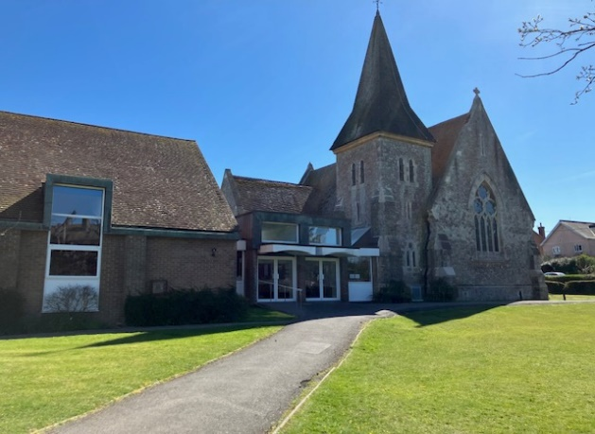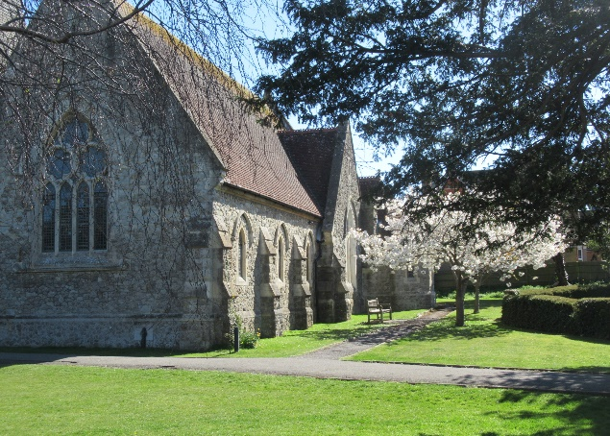

The main church building was constructed in 1875 and later a transept and church hall were added. The church can accommodate up to 180 people for services of worship, seated in a traditional pew arrangement.
St John’s occupies a strategic position within attractive grounds which include a small, consecrated Garden of Remembrance. The site is very visible to passing pedestrians and traffic at one end of the High Street and its location could be exploited to attract new people, especially at key points in the year such as Christmas.
The Church Hall
The church hall building is directly linked to the main church and is connected to a small hall, which can function independently. There is also a small kitchen which serves both halls; the kitchen has the capacity to cater for larger scale events such as church family meals. The main hall can seat about 90 people and is used for a range of in-house activities and meetings; the small hall can seat about 15 people; the facilities are not currently hired out commercially.
‘Withane’ - the vicarage (pictured below) is a 4 bedroomed detached house built in the mid-1980s and is situated in a small residential close about a 5-minute walk from the church. The house offers a good-sized lounge; separate dining room (with a connecting hatch to the kitchen); 4 bedrooms (one with an ensuite shower room; a generously sized study; a conservatory; a small mature rear garden and parking for one car on the drive. The property is owned by the Diocese.
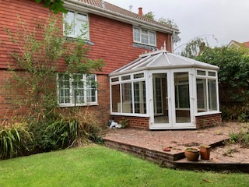
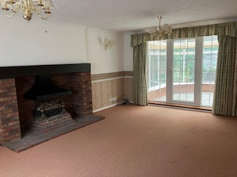

5 St John’s Road

Since 1990, St John’s has owned a 3-bedroom end of terrace house which is located opposite the church and is currently let on a commercial basis to private tenants.

Finances - the church finances are always a challenge. In the 11 years up to 2021, the full Parish Ministry Costs (PMC) were met even when expenditure exceeded income, but since then both St John’s and St Wilfrid’s have been paying less than the Deanery calculation, e.g.

- In 2024 St John’s was asked to pay £81,445 and we were able to pay £51,403, which equates to 63% of the sum requested.
- In 2024 St Wilfrid’s was asked to pay £53,784 and paid £42,276.
- In 2025, the PMC figure was not increased, but instead churches were asked to consider paying 5% more than they did the previous year. St John’s has committed to paying an increase of 6%, pledging £54,492 which was the most we could afford to commit to in our current financial situation. St Wilfrid’s has committed to paying the same in 2025 as it did in 2024.
For the purposes of PMC, the Deanery policy is to assess St John’s and St Wilfrid’s separately, as a result the Parish has the highest PMC request in the Deanery.
Notwithstanding these challenges, we have had good cause to thank God for his timely and gracious provision to meet pressing needs as they arise. We will, however, need to continue to encourage people to review their giving periodically and to trust God that the needs of the church’s ministry will continue to be met. Our commitment is to seek his guidance, particularly in our PCC and prayer meetings, and then follow that leading wherever it takes us.
- Future Priority – to increase the proportion of PMC we can contribute.

Summary of accounts for 2023 and 2024 can be seen on the next page; a full set of accounts can be found in a separate document.

Individual INCOME and EXPENDITURE ACCOUNTS

 | ST JOHN's | ST JOHN's | ST WILFRID's | ST WILFRID's
 | CHURCH | CHURCH | CHURCH | CHURCH
 | 2024 | £2023 | 2024 | 2023
 | £ | £ | £ | £
INCOME
Tax efficient giving | 48,733 | £49,652 | 38,297 | 36,432
Tax refunds | 17,294 | £18,238 | 11,592 | 9,969
Other giving | 5,016 | £4,340 | 3,040 | 3,240
Collections | 6,874 | £5,670 | 5,629 | 7,583
Special collections and Gift Day giving | 1,130 | £520 | 3,152 | 0
Sundry donations & Grants | 34,844 | £32,633 | 5,950 | 6,079
Legacies | 0 | £50,592 | 0 | 0
Parochial Fees | 294 | £399 | 125 | 49
Church hall, rooms & property lettings | 12,326 | £12,261 | 9,956 | 8,074
Fund-raising | 0 | £0 | 13,927 | 3,079
Dividends and interest | 54 | £59 | 659 | 512
Insurance claims | 0 | £0 | 0 | 0
TOTALS | 126,565 | £174,365 | 92,327 | 75,016
LESS: EXPENDITURE | £ | £ | £ | £
Grants given away | 11,730 | £12,552 | 3,358 | 3,882
Parish Ministry costs | 51,408 | £49,140 | 42,276 | 41,004
All clergy expenses | 2,418 | £1,986 | 0 | 0
Clergy housing expenses | 3,629 | £3,109 | 4,179 | 3,940
Rented property costs | 13,418 | £5,791 | 0 | 0
Salaries and wages | 9,519 | £8,980 | 1,636 | 1,517
Church running expenses | 19,142 | £23,956 | 6,407 | 7,395
Church repairs and maintenance | 13,915 | £3,618 | 2,680 | 8,224
Hall running costs | 2,094 | £2,698 | 0 | 0
Hall repairs and maintenance | 2,005 | £8,935 | 0 | 0
Training | 0 | £300 | 0 | 0
Outreach, meetings and mission | 230 | £318 | 0 | 0
Other Direct Expenses | 0 | £0 | 7,160 | 9,504
Youth work | 93 | £23 | 0 | 0
Information Technology maintenance | 1,568 | £1,666 | 0 | 0
Fund-raising and publicity costs | 114 | £134 | 0 | 0
Postage, stationery and copying | 864 | £3,397 | 0 | 0
Sundry administration expenses | 0 | £0 | 1,889 | 1,468
Bank charges | 254 | £283 | 0 | 0
Independent Examiner's fee | 1,185 | £1,185 | 1,185 | 1,185
TOTALS | 133,586 | £128,071 | 70,770 | 78,119
EXCESS OF INCOME/EXPENSES | -7,021 | £46,295 | 21,557 | -3,103

Our New Vicar
Person Specification
With an established congregation and new housing developments within the Parish, St John’s and St Wilfrid’s have the potential for an exciting period of growth. We will look to our new Vicar to help us clarify a vision as to how that potential could be realised and to lead us prayerfully, faithfully and courageously into the future that the Lord has for us.
Given the kind of churches we are, we would want our new Vicar to be an evangelical Christian in theological conviction who has a primary gift in expository Bible teaching and preaching. But of course, that’s just the start and whilst we do not expect anyone to possess all the characteristics identified below, they do nonetheless represent our views and hopes on the main criteria for whoever is called to that role:
Personal Faith and Spirituality:
- Living a life grounded in prayer and shaped by God’s word, who loves and walks closely with the Lord and who has a passion to draw people to Jesus Christ, underpinned by experience of God’s transforming power in their own life.
- Loving the Lord, His people and those who don’t yet know Him.
- Committed to the authority of the Bible and the accurate, authentic interpretation and preaching of the Gospel.
Leadership and Vision:
- Able to lead a Parish and a church team, on a personal, practical and corporate level, providing encouragement, direction and oversight.
- The ability to discern and articulate God’s direction for St John’s and St Wilfrid’s.
- Provide a balanced approach to leadership by being for example:
- An empowering leader who is willing to work collaboratively with others and to delegate appropriately; someone who inspires active participation, teamwork and individual development, recognising, valuing and harnessing the skills and gifts which exist.
- One who can think strategically in determining how the church can continue to evolve and an ability to communicate their vision effectively.
- Servant hearted and committed to prayerfully seeking God’s will for individuals, the whole community and other churches in the Parish.
- Not shy of tackling difficult issues if they arise; resolute in seeing things through and willing to take responsibility for their decisions.
- Committed to care for the environment and God’s creation, embracing the need for St John’s and St Wilfrid’s to fulfil their responsibilities in becoming eco-friendlier churches.
Preaching, Teaching and Worship:
- Proclaiming the whole Word of God by accurate, authentic interpretation and preaching of the Gospel.
- Demonstrating an ability to connect biblical truths to daily life and its challenges in imaginative, inspirational and relevant ways which connect to all age groups.
- Prioritising and championing prayer, both personally and by the church.
- Celebrating and developing a variety of worship styles catering for all ages.
- Being skilled in teaching, nurturing and discipling the church family to grow in their faith, whether established members of the church family or new. These skills will also need to be applied to training and guiding House Group leaders in handling God’s Word clearly and faithfully with smaller groups.
Outreach and Discipleship:
- Is passionate about pursuing church growth and mission locally, being one who:
- Helps us to make the love of Jesus known to more people of all ages seeking to present the Gospel clearly, gently and faithfully to those who do not yet believe.
- Is wise in discerning in how St John’s and St Wilfrid’s can play a more active and meaningful role in supporting ecumenical activities and our local community.
- Will personally reach out beyond the churches and involve themselves in the life of the community and who will invite and challenge us to do the same.
- Is committed to supporting mission partners in the UK and overseas.
Pastoral Care:
An effective, sensitive communicator, who loves people and relates to them easily, individually or in groups, regardless of age, background and stages of faith.
- Approachable, compassionate and understanding, with a pastoral heart and able to make people feel cared for and part of the church family; willing to empathise and provide support in difficult times.
Administrative and organisational skills:
- Competent in church administration.
- Committed to ensuring the churches maintain a strong focus on effectively discharging their responsibilities with regards to safeguarding, people management, finances and compliance with statutory/Diocesan policies and procedures.
- Willing to embrace the place, purpose and potential benefits of digital media in supporting worship and methods of communication generally.

St Wilfrid’s, Lower Willingdon


St Wilfrid’s is an established evangelical church situated in a largely residential area within a mile of St John’s, with a primary and secondary school and a few shops nearby. It currently has a Curate in Charge in post (see page 1* for our future intentions for the Parish). According to the 2021 Census, the Parish in Lower Willingdon had a population of about 6100, but since then there has been new housing development, with more underway and planned. The electoral role is 92, with about half who live outside the immediate ‘district’ of the wider Parish. Worship at St Wilfrid’s is mainly contemporary and informal.
In its life and witness, St Wilfrid’s seeks to Make Disciples of Jesus Christ by:
- Promoting the gospel of our Lord Jesus Christ according to the doctrines and practices of the Church of England.
- Promoting in the Parish the whole mission of the church, pastoral, social, evangelistic and ecumenical.
- Spreading the fame and glory of Jesus Christ, King of kings, and Lord of lords.
- Offering practical support and care for local people of all ages.

Worship

Sunday worship services are held at 10am and 4pm. The afternoon service is known as Sunday@4 and is simpler in structure than the morning service. Sunday@4 is normally introduced by about half an hour of open prayer and praise, followed by a less formal look at some aspect of Bible teaching. Average attendance at the 10am service is 60-70 and 30-40 for Sunday@4.

St Wilfrid’s places great emphasis on the importance of prayer and during the week there are two prayer meetings – Tuesdays at 6.15am and Fridays at 7.30pm. Both prayer times encourage praise and thanksgiving, interspersed with intercession for the blessing of our community and nation and for the outpouring of the Holy Spirit.
Buildings
St Wilfrid’s has its own vicarage, St Wilfrid’s House which is located next door to the church but is owned by St John’s.
The church building comprises a main area for worship, a large adjacent hall and several rooms. The church hall is connected to the main church building and includes a well-equipped kitchen; the hall and smaller room are regularly hired out to a range of community groups and Christian organisations. The Curate-in-Charge at St Wilfrid’s has several exciting plans to develop the church buildings that could make it a very welcoming environment and increase income, but they need investment in infrastructure and staff to bring to fruition.
Ministry, Discipleship and Outreach
The Curate-in-Charge has the assistance of a retired, ordained, non-stipendiary minister (NSM) now serving by permission rather than by licence.
About 35 people belong to weekly ‘home-groups’, which are intended to encourage growth in faith and to encourage obedience to the Lord, Jesus Christ. This obedience is part of St Wilfrid’s calls ‘discipleship to Jesus Christ’ and aligns with the strap line: Making disciples of Jesus Christ.
A group is run which is dedicated to nurturing ladies who are near to the Kingdom or who have recently come into the experience of new life in Christ.
Each autumn St Wilfrid’s hosts a special service called ‘In Loving Memory’, aimed at those in the community who have been bereaved; the service is well attended.
Messy Church and the ‘Mini Wilfs’ toddler group engage younger families and children.
For older children there is a monthly youth club which is attended by about 12 to 15 children, the ambition is to offer this weekly in the future.
St Wilfrid’s hosts visits from the local primary school and church members also take some assemblies at the school. After a lengthy gap, the church has also been able to re-connect with the secondary school (opposite St Wilfrid’s), which is encouraging, and several members run an after-school club there.
A ‘weekly warm space’ event offers people who may be struggling with managing heating bills an opportunity to gather to play board games, read papers, and chat over coffee.
Ecumenical connections exist through a local Churches Together network with mutual engagement in low-key street evangelism e.g. singing in the High Street at Easter and Christmas.
Members of St Wilfrid’s also run a book-table in the Triangle which is a hub in the district with a few shops and a small piece of common ground.
The District Church Council contributes to several charities, including Beachy Head Chaplaincy, which seeks to counsel those contemplating suicide; Spinnaker, a charity involved in supporting local schools; and two charities with projects based overseas.

