
Giving Advisor

Do you

- Enjoy supporting individuals and groups to think creatively about generosity and giving?
- Have a passion to see generosity overflow throughout communities across Cumbria?
- Want to be part of an exciting team working across different contexts and traditions?
The Diocese of Carlisle is looking for a

Giving Advisor to join our Head of Stewardship and Local Ministry Finance and wider Diocesan team to work with parishes across the whole of the Diocese of Carlisle to help facilitate growth in generosity and giving.

For full details and an application pack, please visit https://www.carlislediocese.org.uk/vacancies/

This position has been funded through the Church of England National Giving Strategy. Current funding for the role is secured until the end of 2028. The successful candidate(s) will receive additional support and resources through the National Stewardship Network, as well as annual conferences and regular training.

Specific experience in fundraising, stewardship or working within a church context is not needed. We are looking for someone with a passion for the role and the right transferable skills.

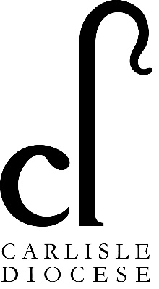
We are open to applications from people seeking full time or part time work. The annual salary for the role is £31,795 FTE per annum (pro rata), plus 15% pension contribution.

Applications need to be submitted by 12 noon on Wednesday 15th April and those applying should be available for interview on Tuesday 28th April in Penrith.

If you wish to discuss the post before applying, please phone the Head of Stewardship and Local Ministry Finance, Sophie Hodge, 07988090477 or email Sophie.hodge@carlislediocese.org.uk

