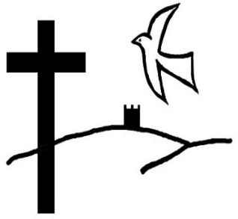
THE HORWICH & RIVINGTON TEAM



TEAM PROFILE - TEAM VICAR POST

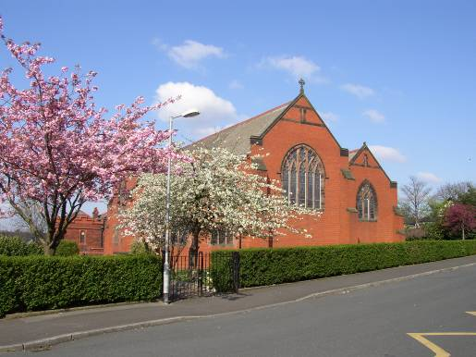
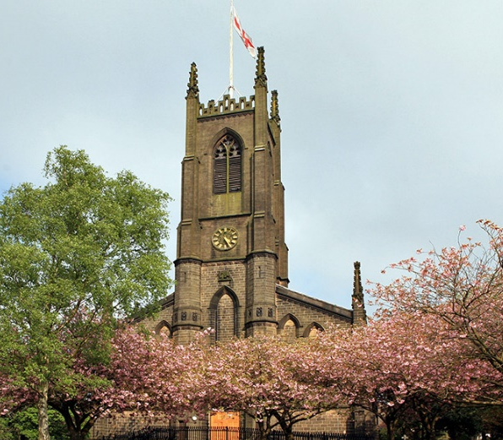
HOLY TRINITY ST CATHERINE’S

ST ELIZABETH’S RIVINGTON
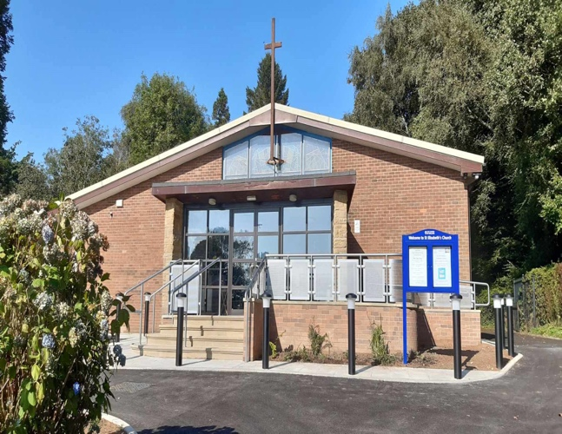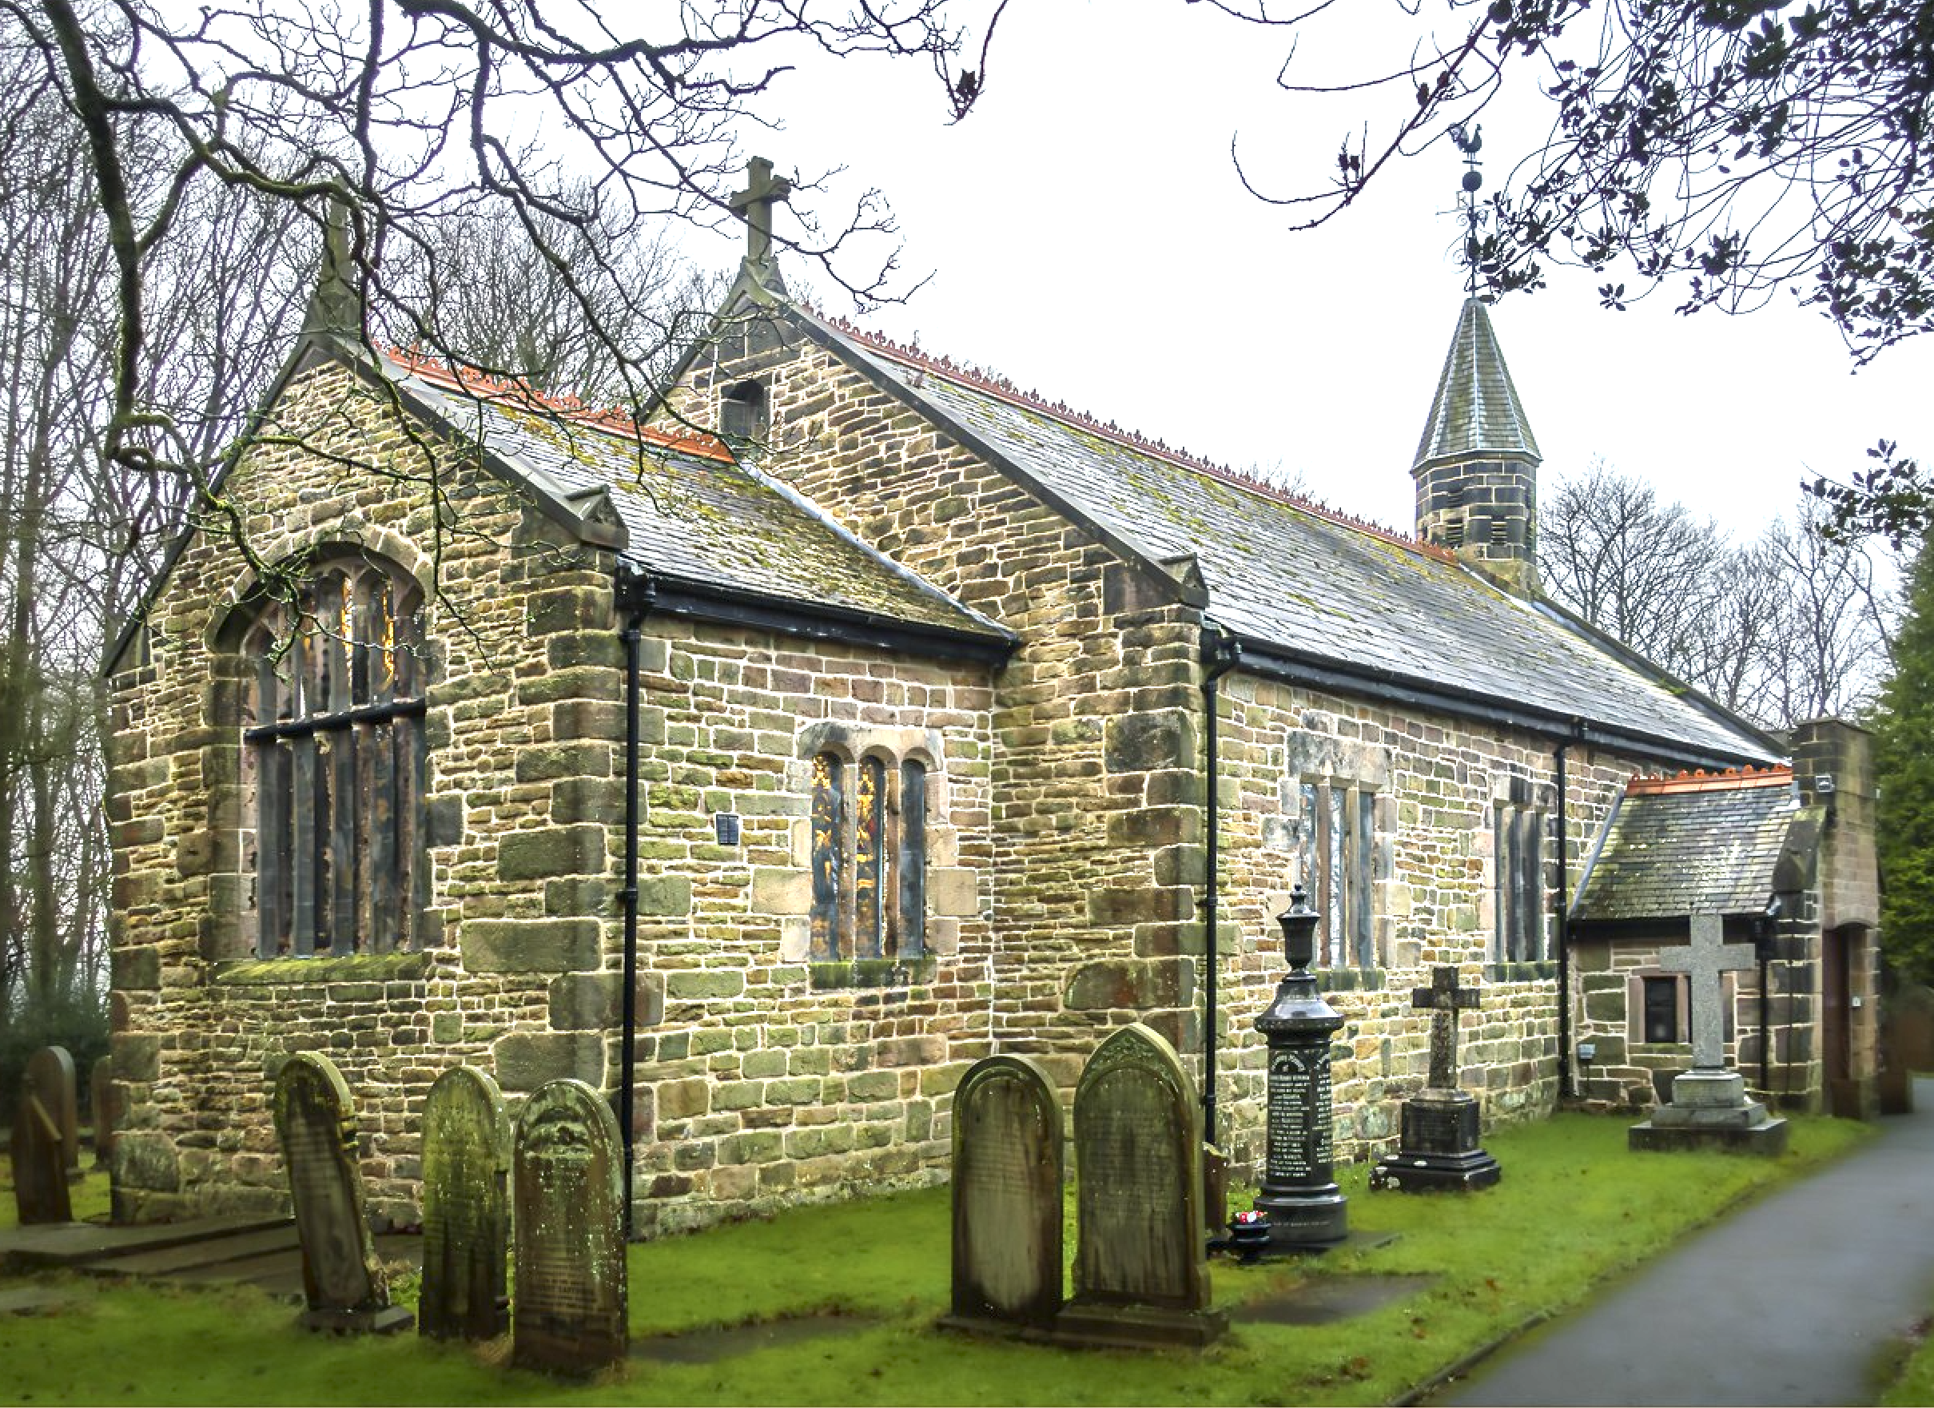
CONTENTS
Page
- Introduction 3
- Team Setting & Churches 3 - 6
- Information and Statistics 7
- The Staff Team 8
- Authorised Lay Ministers. 8
- Lay Involvement Across the Team. 8 - 9
- The Team Vicar 9 - 10
- Community, Schools and Youth Work 10 - 12
- Accommodation + Local Scenery 12
- Bolton West Mission Community 13
- Horwich and Rivington Team Boundaries 14
- Final Comments 15

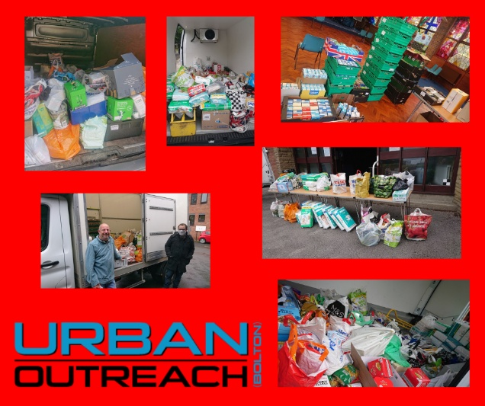
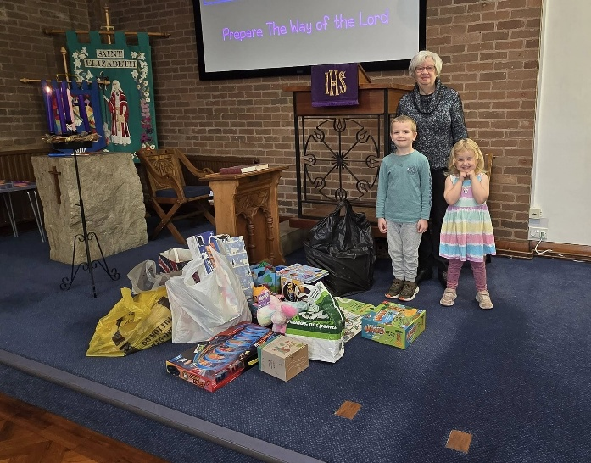
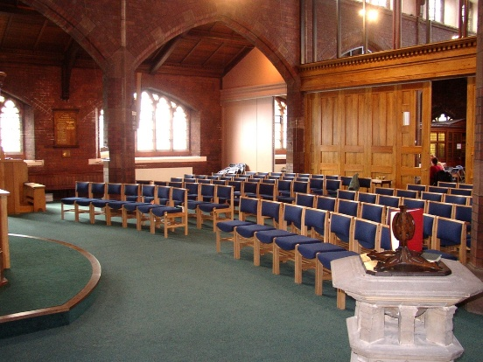
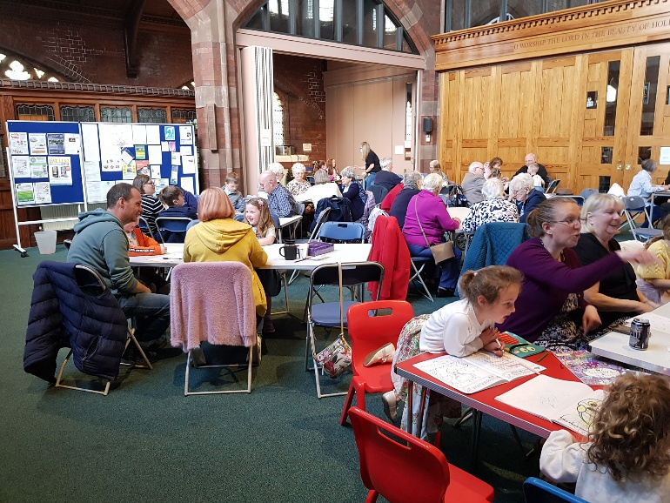

INTRODUCTION
We are delighted you have chosen to look at our profile and hope it will give you a clear sense of how the four churches of the United Benefice of Horwich and Rivington are working together as a team. The United Benefice is a member of the Bolton West Mission Community. The Mission Community is within the Bolton Deanery, which is within the Archdeaconry of Bolton and Salford, in the Diocese of Manchester. If you feel that God may be calling you to join the Horwich and Rivington team, then we look forward to receiving your application. We believe that our team ministry is a fantastic opportunity for someone to come and be part of a committed team of people who are dedicated to a continuation of church mission and growth
THE TEAM SETTING
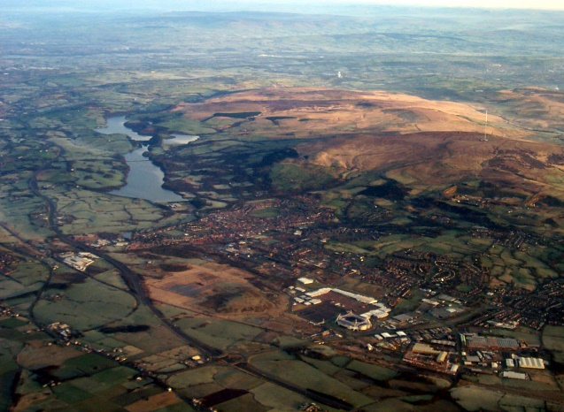

Horwich is a small and distinct township (with a population of around 20,000) within the Bolton Metropolitan Borough. Rivington is a small village, adjacent to Horwich within the Lancashire Council authority. Overlooking the area, are Rivington Pike and Reservoirs which are part of the dramatic scenery and rolling hills of the West Pennine Moors. (See http://www.horwich.gov.uk)

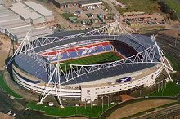
There are good motorway connections to the area, with the three Horwich churches all within two miles of Junction 6 of the M61. Horwich is where Bolton Wanderers Football Club has its home ground - the impressive Toughsheet Stadium. It is part of the Middlebrook Retail & Leisure Park - a major commercial, leisure and retail venue which includes the Bolton Arena, a Commonwealth Games 2002 site. The Arena offers a wide range of sporting facilities and opportunities and acts as the host for the annual Bolton Ironman UK. Nearby is Red Moss, an environmental site of Special Scientific Interest which complements the beautiful countryside of Lever Park and the rising West Pennine Moors immediately behind Horwich and Rivington.

The town of Horwich has a full range of housing from terraced, Council and private property to luxury housing developments and tenant farms. Employment is equally varied, ranging from manufacturing industry to commerce and leisure. Outline planning permission for a further 2,500 dwellings has been approved. Rivington joined the Horwich Team in 1992 and retains the charm and beauty of a small, traditional, rural Parish Church. Horwich is a growing Lancashire township with a broad social mix, (although few residents have overseas family origin) and this breadth brings with it both benefits and challenges, providing a fascinating context for a wide range of Christian ministry and experience.

The Horwich and Rivington Team Ministry offer a range of church traditions with a broadly evangelical focus. The full-time stipendiary team clergy would identify themselves as Evangelicals, while other colleagues come from more central Anglican traditions. However, we are all committed to respecting anything which gives honour to Jesus Christ as Lord and Saviour, in the varied traditions of our churches and town.
Each church has a slightly different tradition and focus which enables each worshipper to attend a service that is matched to their preferred style of worship. Although the Team has been in existence for almost 30 years, we are still reviewing and developing our Team vision and structures. The congregations of three of the Team churches tend to be local people, whilst the great majority of the Rivington congregation come from the surrounding areas adjacent to the parish. The existing Team clergy, while primarily responsible for specific churches, are comfortable working across all the Team. We hope that this pattern of ministry will enable individuals, both clergy and lay, to exercise specialised ministries to serve the churches and the area more effectively in Christian mission and ministry.

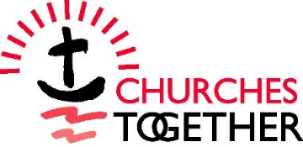
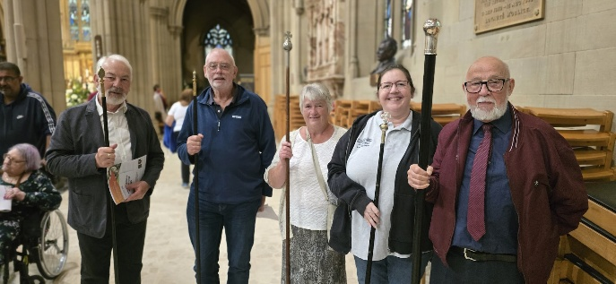
The team churches are part of the Bolton West Mission Community which is within the Deanery of Bolton and the Archdeaconry of Bolton and Salford. The churches are members of Churches Together of Horwich and Rivington, the group of Christian churches in Horwich and Rivington. The church ministers meet regularly. A number of annual events and projects have developed between local churches, including the Middlebrook Angels Retail Chaplaincy Project with a part-time paid Chaplain supported by voluntary chaplains from our local churches and area, who offer a listening ear to staff and businesses on the Retail Park with active support from the Emerson’s Management Group. The chaplaincy project has been further extended to Horwich Town Centre with the Horwich Angels. There are growing links through the interactions of churches and there are united Lent courses, covenant services and acts of civic services such as Remembrance Day. The team churches also support Urban Outreach, a Bolton Christian charity, which provides free school lunches during the summer holidays, a ‘Christmas Dinner on Jesus hamper’, the Storehouse Grub Tub and Winter Watch (serving the homeless). All the Team churches support an array of home and overseas mission and charitable causes including Christian Aid and International Aid Trust (a local charity which sends Shoeboxes abroad).

THE TEAM CHURCHES

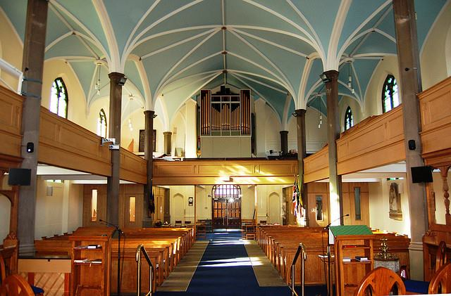
Holy Trinity is the original Horwich Parish Church and is the third church on the site since 1547. The current church was built in 1830-1831 and extended in 1901. The parish has a mixed fellowship, with both traditional Anglican emphases and more modern features which it caters for with two main services on Sunday mornings. One is an informal family service with children’s groups and the other is a Holy Communion or Morning Prayer Service. In 2009, it completed a major refurbishment to the interior of the church to provide better access, worship and fellowship facilities. It also allowed for a broader community use including the annual Horwich Town Council Civic Service; concerts; a Warm Welcome each week for members of the community to come together for food and fellowship as well as other social events and school assemblies by the large Church Primary School next door. Two local nurseries come for their annual leavers and Christmas services. We have the Silver Eco award and have held the Child Friendly Church Award since 2010. In May 2024 an appeal was launched to raise £290,000 for the first stage of work which was urgently needed on the tower, the stonework, the guttering and downspouts.
The work started at the end of May 2025 and has almost reached completion. The church has a dedicated welcome area at the back of church, kitchen and toilet facilities, a crèche room, projector and screens. There is a Parish Hall near the church which is rented during the day by a private nursery and used on Monday mornings by a church Toddler group and at night by uniformed organisations. www.achurchnearyou.com/church/16052/

Services Sundays: 8.00am said Communion service (bi-monthly); 9.15am Informal Service with Music Group (including a monthly Family Communion); 11.00am 3 Choral Communion and 1 Morning Worship service with choir and organ each month; on 5th Sunday Communion with Healing Service; a termly Parade Service. Weekdays: Wednesday morning Communion

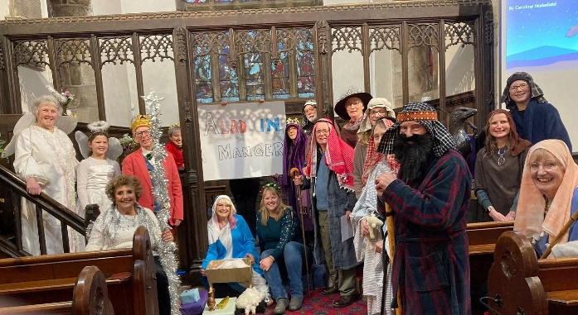
Rivington is a historic village church built almost 500 years ago, with a new extension being completed in 2009 with toilet/kitchen facilities. A number of pews have been removed from one side at the rear of church which created an area used for coffee before and after every Sunday service and for occasional meetings. Although Rivington has maintained a very traditional BCP communion service, the first Sunday in the month is a family service. On the 5th Sunday of the month there is Common Worship. Our church has a warm eclectic fellowship. The churchyard attracts many visitors, and the church is open to all on one Wednesday per month for “Wednesday Welcome,” an opportunity for folk to come in have a look round, spend time in quiet reflection, prayer and a chat, with refreshments provided. There is a separate church hall which is used during term time by the primary school. A Fellowship Lunch with communion or midday prayer is held in the hall on the 4th Tuesday of the month. This is open for all and accessible to those who find the uphill path to church too difficult. www.achurchnearyou.com/church/16056/

Services Sundays: 11.00am 2 BCP Communion, 1 Common Worship Communion and 1 Family Service each month.

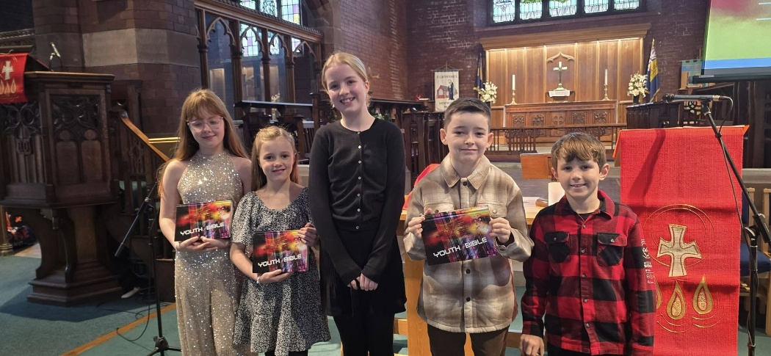
St Catherine’s was refurbished in the late 1990’s to make a multi-purpose and adaptable building seating 200+. It is situated on a mainly terraced-housing estate built for railway workers (c.1900), with many new houses also being built in the last 35 years. There is now an ongoing significant building development in the area. For the greater part of the twentieth century, St Catherine’s was broadly middle-Church of England. However, since 1997 it has taken a more evangelical approach to worship and mission. At our Sunday service we have a Sunday Club that runs once a month during term time. Our music is a mixture of traditional and contemporary, using organ, audio and video led songs. There is a midweek service on Thursday after school for children and their families and a Messy church once a term. We hold a Christingle service on the afternoon of Christmas Eve which is always well attended and usually attracts over one hundred people. We hold afternoon teas for seniors from church and the community four times a year and these are well attended with between thirty and forty people usually attending. The church building is also used for a variety of church and community events e.g. Toddler Group, School Services; Brass Band Concerts; Social Events; the annual Christmas Market; and lettings to local organisations. www.achurchnearyou.com/church/16054/
Services Sundays: 11am 2 Common Worship Communion, 1 Informal service, 1 Sunday Worship service. Thursday 4.00pm All Age Service


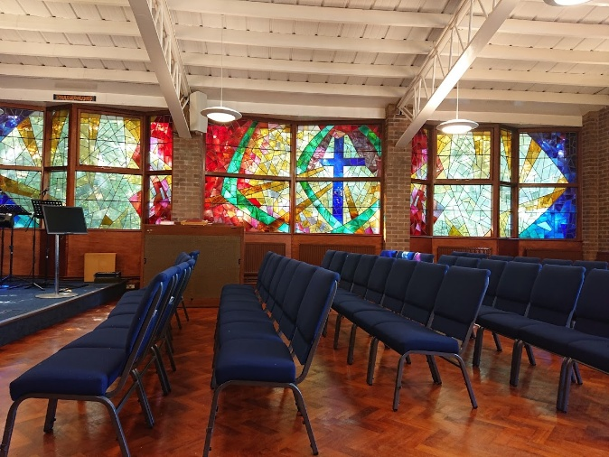
St Elizabeth’s has its origins in a Church Army Mission Van, visiting Horwich in 1882. In 1967 it moved from a previous ‘Mission’ building, into the modern and attractive present-day church and was fully refurbished in 2007. It now lends itself to more flexible, informal and creative styles of worship. We offer a variety of Sunday services. Once a month there is a BCP service (said), a family focused All-Age Worship and ‘ALIVE and FREE’ –informal, contemporary worship in the evening. This is cross team and part of our outreach programme. Over the remaining weeks, we have two services of Holy Communion and a Morning Worship. Our music is a mixture of contemporary and traditional, using audio and video led songs. A small music group plays on occasions. At the present time, the children meet in their own groups on two Sundays per month. We are a welcoming community and have recently invested in the Church building to make it more accessible for all, by building a new entrance and ramp. Adjacent to the church, is a purpose-built Church Hall with kitchen. This is used by regular groups, including uniformed organisations and a variety of other community groups. The Church is also used two nights a week by local choirs. We have a heart for mission and use our grounds and buildings for outreach e.g. Family Fun Days, Christmas Fayres and other social events. We also run a weekly ‘Food and Friendship’ group which offers local people the opportunity to meet, eat and make new friends in a warm and welcoming space. Once a term we have an afternoon tea with entertainment, for the seniors in our church and local community. We participate in the team ‘Christmas Dinner on Jesus’ distribution, and the church is the collection point for the team ‘Grub Tub’ food donations, supporting Urban Outreach. BL6 free school lunches have been distributed from our Church Hall, during the school holidays. We collect toys for ‘Fort Alice’ around Christmas time. St Elizabeth’s serves a mixture of council and private housing. We are delighted to have recently welcomed new families and are seeing signs of new growth. We would love to see this blossom and develop into a thriving ‘Church for our time’ (quote from one of the Mission Church Army Captains).
www.achurchnearyou.com/church/16053/

Services Sundays: 1st Sunday BCP Communion 8.30am, 9.30am All Age Worship; Other Sundays 9.30am 2 Communion Services, 1 Morning Worship; 7.00pm Alive and Free (monthly).

INFORMATION AND STATISTICS

 | Holy Trinity | Rivington | St Catherine’s | St Elizabeth’s
Electoral Roll 2025 | 109 | 66 | 43 | 66
Average Weekly Att
Adults | 65 | 27 | 26 | 33
Under 16 yrs | 20 | 2 | 7 | 9
Parish Share 2024 | £40,000 | £25,000 | £21,000 | £24,000
Parish Share 2025 | £45,000 | £26,250 | £22,050 | £26,000

The Electoral Roll figures followed the full review of the roll in 2025 and were reported at each church’s Annual Parochial Church Meeting. The Average Weekly attendance figures are as reported on CofE Statistics for Mission 2024/ 2025. All four churches paid their parish Share in Full in 2024 and in 2025.

OCCASIONAL OFFICES 2025

 | Holy Trinity | Rivington | St Catherine’s | St Elizabeth’s
Baptisms | 29 | 6 | 1 | 4
Weddings | 1 | 4 | 0 | 0
Funerals - Church | 15 | 9 | 9 | 6
Crematorium | 7 | 1 | 5 | 1
Burial of ashes | 9 | 9 | 5 | NA

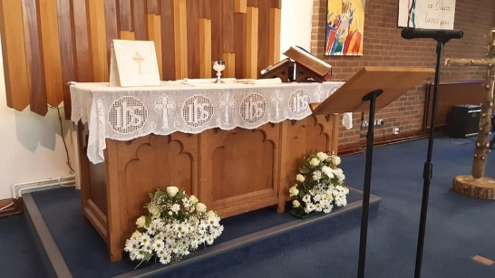
The churches recognise the huge mission opportunity afforded by working with baptism families. We encourage baptisms as possible to take place within main Sunday services, but often have too many baptism requests to enable this to happen or families want to invite large numbers of guests and so do many after the services. We try however, to make these a real mission opportunity. Through our baptism preparation sessions and the baptism services themselves, we are building closer links with previously unchurched families and encouraging attendance at church.

For weddings as with baptisms, we try to forge closer links with the wedding couples we relate to each year. We run an annual Marriage Preparation course (using the Marriage Preparation Course material from Holy Trinity Brompton).

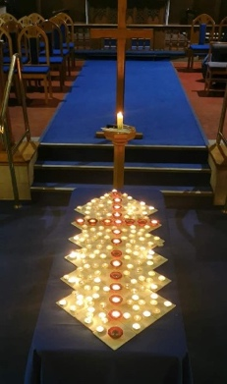
With regard to funerals, we hold an annual Team Memorial Service and open the church during the afternoon in the late Autumn at Holy Trinity, specifically for recently bereaved families but with many others attending, to give them an opportunity to remember their loved ones and to take a further step along their journey of loss. We invite all the bereaved families we have related to over the previous couple of years and it has been noticeable how the attendance at this service has been steadily increasing. This service was organised in cooperation with the local funeral service and is one way in which we seek to maintain contact and offer support to local bereaved families.

THE STAFF TEAM

The staff team currently has one 2 full-time stipendiary clergy with a vacancy for the Team Vicar post; two Voluntary Ordained Local Ministers (OLM) and two Reader Emeritus. The team is supported by four retired clergy members who have permission to officiate. The staff members are as follows:
Stipendiary Clergy | Revd Nicola Butterworth Team Rector
Ordained Local Ministers | Revd Nicola Gillard Associate Minister  Revd Peter Harley Associate Minister
Retired Clergy | Revd Dr Gill Smart  Revd Caroline Tracey  Revd Canon Michael Williams
Reader Emeritus | David Hawes  Dr Ron Knott

The team have a weekly staff meeting normally on Tuesday. Daily prayers are encouraged through personal devotion. A termly rota is prepared sharing service responsibilities around our team of stipendiary, OLM & retired clergy, with Readers, Team Authorised Lay Ministers and other lay helpers also assisting with non-Eucharistic services. The Team Rector is rota-ed to take weekly services primarily at Holy Trinity & Rivington churches, and the Team Vicar primarily takes services at St. Catherine’s and St. Elizabeth’s churches, however both also take services in the other churches. The rota is currently prepared by the Team Rector.

AUTHORISED LAY MINISTERS

The clergy team is supported by a team of 12 Authorised Lay Ministers (ALM) serving God’s people across our churches in areas of Worship, Pastoral Care, Community, Mission, Prayer & Spirituality and Youth, some covering more than one specialism.
 | Holy Trinity | Rivington | St Catherine’s | St Elizabeth’s
Children & Families |  |  |  | 1
Pastoral |  |  |  | 1
Pastoral Outreach & Listening | 1 |  | 1
Prayer & Spirituality |  |  | 1
Worship | 2 |  |  | 1
Worship & Liturgy |  | 2 |  | 2
Youth |  |  |  | 1

LAY INVOLVEMENT ACROSS THE TEAM
Each church has a Pastoral Care scheme operating on different models, with a team of Pastoral Assistants who take communion out into individual, nursing, and residential homes. For Child Protection and Adult Safeguarding, all churches operate common policies and procedures. There are a number of active house groups and prayer groups across the Team.

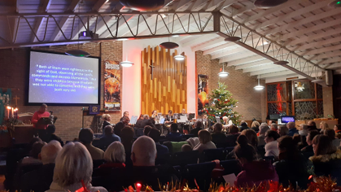
As a Team we hold regular Simply Christianity/Alpha/ Discipleship groups as well as confirmation preparation (adult & young people) and admission to communion. All four churches have committed to be Fair Trade parishes. In terms of social activities, we are a very sociable Team; Ladies’ Fellowship; Open Door group; midweek warm spaces and coffee mornings; events to support senior citizens; afternoon teas; regular concerts and a variety of other social activities which are advertised on social media.

THE TEAM VICAR
We are looking to appoint a candidate who has a deep and sustaining faith which is rooted in prayer and a love for God’s people. We are looking for someone who sees the benefit of being proactive in using social media; is open, approachable and flexible and is a good communicator and listener and ideally has a sense of humour. This candidate will have oversight of two of the churches in the team but will be a presence in all four churches.
The core responsibilities of the post include preaching the Gospel, teaching about faith, encourage people to attend Bible studies, preparing children to be admitted to receive Holy Communion, confirmation classes, and other educational programmes for people of all ages and stages of faith. This is alongside presiding at services of Holy Communion, various styles of Sunday morning Worship, along with baptisms, weddings, funerals, and other liturgical celebrations.
We are looking to:
- further develop creative approaches to worship which encourage lay participation. The team model encourages collaboration, the sharing of gifts, and a broad distribution of pastoral oversight. It allows the church to serve the community, adapt to changing needs, and nurture leadership among clergy and laity alike.
- develop practical and effective ways of increasing outreach and evangelism, especially in reaching families and young people as we recognise the changing structures of family life. Which emphasises that ‘Church on Sunday’ no longer works for many people.
- provide spiritual support and guidance to individuals and families, visiting the sick and the bereaved, offering counselling and prayer, and promoting the overall well-being of the church community. Compassion, empathy, and the ability to listen deeply to the joys and struggles of others are key essential qualities.
- maintain strong links between our churches and the church schools (including the role of ex-officio Governor at St Catherine’s Primary), along with connections in the other schools in the community. We hope the right candidate will build on and develop young people’s work both in our schools, in our churches and in the community working collaboratively to develop this.
- maintain and develop community links and be a visible presence in the community building on the existing strengths within our churches and also those with our ecumenical partners.

It is important that the candidate is organised and can plan ahead effectively. They will share responsibility for the governance of the benefice with the Team Rector and will be responsible for the organisation of PCC meetings for two of the churches. They will oversee safeguarding along with the PSO and will work with volunteers to ensure the smooth running of church life. A healthy relationship between the team vicar and the team rector is foundational for effective ministry. Each person brings their own gifts and leadership to the shared mission. Therefore, regular communication, mutual respect, and a commitment to shared vision will help foster a positive working environment.

Team parish ministry is fast-paced and varied, often shaped by the rhythms of worship, the needs of parishioners, and the opportunities of the wider community. However, it has challenges and so the candidate will need to be someone who can demonstrate resilience and patience as we encourage people to embrace change, along with supporting the well-being of the team and the wider church.

Serving in the Horwich and Rivington team is both demanding and deeply rewarding. It calls for a servant heart, a collaborative spirit, and a passion for the mission of God in the world. As team vicar you are an integral part of this team as we continue to develop the vision, not only for individual churches, but the team as a whole; you will share the joys and burdens of ministry, as we share the Gospel message of hope, love, forgiveness and grace at the heart of Christian faith.

COMMUNITY, SCHOOLS, CHILDREN & YOUTH WORK

Community
As is illustrated in this profile, the team has strong community and civic links which include the Remembrance Sunday Civic Service; the Horwich Town Council Civic Service; the lighting of the Town Christmas Tree; the Middlebrook and Horwich Angels Retail Chaplaincy Projects which are linked to the Bolton Town Centre Chaplaincy; work with Urban Outreach; work with Horwich Heritage; the Team Memorial Service for bereaved families; events to support senior citizens; afternoon teas; regular concerts and a variety of other social activities.

Schools
Horwich Parish C E Primary School  Voluntary Aided  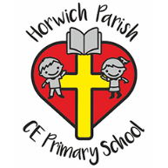 | - The school is sited right next to Holy Trinity Church. It has a double form entry per year.  - The school uses the church three times a week for collective worship with the whole school.  - The Team Rector is involved in leading regular worship and occasional lessons.  - The composition of the governing board stipulates the number of Foundation Governors appointed by the church and by the diocese.  https://www.horwichparish.net/
St Catherine’s CE Primary School  Voluntary Aided   | - The school had a new building in 2003 and has a single-form entry per year.  - The school holds services in church three times a year for special celebrations.  - The Rector is involved in leading regular assemblies and occasional lessons.  - The composition of the governing board stipulates the number of Foundation Governors appointed by the church and by the diocese.  https://www.st-catherines.bolton.sch.uk/index.asp
Rivington Primary School   | - The school is a small Lancashire Authority school with an independent foundation background.  - The church hosts and leads occasional services a year, occasional assemblies and occasional lessons.  - The school uses the Church Hall.  http://www.rivingtonprimaryschool.co.uk/
Claypool Primary School   | - Although St Elizabeth’s Church does not have a Church School, it has links with the nearby Claypool Primary School.  - The school comes to the church for its Carol Concert.  https://www.claypool.bolton.sch.uk/
Rivington & Blackrod C E High School  Voluntary Controlled   | - The school is part of the Leverhulme Academy Church of England and Community located half-way between Horwich and Rivington, with around 1,800 pupils.  - A number of church members are Governors there.  - Clergy conduct assemblies at the invitation of the school leadership team.  - The composition of the governing board stipulates the number of Foundation Governors appointed by the church and by the diocese.  https://www.rbhs.co.uk/index.asp
Other schools | - There are other primary, high, special and independent schools in the area.

Children & Youth Work

Sunday - Children’s Group Activities  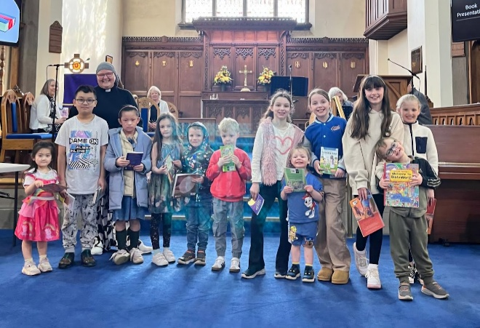 | - Holy Trinity: During the Sunday 9.15am services the children have activities in the Narthex at the back of church. The Church holds the Bishops 'Child Friendly Church Award'.  - St Catherine’s: Sunday Club 3-11yrs, meets monthly during term time.  - St Elizabeth’s: The Sunday Club meets twice a month. Its aim is to bring the Bible to life in a fun and enjoyable way and provide an introduction to Christian life.
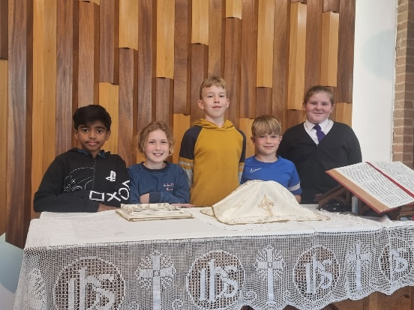  Other days – Children & Youth Groups | - Team Groups -Inspire – a group for 9–13-year-olds which developed from 2021 Admission to Communion group.  Inspire meets on Wednesday evenings in term time at St Catherine’s.  - Holy Trinity - Horwich Parish Wiggle Tots: Monday morning 9am -11am, for pre-school children, with a Christian focus.
Link Groups  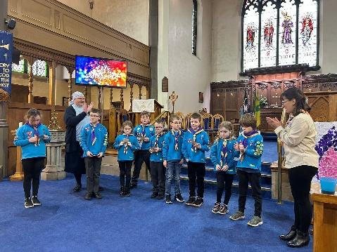 | - Holy Trinity - Explorers, Scouts, Cubs, Beavers, Rangers, Guides, Brownies & Rainbows.  - St Elizabeth’s - Scouts, Cubs, Beavers, Brownies & Rainbows.  - St Catherine’s - Time 4 Twos Friday mornings  10.30am for pre-school children.

AccommodatioN

There will be a four-bedroom house available for the post holder situated within the parish boundaries.


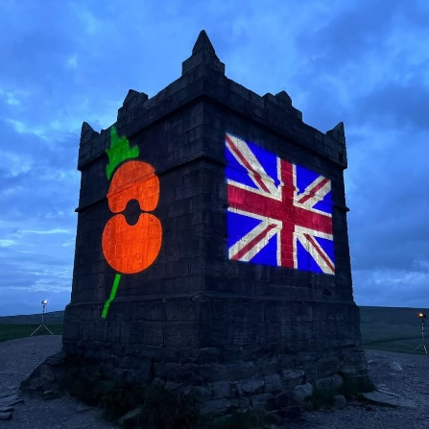
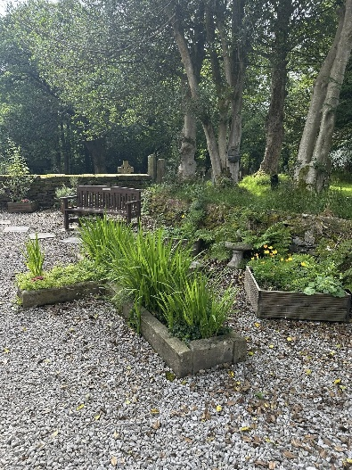
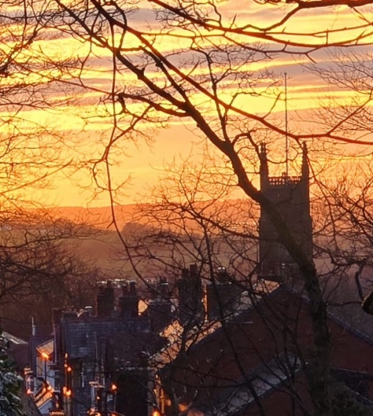
LOCAL SCENERY

Bolton West Mission Community
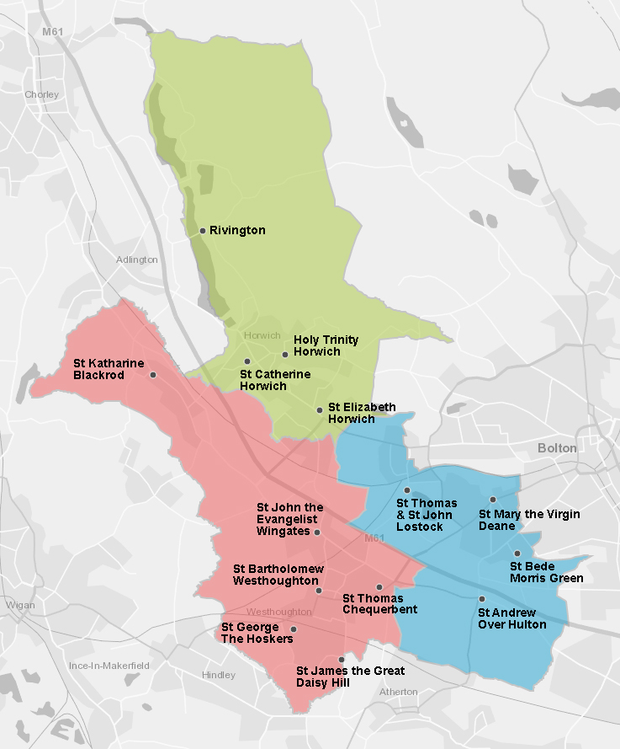

Introduction
The Bolton West Mission Community is one of the four Mission Communities in the Deanery of Bolton which is part of the Archdeaconry of Bolton and Salford. The West Bolton Mission Community consists of three groups of churches. These are Horwich and Rivington; Deane, Lostock and Over Hulton; and Westhoughton.

Prayer and Support
The Incumbent level clergy meet monthly and there are occasional meetings for clergy and ministry team members from across the Mission Community.

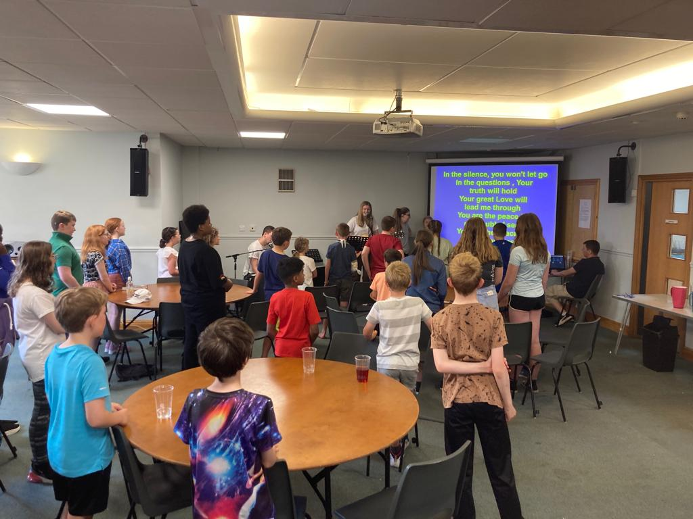
Shared Youth Ministry:
There are termly youth leaders’ gatherings from across the Mission Community. There are also termly youth events to bring our young people and our youth groups together including an annual residential which takes place in June each year. The residential, Catalyst, is now in its third year and on average 35 young people, from across the Mission Community, attend together with their leaders. A fourth event is planned for March 2026.

Mission:
There was a shared 'Connect' Project post Easter 2024 - where each church across the Mission Community held invitation events as we sought to be more intentional in our evangelism with shared launch and celebration events.

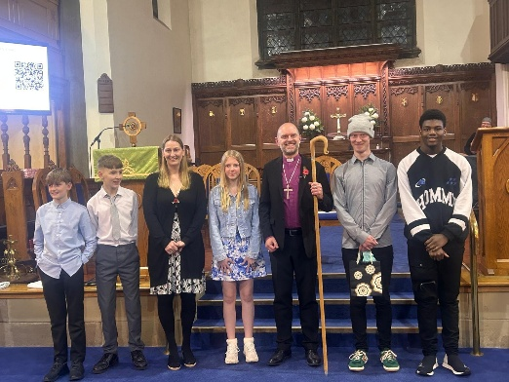
Confirmation:
We share an annual Confirmation service for the Mission Community

What we want to develop in the future
- Shared Youth Ministry across our Mission Community
- Prayer and Praise Events to bring our Mission Community together for more corporate prayer opportunities.
HORWICH AND RIVINGTON TEAM BOUNDARIES

Holy Trinity parish is in the centre and east of Horwich, St Catherine’s is in the centre and west of Horwich and St Elizabeth’s in the south of Horwich. Rivington parish is to the north of Horwich.

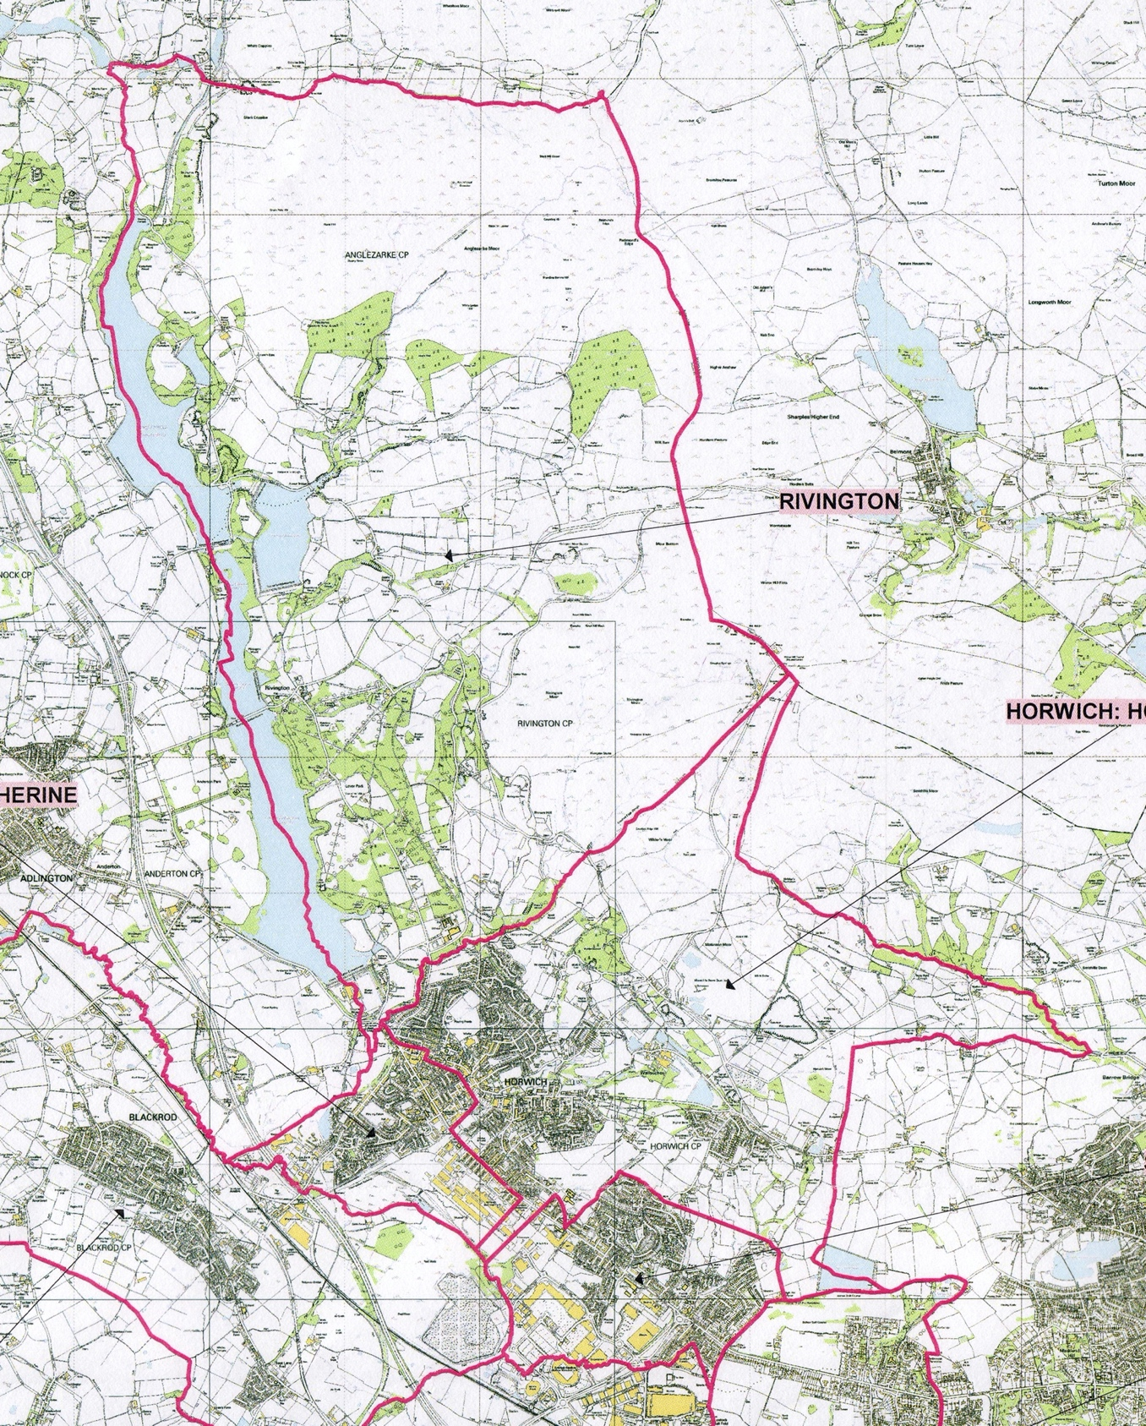

And Finally….

We believe that the Horwich & Rivington Team provides a great opportunity for engaging with and contributing to Church life today. Our clergy work well together as colleagues, partners in the Gospel, and friends, and look forward to welcoming a new colleague to share in the challenge of what God is doing here.

As a Benefice Team, we promise to:
- Uphold you in prayer as an individual and in your role.
- Provide practical support through active churchwardens, lay, and ordained leaders.
- Respect your need for time with family, friends, and God.
- Explore ways to reduce the strain of administrative tasks.
- Encourage friendship and fellowship through social events and informal gatherings.
- Offer you privacy in your home which is a place where you can relax.
- Be honest about our challenges, but hopeful and proactive about how we face them together.
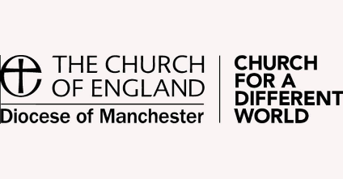
We are also part of a wider Diocesan family that takes wellbeing seriously. The Diocese of Manchester provides a range of resources and support for clergy wellbeing, including access to pastoral care, counselling, and spiritual direction.

You will be supported by a committed team who genuinely want you to thrive. Together, we will work collaboratively, valuing you and your ministry and making space for your rest and renewal. We also hope to be a community where you find laughter and joy alongside the work of ministry.

We recognise that parish ministry brings both joy and challenge. However, we believe this role offers the scope to make a real difference—spiritually, pastorally, and missionally— in the life of our parishes and beyond.

We hope this profile has given you a sense of how our United Benefice offers a unique and exciting opportunity to become part of a faithful and committed church community—rooted in tradition, yet open to growth and renewal. We are eager to support you and work alongside you in nurturing faith, serving the wider community, and engaging with all generations. With strong foundations already in place and a clear vision for the future, we are trusting and praying that the person God is calling will join us for the next chapter of our shared journey.

