
Benefice of Headington St Mary’s
Serving Barton, Sandhills and Barton Park
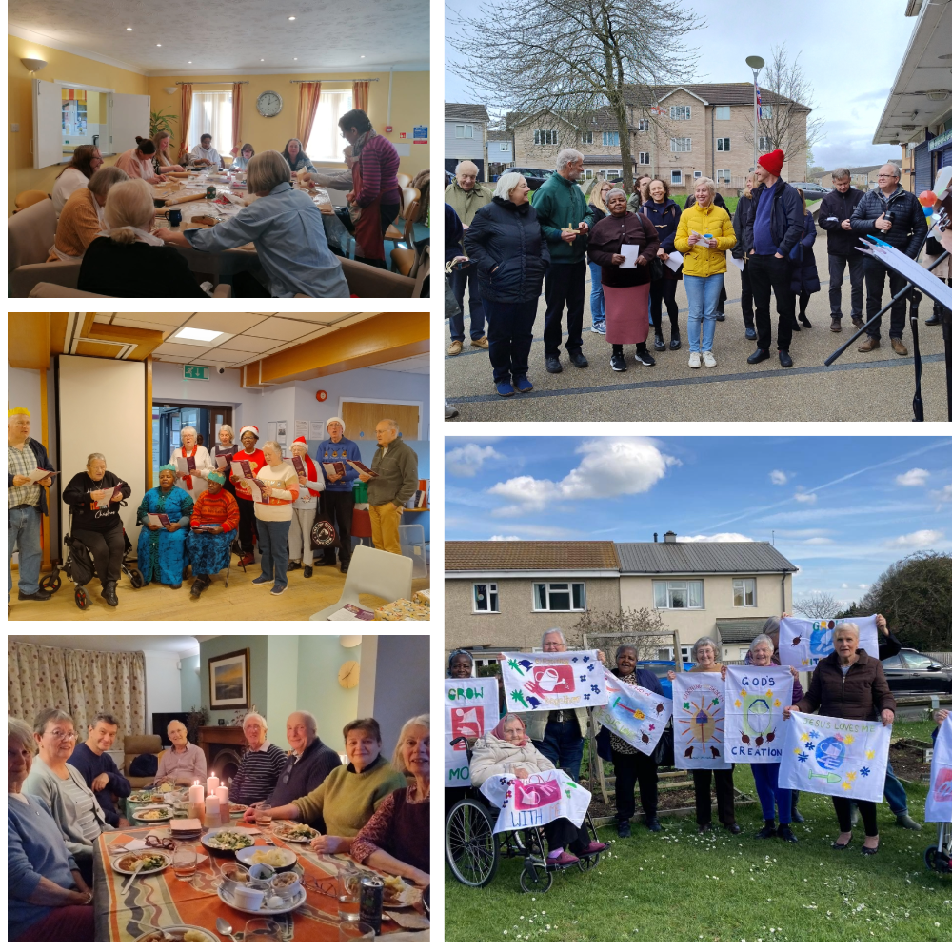
Spend time with Jesus | Become like Jesus | Do the things Jesus did
Parish Profile
2026
Contents
- Page 3: Could you be our next vicar?
- Page 4: Foreword from the Bishop of Oxford and Area Dean
- Page 5: Welcome
- Page 6: Church life and pattern of worship
- Page 8: Location and parish
- Page 10: Our community
- Page 12: Our history
- Page 13: Our buildings
- Page 16: What we can offer you
- Page 17: Who we are looking for
- Page 19: Appendix

With God’s help, could you be our next vicar?
We are a church in transition, looking for a new vicar, out of our building whilst a major renovation takes place and thinking through how we can move forward to love and serve our parish.
We are looking for our vicar to be someone with a heart for God, for the poor, and for mission. Someone who is excited by the message of the Gospel and can encourage each member of the flock. Someone who delights to see God glorified and celebrated by his church.
Could you take forward our vision that St Mary’s becomes increasingly:
- an intergenerational church
- somewhere everyone is welcomed, valued, cared for and encouraged to use their gifts
- a place where people encounter the Lord through Word and Spirit
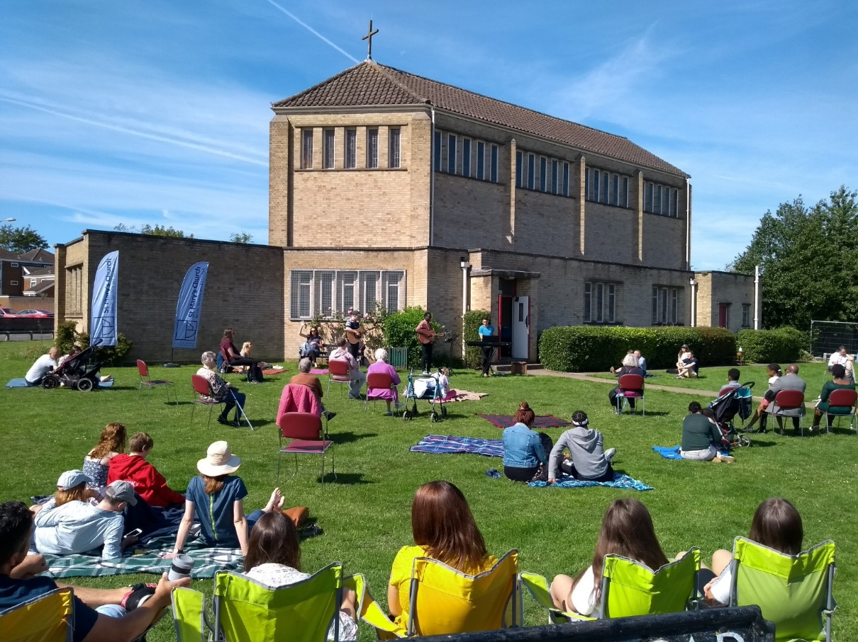
- a spirit-filled congregation who serve and witness together throughout the parish
Foreword
From the Bishop of Oxford:
On the day my appointment was announced as Bishop of Oxford, ten years ago, I was taken to St Mary’s Barton. A new project to revitalise the Church for mission had just begun. There has been significant fruit and rebuilding since that time. The congregation has grown as has the ministry team through difficult challenges of illness and bereavement. St. Mary’s is now a united, committed, resilient congregation deeply rooted and connected with its parish in love and service and with a church building in a very strategic location, just off the Headington roundabout. The completion of the major building project this year will bring the church to the threshold of an exciting new chapter full of potential. The new incumbent will join a new group of incumbents working together across the four Headington parishes. As a Diocese we will be seeking a new incumbent who will be committed to the area and its people, who will look to grow the congregation further in the coming years, who will build strong links across Headington and who has the capacity in time to be a training incumbent for a curate.

From Clare Hayns, Area Dean of Cowley and Vicar of St Mary’s, Iffley, Rose Hill and Donnington:
Thank you for considering St Mary’s Barton. As Area Dean, and as a fellow parish priest within the deanery, I am very pleased to commend Cowley Deanery as a diverse, dynamic and missionally engaged part of the Diocese of Oxford.
The deanery encompasses a wide range of parishes across the eastern side of the city, each serving communities with distinct identities, cultures and contexts. Over the past two years, there has been significant change, with many parishes welcoming new incumbents, experiencing vacancy, or approaching forthcoming retirements. This makes it a particularly exciting time to join the deanery. You will find welcoming and supportive colleagues, monthly Chapter gatherings, and a strong commitment among ordained and lay leaders to collaborative ministry, mutual support and shared mission.
St Mary’s itself has also been through a period of transition. There is a growing sense of anticipation as the congregation looks forward to returning to their building and restarting much of the pioneering work which has had to be paused recently, and they are looking forward to discerning what God is calling them to next. You will find a committed and supportive congregation, with a genuine desire to serve and engage their local community.
This is a parish situated in an area of significant need, and there is both openness and energy for exploring creative and faithful ways of responding. It offers a meaningful and rewarding opportunity for ministry, rooted in both challenge and hope. If you would like a conversation with me, please get in touch – areadeancowley@gmail.com

Welcome
We are a diverse, multicultural church, in Cowley Deanery, Diocese of Oxford. We combine evangelical faith with informal worship centred on the Eucharist and are committed to Bible-based discipleship and mission.
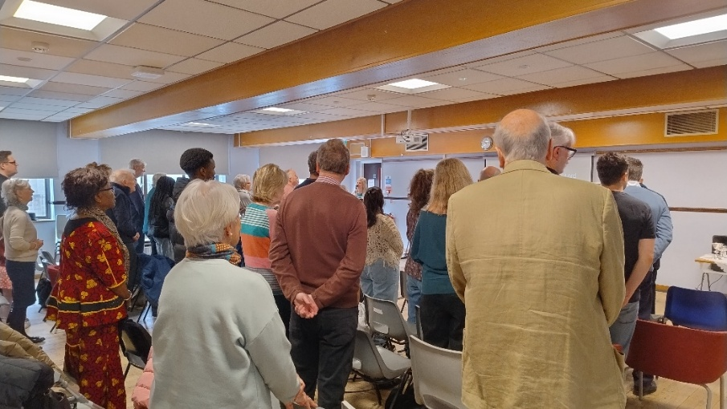

Our congregation recently completed a survey asking what they valued about St. Mary’s, joyfully the comments supported the view that St Mary’s offers a diverse, welcoming and caring community with a commitment to local mission.
Companionship, compassion and communion
All kinds of “ordinary” people meeting Jesus
Love and acceptance
Resilience... how we have carried on during the challenges

It brings us closer to God. I can’t live without church.
Great mutual support and prayer from my house group
Community and genuine love, a wonderful mish-mash of all kinds of people
It’s a family, and I want more people to come and feel part of it

The sense of belonging, love and friendship

What do you value about St Mary’s?
Church life and pattern of worship
Our usual pattern of church life has revolved around a communion service on Sunday mornings. Once a month we hold an all-age service, plus small groups and various midweek meetings. In the last 18 months, due to the absence of our incumbent through illness and bereavement, we have developed a different pattern so that we can utilise the support from our retired clergy and LLM volunteers.
During the work on our church building, Sunday services have continued in the local neighbourhood centre, Christmas carol services transferred to the streets (with an evangelistic focus), meetings have been held in homes, and the craft group moved to the common room in a local retirement housing complex. For special events and services, we have teamed up with like-minded churches in and around our parish.
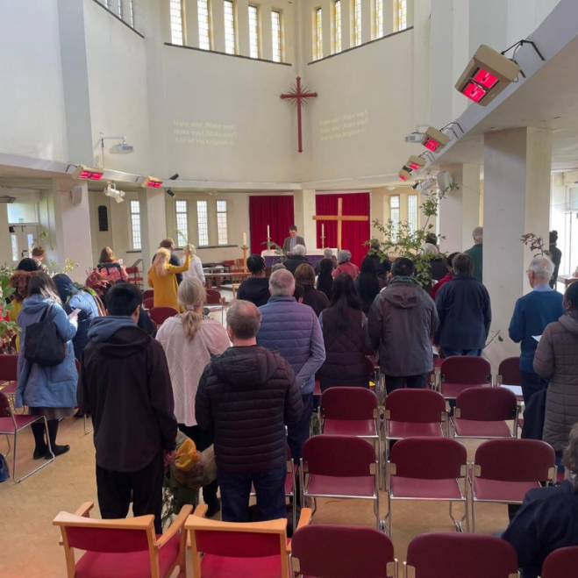  Sunday worship before… |  | 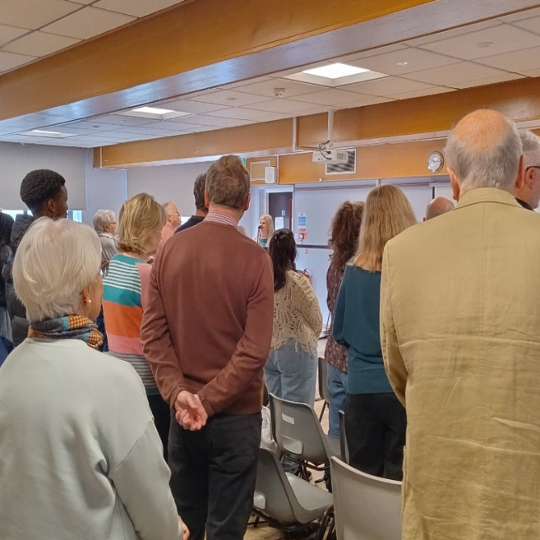  … and during our refurbishment
The congregation has ‘stepped-up’ to ensure the smooth operation of Sunday morning worship. This includes set-up, hospitality, welcome, prayer ministry, and service leading teams. This move towards ‘every member ministry’ has brought the church closer together during a period of uncertainty.
Pastoral care primarily occurs through our four small groups, meeting in Headington (2), Barton, and Sandhills. We continue to pray for the opportunity to begin a small group on the Barton Park estate.
Informal pastoral care also uses our numerous WhatsApp groups, particularly the Women’s and ‘Blokes’ groups, to identify need so we can provide support.
Our worship is led by a small music group in both traditional and contemporary genres, but we will also use our organ again once we are back in the church building. Led by a former music teacher, our enthusiastic choir is open to all. We also look forward to resuming our summer open-air services on the church lawn.
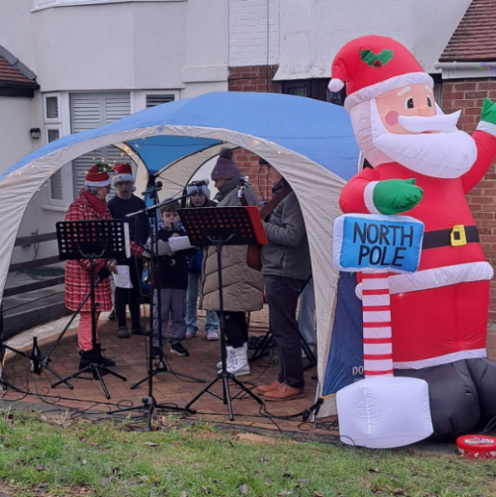
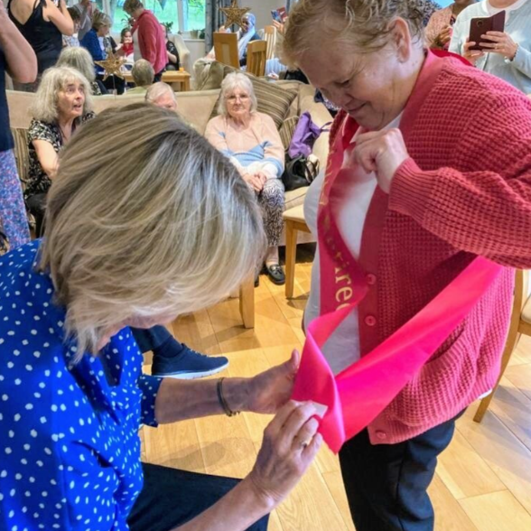
Regular corporate prayer happens in the small groups and a short prayer meeting before the Sunday morning service. We have also begun monthly united prayer with Barton Community Church (BCC), and occasional prayer walks. A number of people are part of prayer triplets.
A birthday in our Ladies’ group
Driveway Carols led by our Sandhills small group

Our Bring and Share lunches have encouraged a continued sense of community for members whilst the building is being refurbished.
As well as joint outreach including open air worship with BCC, we are building relationships with our neighbouring parish (Holy Trinity Headington Quarry) and the local United Reformed Church in Risinghurst, with a view to joint youth work.

Location and parish
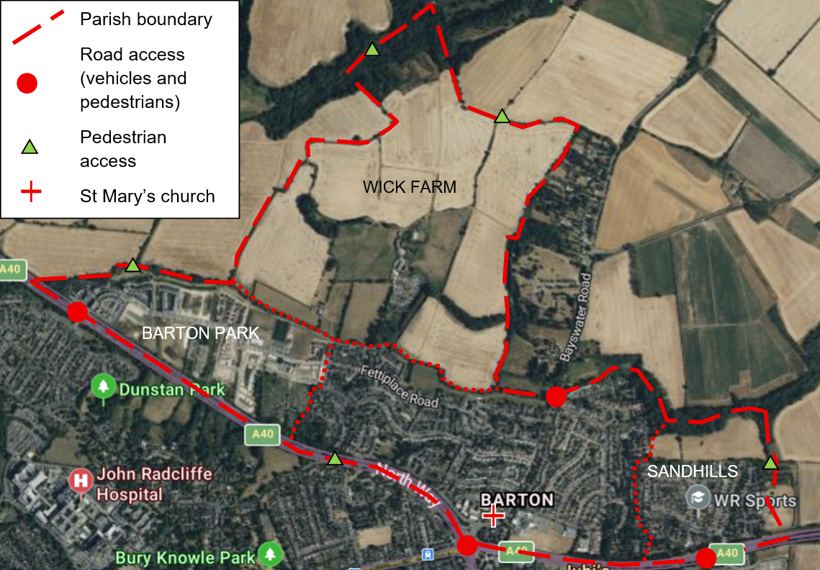

The parish encompasses Barton, Sandhills, and Barton Park, and will comprise around 9,000 residents once the Barton Park development is complete. These three areas are quite different, and each offers different opportunities and challenges to mission.
Barton is a former council estate of about 4,000 people, now a mix of social and private rented housing plus a few owner-occupied houses. There are also two static caravan parks on the edge of the estate. In stark contrast to Oxford as a whole, Barton includes neighbourhoods ranked among the 25% most deprived in England.
Barton Park is a new estate of about 900 homes under construction in the west of the parish. Sandhills, to the east, is a smaller estate of mostly private housing. To the north, beyond the Bayswater Brook, is agricultural land, where plans have been approved for a new development of another 1500 homes, of which about half will be in the parish.
The parish has direct bus services to the city centre, local hospitals and nearby towns as well as central London, Heathrow and Gatwick.
There are three primary schools in the parish (Bayards Hill, Sandhills and Barton Park). There is also a specialist school (Endeavour Academy) for children who would benefit from an autism specific environment. Older children attend secondary schools in surrounding areas – mostly Cheney School in Headington, The Swan School in Marston or Wheatley Park School. Other nearby educational institutions include Oxford Brookes University and several private schools.
Community amenities include the Barton Neighbourhood Centre and adjacent shops, the sports ground and pavilion at the entrance to Barton Park, and a leisure centre with swimming pool.
Major employment in the surrounding area includes the John Radcliffe (JR) and other hospitals, industries clustered around the BMW/Mini plant in Cowley, and various commercial and university employers in central Oxford.

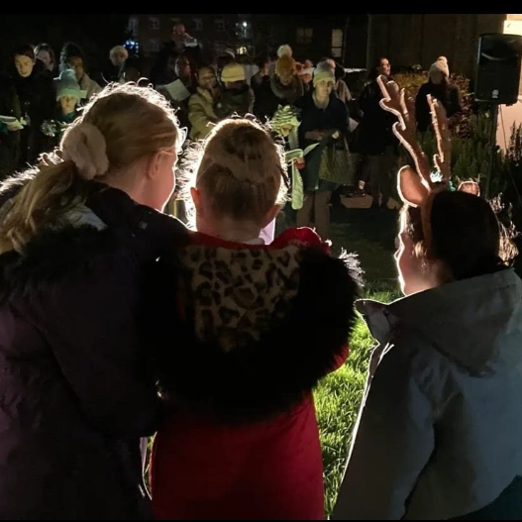
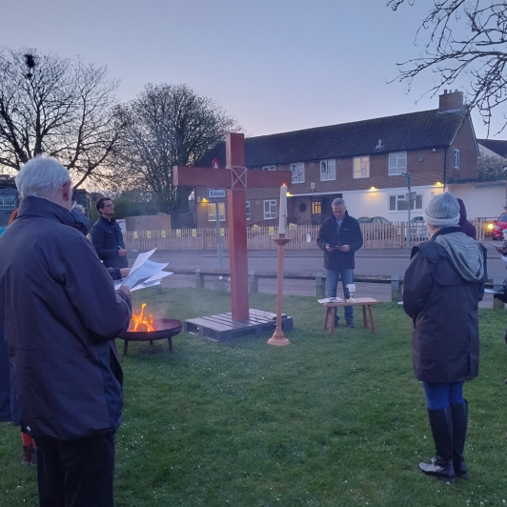
Our community
Easter sunrise service

Our Christmas tree lighting event

We are committed to playing an active part in the local community. This has included working with the local schools, serving as school governors, leading assemblies, organising class visits to the church and using the church for special services. Lighting up our Christmas tree each year has become a Barton tradition, involving all three primary schools plus the Oxfordshire Youth Brass Group. At Townsend House, the care home opposite the church, we offer a monthly Songs of Praise service for the residents, plus occasional special events.
We recruited a part-time Community Development Worker in 2019 until 2024, which enabled several initiatives to serve our neighbours. Over the last few years, we have developed several programmes in cooperation with social prescribers based at the local GP surgery, aiming to relieve social isolation. In Barton Park, we visit new occupants with a welcome pack as soon as possible after each block of housing is occupied. Over the last year, we have visited approximately 120 properties. We have also helped organise occasional social events.
We take part in local neighbourhood events, support Beautiful Barton with litter picks and bulb planting, and have hosted community exhibitions as part of the Oxford Art Weeks Festival. During the pandemic, we used a series of displays outside the church to encourage passers-by.

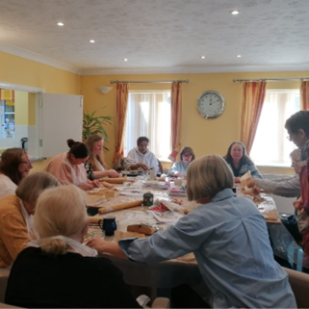
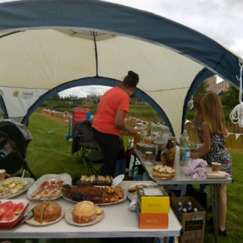
St Mary’s actively supports various international mission agencies through four dedicated gift months per year, including several agencies where church members or their relatives are working.
Meeting new residents of Barton Park
Craft group in action
A few of our community groups have been paused whilst the work on the Church Building takes place. We hope to revive our gardening group (Barton Growers), digital challenges drop-in sessions and potentially our toddler group which had been running since 2018. Whilst there has been disruption to some of our groups, we are happy to witness our craft group thrive and grow in its new home. The craft group has 10-15 members aged between 30s and 80s.
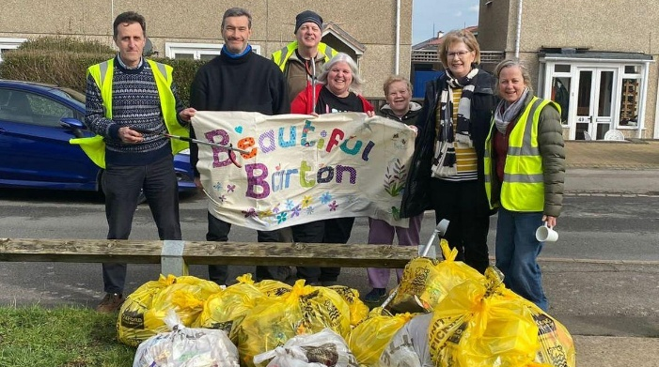

Beautiful Barton litterpicking

Early and recent history
The church of St Mary, Headington, designed by Nugent Cachemaille-Day, was consecrated in 1958, but services had been held in Barton and Sandhills since the 1930s in other buildings. In 2015, our building was home to a typical Sunday congregation of about 35 loyal but mostly ageing saints. The majority of these lived within the parish.
St Mary’s entered a diocesan-initiated partnership with St Aldates Church, Oxford, between 2015-2021. Under the community-focused leadership of our previous incumbent this resulted in leadership support, new outreach ministries, and steady growth for St Mary’s. New ministries to the community included setting up a toddler club, youth group, coffee drop-in, bereavement support group and school assemblies.
The last few years have been more challenging with a loss of leadership, not due to lack of commitment, but sadly through illness and bereavement. The support of retired clergy and dedicated lay volunteers has been invaluable during this time.
The accompanying emergence of ‘every member ministry’ is a significant development; it provides a foundation on which the new vicar can build. By distributing routine responsibilities throughout the congregation, the incumbent will have the opportunity, with the support of the church, to expand and extend St Mary’s ministry.
Whilst we have experienced recent challenges, we have also had reasons to celebrate. In May 2025 the project to refurbish our church building began. This project, known as Building to Serve, or B2S, has included the addition of a kitchen, an office and accessible toilets. The project has cost >£850k, as a church of around 60 members, we thank God for his provision. Phase one of B2S should be completed by June 2026 - we look forward to making full use of our improved building to serve our community. Phase two will explore an opportunity to add a church hall.

Buildings
There are three church buildings in the parish:
- the church
- the vicarage
- a house on Barton Park, owned by the diocese, where the previous curate lived

Church
The church building is prominent at the entrance to Barton from the main road network and is well-regarded within the community as “our” church. There is, and will continue to be, moveable seating to accommodate up to 100.
At the east end, there is a meeting room that was formerly a small chapel dedicated to King Charles the Martyr, with stained glass windows. The Church has a two-manual Nicholson pipe organ, which we are looking forward to returning to.
A large area laid to grass, with young trees and shrub borders surrounds the church.
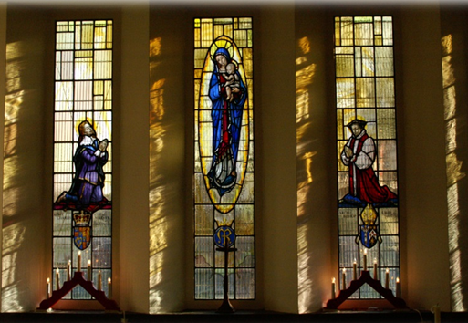
The last quinquennial inspection was carried out in 2024.

Building to Serve
As mentioned, St Mary’s building is undergoing long needed renovation so that it can be more readily available for our mission to the local community.
Building to Serve Part 1 is currently under way and almost fully funded. It addresses the defects in the building to make it weatherproof, improves accessibility, insulation and heating, and provides space for a new meeting room, kitchen and small office.
The improvements to accessibility, including an accessible toilet, will be great additions to the current sound system with induction loop facilities and disabled access available at the West and South doors.
We are in the early stages exploring a follow-on project (Building to Serve Part 2) working with the diocese, the City Council and a local housing association to build a new church hall on the site of the one demolished several years ago, having fallen into disrepair.
Several flats for social rent would be built on the same site, with the transfer of the land for the flats funding construction of the hall.
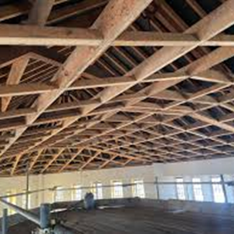
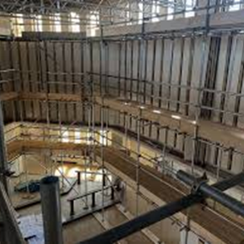
Roof repairs and ventilation system underway
Scaffolding in place to prepare for insulation, secondary glazing & re-wiring

Vicarage
The vicarage is a four-bedroom house with garage and large, enclosed garden** laid to lawn, with several fruit trees and shrubs. The vicarage occupies a position adjacent to the Church.
On the ground floor of the house, there is a large sitting room with French doors that open onto the back garden, a dining room, a second reception room (currently used as a study) and a kitchen. Off the kitchen is a utility room with doors leading into the garden. There is also a separate downstairs cloakroom with toilet.
On the first floor, there are four bedrooms, two of which are double, and a bathroom. The property benefits from solar panels, double glazing and central heating.
At the front of the property there is an enclosed garden with ample off-road parking.
(** Note as part of Building to Serve Phase 2 the farthest third (or so) of the rear garden may be fenced off to become part of the new church hall site.)
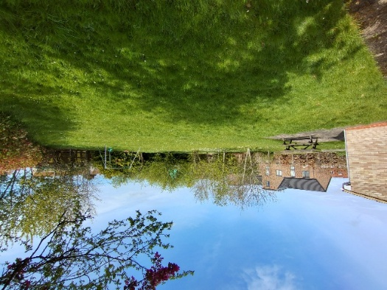
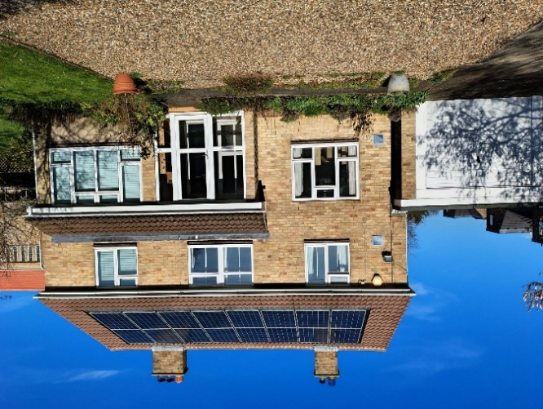
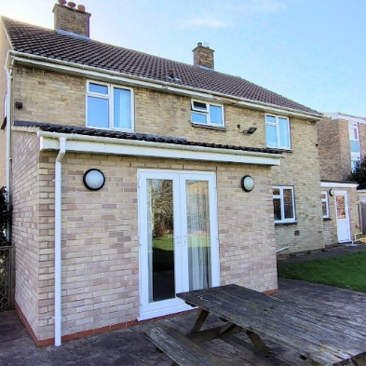

What we can offer you
St Mary’s is looking forward to our next chapter as we re-enter our much-beloved church building and welcome a new vicar.
We have been through a time of challenge and change but this has presented us with the opportunity to work together through these challenges with guidance from God. If you were to join us at St Mary’s, you would be supported by the same strong, welcoming team and offered a hand of friendship.
We are fortunate to have two retired clergy members who hold PTO, as well as numerous lay service leaders, worship leaders, bible teachers/preachers and children’s leaders - all of whom are ready to work with our new vicar to celebrate God, to share the message of the Gospel and encourage each member of the flock.
There are established arrangements in place assisting with admin tasks such as producing the weekly and monthly notices, along with support setting up for services. We are in a fortunate position where we are supported by two knowledgeable churchwardens, who have continued to uphold their duties during the vacancy period.
The new vicar can be confident in knowing through the creation of effective policies and procedures, including safeguarding, St Mary’s is determined to be a safe place for all. We also know the importance of competent financial management; our treasurer works hard to keep St Mary’s financial records up to date and transparent.
We expect and encourage the vicar to take proper holidays / time–off and time for reflection and refreshment of the spirit. We hope the vicarage can offer a comfortable space to rest and reflect, whether that be in the garden or one of the reception rooms.

Who are we looking for?
Personal qualities
- Secure in their own Christian faith with evidence of a deep prayer life and ability to draw on a wide range of spiritual resources
- Desire to bring people to faith in Jesus Christ and see the church grow
- Demonstrate empathy for those who are suffering and provide faith-based comfort and reassurance
- Use a range of strategies to support personal physical and mental wellbeing and resilience
- Be self-motivated and able to organise and prioritise tasks
Leadership and working collaboratively
- Build on existing small groups and leadership teams within the church
  - Seek fresh vision together for the next stage of our church life
  - Look for opportunities to work with other churches in prayer, mission and social outreach
Worship and preaching
  - Be able to engage through preaching with a broad range of listeners with varying outlooks, ages and understanding
  - Ensure all aspects of ministry are Bible-based
  - Encourage lively and engaging worship that respects the church’s liturgy and traditions
  - Ensure worship and preaching is grounded in real life and is intergenerational
Pastoral care
  - Review pastoral arrangements within the church
  - Recognise and support people who are vulnerable
  - Value the diversity in our congregation
  - Good listening and communication skills
  - Able to handle difficulties and conflict calmly, promoting reconciliation and collaboration
  - Recognise the high priority of good safeguarding practices and promote good safeguarding culture within church community
Mission and outreach
  - Encourage every member to witness with compassion in their daily environment
  - Re-engage with schools and other community groups
  - Extend our outreach and service to those in need in our local community
  - Develop estate ministry through links with community organisations
  - Motivating, inspiring, coordinating and collaborating effectively with volunteers
  - Engage proactively with local schools
Stewardship and benefice organisation
  - Work with the existing congregation and structures to facilitate church
  - Encourage personal giving and good financial management
  - Actively support a second building phase of a church hall on land adjacent to the church and vicarage

Appendix – further details

The congregation
There are currently 66 names on the Church electoral roll, of which approximately 50% live outside the parish. There is a regular Sunday congregation of approximately forty-five.
St Mary’s attracts a diverse, multi-cultural congregation. Members come from a wide variety of backgrounds and from many countries including Ghana, India, Jamaica, Nigeria, Pakistan, Uganda, Zambia and Hong Kong. The social mix includes a range of psychological, health and social care needs, and a wide range of occupations including academics and other professionals.
Following the departure of a couple of young families last year, 75% of the congregation are aged 50 or over, so outreach to families and young people is a priority over the coming years.

The church is blessed with gifted and experience individuals, including two retired Anglican clergy, a Baptist minister licensed by the Bishop to preach, a former free church minister, and several people with missionary experience.
Whilst out of the building, we have had no weddings or baptisms, four funerals for church members held at the local crematorium or other churches and two services of thanksgiving for children.

Finances
St Mary’s is registered with the Charity Commission. Our charity number is 1209987.
We are recognised as an Urban Priority Area and are not a wealthy parish. Many of our congregation and regular givers are pensioners. Most of our income from the congregation is given via standing orders with Gift Aid declarations in place. A regular annual income of approx. £75,000 usually arrives for general expenditure.
Although struggling at times, St Mary’s has made it a priority to pay its allocated parish share to the Cowley Deanery, even after it rose dramatically in 2024, from £17,000 to £32,561. Our parish share for 2026 is £32,806.
Regular mission giving is also important at St Mary’s. Financial support has been provided to various international, national and local charities.
A copy of the annual report, including audited accounts (2024), as presented at the last Annual Parochial Church Meeting (2025) and a draft balance sheet (2025) are available on our website.

Safeguarding
The parish is committed to promoting a safer church which shapes our culture and how we work together as a team. We are committed to total compliance with the Church of England’s Safeguarding Policy.
PCC members and other volunteers are aware of the safeguarding processes that need to be followed, particularly if anyone were to raise concerns. Our Parish Safeguarding Officer can be contacted at safeguardingstmarysbarton@gmail.com.

Communications
In a digital age, most regular communications are by a weekly newsletter and monthly magazine emailed to those who have given consent.
The church website St. Mary's Church Barton gives a flavour of the church and provides background details on policies, etc. However, more resources need to be devoted to keeping it up to date so that the opportunity it provides is fully exploited.
Informal communications also occur through various WhatsApp groups which are created and closed according to need.

