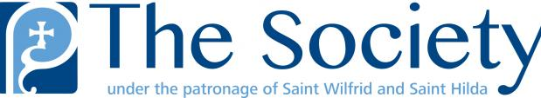
ST JAMES THE GREAT
PARISH CHURCH
Astbury St, Congleton, CW12 4EF
A Church in the Society of St. Wilfrid & St. Hilda
PARISH PROFILE
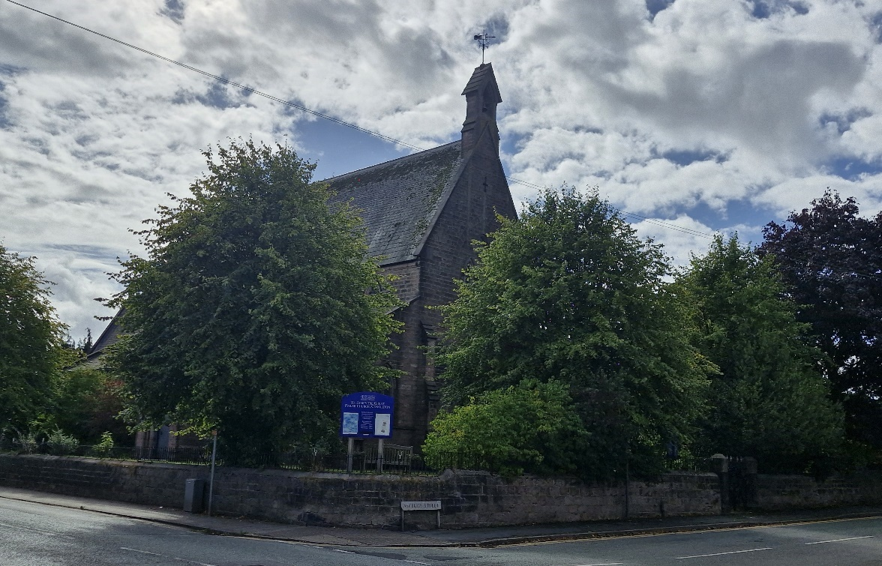
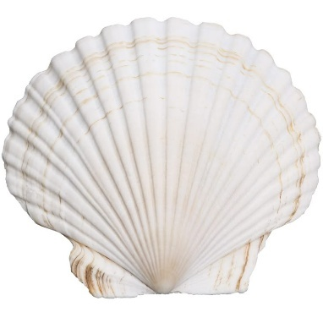
St James’s Church has a tradition of Anglo-Catholic worship which began 94 years ago.
The church is a member of the Society of St Wilfrid and St Hilda and is part of the See of Beverley.

Could you be our new Priest?

We are looking for a new incumbent who will work with the currently small, but dedicated, worshipping community at St James to build on the excellent work and leadership during the ministry exercised by Fr Jonathan during our vacancy. We have welcomed so many new faces into our beautiful building at reinvigorated services and events in the last 9 months, and slowly but surely this is bringing positive results. We have reconnected with local schools and would love to see this continue and bear fruit. We are eager to work alongside a new priest to continue this journey and rejoice with them in spreading God’s word and our fellowship to others. We are praying for…

- A priest with a genuine love for people and a desire to serve them, offering compassion, support and guidance. A good listener and wise counsellor with ability to connect to people of all ages and backgrounds.

- A priest who is committed to the Anglo-Catholic tradition and can effectively explain its concepts in an understandable way, making it inclusive and accessible.

- A priest who emphasises the centrality of the Mass as the source and foundation of all our work in Christ’s name.

- An approachable and relatable priest who can lead our community in deepening faith and grow the church by guiding us in spiritual growth and encouraging participation in all aspects of ministry.

- A priest who works collaboratively, discerning the gifts of others and empowering them to live out their faith in everyday life.

- A priest with a demonstrable commitment to fostering a strong and effective safeguarding culture.

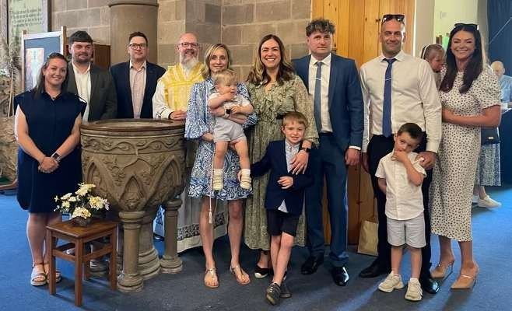
A recent christening at St James.

Welcome to St James Church Congleton
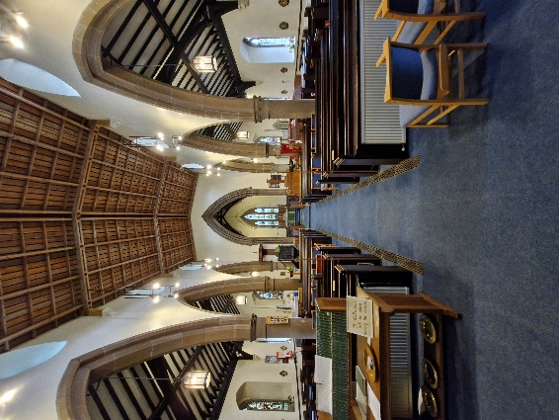
Built between 1847 and 1849 our church has a reputation locally for its warm welcome to visitors and congregation alike. Anglo-Catholicism was introduced to St James Church between 1925 and 1930 and is still practiced today. We are an ‘island church’, the only church within a radius of 15 miles that provides Anglo-Catholic worship.
Our urban/suburban parish of around 10,000 people covers the west side of Congleton including part of the town centre. We engage meaningfully with the local community through Churches Together in Congleton supporting community events including the ecumenical Good Friday Service, and Congleton Bible Week. We have also hosted concerts and communal services for Churches Together in Congleton. We have good relations with St Mary’s Roman Catholic church where some services are shared, and with two Anglo-Catholic churches in Crewe, namely St Michael’s and St Barnabas.
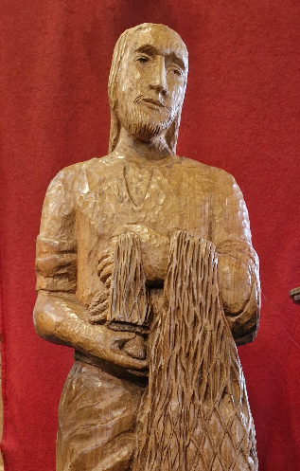
In 2008 we undertook a major re-ordering which improved accessibility by levelling the floors, opening up the back of the church, re-designing the kitchen area and providing a disabled toilet and improvements to the Church Room. We removed steps and installed a ramp at the church entrance, widened the aisles and removed some pews to enable those with mobility issues to be seated comfortably at the heart of the congregation, reflecting our ongoing commitment to inclusivity and shared worship. People often gather here with their coffee after the service and on the opposite side we have a dedicated child friendly area. The removal of the old organ pipes opened and lightened the nave and chancel and the introduction of a computerised organ console vastly improved the quality of sound in the church.
Our church building is well maintained and much loved, with our dedicated flower-arrangers adding to the beauty of the worship space. The wooden sculpture of St James the Fisherman, which was gifted to the church, reminds us of the saint to whom we are dedicated, and our calling to follow Jesus.

Current Service Times
Sunday
10:00 Sung Parish Mass

Wednesday
10:00 Said Parish Mass

Confession, Holy Baptism and Weddings:
by appointment.

Special services take place throughout the year.
A small example are;
In Lent, Exposition of the Blessed Sacrament & Stations of the Cross
The Patronal Festival of St. James.
At Harvest, a Thanksgiving Sung Mass.
Sung Masses for All Saints Day and All Souls Day.
At Christmas, a Crib Service and Carol Service with Benediction.

Eucharistic vestments are worn, and we use the New English Hymnal and Anglican Hymns Old and New for our sung worship. We have a small but dedicated robed choir and two regular organists.

Every Sunday morning after the Mass, we have tea, coffee and biscuits in the Church Room. It is an opportunity to meet friends, catch-up and to further welcome newcomers.
Our serving team is part of the Guild of Ss. Francis & Chad. We have regular Guild Services, throughout the year at, St. Michael, Coppenhall; St. Barnabas, Crewe;
St. Andrew, West Kirby; and of course St. James the Great, Congleton.
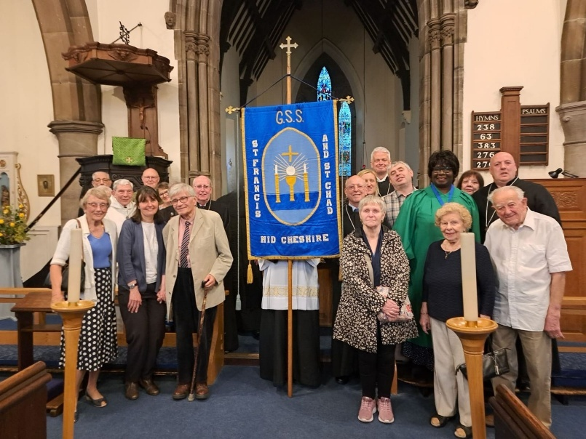
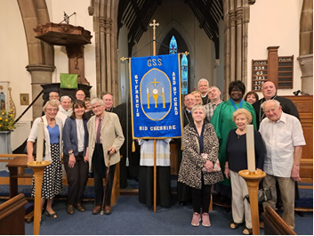

The town of Congleton and surrounding area
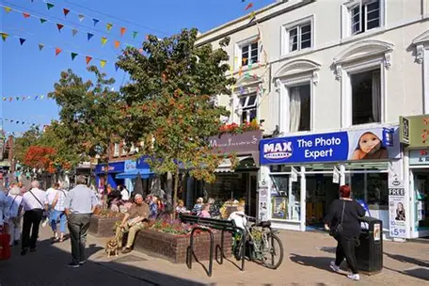
Congleton has been described in the national newspapers as being one of the best places to live in Britain. It is a delightful small market town consisting of approximately 30,000 people. Long ago it was a thriving silk manufacturing town and later a modern textile town. A few textile businesses remain, and Congleton businesses are a mixture of small hi-tech and engineering.
Congleton Town Centre
The town has a lot to offer with a beautiful park, its own museum and some splendid historic buildings. Our active Town Council encourages civic pride, with spectacular floral displays every summer and lots of events and activities. We are near to the renowned Clonter Opera Theatre and have an annual Jazz and Blues Festival in August.
A short walk or drive takes you quickly into the countryside. Situated in South Cheshire and close to the Peak District and the Shropshire border, it is a walker’s paradise.
If birdwatching is your thing, we’re close to Brereton Country Park and Astbury Mere, both great for bird and wildlife.
Congleton town is a very active community with its own theatre, and thriving branch of the University of the Third age (U3A) providing numerous activities. Congleton has two active Probus groups, a horticultural society and a history society. There is also an excellent Leisure Centre recently revamped.
We have two high schools and eleven primary schools with lots of groups for children.
For young people there are also numerous activities including, Scouts, Girl Guides, Army and Air Force Cadet groups.
The town is expanding, with extensive new housing estates being built to the west of the town, much of it family housing. We anticipate that new people bring with them new opportunities for mission and growth.
On the A34, and eight miles from the M6, Congleton is within easy reach of Manchester, Stockport and North Wales with its famous seaside resorts.

The Vicarage

2 Newby Court, West Heath, Congleton
We have recently replaced our old vicarage, and the Diocese has purchased a more modern property in West Heath, an attractive part of Congleton. A photograph of the property can be seen in the centre below. The new Vicarage is approximately a mile from the church.
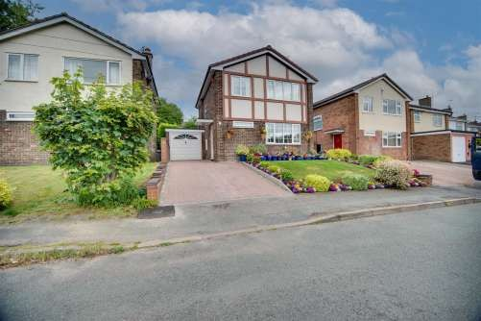

It is an attractive detached property with lovely front and rear gardens boasting a great degree of privacy. The driveway block paved and is fit for two or three cars. It leads to a very useful garage with both vehicle and pedestrian access.
The house comprises:
Two reception rooms plus study
Three well-proportioned bedrooms
Tasteful bathrooms and spacious breakfast kitchen
The house has the benefit of being in a quiet cul-de-sac and is a short stroll to excellent schools, shops and countryside.

Safeguarding
Parish Safeguarding Officer: Angela Balcombe

At St James’ Church we take Safeguarding seriously. It is the responsibility of everyone at church to keep vulnerable adults and children safe. We are undertaking to do all that is required to meet the diocesan guidelines.
I am available for people to get in touch with should there be any concerns. Alternatively, people are encouraged to contact the Diocesan Safeguarding Team directly. We display posters on the notice board and details of how to get in touch on our ‘A Church Near You’ website.
In 2024 the Diocese introduced a ‘Safeguarding Dashboard’ which is an online facility which allows parishes to check their progress and access information and guidance.
As a Parish we comply with different aspects of safeguarding, for example DBS checking, the adoption of appropriate policies, the completion of courses etc.
The dashboard shows how far we have come on our journey. We have almost completed Level 1, have made progress on Level 2 and have been invited to start on Level 3. There is always an element of ‘working towards’ but we are making good progress.
One happy consequence of starting our Dashboard journey is that our ‘A Church Near You’ presence has been refreshed under a new editor. This means that people can contact us and can see when our services are; and they have! It is a good alternative to a Church website which presently we are unable to create or maintain.
In the near future the church wardens will be completing their Safeguarding Leadership courses and I will be completing a ‘Safer recruitment’ course.
In conclusion, we are well on our way to fulfilling all that is required of us to ensure that St. James the Great at Congleton is a welcoming and safe environment for all. We are serious about our duties regarding safeguarding and wish to work with our new priest to continue the good work we have started.
Ultimately, we are putting into action our calling from Jesus to show care and compassion to everyone, and to love and protect them.
With the grace of God, we will.

Financial Statement and Accounts

Treasurer: Mark Thomas
2024 was a very challenging year for our finances caused by significantly increased energy costs and the previous year income (2023) being boosted by a generous legacy.
Our approach each year has been to set our Parish Share payment to match our surplus income over expenditure. For example, in 2023 having paid £21,000 (53% part payment) of the parish share we broke even.
In 2024 we continued with Parish Share payments at the same level £21,000 for the year, but as a result our expenses have exceeded income by £6,156. This ‘loss’ or reduction in our already depleted reserves is against a background of continuing to only approve essential expenditure.
An analysis of 2024 to 2023 reveals the following year on year variances:
Income: Giving -£614, Fetes etc -£563, One off legacy in 2023 -£5,000, Fees -£113, Gift Aid -£94, 100 Club -£205
Payments: Ministry -£243, Energy +£1,777, Insurance +£151, Repairs -£1,596, Upkeep Services -£206, Other+£246
To summarise the main components of the variance were a legacy (Tom Hulme RIP) of £5,000 in 2023 that helped us break even that year and then increased energy costs in 2024 of £1,777.
As a result our reserves at the end of 2024 were only 52% of the reserves at the end of 2023
Whilst not within the scope of this 2024 report, in early 2025 the PCC have discussed the situation with both the Diocesan Accountant and Bishop Stephen and confirmed a 2025 budget that prioritises restoring our reserves to an appropriate level.
Many dedicated members of our worshiping community continue to donate essential items for the ongoing upkeep of services, the building, its decoration and the hospitality provided after services. This generosity is not quantified in the accounts but nonetheless is a very real reduction to our actual running costs to help our difficult financial situation.

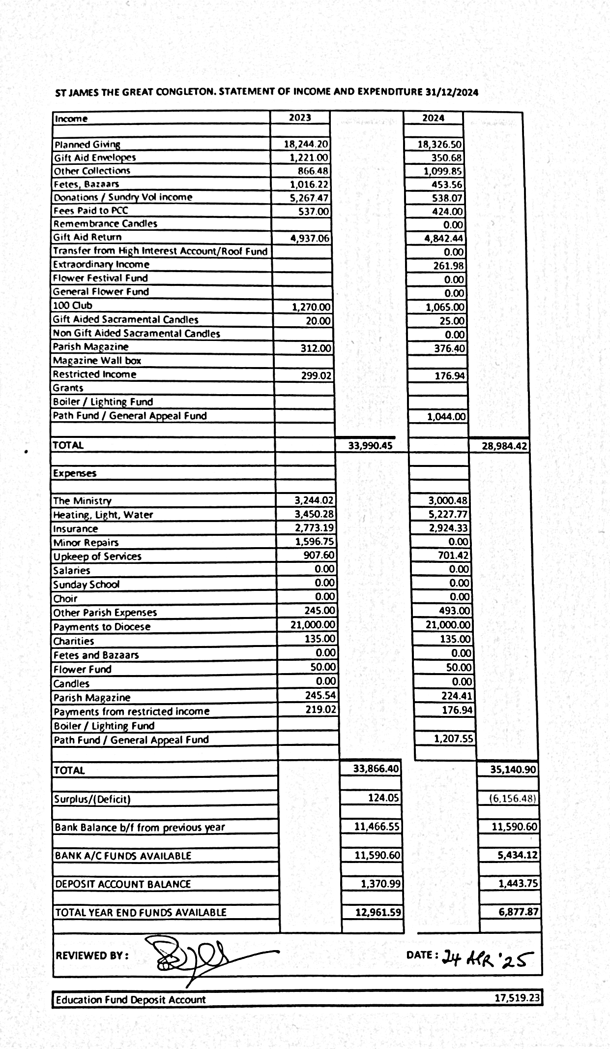

Our hopes and dreams
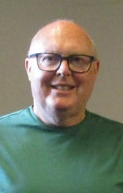
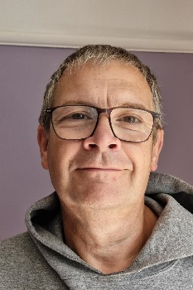
Churchwardens:
Patrick Andrew and Philip Balcolme

This profile is an honest assessment of where we are at present. Over the last 14 years, the congregation has become smaller. We are an ageing congregation with an average Sunday attendance of 25-35 and 45 on our electoral roll. However, following the departure of Fr. Colin Sanderson, we have been blessed with help from a curate based in Crewe, Fr, Jonathan Roberts, who has started to turn things round with a core of dedicated churchgoers. Through him we have experienced a richer liturgy throughout Holy Week and Easter, something we would like to see continued.
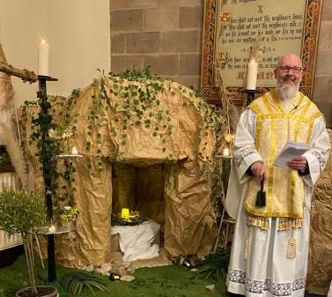
‘From the moment I arrived, I have been warmly welcomed into this loving church family. The kindness and hospitality I have received is a testament to the spirit of this community – a spirit that radiates through everything we do together’.
Fr Jonathan Roberts, Curate

Easter garden with a ‘life size’ tomb.

2024 was a very challenging year for our Finances and whilst we maintained the commitments made to the Diocese regarding our Parish Share, we depleted our reserves. In February 2025 a recovery plan was agreed with the diocese. We are now seeing an increase in regular giving and fees and as a result our half year results are ahead of budget. We need someone with a proven track record of effective church growth to encourage us. The re-invigoration of our stewardship and a plan for encouraging regular giving is an important priority.
We do not have the advantage of a church school but there are schools within the parish who are open to our involvement. We are encouraged by the resurgence of an interest in faith and spirituality among younger generations and would love to be a beacon of light, love and learning to them.

There is potential for further mission through the occasional offices, especially baptism. We recently had our first baptism for a considerable period and over 70 people attended the event including many children. Ideas on how to expand this ministry would be warmly welcomed.

We would like to investigate the possibility of having the church building open more often for visitors and to offer hospitality. We recently had an open coffee morning which was quite successful and as result, we now have some new people who are regularly attending the services.

We celebrated our Patronal Festival more widely this year, inviting local dignitaries to this service. We provided hospitality with a buffet and entertainment in the church room after the service. We had upwards of 100 people attend the service. This was a real morale boost and showed us that the church is still important to many local people.
‘You have all shown complete and unwavering commitment in everything we have done and accomplished so far. People have stepped out of their comfort zones and taken up new duties and roles enabling us to flourish as a worshipping community. Let us continue to be bold in our witness, creative in our outreach, and joyful in our worship. The foundations are strong, the Spirit is moving, and the opportunities before us are rich. Anything is possible with God and God is moving in this place!’
from the APCM Report 2025

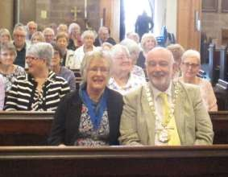

There are opportunities for involvement in social action in Congleton. St James has for many years supported the funding of East Cheshire Hospice and we support Westland Court; an organisation that houses homeless people. We have 3 residential and nursing homes in the parish and would like to see our pastoral care of older people expanded.
So, things now are looking much better, and we wish to build on this. We have hope in the future if we can find the right priest to lead us. We believe that the future is in God’s hands, and we pray for the vision to enable us to continue to offer a place of love, fellowship and faith in our corner of God’s Kingdom.

The Diocese of Chester offers excellent support. We are in the Archdeaconry of Macclesfield and the Deanery of Congleton. The strapline for the Diocesan mission is Together in Christ, Sharing Hope: Making a difference to the 1.5 million who don’t yet know Christ. We share this vision and want to make a difference where we are.
So, if you are up for a challenge, we are open to change. We are realistic but hopeful, certainly not perfect, but trying to be more like Christ. We have humour and hospitality and look forward to receiving your application.

