

Marketing & Communications Officer
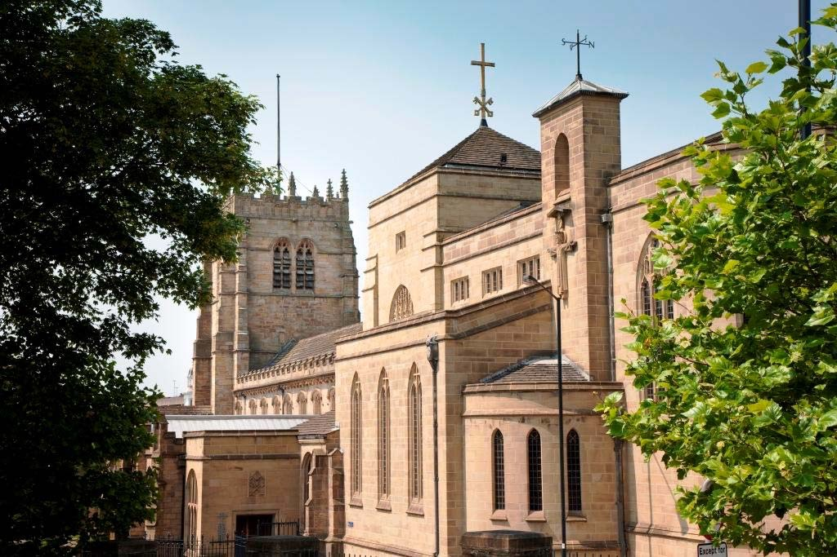



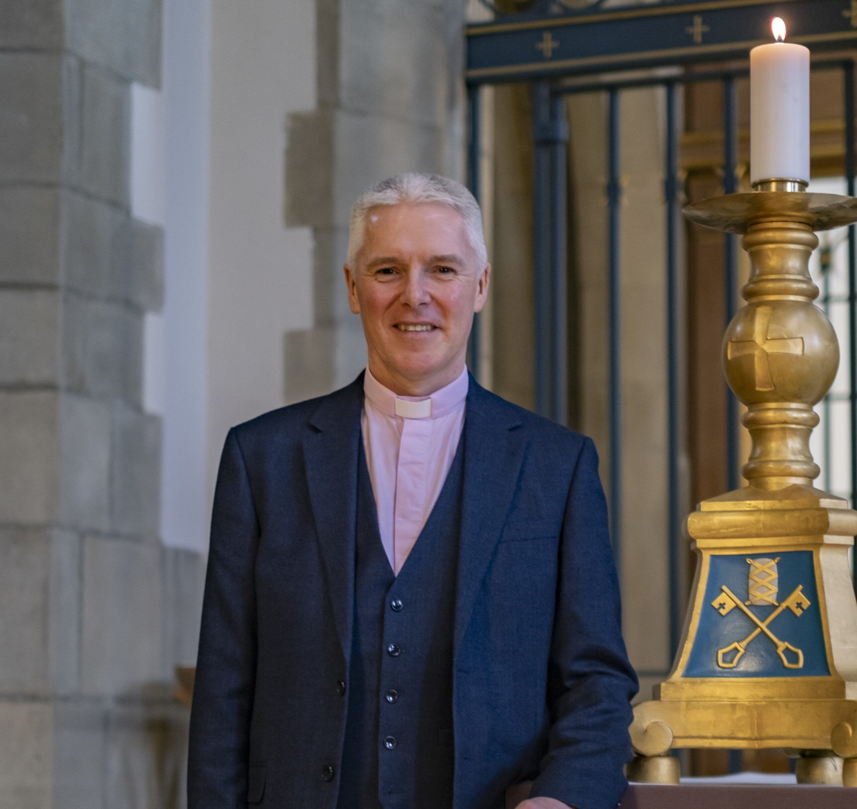
Dear Applicant,

Thank you for your interest in the role of Marketing & Communications Officer at Bradford Cathedral.

This is an exciting moment in the life of the Cathedral, and I am delighted that you are considering joining us.

Bradford Cathedral has stood at the heart of the city for over 1,400 years. We are a place of prayer and worship, but also a place of encounter, creativity, learning, heritage, music, and civic life. As Bradford continues to grow and change, so too do the opportunities before us as a Cathedral. We believe we have an important role to play in helping people discover hope, belonging, purpose, and community.

Our vision is:
"To weave Jesus into the rich fabric of the city and beyond, ensuring that all can discover who they were created to be and that no one is passed by."

This role sits at the centre of that work.

Whilst the accompanying Role Description outlines the key responsibilities of the post, we hope you will see this position as much more than a list of tasks. We are seeking someone who can help us tell our story well; someone who can recognise the richness and diversity of the Cathedral’s life and communicate it with clarity, imagination, and authenticity.

We are particularly keen to welcome someone who will bring fresh eyes, creative thinking, and a willingness to ask good questions. We do not expect applicants simply to fit into an established pattern. Rather, we are looking for a colleague who will help us discern new possibilities, strengthen our communications, deepen our engagement with the communities we serve, and help us share more effectively the impact of our ministry and mission.

This appointment comes at a particularly exciting moment. Bradford Cathedral is entering a season of opportunity and renewal, with work underway to review our strategy, strengthen our organisational culture, and ensure that our resources are aligned with our vision for the future. As a result, this role offers more than responsibility for delivering communications activity; it offers the opportunity to help shape how the Cathedral presents itself, engages with its communities, and tells its story in the years ahead. We hope to appoint someone who will bring insight, creativity, and wisdom to that journey, helping us communicate not only what we do, but why we do it.

Equally important is finding someone who understands who we are and who we are becoming. We hope to appoint a colleague who will flourish amongst us and whose gifts will help shape the next chapter of the Cathedral’s life. In return, we are committed to creating an environment in which people can grow, develop, and be encouraged to fulfil their potential.

Ultimately, we are seeking more than a skilled communications professional. We are looking for someone who will come to know and love this place, who will help us grow, and who will find themselves growing alongside us.

If, having read the information enclosed, you believe that your skills, experience, and aspirations align with this opportunity, I would be delighted to receive your application.

Thank you once again for your interest in Bradford Cathedral. I hope this pack gives you a sense not only of the role itself, but also of the possibilities that lie ahead.

With every good wish,

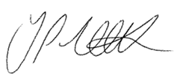

The Revd Canon Jonathan Triffitt
Dean of Bradford

About Bradford Cathedral
Bradford Cathedral stands at the heart of one of the most diverse and dynamic cities in the United Kingdom.

As one of the three cathedrals serving the Diocese of Leeds, alongside Ripon and Wakefield Cathedrals, Bradford Cathedral plays a distinctive role within the life of the Diocese and the wider region. Situated at the heart of a vibrant, multicultural city, the Cathedral serves both as the Cathedral Church for the Bradford Episcopal Area and as a parish church rooted within its local community.

We seek to be a place where worship, prayer, hospitality, learning and mission come together in ways that enable people to encounter God, discover belonging and participate in God's mission.
Our vision is:

"To weave Jesus into the rich fabric of the city and beyond, ensuring that all can discover who they were created to be and that no one is passed by."

Rooted in the Anglican tradition and shaped by the richness of Bradford's many cultures, communities and faith traditions, we seek to be a Cathedral that is prayerful, welcoming, imaginative and outward-looking.

Throughout the week, people gather for worship, prayer, education, music, cultural events, pastoral support and community life. We welcome visitors from across the city, region, nation and world, while remaining committed to serving those who call the Cathedral their spiritual home.

As Bradford celebrated its year as UK City of Culture, the Cathedral played a significant role in the cultural, civic and spiritual life of the city, welcoming more than 13,000 visitors from 47 countries, engaging thousands of children and young people through education programmes, and creating opportunities for encounter, reflection and community through worship, music, heritage and the arts.

Today, Bradford Cathedral is increasingly recognised as a place where people from diverse backgrounds can gather, explore faith, build relationships and contribute to the flourishing of the city and beyond

Role Overview
The Marketing & Communications Officer will lead and coordinate the Cathedral’s communications and marketing activity, helping to strengthen public engagement, support the Cathedral’s mission and ministry, and develop clear, confident, and consistent communications across digital, print, media, and public channels.

The role supports communications and audience engagement across the Cathedral’s worshipping life, music, heritage, education, visitor experience, and public events programme, helping to communicate the breadth of the Cathedral’s life to existing and new audiences.

Working collaboratively across clergy, music, operations, heritage, education, visitor experience, and events teams, the postholder will help ensure coherent and effective communications across the Cathedral’s life and ministry.

The role combines hands-on delivery with strategic development, helping the Cathedral prioritise and strengthen its communications activity during a significant period of growth, public engagement, and organisational development.

Key relationships

Reporting to

- Chief Operating Officer

Key Colleagues

- The Dean
- Canon for Intercultural Mission & the Arts
- Canon for Discipleship & Growth
- Commercial Manager
- Director of Education & Visitors
- Director of Music

Key lateral and other relationships
- External service providers, such as design & print suppliers
- Association of English Cathedrals
- Diocese of Leeds
- Media outlets
- Audiences
- Volunteers
- Cathedral Wardens

Key responsibilities

Communications & Storytelling
- Develop and coordinate the Cathedral’s communications across digital and print platforms.
- Create engaging and accessible content which communicates the Cathedral’s worship, mission, heritage, music, education, community engagement, and events.
- Identify and develop stories which strengthen public understanding of the Cathedral’s life, ministry, and impact.
- Support clergy and colleagues in communicating key initiatives, projects, and events clearly and effectively.
- Help ensure a consistent tone, identity, and visual presentation across communications.

Digital Communications
- Maintain and develop the Cathedral website and social media channels.
- Plan and schedule digital communications campaigns across relevant platforms.
- Create and curate content including graphics, photography, newsletters, and promotional materials.
- Coordinate regular email communications and audience updates.
- Monitor digital engagement and provide insight into audience growth and communications effectiveness.
- Ensure digital communications remain accessible, welcoming, and aligned with the Cathedral’s values and priorities.

Events Marketing & Public Engagement
- Lead marketing and communications support for the Cathedral’s worshipping life, events, concerts, exhibitions, heritage activities, visitor programme, and public events.
- Support the promotion and interpretation of the Cathedral’s heritage, learning, visitor, and community engagement activity.
- Coordinate event listings, promotional campaigns, ticketing communications, and publicity materials.
- Develop partnerships and external promotional opportunities with local and regional organisations, networks, and media outlets.
- Support audience growth and public engagement across a diverse range of audiences and communities.

Media & External Relations
- Draft press releases and coordinate media communications where appropriate.
- Build positive relationships with local media, cultural organisations, tourism partners, and community networks.
- Monitor public communications and media coverage relating to the Cathedral.
- Support the Cathedral in responding appropriately to communications opportunities and reputational matters.

Internal Coordination & Communications Support
- Coordinate communications calendars, workflows, and priorities across the Cathedral.
- Maintain marketing assets, image libraries, and brand resources.
- Support colleagues with communications advice and practical guidance.
- Assist with monitoring communications budgets and external suppliers.
- Contribute to the ongoing development and prioritisation of communications systems, processes, and platforms.
- Help evaluate the effectiveness and sustainability of communications activity, recommending improvements and appropriate priorities where needed.

Person Specification
REQUIREMENTS | ESSENTIAL (E)  DESIRABLE (D) | MEASURED BY:  A – Application form  I – Interview  D – Documents  R –References
Qualifications & Experience
Educated to A-Level standard or equivalent professional experience in communications, marketing, digital media, public engagement, or a related field. | E | D
Experience of working in a communications, marketing, public engagement, or digital communications role. | E | A/I
Experience of managing websites, social media platforms, and digital communications channels. | E | A/I
Experience of working collaboratively across teams and with a range of stakeholders. | E | A/I
Relevant qualifications in communications, marketing, media, public relations, digital communications, or a related discipline. | D | D
Experience of media relations and press communications. | D | A/I
Experience of promoting events, public programmes, or audience engagement activity. | D | A/I
Experience using design, photography, video editing, or email marketing software and platforms. | D | A/I
Knowledge
Understanding of effective communications and marketing principles across digital and print platforms. | E | A/I
Understanding of how clear and engaging communications support public engagement and organisational reputation. | E | A/I
Awareness of the importance of brand consistency, tone, and audience-focused communication. | E | A/I
Understanding of safeguarding responsibilities and commitment to maintaining safe and appropriate professional boundaries. | E | A/I
Understanding of the life and work of cathedrals, churches, or faith-based or other cultural organisations. | D | A/I
Understanding of accessibility and inclusive communications principles. | D | A/I
Awareness of reputational management and public communications within complex organisations. | D | A/I
Skills & Abilities
Excellent written and verbal communication skills. | E | I/R
Ability to produce engaging, accurate, and accessible content for a range of audiences. | E | A/I/R
Strong organisational and administrative skills. | E | A/R
Ability to work independently and use initiative appropriately. | E | AI/R
Ability to plan and coordinate communications activity across multiple projects and deadlines. | E | A/I
Competent IT and digital skills, including confidence using content management systems, social media platforms, and Microsoft Office applications. | E | A/I
Graphic design, photography, or video content creation skills. | D | A/I
Ability to analyse communications performance and audience engagement data. | D | A/I
Experience of coordinating external suppliers, print production, or advertising campaigns. | D | A/I
Behaviours & Personal Attributes
A collaborative and collegial approach to working with others with the ability to build positive working relationships. | E | I/R
Creative and proactive approach to communications and problem-solving. | E | I
Ability to exercise good judgement and handle sensitive matters appropriately. | E | I
Sympathy with the mission, ministry, and values of the Cathedral and the Church of England. | E | A/I
Commitment to safeguarding, equality, diversity, and inclusion. | E | A/I
Interest in the role of cathedrals within civic, cultural, and community life. | D | A/I
Enthusiasm for developing new approaches to audience engagement and public communication. | D | I

Terms and Conditions

Bradford Cathedral is committed to safeguarding and promoting the welfare of children and all vulnerable people. This commitment is shared by our staff and volunteers.
Reporting: The post holder will be line managed by the Chief Operating Officer but will also work closely with a range of colleagues, including both clergy and lay staff.
Place of work: The post is based at Bradford Cathedral.
Salary: The salary is £16,800 per annum (FTE £28,000) which will be paid by credit transfer on or around the 24th of each month.
Hours: The is a part-time post – 22.5 hours per week. The post holders standard work pattern will be Tuesday, Wednesday, Thursday – 9.00am to 5.00pm (with a half hour unpaid break). Due to the nature of this post, it may be necessary to occasionally work at weekends and in the evening.
Holidays: The holiday entitlement for an equivalent full-time post is 28 days plus bank holidays (a total of 36 days or 270 hours). This entitlement will be applied pro rata to this post meaning 162 hours would be available for the year.
Pension: The Cathedral participates in the Church Workers Pension Fund. The Cathedral will pay a 5% contribution to the pension scheme provided you pay a minimum of 3.5% of your salary into the scheme. You will be automatically enrolled unless you decide to opt out.
Notice period: One month.
Referees: Names and contact details of two referees will be required.

How to apply

Please apply through the advertisement listed on Church of England Pathways at:
https://www.cofepathways.org/members/modules/job/detail.php?record=10403

The deadline for applications is Sunday 19 July 2026. Interviews will take place on Wednesday 29 July 2026 at Bradford Cathedral.

