
Network Youth
Church Leader:
Solway Deanery, Cumbria

RECRUITMENT INFORMATION
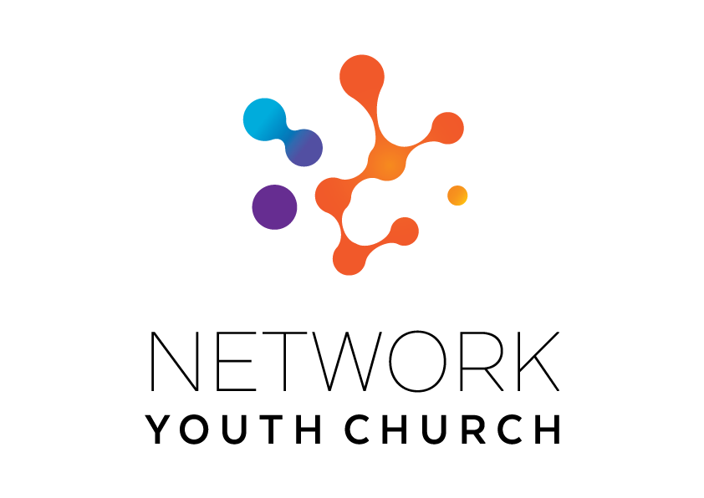

In this pack you will find:
Introduction to NYC
About Growing Younger in the Diocese of Carlisle
About the role
Information on the local area
Job Description and Person Specification
Key links for more information
Introduction to Network Youth Church
We are seeking to appoint new leaders for Network Youth Church. Network Youth Church is a new way of doing and being church with young people across Cumbria. As Cumbria operates as an ecumenical county NYC also operates ecumenically where possible and relates to the ecumenical mission communities in the deanery where it sits. We create spaces which are safe and welcoming, but don’t shy away from the big questions of life, working to encourage confidence, participation, understanding and growth. It is a part of the county-wide God for All and Growing Younger strategies, which recognise that we need to develop different and new ways of being church, alongside those that already exist. This means that our work is informed by the strengths of the local church, but everything we do is governed by what works best for our young people, and that may mean doing things differently.

We began in response to low numbers of young people engaging with church in Cumbria thirteen years ago and have since grown into one of the most creative faith-based youth projects in the UK. We take a pioneering and inclusive youth work approach to support the personal, social and spiritual development of young people across the county. NYC is inclusive and welcoming to all young people.
NYC runs everything from drop-in youth clubs to question spaces, cafe spaces to prayer spaces, schools work to street-based youth work, outdoor activities, days out residentials and summer camps. There are activities happening in halls, churches, cafés and classrooms. There are large scale events which happen once a year, gathering all the young people from across NYC Cumbria, and there are smaller, more local events where young people from different areas can meet. We also provide opportunities for young people to go on different events: both locally and nationally.

When the NYC is at full strength there are 11 NYC Leaders, each responsible for the development of ministry across a deanery. We employ different approaches in different areas depending on the context and geography and each NYC has a local Ministry Council to help set strategy, develop local connections and support the local NYC Leader.

NYC Leaders are employed by the diocese and local work expenses are covered by the deanery. A local line manger helps oversee the work in partnership with the Growing Younger Enabler for Youth who oversees the whole of NYC.

About Growing Younger and the Diocese of Carlisle

This is a significant, hope-filled but challenging time for the Church of England in Cumbria.

Alongside our ecumenical partners we have recently renewed our vision and strategy, God for All, as we look to the next decade.

The vision centres around four key values which frame our priorities:

1. Follow Daily:
We will help each other to follow Jesus more closely, seeking to grow as his disciples in all aspects of life, both corporately and as individuals
2. Care Deeply:
We will listen to our local communities and respond in loving service, seeking to transform injustice, challenge oppression and pursue peace & reconciliation.
3. Speak Boldly:
We will share our faith in Jesus Christ in everyday ways, seeking to connect with everyone, especially those currently unrepresented in our churches. We’ll do this in both time-honoured & pioneering ways.
4. Tread Gently:
We will strive to safeguard the integrity of God’s creation, seeking to sustain and renew the life of the earth.

These are the building blocks that help us define our core purpose as Church and our main tasks.

The Diocese of Carlisle covers (more or less) the County of Cumbria and is part of an ecumenical covenanted partnership with three other denominations - the United Reformed Church, the Methodist Church and The Salvation Army. The county is divided into 34 Mission Communities: local ecumenical groupings of parishes and other churches. Mission Communities bring together churches in a geographical location to share ministry and work together in mission and outreach.

One of our strategic areas is Growing Younger. As in so many places, our congregations are generally getting older and smaller. In the ten years from 2010 to 2019, numbers worshipping on Sunday in the diocese fell by 27% from 13,100 to 9,500. This decline has happened across all sizes of churches. Church attendance and membership in our less affluent, urban areas is particularly low.

Over the last 13 years the diocese has invested in Network Youth Church (NYC) as a response to the challenges we are facing. NYC is a way of doing and being church that helps young people discover life in all its fullness, explore the Christian faith, and develop the skills they need to live, learn, work, and interact successfully with others. Last year, almost 2000 young people interacted with NYC, with around 800 engaging regularly in Christian discipleship.

We also have a strategic objective of growing younger in our leadership. Currently just under half of our clergy could potentially retire in the next 10 years, and only 9.4% of our ordained leaders are aged under 40. In 2022, the diocese relaunched its Intern Scheme, the Northern Young Leaders Project. This scheme is part of the Ministry Experience Scheme for the Church of England. We also partner with the Norwegian Mission Society to accept interns from across the globe. Working in placement churches, this year long scheme offers opportunities for young people to grow in leadership and explore their calling to ministry. This year, we have re-launched our Young Leaders training programme, the Youth Labyrinth. We are currently recruiting for the 2027 intake for both of these exciting projects.

About the Solway Area

Solway Deanery has had many years of successful ministry through Network Youth Church and now is an exciting time as we seek to see this develop further across the Deanery, especially in our local churches and Mission Communities. Currently we have three mission communities – Workington, Criffel View and Solway Plain. There are also a growing number of Network Youth Church ‘cell groups’ within the Deanery, in addition to the work that we do with children in Year 6 and above in some of our local schools.
The Deanery has historically covered a large geographical area, stretching from Distington as its southernmost point to Bowness on Solway in the north. To the west it covers the coastline of the Solway Firth and to the east reaches the edges of the western lake district at Caldbeck and the boundary of the Solway Deanery in the Cockermouth area. It is predominantly a rural deanery with numerous small village communities, together with the larger more urbanised towns of Workington, Maryport and Wigton. In Spring 2026, it is planned that the Solway Deanery will split into the two smaller deaneries of Workington and Solway. The new NYC Leader will work across both deaneries.
The great diversity of the deanery is one of its greatest challenges but also one of its greatest strengths. From farming to football, retail to rugby, and fishing to factories, it can all be found in the Solway Deanery.
Family is also of great importance in this area of Cumbria, especially our young people, as it is across the whole of the Diocese of Carlisle, with sons and daughters often staying close to home and starting their own families.
Solway Deanery is fully committed to supporting the diocesan ‘Growing Younger’ and seeing our Network Youth Church thrive and go from strength to strength.

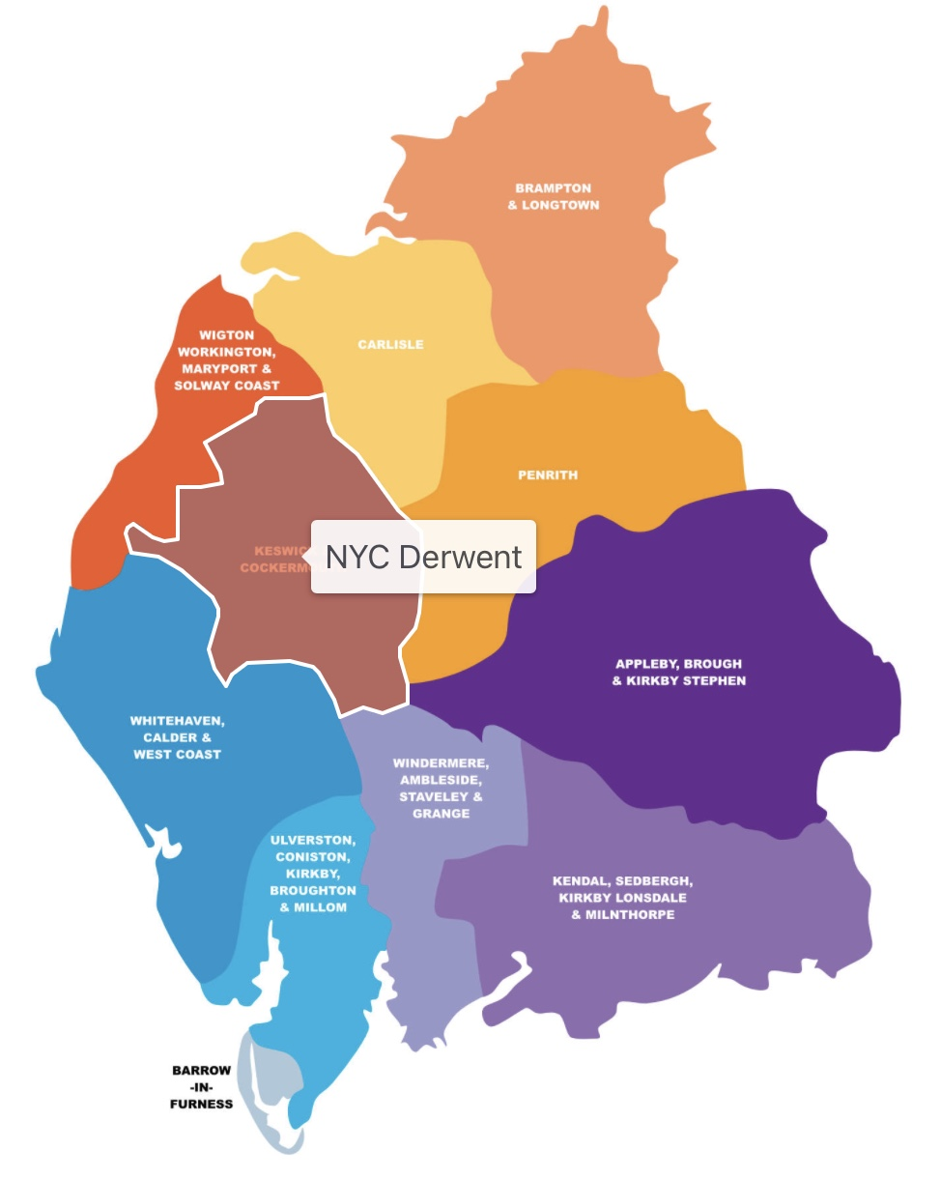
Solway NYC

Solway NYC Activity

Solway Network Youth Church is a vibrant suite of faith-based projects stretching across the deanery. It has been skilfully and lovingly developed and established over the last 13 years, and we are now seeking a new leader who is called to minister to our young people, bringing hope and pointing them to Jesus.

We are looking for someone with the skills to support and resource our committed team of volunteers and inspire and develop our young leaders.

Solway Network Youth Church is made up of many different groups and projects including cell groups, after school clubs, residentials, and a thriving Student Leadership Program, focused on Christian leadership. Currently, there are cell groups in Silloth and Wigton, a fun-filled after school club at Maryport Primary and a student leadership program, run in partnership with the King’s Church, Cockermouth.

Network Youth Church Solway works with local churches across the deanery to support teams of young worship leaders in our schools and deliver interactive prayer spaces that hundreds of children enjoy visiting every year. There are also important opportunities for young people to go deeper with their faith through a fortnightly gathering where they can ask the big questions of life, worship, pray and study the Bible together. The worship is often led by the young people themselves.

Twice a year, the members of Solway NYC are invited to enjoy a weekend away together at the Knock residential centre. This is a time of great celebration and fun as they learn about what it means to be a disciple of Jesus. There is also an annual deanery gathering called Ablaze and last year, this included inflatables, samba drumming, football, crafts, hair wrapping, nerf wars, burgers and circus skills in addition to the opportunity to take some time out to reflect, be quiet, or pray in the God Tent.

In recent years, it has become tradition to end the summer with an overnight camp in the Archdeacon’s garden. This has been a time to celebrate the year that has past and look forward to all that the new academic year holds.

As a Network Youth Church, Solway is one of eleven NYCs throughout Carlisle Diocese. Together, they collaborate on county-wide projects throughout the year including, The Big One and the Advent Calendar project. The Big One is a day-long, fun-filled event hosted by NYC Leaders and attended by several hundred young people from all over Cumbria. It is an opportunity for young people to come together and be encouraged that they are not alone in their faith. Through the Advent Calendar project, NYC Leaders make and give away hundreds of bespoke Advent Calendars to share the real meaning of Christmas with our young people.

We are not looking for a traditional church-based youth worker, but rather a mature Christian leader, with a passion for discipling young people. And the leadership skills needed to nurture and equip our committed team of volunteers for their vital roles in Solway NYC. This is a unique role that requires someone who can pick up this incredible collection of projects and precious individuals, empowering them to thrive as they grow together and build God’s kingdom in this beautiful corner of Cumbria.


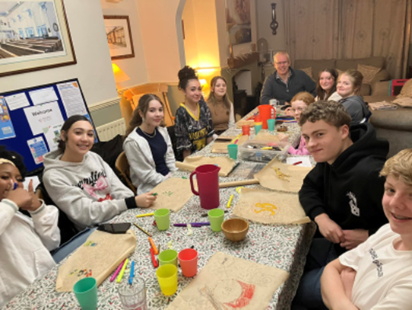

Job Description
JOB TITLE: Solway Network Youth Church Leader
REPORTS TO: Local Line Manager and Growing Younger Enabler for Youth
DEPARTMENT: Solway Deanery (this includes communities of: Wigton, Aspatria, Silloth, Maryport, Workington and the surrounding rural areas).
PURPOSE OF ROLE:

- To grow, develop and lead a Network Youth Church in the local deanery/deaneries, for young people aged 11-18.

- To create opportunities for young people to explore and experience the Christian faith whilst growing and developing personally, socially, spiritually and emotionally.

- To develop a strategy for outreach work with ecumenical partners and schools, in line with the Growing Younger strategy and wider God for All strategy.

- To establish new and exciting, relevant forms of church that are brave and creative whilst being sensitive to time honoured church and in-line with the wider God for All strategy.
KEY ACCOUNTABILITIES:
- To develop the growth of youth church across the deanery/deaneries, using the NYC / New Worshipping Communities model as appropriate with particular attention to the key areas where secondary schools are located.

- To develop a strategy for engagement with young people outside of church contexts which will include a bespoke approach across the area.

- To provide and develop an environment/context in which young people can explore Christianity and be nurtured in the Christian faith.

- Work with churches and existing youth work projects across the deanery/deaneries, to equip, resource and model, high quality Christian youth ministry as God leads.
- To provide pastoral and safeguarding oversight of the young people including use of social media.
- To pray for the young people of Cumbria, particularly those in the local deanery/deaneries.

- To develop the talents and spiritual gifts of young people and volunteers, supporting them to grow their leadership skills and service among the NYC as we partner with churches and charities to train and grow NYC and young, Christian leaders.

- To identify, develop and equip volunteers for leadership roles within the Network Youth Church and to enable young people to participate in the Youth Labyrinth.
- To be an advocate and educator about youth culture, youth church and youth mission with local clergy, church members, church leaders and the wider community.
- To meet at regular intervals (once a term) with the local NYC Ministry Council and the wider NYC team.
- To work collaboratively with NYC Leaders, clergy, ecumenical partners, and others involved in youth ministry across the deanery/deaneries.
- To work with the Ministry Council in the development and delivery of the growing younger strategy, including supporting young people’s faith development across the key transition points. E.g. between Year 6/7 and post 18.

- To develop age compliant and appropriate social media profiles with effective safeguarding at the centre.

- Facilitate opportunities for young people to participate in both local and national events and residentials (e.g. The Big One and Dreaming the Impossible).

- To promote the work of the Network Youth Church to Christians in the Deanery, reporting on its work to each Deanery Synod.

- To be part of the Deanery Chapter/s as a church leader in the Deanery, and to attend other ecumenical meetings if appropriate.

NETWORK (Key people with whom the role liaises)
INTERNAL: Children and Families Workers and other Lay Leaders, local Clergy, NYC Leaders, Diocesan Safeguarding Team, Archdeacons, Diocesan Ministry, Mission and Innovation Team, Programme Office, other employees.
EXTERNAL: Volunteers, Secondary schools in the area, various appropriate external organisations and statutory bodies, and where appropriate local councillors.

Person Specification

Experience
- An occupational requirement exists for the post holder to be a practising Christian in accordance with the Equality Act 2010.
- A proven track record in work with young people principally of secondary school age.
- Experience of contextual youth mission and outreach.
- Experience in leading groups that nurture and disciple young people in the Christian faith.
- Able to demonstrate experience in growing young, Christian leaders.
- Recruiting and training volunteers.

Knowledge
- Ability to demonstrate an understanding of the world of young people aged 11-18.
- Hold a recognised qualification in youth work or other related qualification or have relevant experience working with young people.
- Be aware of issues affecting young people living in rural communities & market towns
- Have knowledge and experience of contextual youth ministry and outreach and pioneering youth ministry.
- Able to demonstrate a knowledge of safeguarding/health & safety requirements when working with under 18s, young leaders, vulnerable young people and volunteers.

Skills and Aptitude
- Able to build and maintain respectful, child-centred relationships with children and young people.
- Able to effectively communicate with children, young people and families in ways which value them.
- Have a proactive commitment to mission embodied in a pioneering spirit.
- Demonstrable resilience which is supported by effective spiritual and wellbeing practices.
- Able to build and lead a team of volunteers.
- Be willing to work collaboratively with others involved in youth ministry.
- Be willing to work with the clergy and ecumenical partners and attend Chapter meetings.
- Be willing to work ecumenically with fellow Christians and other youth agencies.
- Computer literate.
- Able to write and deliver reports to Deanery Synod, Circuit and Mission Communities on the work as appropriate.
- Able to plan a course of action and develop a ministry with support from others.
- Be open to ongoing professional training.
- Be able to work with young people from a diverse range of backgrounds and identities across a diverse geographical area.

Other
- Be a committed member of a local church, in addition to worshipping at Network Youth Church.
- A willingness to work flexible hours to fulfil the requirements of the role, includes evenings & weekends.
- The post-holder will be required to complete enhanced DBS checks.
- Awareness of Health and Safety and Safeguarding procedures and practice.
- Holds full UK driving license and has access to own transport.
- Due to the geography of the area and relational nature of the post ideally the candidate would be willing to live within the local deanery/deaneries.

Desirable Criteria

Experience
- Experience of involvement with secondary schools.
- Experience of detached youth work.

Terms and Conditions

Salary: £31,795 FTE

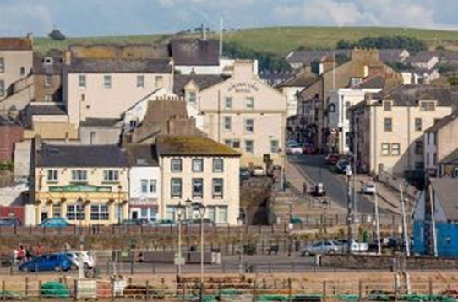
Pension: Church of England Pensions Board Church Workers non-contributory, defined contributions scheme (employer’s contribution is 15% of salary).

Car: mileage paid at 45ppm.

Office provision: TBC.

Equipment: A laptop and smartphone with remote access to email is provided.

Working expenses: fully funded through the deanery.

Other benefits: 34 days annual leave including public holidays.

Hours: 35 hrs per week with a flexi-time and TOIL system in operation. There will be a requirement to work outside normal office hours for some of the time.

This post is subject to an occupational requirement that the post holder be a practicing Christian under Part 1 of Schedule 9 of the Equality Act 2010.

Useful Links and Further Information:
Diocese of Carlisle: https://www.carlislediocese.org.uk/
God for All General: www.godforall.org.uk
Network Youth Church: https://www.networkyouthchurch.org.uk/
Northern Young Leaders Project: https://nylp.co.uk/

