

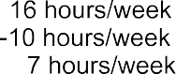



3 February 2026











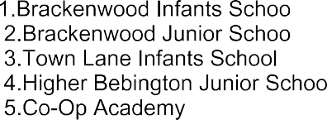



YES
YES



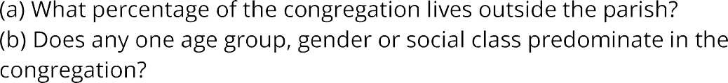






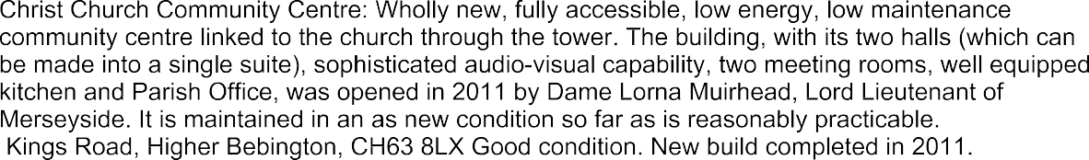





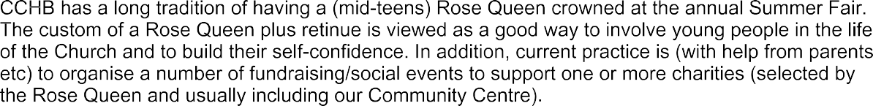














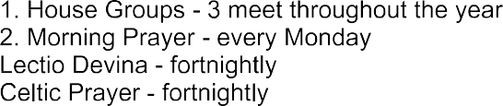





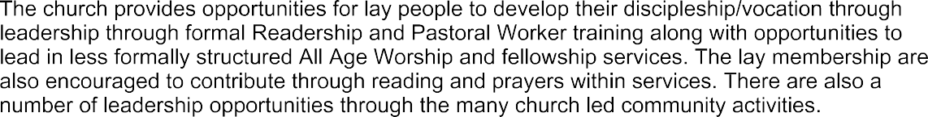






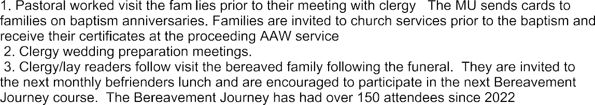
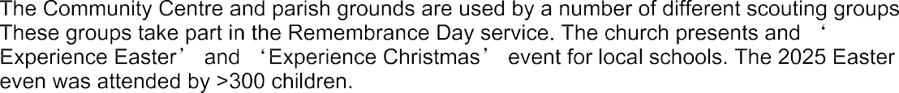

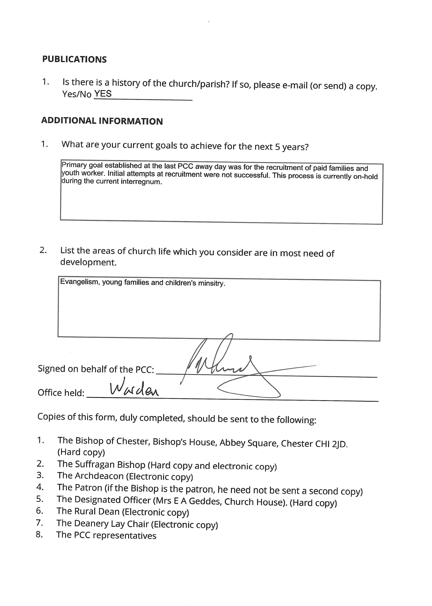

Christ Church Higher Bebington – Fact Sheet Appendix A

Appendix A Church Services Ǫuestion 2

Service | Sunday  08:30 10:00 |  | 11:45 | 16:00 | 18:30 | Wednesday  10:00
Holy Communion (BCP1) | Every  Week
Holy Communion (CW1) |  | 1st, 3rd  and 5th |  |  |  | Every Week
Short Holy Communion  following All Age Worship (CW1) |  |  | 4th
All Age Worship |  | 2nd
Service of the Word often  with baptism |  | 4th
Praise and Play (informal  service for families) |  |  |  | 1st
Sung Evensong (BCP) |  |  |  |  | 2nd
Fellowship Service (Lay  led informal service to a set theme) |  |  |  |  | 4th

Notes:
1. BCP = Book of Common Prayer CW= Common Worship

Christ Church Higher Bebington – Fact Sheet Appendix B

Appendix B
Church Education and Social Provision

Ǫuestion 2 (a) – What provision is made by the church for teaching (a) children
- The church ministry team have a good relationship with all the schools in the parish and attend the schools on a regular basis.
- Children and families team meet monthly to review activities and has recently introduced half-termly Saturday Family Fun afternoons.
- All the schools in the parish use the service for a variety of events including school services for the main festival event at Easter, Christmas, harvest. The church also hosts the children from the local schools for immersive ‘Experience Easter’ and Experience Christmas’ events. The easter 2025 event had >300 children attending.
- Other church led children teaching activities, include:
  - Praise and Play – monthly
  - Lego church – monthly
  - Sunday Club – monthly
  - All Age Worship - monthly

Ǫuestion 3 (c) List church organisations with approximate numbers for: (c) adults:
The church provides a range of community activities through its Community Centre in addition to its commercial activities, including:

Group | Numbers
Baby Group | 10-12
Befriender’s Group | 15-20
Carer’s Group | 20-25
Gardening Gang | 6-8
Indoor Bowls | 8-10
Knit and natter | 30-35
Luncheon Club | 24
Men in Sheds | 10-12
Mother’s Union | 18-20
Oasis (mental health group) | 5-7
Sewing group | 8-10
Singing café | 25-30
Toddler group | 25-30

Christ Church Higher Bebington – Fact Sheet Appendix C

Appendix C
Outreach and Mission

Ǫuestion 2 Give details of the support for home missions and charities.
Christ Church Higher Bebington has ongoing relationships with a range of home missions and charities. CCHB supports the Birkenhead-based Wirral Churches ARK Project (funding accommodation, community projects, healthcare and activities to help tackle homelessness) and the Wirral Foodbank (providing emergency food to local people in crisis) through a combination of grant funding and supply of goods. Direct financial support has been given to Ferry Families (supporting families in nearby New Ferry - an area of significant multiple deprivation).

Members of the congregation are encouraged to offer furniture and other household items to BESOM Wirral which supplies such items to people in need. Our Rose Ǫueen each year chooses a local charity to support through her fundraising efforts. In recent years, these have included the Charles Thompson Mission (providing care and support, food and clothes, to those across Wirral who are living in poverty), FORUM Housing (supporting young people with housing needs) and Hayfield School which focuses on children with special needs.

Nearer to home, the Vicar and Churchwardens are the trustees of the Thomas Robinson Charity which was set up to support "the poor and needy of Higher Bebington". Grants of cash are made available to individuals or families needing special help.

Led by our Vicar, Revd Michael Loach, CCHB has developed links with the mosque in Birkenhead to build a positive relationship with another faith group.
A summary detailing the various community/charitable causes supported is detailed in table 1.

Christ Church Higher Bebington – Fact Sheet Appendix C

Group
Ark (homeless)
Besom (furniture collection/distribution)
Charles Thompson Mission (Homeless, poverty).
Christ Church Rose Ǫueen (fund raising activities of
the year)
Contact/relationship with local mosque
Ferry Families (family support)
Forum (youth housing)
Thomas Robinson Foundation (church foundation –
offering grants for special needs of the poor in the parish) Trustees are the Vicar and Churchwardens)
Wirral Food Bank (social)
Table 1

