Parish
Profile
St. Mary’s Church, Wallasey May 2025

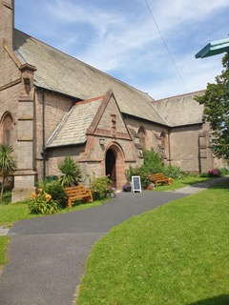

St Mary’s Church is a beautiful historic building in the heart of Liscard. Recorded as a designated Grade 2 listed building, the church has served this part of Wallasey since 1877.
Welcome to St Mary’s!
We are a warm, vibrant, and welcoming church. Our doors are open to everyone regardless of where you come from or where you are on your spiritual journey.
At St. Mary’s we believe in embracing the faith of our community. Whether rich or poor, happy or sad you have a place in our hearts. We welcome singles, couples, families, and those who may feel alone. We celebrate the uniqueness of each person and extend our love and support to all.
If you are a newcomer, a lifelong believer, or someone exploring faith for the first time, you will find a welcoming community here. Our services are rooted in the rich traditions of the Anglican Church, with a modern contemporary style which would be considered low church, yet we strive to make everyone feel at home, regardless of their background or beliefs.
Our church is dedicated to embodying the principles of the Chester Diocese, striving to be "Together in Christ, Sharing Hope." We aim to help bless each individual among the 17 thousand people in our parish community, focusing on one life at a time. Our mission encourages us to grow in faith that is fuller and braver, to practice loving service that transforms lives, and to engage meaningfully with our local community through strong partnerships.

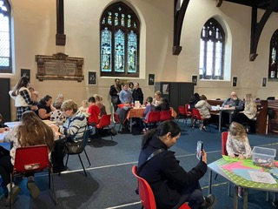
St. Mary’s is a place where you can be yourself, find new friends, and grow in your faith. We invite you to join us for worship, fellowship, and service to our community. Come and experience the warmth and love of our parish family.

The Church – buildings and resources
The foundation stone was laid in January 1876 and building work was completed by 1878.The Bell Tower was added in 1882, and bells were added in 1887. Our Church does need roof repairs in several places to stop the ingress of dampness. Repairs to the surrounding mosaic tiles on the High Altar are also required.
Overall, the Church is in a reasonable state with significant improvements made to the kitchen/meeting area.in recent years. Consideration will need to be given in future years to improve disabled access for mobility scooters and wheelchairs.
New seating for the congregation will be installed and improvements to our sound system will be required, once the necessary faculties have been obtained.
We have a beautiful garden surrounding the Church Building which is enjoyed by Church members and appreciated by community. A small team from Church maintain the garden and anyone willing.
Music and arts feature at St Marys, we have 3 accomplished Organists, and Bell Ringers regularly appear to ring our 8 Bells. Our services use contemporary worship songs, and we embrace concerts by our music school featuring cello and violin to a high level.
We are a Church totally integrated and involved with our community and have grown slowly and steadily.

The Church – Activities - Our Events at St Mary’s
Worship/Prayer/The Word
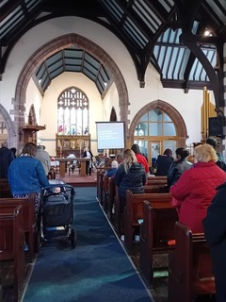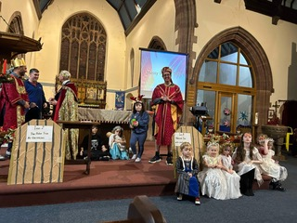
Sunday Morning Holy Communion 10.30 am
Monday Morning Prayer
Wednesday Celtic Morning Prayer - 10.30 am

Weekly Activities
- Monday --Gardening for the Soul. With Light Lunch
We have a large garden that needs tending, we adopt an eco -friendly approach and children come from the local school to help us along with their teachers as part of the curriculum. We have people that also come to engage with the garden as their time permits. We encourage the local community to be involved.
Monday Eve – Our New Home group for those new to the faith.
- Tuesday - Bumps and Babies 0-3 Tuesday Morning. This is a new Baby Group aimed at expectant Mums and new Mums in a relaxing environment to find new friends and friendships.
- Wednesday …Celtic Prayer & Warm Space at the ‘Round the Back Café.’ With food This is formerly our Crafty Café which is now part of the Places of Welcome, and everyone is welcome to the Wednesday Hub, prayer, food or craft,
- Lego school coming soon
- Friday Pastoral and Admin /Music practice and clean God’s House
- Saturday Music School Partnership with Charity Early Music as Education
Children who would not normally have music lessons are provided through this charity the ability to learn cello or violin. They link with two schools in our Parish and then with us as we work in partnership with them.

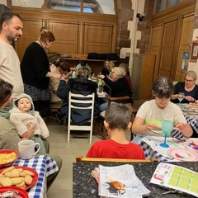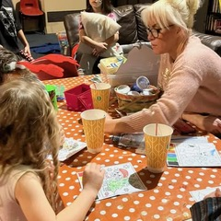
Messy Church we have 20 families attached to Messy church, and a lovely faithful core that also move across Church in different events. They are Church in themselves.
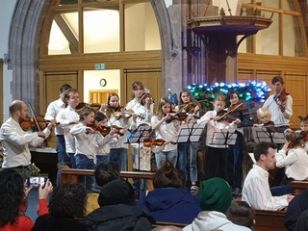
Saturday Music School

Monthly Activities
- Monthly Contemporary Worship “Revive” with life Testimonies /short talk. Evening
- Monthly Prayer Meeting
- Monthly Messy Church
- Monthly Ladies Lunch
- Monthly Breakfast Club
- Monthly service at Leighton Court
- Quarterly Bereavement Fellowship

Community Homes
- Regular Engagement with Gerard Corr Residential Independent Living
- Regular Engagement with Leighton Court
- Sandstones Care Home we make visits.
- Links with Wirral Age Concern and Care Homes for Harvest and Bereavement Journey, Christmas and all Church Festivals\

Good School Links
Schools
- Regular Involvement and good relationship with Egremont Primary (state school) regular visits /involvement throughout the year. Rev Chris is their Chaplain.
- Good relationship and involvement throughout the year with Liscard Primary (state school) Services and History; Garden groups, whole school Christingles.
- Christmas carol services with both schools
- Lessons and assemblies, Remembrance Day: Harvest Festival and have the school choir in at Festival times.
Regular Community events
- Delivery of Food to school-referenced families
- Burger in Bounce…regular throughout August each year, with huge numbers attending. 2023 we had 780 through the gate, (over 4 weeks) 2024 a bit better with 465, (over 3 weeks) it is very popular as a free day out for families, we are supported by TLT and Brakes charities and all so from Beresford’s Butchers for our Burgers
- Harvest Festival is linked with Generosity Week and Thankfulness each year
- Harvest Sunday service
- Messy Church Harvest
- Leighton Court Care Home Harvest
- Pancakes and Plonk
- Agape Meal

- Discipleship Courses: Discipleship and Prayer are integral to the foundation of our church.

- Discipleship Explored
- Hope Explored/ Youth Alpha
- Flipped by Malcolm Duncan
- Lectio 365 Lent course
- Advent courses
- Bereavement Journey every 6 months
- The Wellbeing Course by Hope UK

Our Current Leadership
Associate Vicar ...with day-to-day responsibility for St Mary’s. Rev Christine Turner
Church Wardens John Turner and Ken Eaves
Assistant Church Wardens Chris Jones and Mr Jalal Hoseyni
Treasurer Rev Chris establishing MY Funding
Parish Administrator / PCC Secretary Jeremy Maynard
Safeguarding Officer Jeremy Maynard
Bereavement Journey Rev Chris, Jan Mahner, Ken Eaves
PCC: Members Abbey McCann: John Turner; Arianne Denness; Ken Eaves, Jeremy Maynard; Barbara Bonshor; Chris Jone

Occasional services

Baptisms
Baptisms 12 in 2024 and still regular though each month, serving our community and further.

Weddings
Weddings are around 2 and this is an area of development.

Funerals
Usually, we have done 2 a year. However, in 2025 we had done 8 before May which was a big increase , especially in an area where we have competition from quick cremations and Celebrants.

Our Average Attendance Stats
Weekly Sunday services are not representative of all who consider themselves connected, due to child or work commitments. Many more are involved in the week, serving in some capacity, or engaging in some way. This is about 35.
In 2024. Sunday Children 5. And adults 28 for our records

Special services/Evenings
For the size of our church, people engagement wit0 events are good.
Christingles in Advent are always numerically 550/600 and start the Christmas connection with school who have their whole school events with us. Christmas is very big for us with Carol concerts and music concerts bringing in many people over. Last Christmas we had about 1000 people though our doors, with a high evangelistic effort on all parts.
Our Harvest Festival is now community wide with Messy Church and Care Homes and Age Concern joining with Harvest Festival as we take food and hampers to those alone.
Our Burger and Bounce is about 650 over the 3 weeks and is very popular with community far and wide and some have engaged with other services / events within church. we have the Longest Night and our Remembrance Day which is sometimes linked with Civic events .
We also have musical concerts and events. This area has been a new direction that is fruitful.

WE SEEK AN INCUMBENT/VICAR WHO:
- Enjoys leading different styles of worship and relates well to all age groups.

- Provides confident leadership to all three churches, to enable growth in numbers and faith.

- Who will continue to foster the healthy Safeguarding focus, that has been developed at St Mary’s by Rev Chris, who is at present Leader Recruiter over St Mary’s, St Paul’s and St Lukes.

- Who will continue to encourage the ethos of an Everyday Faith that is part of the missional direction at our Church.

- Will be a good pastoral vicar who is responsive to the needs of all three churches and their communities.

- Is a motivating and inspiring leader who is forward-thinking and proactive and is also sympathetic to each church’s history and the makeup of the current congregations.

- We are looking for a compassionate and dynamic leader to guide our parish through a time of renewal and growth and can inspire and deepen our faith through thoughtful preaching, meaningful worship, and pastoral care.

