++++

The Diocese of Manchester

PARISH INFORMATION AND PROFILE for:

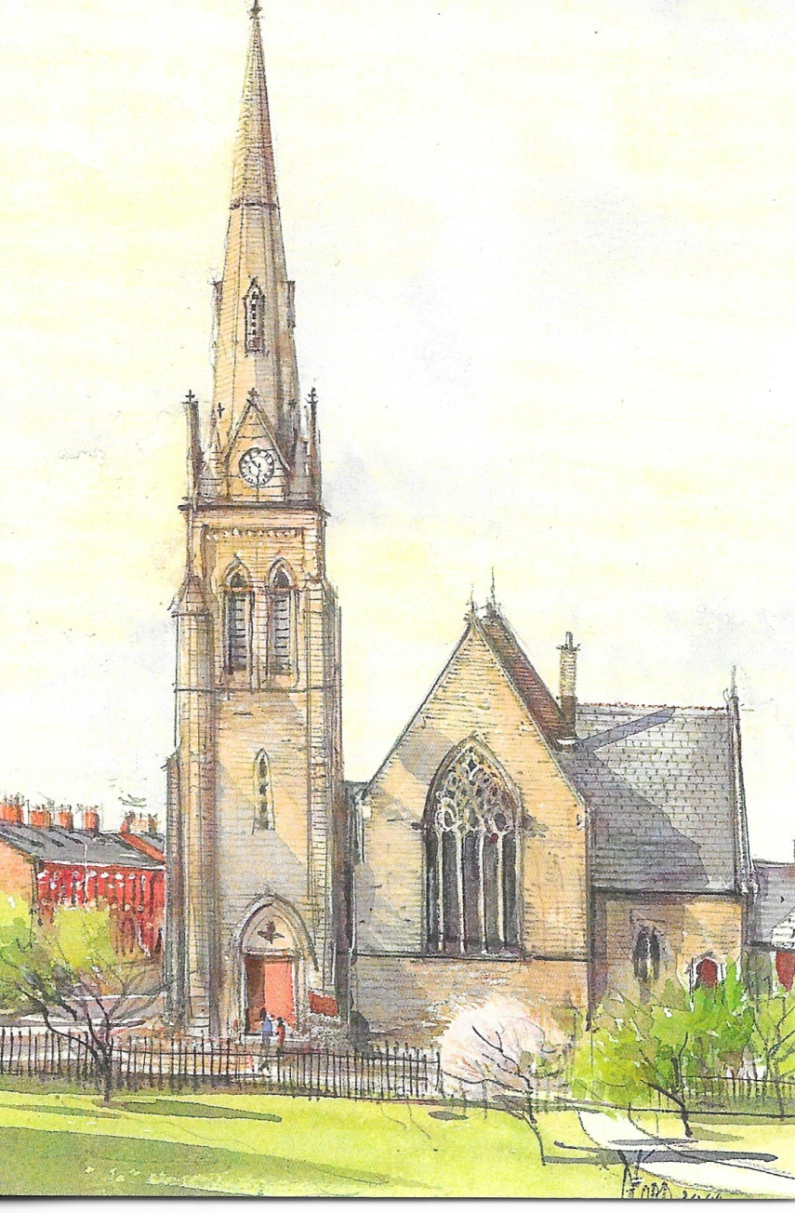

ST MARK with CHRIST CHURCH, Glodwick,Oldham

(united benefice of St Mark and St James)

INTRODUCTION

The parish of St Mark’s carries the spiritual legacy of Oldham’s cotton mill boom era and its temporal legacy of industrial housing and present day ethnic diversity and deprivation. Linked with the former Christ Church it carries Christian mission into the future with an unusable church hall and a church building in a process of long-term restoration and re-ordering in a united benefice.

The last incumbent implemented many programmes for spiritual study, community and site regeneration. He had a vision and a method which nature
(a collapsed hall roof) and financial restraints elsewhere did their best to frustrate. Under his cure St Mark’s developed a strong mission ethos and community identity.

We aim to continue that ethos and vision under the spiritual leadership of a dedicated priest. St Mark’s church and spire stand in an elevated position as a local landmark. With the right incumbent its team spirit could be one too.

BASIC INFORMATION AND STATISTICS

  - Full name of parish

St Mark with Christ Church, Glodwick, Oldham

  - Title of the post that is vacant

Incumbent Vicar

  - Name and address of patron

Bishop of Manchester

Archdeacon of Rochdale The Ven. Cherry Vann
57 Melling Road,
Oldham
OL4 1PN
archrochdale@manchester.anglican.org
0161 678 1454

Area Dean, Oldham East Rev. Lyn Woodall
St John the Baptist, Hey
1 Owen Fold
Oldham
OL4 3DT

2.4 Official clergy housing:

The Vicarage will be the one situated in St James’ parish. Please see their profile for further details.

  - Official population

14,600 (2011 Census) 15,186 (2015 estimate)

  - Number on electoral roll 58

  - Average Weekly Attendance for the last 3 years 43

  - Average Weekly Attendance of children and young people under 16 5

  - In the last twelve months, numbers (if applicable) of:

a. those baptized 5

b. those admitted to holy communion before confirmation 0

c. those confirmed 4

d. marriages 2

e. funerals 14

f. Christmas communicants (all services) 43

g. Easter communicants (all services) 55

  - Anglican churches and licensed places of worship in the benefice or parish(es) profiled here

a. Name of principal church

St Mark with Christ Church

b. Approximate key dates for the building

1875-6 Construction and Dedication

c. Approximate seating capacity

450

- Last Quinquennial inspection

Last Quinquennial inspection was 2017. Copy available.

- Name of any attached or nearby hall or other similar facility

St Mark’s House and Parish Hall

f. details of other Anglican churches or licensed places of worship in the
benefice or parish(es) profiled here

St James (united benefice) who have compiled their own
Profile

  - Details of publicity that the parish produces e.g. newsletter, magazine

Sunday pew sheet, Monthly magazine (St Mark’s Parish News)- 65 copies

  - Address of website and other social media

Facebook Page – St Mark’s Glodwick. Website under re-construction.

Names of churchwardens

Mrs Susan Taylor
8 Spring Clough Drive,
Oldham
OL8 2XA

Mr Michael Higgins,
12 Alandale Drive,
Royton,
Oldham,
OL2 5TU

  - Representatives

Derek Swallow, Emeritus Reader and Susan Taylor, Churchwarden, were elected as representatives at the PCC meeting of 9 Sept 2018. Michael Higgins, Churchwarden was elected as reserve representative.

PRIESTS (ORDINATION OF WOMEN) MEASURE 1993
HOUSE OF BISHOPS DECLARATION ON THE MINISTRY OF BISHOPS AND PRIESTS 2014

PCC unanimously agreed to continue under the House of Bishop’s
Resolution at a meeting held 30 July 2018.

LOCAL COMMUNITY

Glodwick is best described as a working class area. While there is a small West Indian community, over Sixty per cent of the social make-up now is Muslim, of mainly Pakistani origin, who live in close proximity to the church. Only 20% are ‘white British’. There are no large entertainment or public venues in the parish, other than church or mosque. There is a growing population of asylum seekers and migrants from Eastern Europe.
The Parish’s IMD score is 52.4314 placing it among the 10% most deprived areas of the country. Part of the parish falls within the most deprived 5%.
The population has been rising since 2001, mainly from Muslim families and east European immigrants. There is a good balance of age ranges, though 33% are between the 30-59 age group. 62% are Muslim Asian, 28% white.
Ongoing issues are Old housing stock (cotton mill era terraced), low skills, unemployment, cultural constraints
There is a mix of late 19th century ‘mill-town’ brick terraced housing, early 20th century and modern housing estates, with modern detached housing on former farmland. There are older mill owner and managers’ houses, many of which have been converted into care homes.
We engage the local community through the Parish Shop, Food Bank, Allotment, Christmas Fair, Church social events Summer Outing, Magazine, Website and Facebook.
Industry has declined in the parish. Small scale workshops and business operate in surviving mill buildings and older premises. There is a health centre on Glodwick Road and a major council depot. A Royal Mail delivery office is situated on Hamilton Street. The council Parks & Recreation Department has its HQ in Alexandra park and has a good relationship with our allotment. There is a parade of shops on Abbey Hills Road, Glodwick Road and Waterloo Street. The main shopping area is the centre of Oldham which has large stores, a market and cinema.
Over the last few years we have introduced an annual ‘Beating the Bounds’ walk as an opportunity for parishioners to get to know the community and the extent of our mission.
Two large amenities are situated in the parish: Glodwick Lows, a hill, part quarried, part tree and heath, turned into a geological and nature park; and the award-winning newly refurbished Alexandra Park with extensive walkways, boating lake and cafe.
While the bulk of Glodwick can be described as ‘Urban’, the eastern fringes are semi rural and border the Medlock Valley.

SCHOOLS AND VOLUNTARY GROUPS

The following schools lie within the parish.
Alexandra Park Junior School
Alt Primary School
Horton Mill Primary School
Glodwick Infant School
Greenhill Primary School
Roundthorn Primary School (on boundary -relationship with St Mark’s)
We maintain good to poor relations with these schools. Four schools are primary Muslim but church visits by schools are common as are requests for school assemblies.

Various community groups used the hall before it became unsafe to use. At present the parish shop is situated in St Mark’s House (9 volunteers) and our allotment is nearby with a potential for schools and community groups to use. It will have its own committee and community volunteers.

WORSHIP AND WORSHIPPERS

Sunday Parish Mass is held at 09:30 AM. Weekday Masses before the interregnum were held on Monday, Wednesday and Saturday at 10:00 AM. A half hour ‘quiet time’ at 09:30 was held on Saturday before the Blessed Sacrament. This has been reduced to Wednesday morning only during the interregnum
Common Worship and the Missal are used.
Chasuble is the normal vesture for ministers with a cope for processions.
The majority of the congregation are over 60, most over 40 with mix of younger children but overall incoming profile is better than most Anglican churches, with several young families and people. Asylum seekers come and go. The congregation is predominantly female.

20 worshippers live outside the parish boundary

The style of worship is Modern Catholic. The Blessed Sacrament is reserved. Throughout the year there are study groups.

CHURCH-BASED ORGANIZATIONS AND GROUPS

We have a ‘residual’ choir and bell ringing team but numbers have fallen and the ringers currently are redundant. There is a peel of 8 bells. Before the interregnum we had an intermittent Sunday School but the teacher has now left the parish. There is a parish visiting team. There is a parish allotment project overseen by a development worker in partnership with outside investment bodies and volunteers. The Parish shop is run by church and community volunteers. Study groups meet regularly throughout the year.
Choir practice used to be every Friday but we now lack an organist. The shop opens weekdays depending on availability of volunteers. Study groups meet on a regular basis most weeks of the year. Coffee mornings and Cheese and wine evenings are held.
We have 3 choir ladies, 2 ringers, 2 ALM visiting team, 9 shop volunteers.
Compared with former times the social life of the church is limited to Sunday tea and coffee after Mass, annual coach trip, and fund raising events. There is also the ‘social’ dimension of the Parish Shop and allotment, Christmas fair Cheese and Wine gatherings, fund raising entertainments, Lent lunches, And Beating the Bounds.
There is a dedicated magazine production and distribution team

NEIGHBOURING ANGLICAN CHURCHES AND PARISHES

See the Deanery Mission Plan - St Mark’s is forming a joint benefice with St James’s under one stipendiary Priest.
Currently we have shared summer coach outings with St James’s and
St Michael’s (RC). This year we shared feast day Masses, joint carol services and study groups with St James’s.
Currently we undertake to work smoothly with St James’s to make the united benefice work. We have had to re-arrange Mass times to accommodate a shared stipendiary priest and hope to work together to achieve a common goal and suitable priest.

See Mission Plan

ECUMENISM

There are 4 other churches in the parish.
Bethel church
St Michael’s RC church (due to close)
Hope Congregational (infrequent worship)
Salvation Army (on boundary)

Over the last half century former churches have closed while mosques and madrasas have been erected. In this period of change joint social outings and gatherings with nearby churches have been shared. Occasional hosting sessions have been shared with Muslims.

Both the Bethel minister and Roman Catholic priest have lived outside the parish with oversight of other churches. Contact has been fleeting. Hope Congregational have had no minister for a number of years. Likewise Salvation Army officers live out of parish. St Mark’s is the only ecclesiastical body whose priest lives in Parish. Enduring Christian presence rests with St Mark’s.

There is no active Churches Together organisation but there is an interfaith forum to facilitate Imam/Priest meetings to explore common ground in faith and community.
No other church or denomination uses our buildings for worship or other activity.

MINISTRY

There are no other ordained ministries licensed to St Mark’s.
We have one Reader emeritus.
We have 4 commissioned ALMs (2 Pastoral Care. 1Community, 1 Parish Administration). We have 1 Prayer and Spirituality ALM awaiting commissioning.

A number of lay people are licensed to assist with Holy Communion. Our reader and licensed lay people take Holy Communion to the housebound and to a number of Residential homes. We have intercessors and servers for Mass and regular readers of the lesson, We have formerly run a weekly Sunday School but attendance and availability of regular supervision have suffered over the past year. Alternative scheduling has been discussed. Children take an active part in the Sunday worship. We have Sunday worksheets for children who attend. We have a number of volunteers from St Mark’s and outside (both Christians and other faiths and none}, who run our parish shop (charity second hand). In association with this we also run a food bank. We hope the allotment will further our mission and ministry.
We also undergo pilgrimages to the Holy Land and Walsingham and share Feast and Holy days with Society Churches. We attend Corpus Christi at St James’s.

Our ongoing restoration project has restored St Mark’s House for teaching and study groups.

We are awaiting a DAT decision on our heating upgrade

Funding has been granted to extend the contract of our development worker. Our current projects are the ongoing plans to restore and re-order the interior of the church, to create community space and engagement, along with the continuing development of the allotment.

MISSION

The Mission Action Plan has been constantly updated by the Mission Committee since 2008. We aim to grow disciples spiritually and actually, to serve the community of Glodwick by Christian outreach and action by being Christ in the community, nurturing those whom we come into contact with and meeting them where they are in the love of God.

See Mission Statement.
See Mission Action Plan

Our pressing priority is to install a new incumbent and support him and the mission plan.
Our engagement with the parish has grown through ALM and development worker support. We have seen new faces in church, in the younger age range. But social movement and mortality sometimes seem to leave us standing rather than progressing.
We look for growth through the Mission aims and plan, through funding for ongoing renovations and improvements in the church layout to facilitate community use.

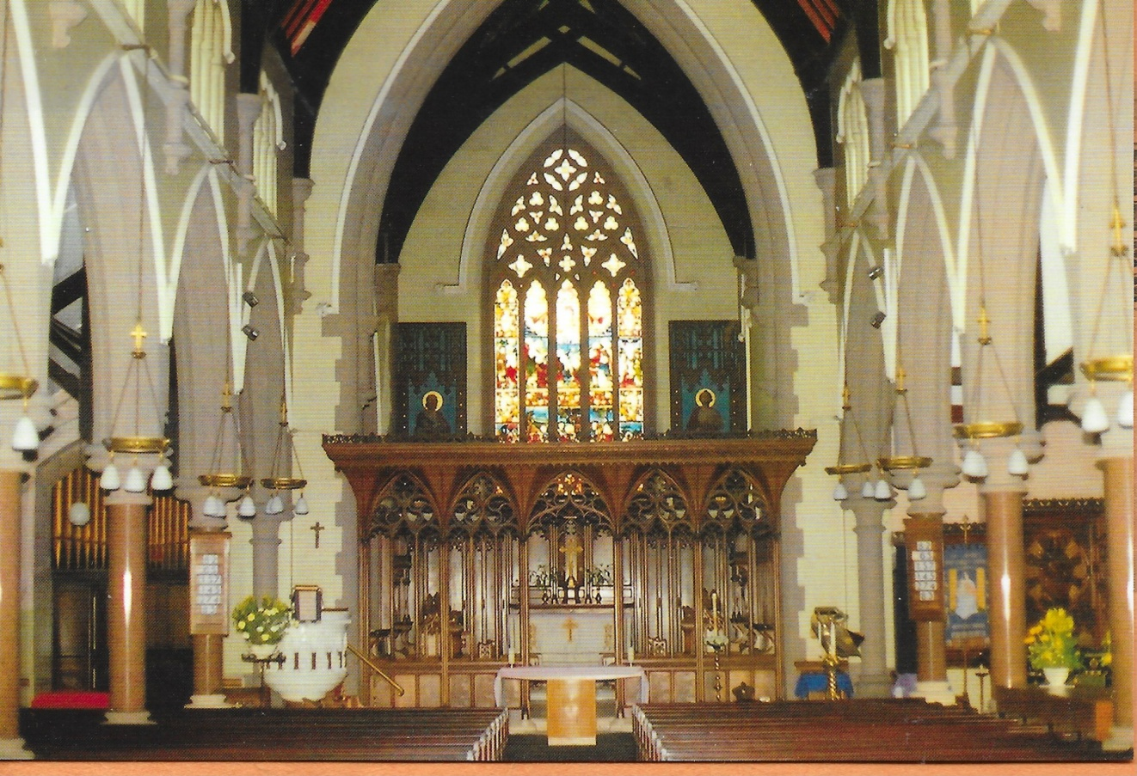
.

FINANCE AND STEWARDSHIP

See Accounts for the last three years

The last stewardship campaign was our Jigsaw Campaign 2013.
Copies of accounts attached.
The parish is committed to paying its full Parish Share and since 2011 has done so. However without this year’s agreed reduction in the projected parish share and a scaled back five year annual increase we would have struggled to meet this year’s full contribution. Rising costs, overall falling attendance and Benefice changes to accommodate St James’s (earlier Mass times) have affected giving.
During the diocesan agreement process the parish share is (2018) £8,000 (2019) £9,000 (2020) £10,000. By agreement 2017’s contribution was reduced to £10,000.
The parish priest’s expenses were met in full -On accounts £1,271 reimbursed last year
The parish participates in Gift Aid but has difficulty supporting money gifts elsewhere. We contribute to the Booth Centre annually through the Harvest Festival. Also Francis House Children's hospice. Otherwise we have our own food bank and support ongoing outreach in the parish.

- THE NEXT PARISH PRIEST

He must be member of Society and have a strong Catholic faith. He must be able to work collaboratively with retired clergy, reader, ALMs, PCC and people. He should have a mature faith.

He should be a priest who stands within the catholic tradition of the Church of England willing to be a visible presence at the heart of the parish and the wider community.

He would encourage a younger congregation.

He would have the will and skills to give oversight to ongoing parish projects.

He would have experience in being an incumbent, able to engage with a culturally diverse parish.

He would encourage and participate in parish visitations.

He would be a good communicator with people of all ages and levels of understanding.

Moreover he would be a priest who will be able to see the potential in our church and parish and help move it forward.

