Parish of St Paul Kersal Moor and St Andrew Carr Clough

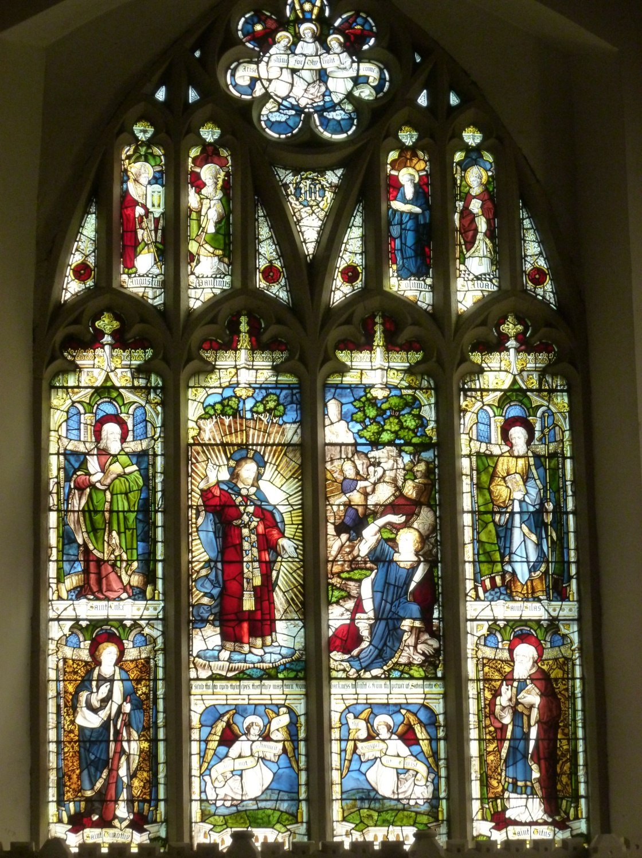

Parish Profile 2017

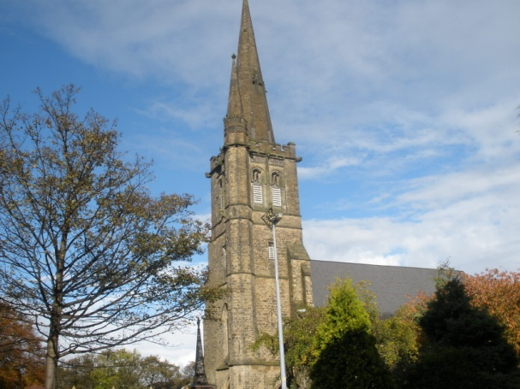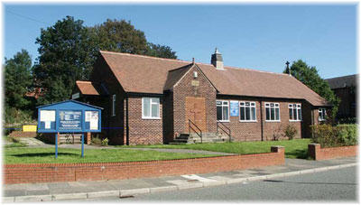
St Paul Kersal Moor St Andrew Carr Clough

Our Parish Mission Statement: Our aim is to KNOW God through Jesus; to GROW in faith; and to SHOW his love in our community

Our Parish Inclusion Statement: We believe in an inclusive Church - church which does not discriminate on any level, including economic power, gender, age, mental health, physical ability, race or sexuality. We believe in a Church which welcomes, accepts and serves all people in the name of Jesus Christ; which is scripturally faithful; which seeks to proclaim the Gospel afresh for each generation; and which, in the power of the Holy Spirit, allows all people to grasp how wide and long and high and deep is the love of Jesus Christ.

1. Introduction
The parish of St Paul Kersal Moor and St Andrew Carr Clough is situated in the suburbs of North Manchester. It is an area of social housing and older and postwar private housing of all types. Areas of public open space provide opportunities for leisure activities and exercise, though numbers of shops and businesses are limited. New private and social housing developments have sprung up on both sides of the parish, but not enough new residents come to our church services. Residents come from a range of backgrounds, origins and faiths: most care about the area in which they live, and local issues bring and bind people together. It is a place where God is worshipped in churches and synagogues.

The parish is served by two churches: St Paul’s, a traditional parish church with a modern outlook, with a congregation of active older people, young families and a thriving group of teenagers; and St Andrew’s, a modern building on a social housing estate, currently small in numbers but strong in commitment, with a catchment area increasingly popular with young families which makes it well placed to take up the challenge of outreach and growth. Our churches are committed to presence and engagement, and our Child Friendly status emphasises their mission to reach out to the next generation. This is the right time to sustain and consolidate at St Paul’s, and build at St Andrew’s, working together as a parish united in its commitment to its Mission Statement.

2. People
Rector: vacancy on the resignation of Revd. Canon Lisa Battye (2002- 2017)
Associate Minister: Revd. Mike Dyson OLM (from July 2012)
(OLMs in training: Hilary Shedlock [Y3], Andy Smith [Pioneer Y3])
Churchwardens: David Martin (St Paul’s) + 3 assistant wardens
Judith Walsh (St Andrew’s) + 2 assistant wardens
Readers: Heather Martin (based at St Paul’s)
Kathryn Disley (based at St Andrew’s)
Anne Rockley (based at St Paul’s)
Anthea Darlington (based at St Paul’s)
Reader Emeritus: Beryl Proctor (based at St Paul’s)
(all Readers have a parish-wide remit)
ALMs: Eileen Booth (spirituality and prayer)
Davina Heyhoe (creative worship)
Revd. Canon Noel Proctor (retd.) provides pastoral and service support
Safeguarding and Child Protection Officer: Chris Reid

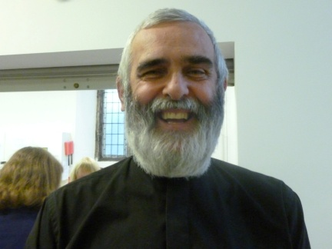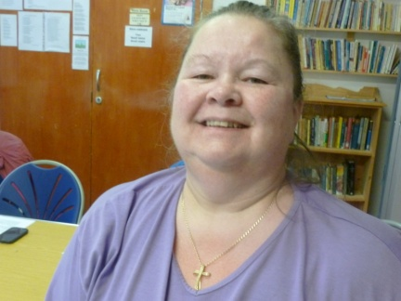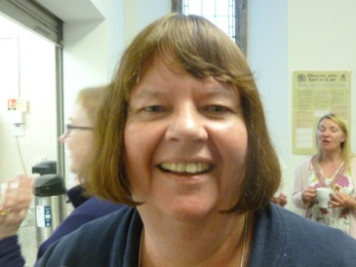
Revd Mike OLM Reader Kath Reader Anthea
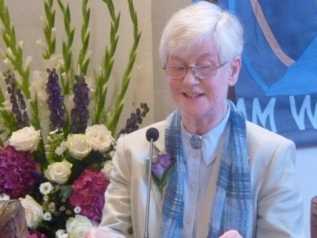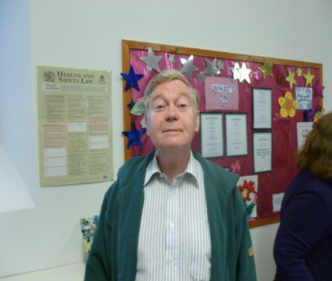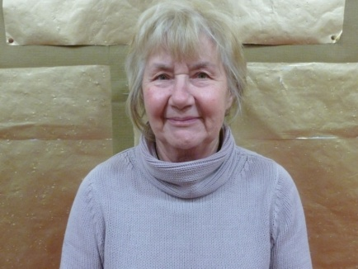
Reader Heather Warden David (St Paul’s) Warden Judith (St Andrew’s)

3. Parish setting
The parish is situated in Greater Manchester, north-west of Manchester city centre, and covers the part of the Higher Broughton area of Salford known as Kersal and the two adjacent areas of Prestwich known as Rainsough and Carr Clough. It thus straddles 2 metropolitan boroughs, Salford and Bury (of which Prestwich is a part).

Churches
St Paul’s (Moor Lane Salford) was built in 1852 to serve the people of Kersal Moor and Rainsough. It is a large traditional Gothic Revival building encapsulating a range of medieval styles (building guide available). St Paul’s established 2 daughter churches, one of which, St Andrew’s (Woodward Road Prestwich), built originally in the early 20th century, was rebuilt to serve the Carr Clough estate as a mission church in 1954 and subsequently was reunited with St Paul’s as a united parish.

After an arson attack in 1987, St Paul’s was reordered and reopened in 1991 to provide flexible and functional worship and social/community use areas within the modified external structure. It now seats 250+. It is surrounded by a large (11,000+ burials) graveyard, a popular final destination for many local Victorian worthies. The churchyard is now only open to ashes burials in a new garden of remembrance and occasional ashes/full burials in existing graves.

St Andrew’s was extended in the 1960’s and reordered in 1992, providing a community focus at the heart of Carr Clough. It can seat 80+.

The parish has one other building: Rainsough Community Centre, the former scout hut on Kersal Road Prestwich, now a focus for local community events and activities.

The nature of St Paul’s building, its geographical location and accessibility and ease of parking mean that it is used by the Diocese for a range of events.

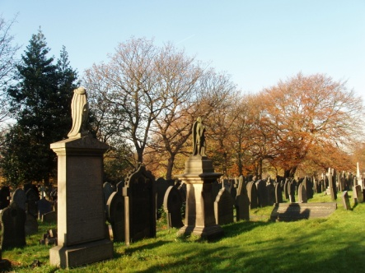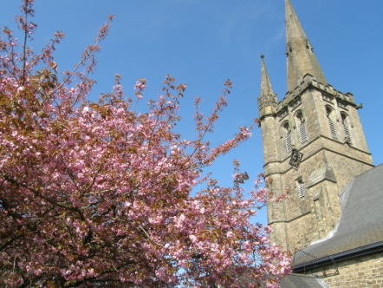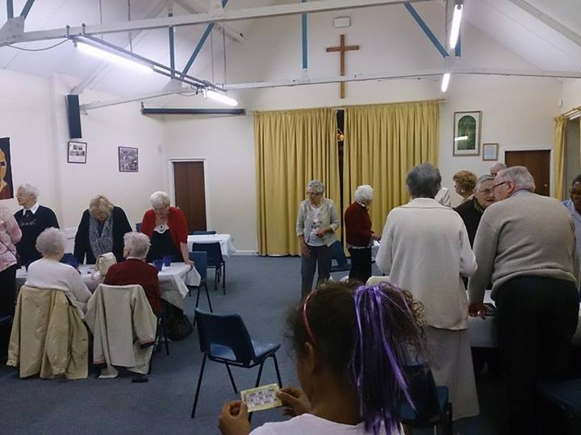
St Paul’s churchyard Blossom time, St Paul’s Harvest Supper, St Andrew’s

Population/housing
The area is characterised by suburban estate housing around Kersal Moor, site of special scientific (flora and fauna) and historic interest. There is no manufacturing industry left (Agecroft power station and Cussons soap works have gone) and currently the main employer is HMP Forest Bank (privately run). The presence of the Salford City Football Club on Moor Lane and its association with the Manchester United ‘class of ‘92’ is a recent new development in the area with potential for community focus..

The parish population is approx. 11,400, of whom 38% consider themselves to be Christians and 40+% are orthodox and largely observant Jews. The parish includes much of the Manchester eruv, Jewish ritual enclosure to enhance family Sabbath observation, which attracts more Jewish families. The social mix is mainly white middle class and working class, with pockets of high deprivation and social need. There are few shops and no public houses.

There are 4 distinct areas within the parish. Broughton Park, once graced by the large homes of 19th century Manchester merchants, consists of suburban high quality estate development, mainly mid-20th century, with a population now almost entirely of observant Orthodox (haredi) Jews. Many more live in the private housing in the rest of Kersal. We are proud of the opportunity this creates to work together with our Jewish neighbours to a greater understanding of the basis of our faith. Kersal is a suburban area of mid-20th century detached/semi-detached properties around and upon Kersal Moor, with new flats and family home development off Oaklands Road and older (1922) social housing on Littleton Road to the west. Rainsough includes a UPA 1920’s council housing estate and some older terraced housing. Carr Clough is a mixed 1940’s/50’s council/private housing estate. Small numbers of EU immigrants are scattered throughout the parish, predominantly Eastern European (Poles, Ukrainians, Lithuanians, Moldovans). They form part of the traditional substantial minority of RC worshippers characteristic of Lancashire towns.

The population of the parish is reflective of all areas of society, from significant social and economic deprivation to well-qualified middle class affluence, and all stages in between. St Paul’s serves a population tending towards the latter and St Andrew’s the former. Here is a statistical breakdown of our regular attenders by age compared with residents in the parish and Diocesan church attendance (further parish statistics can be found in the C of E Research and Statistics document Salford 240138 Kersal Moor St Paul, available as a PDF on line).

Parish Age 0-18 27% Church: Age 0-18 18% Diocese: Age 0-18 28%
pop.: Age 19-64, 57% Age 19-64 47% Age 19-64 45%
Age 65+ 16% Age 65+ 35% Age 65+ 27%

This is broadly reflective of attendance percentages in similar urban areas. While we are pleased that we have so many young people compared with some churches, we cannot afford to be complacent, and this remains a priority for mission. The parish aims to provide a range of missional and outreach opportunities, especially in the council and private housing estate areas of Carr Clough and Rainsough and the new housing developments in Kersal, where many young families live and relatively few residents attend our churches.

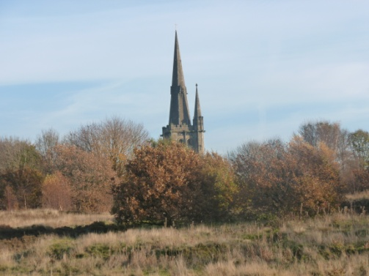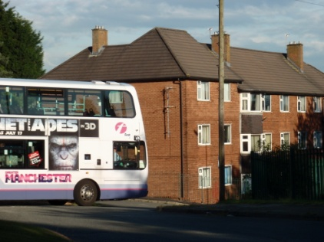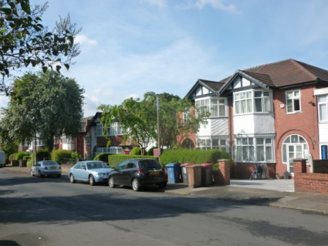
St Paul’s Church from Kersal Moor flats on Carr Clough suburban road in Kersal

4. Church
Congregations
Currently there are 157 on the electoral roll (2017 after a recent revision); two-thirds of regular attenders are over 50. One third at St Paul’s travels into the parish; a quarter at St Andrew’s. Average Sunday morning attendance over the past 3 years is as follows: St Paul –adults 72, children 21; St Andrew- adults 20, children 5. Wednesday morning communion at St Paul’s: average attendance 40 (20+ church members attend on Wednesdays only); afternoon prayers at St Andrew’s: 7.

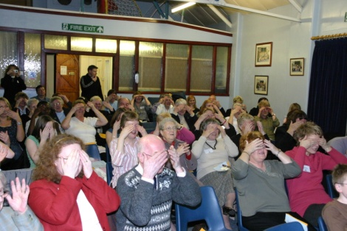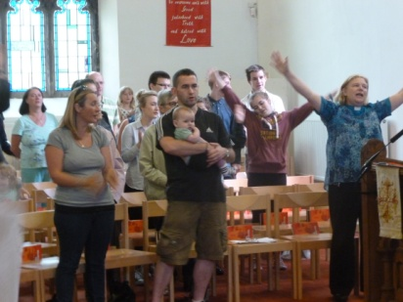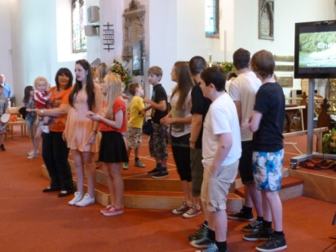
Bishop Nigel’s pilgrimage, St Trinity Sunday at St Paul’s Presentation Sunday St Andrew’s 2007 Paul’s

Tradition
There is a broad, open evangelical tradition at both churches, St Andrew’s being more informal and St Paul’s more traditional. Over recent years, worship styles have drawn closer together and increasing numbers are happy to attend either church. This has enabled us to hold more joint services. A large parish group attends the ‘Spring Harvest’ evangelical Christian celebration every year. There is a range of music from traditional hymns to current worship songs: at St Paul’s, a pianist/ organist accompanies worship assisted by a ladies’ choir led by the Music Director; St Andrew’s currently has a mixture of live piano accompaniment, CDs and YouTube clips. The contribution of music to our worship is a current focus for development- policy ratified by PCC in September 2014. Modern technology is well used at both churches for liturgy, songs and Bible passages, visual aids, sermons and presentations, information and music- 2 large screens at St Paul’s, 1 at St Andrew’s.

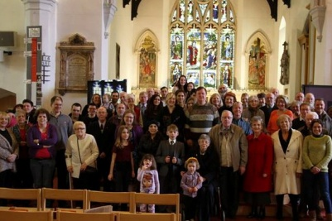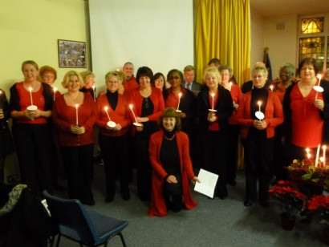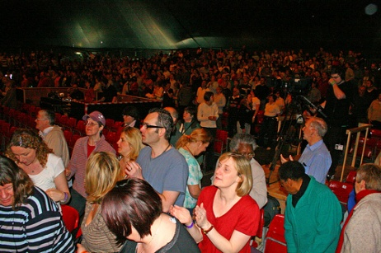
St Paul’s worshippers Ladies’ choir Spring Harvest

Pattern of worship within the parish

Sundays: 10.00 a.m. at St Paul’s and 11.00 a.m. at St Andrew’s, using Common Worship Order One Eucharistic prayers (linked to festivals and aspects of the Church Year where appropriate) and Morning Praise, with more freedom to innovate, alternately. Holy Communion is celebrated in the parish every Sunday. Worship includes all-age, parade, and occasional joint services, and in addition a range of special and seasonal services e.g. memorial service, Good Friday meditation. Currently our sermons are both lectionary-based and thematic, aiming for high quality learning, spiritual growth, relevance and support for individual and group mission and evangelism. They are linked to helping us achieve the aims of our Mission Action Plan (see below). There are thriving young people’s groups at St Paul’s with the whole church family taking communion together.

Wednesdays: 10.00 a.m. at St Paul’s- short Holy Communion A (with worship song and homily) followed by coffee. The growing congregation enjoy the familiarity of the liturgy and the opportunity for weekly Eucharist: some regulars attend other denominations on Sundays, making this a truly ecumenical occasion. Integral to this congregation are members from Broughton House and Holt House care homes.
2.00 p.m. at St Andrew’s- short act of worship with occasional Holy Communion

Weekdays: 9.05 a.m. Morning office (Mon/Tue/Thur); Wed parish prayers 9.15 a.m.. All welcome (attendance usually 3-8).

First Saturday of the month: Messy Church from 2.30-4.30 pm at St Andrew’s- a Fresh Expression of worship open to all families with young children, run jointly by members of both churches and the Worldwide Church of God.
Occasional offices: baptisms take place during the main services on a fixed Sunday each month as required during the year, and are tailored to meet the needs of the families involved. Candidates and families worship at the church at least for the previous 12 weeks. Funerals, burials, ashes burials and weddings are by arrangement with the Rector.

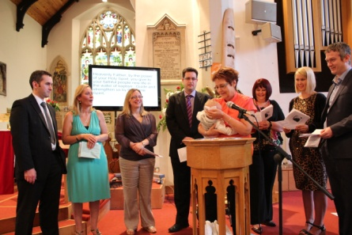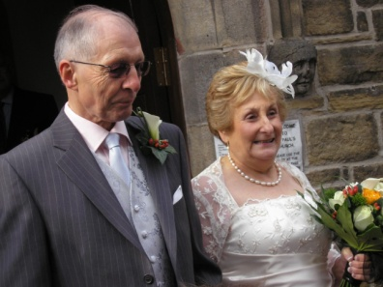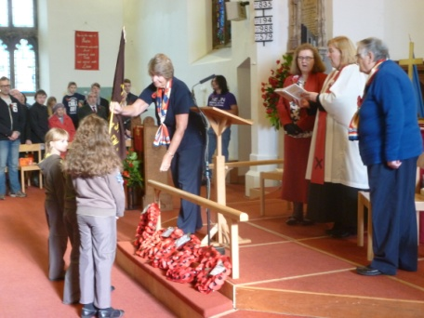
Baptism Wedding Remembrance Sunday

Lay involvement
Lay leadership and involvement are encouraged and promoted at all levels. Many of those in leadership in the parish are involved in leading services and giving talks. Members are encouraged to bring the experience gained in other walks of life to benefit the life and work of the parish. We are fortunate that so many people want to exercise this ministry. This is a parish in which opportunities to use existing skills and develop new ones are encouraged, and where people are eager and willing to share the benefits of their experiences with others. We aim to make our buildings welcoming and comfortable, and our congregations are welcoming, open and ready to share the Good News with newcomers, who receive Welcome Bags and contact from within the leadership team.

The parish currently has five Readers, (including a Reader Emeritus), and two Authorised Lay Ministers with remits for developing prayer and spirituality, and mission through creative arts and worship. The team of lay assistants is led by a Sacristan and provides home communion where needed. The sidespersons’ team is headed up by the Wardens. Many members are involved in lesson reading, intercessions and post-service prayer ministry, including four trained Spiritual Companions. Over 30 people are involved in a telephone/email Prayer Wheel for emergency prayer needs. The GROW group (see below) co-ordinates a parish-wide pastoral team which is available for welcome, talk, prayer and general support, and has responsibility for ensuring members no longer able to attend either church are visited, written to, phoned and supported. Lay members act as baptism sponsors and provide post-bereavement support. An enthusiastic group of flower arrangers at St Paul’s and committed individuals at St Andrew’s ensure high quality displays at all times which enhance the beauty and atmosphere of both churches.

This is a parish in which vocations are encouraged, supported and developed, and we have an enviable record of callings to voluntary and paid ministry. Currently 2 of our members are pursuing their calling to ordained ministry in the parish and outside (Pioneer ministry), and a third will be going forward for consideration shortly. All active members’ skills, talents and gifts are recognised, listed in the parish Discover Your Gifts/ Stewardship record and updated regularly; they can be approached to use them at any time by the leadership team. Members are encouraged to steward their giving, of time, skills and money. As a parish we work with the Diocesan Stewardship Officer to help us do this better. We have an excellent reputation as a training parish, providing opportunities for ordinands and others pursuing vocation to work alongside lay/ordained persons in order to explore and experience a range of opportunities to use existing and develop new skills for present and future ministry; and at the same time contribute to the parish’s mission in Kersal and Carr Clough.

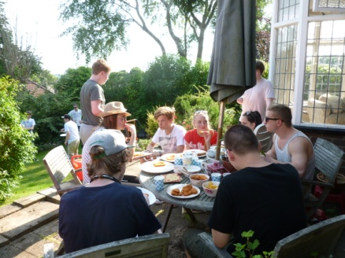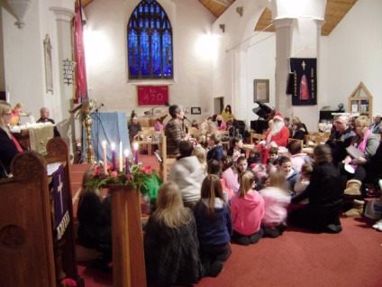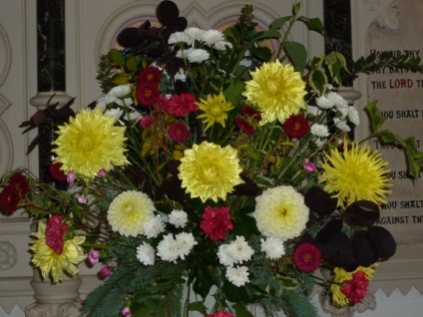
Youth progressive meal ALM (spirituality) leading prayer Flowers for Harvest Festival

Children and Young People
Our mission to children as a parish is essential to ensure that the next generation grow up with the knowledge and experience of the bible and the love of Jesus to enable them to make their own choices about church and faith in the future.

Children’s and young people’s groups meet at St Paul’s on Sunday during service times. They cater for a wide age range- 0-21. Parents are welcome to accompany babies and toddlers to the Scramblers group. Activities include bible study, stories, craft activities, music, drama and discussions on topics relevant to the lives of the teens and early 20s. A team of 7 leaders including the Young People’s Co-ordinator, plus other volunteers (all DBS checked) lead the groups, assisted by several parents. The needs of the younger people are borne in mind when planning the monthly services at which their groups stay in. At Christmas, Easter, Presentation Sunday and other occasions, children play a significant role in the All Age Worship services. Thanks to the work of our young persons’ team, we were the second church in the Diocese to receive Child Friendly Church status.

There is significant input from a designated team of Readers and the Rector into St Paul’s School and Butterstile School on a regular basis. We welcome all St Paul’s pupils and many parents to services in St Paul’s Church 4 times a year, including communion.

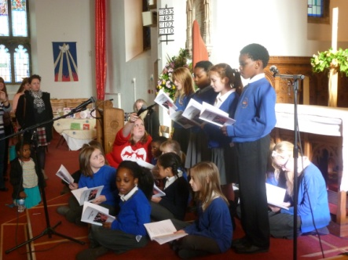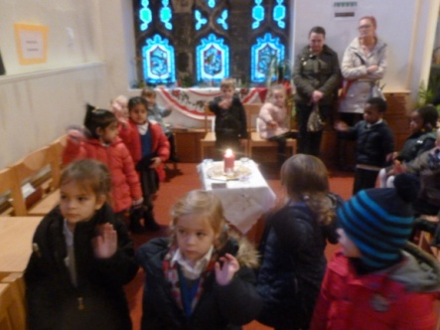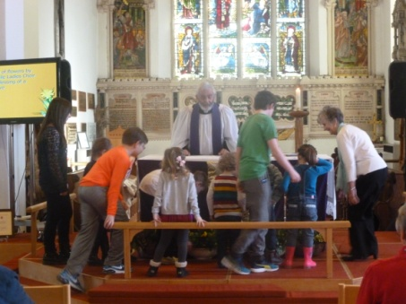
St Paul’s School service Easter Experience- Reception Mothering Sunday

‘Messy Church’ is the children’s provision at St Andrew’s, run jointly by the parish and the Worldwide Church of God monthly as a ‘Fresh Expression’ of church- currently an average of 50 adults and children from the local area attend. Having just completed its 3rd year of mission to Carr Clough, we celebrated our first baptism service this September.

C3 (‘Carr Clough Church’) barbecues in July and August at St Andrew’s reach out directly to young people and their families in the community during the long summer holiday. We are committed to finding ways of extending this throughout the year.

Mums & Tots at St Paul’s reaches out to all in the community, and is well supported by grandparents and members of the Eastern European community. All are invited into the Worship Area to celebrate Christmas, Easter and Remembrance Day.

Uniformed organisations: scouts and cubs (based at RCC) and guides, brownies and rainbows (based at St Andrew’s) are a vital part of our outreach to young people in the community: the guides etc are involved regularly in parade services at both churches, and Thinking Day and the parish carol service at St Andrew’s.

This summer we have welcomed a ‘Time for God’ youth worker with us for a year to enhance our young people’s work and provide support to a range of parish activities.

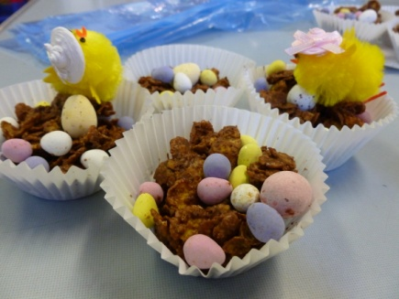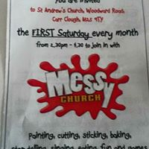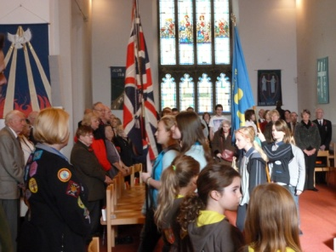
Mums & Tots Easter cakes ‘Messy Church’ Guides and Brownies on
Remembrance Sunday

Home, Study and Other Groups
The Bible and prayer are at the heart of parish life, as is the desire to follow in Jesus’ footsteps as disciples together. In order to promote this, there are a number of groups within the parish which enable people to meet, pray and study together. We have moved in recent years from having several mixed home and bible study groups to a more eclectic range of groups and activities designed to best meet the identified needs of the current congregations.
A mixed age homegroup meets fortnightly on Wednesdays. A Christian meditation group meets every Sunday evening. The parish recently completed its 21st Alpha course. Parish-based Spiritual Companionship and prayer courses take place most years. Day ‘retreats’ in venues away from the parish are a current feature, attracting people for whom regular commitment is difficult.
At the appropriate season the parish runs Advent, Lent and Pentecost study days or courses. Study and symposium events where Jews and Christians meet and learn together are a regular occurrence.
The parish Confirmation course runs annually for anyone wanting to make the commitment to full church membership. Children are admitted to communion each year after following the ACE Admissions course (2017- 4 children).

The Staff Team (clergy, wardens) meets 6 times a year, sometimes for Bible Study together; leader teams (Readers; leaders of subgroups) meet as required and the whole Leadership Team meets at least twice a year, to overview the management structure, to respond to parish needs and to help the Rector to articulate the vision which the PCC seeks to pursue. The team is committed to ensuring that those in training for the ministry share in its roles and responsibilities while they are with us.

All church members are encouraged to form support links appropriate to their needs. These include a fortnightly afternoon ‘Time Out’ group for crafts, discussion and sharing, monthly Men’s Group for study and discussion, and prayer triads of like-minded people. Church members are encouraged to attend the programme of study and prayer groups available at Katherine House (FCJ Order) in nearby Singleton Road. Each summer there is a 2-day ‘Holiday at Home’ activities event for over-60s at St Paul’s, a major outreach event attracting 60+ people from church and beyond.

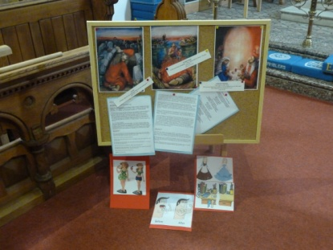 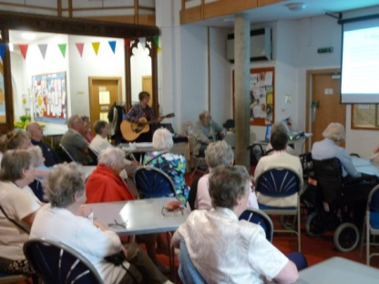 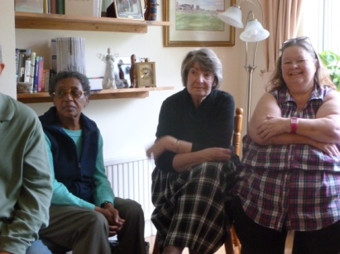 Lent course prayer station Holiday at Home Time Out group

The Parish Structure
As a parish we are committed to mission, seeing ourselves as one church with three buildings to use in this work. The parish has a Facebook page and website: stpaulsparish.org.uk

The PCC is concerned with our long-term vision and planning, and has delegated the organisation of the day-to-day work and mission of the parish to 3 interest groups based on our Mission Statement; to KNOW God through Jesus (group 1); to GROW in faith (group 2) and to SHOW His love in our community (group 3). [See Appendix 2 for Management Structure] It has a remit to promote the Parish Mission Action Plan and through it to realise its Mission Statement and to keep church members informed and supported in order to achieve its objectives. Each year PCC members take part in an ‘away day’ focussing on an aspect of growth.

The KNOW group deals with finance and buildings, the GROW group encompasses teaching, serving, prayer and care, and the SHOW group covers events, publicity, outreach and Fresh Expressions. Details of the work of these groups can be found in the Additional Information document.

SPACE (St Paul’s Ancient Churchyard Environment) is the churchyard support group which promotes every aspect of churchyard life- spirituality, nature, environment, history and community- and involves members from the whole community.
The Worship Planning Group is a subgroup which consists of worship leaders at both churches (clergy, Readers, ALMs, musicians) which meets 3 times a year to evaluate the quality and nature of our church services. Both these groups report directly to the PCC.

Links with others
- Churches Together in Prestwich & Kersal – variety of events with partner churches, including Prestwich Carnival, Easter Walk of Witness, Pentecost and Christmas celebrations and events
- The Worldwide Church of God worship every Saturday afternoon at St Andrew’s, with links between the churches cemented at the annual joint Maundy Thursday footwashing service and Carol Service,and through monthly Messy Church, which they help to facilitate
- ‘Espresso Church’ at Costa Coffee Prestwich: monthly Monday evening ‘fresh expression’ of church in Prestwich village which we help run with others from CTiPK (currently led and promoted by our Pioneer ordinand)
- ‘Flourish’ conference annually with local Methodist circuit hosted at St Paul’s for study, prayer, fellowship on current Christian themes (attendance c 150)
- Deanery- hosting occasional Deanery ‘still hours’ and other deanery events including opportunities for churchwardens to network across the Deanery (promoted by Canon Battye as Area Dean of Salford)
- Salford Prayer Network and Network Manchester- churches and community leaders talking and planning together
- Rainsough Community Centre- using our building (the ‘Scout Den’) for community support and links, including the Apostolic Church of Faith and Acts of Zimbabwe
- Prison visiting at HMP/YOI Forest Bank
- Salford City Football Club Forum, where club and neighbourhood representatives meet: church representation
- St Paul’s CE School and Butterstile CP School- assemblies, RE and music support with regular St Paul’s School services in church (see below)
- Uniformed organisations are based at RCC and St Andrew’s (guides, brownies, rainbows) and take part in services at St Andrew’s Church (St Paul’s parade for Remembrance Sunday)
- Ministry to the elderly- home communions and services in local elderly persons’ homes including Broughton House for Disabled Ex-Servicemen and Holt House (Salvation Army)
- Tithing 10% to missionary causes and charities at home and abroad plus giving via special events, and St Paul’s Coffee Morning ‘Send a Cow’ link
- Christmas Romania shoebox appeal: over 100 shoeboxes sent each year
- Borehole Appeal: funds have now been raised for a borehole to enable former Careforce worker Nicholas Odhiambo to run the family farm in Kenya and provide others with water; and for a larger tank to make collecting water
easier (5th Mark of Mission)

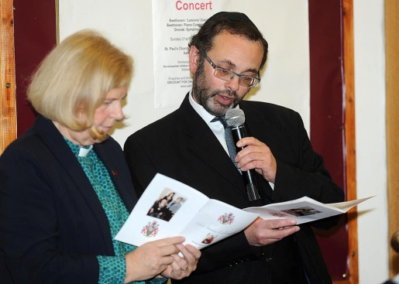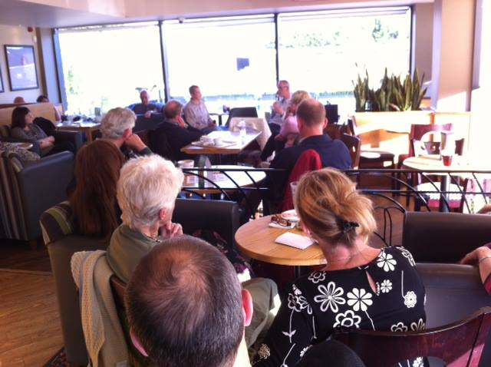
Joint Christian-Jewish celebration for Mayor Espresso Church at Costa Coffee
of Salford’s inauguration at St Paul’s Prestwich

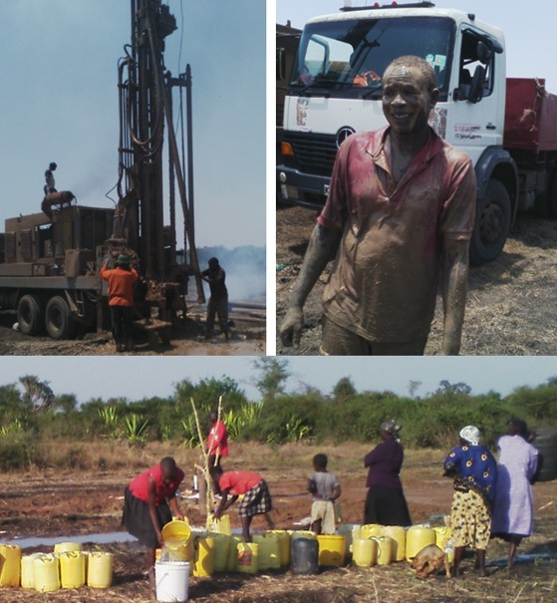
Borehole project, Kenya 2016-17

Communication and Community
Both buildings play an active role as centres for the community, hosting a range of activities some of which are church-linked and others community-linked. Use of the buildings and contact with local schools play a major role in our outreach and evangelism. Details of our events and publications are listed below:
- The parish produces a free fortnightly Newsletter detailing all parish and relevant local events, plus a special seasonal magazine at Christmas, Easter and Summer
- Broughton House and Holt House residents and staff attend Wednesday morning services and coffee morning: both care homes receive Holy Communion and pastoral visits from our team of clergy, lay assistants and pastoral carers
- Both buildings are in daily use by community groups: at St Andrew’s: Cherry Trees playgroup daily, and weekly Keep Fit and Mums and Toddlers at St Paul’s; Kumon Education; Mums and Tots (outreach from the church); weekly Baby Sensory group; Prestwich and North Manchester Sling Library; Friends of Kersal Moor
- St Paul’s is the rehearsal base for Salford Symphony Orchestra and hosts its concerts twice a year
- The social areas at both churches are used regularly for parties and celebrations, as well as concerts and other events
- Church social activities include Christmas and Strawberry Fairs, parish picnic, Junior Church fun day, plant sales, Christmas lunch, Harvest supper, weekly bring and buy, bring and share lunches and special celebrations
- Young people are encouraged to attend Criccieth Pathfinders camp every year: funds are raised regularly to enable everyone who wants to go to be able to attend

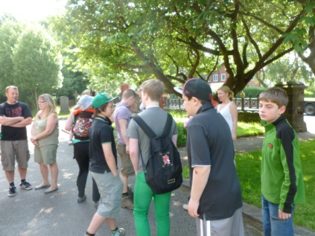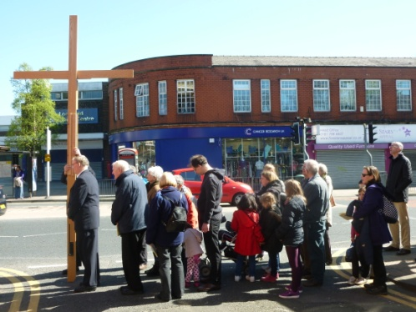
Camp fundraising walk Shoeboxes for Romania Good Friday Walk of Witness

Events and Outreach
The parish aims to hold events aimed at outreach whenever these can be arranged and promoted, to draw in people from the local communities. Relatively few of our members come from the major housing developments in the parish, both council and private housing, yet these are where our young families are concentrated. Each year the ‘Christmas Experience’ and ‘Easter Experience’ exhibitions at St Paul’s tell the Christmas and Easter stories to visitors, including each class at St Paul’s School. Our Christingle service, advertised on our parish Facebook page attracts large numbers of young families. The C3 initiative of summer barbecues and informal worship aims to draw in the local community. Special occasion events plus all the regular fair and supper events help us to have fun together and raise money while at the same time welcoming in the local community. This year (2017) we plan to have carol singing outside both churches.

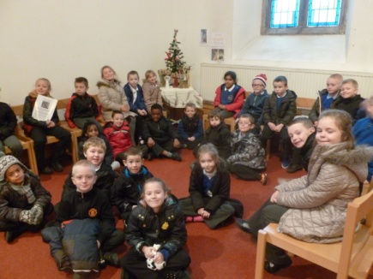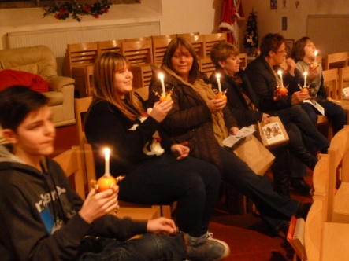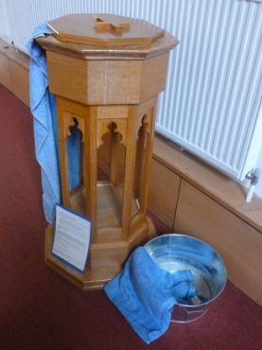
Christmas Experience with Y1 Christingle service Easter Experience

5. Realising the Vision
We try to live out our parish Mission Statement, written in 1991- ‘Our aim is to KNOW Jesus, to GROW in faith, and to SHOW His love in our community.’

Mission Action Plan/Plan for Growth
In 2005 the parish produced its first Plan for Growth (now part of the Diocese’s Mission Action Planning initiative), as part of a Deanery initiative looking at where we as a church are now, where we want to be in the future, and how to achieve this. We aim to grow in numbers, in depth, in outreach, in grace and in wisdom, and to walk in the footsteps of our Master as whole-life disciples, showing his love wherever we are. The PCC takes a lead in this, but anyone with an interest is invited to meet together annually to plan, train, review our objectives and our success criteria in order to move our aims forward, and report back to the PCC. A committed small group of evaluators working on behalf of the PCC brings a range of perspectives aiming to make the Plan a way of life rather than a reference document.

During our 12 years we have grown in depth through high-quality worship and study opportunities, through our groups and in our learning; we have grown in numbers and regularity through making our service times, their content, our welcome, our groups and our pastoral work more relevant and appealing to young families and older people of all ages and interests, by ensuring our young people’s needs are met and that they are at the heart of all we are and do; in outreach through sharing our stories and experiences, by putting ourselves at the heart of our communities and using our individual and collective gifts and talents more appropriately; and in grace through being welcoming to and accepting of all, through more and better prayer and opening ourselves to what God wants. We aim through prayer, study, sermon themes and reading the Bible every day to gain wisdom to underpin all that we hope to achieve. Where relevant we have policy and practice documents which help give structure and rigour to all that we do and aim to achieve.

For 2 years (2010-12) we worked in partnership with the London Institute of Contemporary Christianity to support us to realise our vision, through their ‘Imagine’ project, with Chick Yuill as our consultant. This has helped us to become better at all these things, and especially to make those small but effective changes which come about if we live in our communities as whole life disciples of Jesus and eventually bring others to a closer relationship with Him. We have learned to share our stories and to witness more effectively on each person’s ‘front line.’ From 2015 we have been focussing on identifying ‘what will make the boat go faster’ and implementing it through our Plan. In 2016 we changed the name of the Plan for growth to the Mission Action Plan, in line with the Diocese’s ‘Fit for Mission’ initiative.

Currently (2017) we aim to continue to embed our new management structure to bind us together more closely and work more effectively to witness as a single parish with three buildings; to keep prayer central and provide opportunities, training, help and support to enable all our members to pray; become more effective disciples by creating a culture of discipleship in all we do, equipping ourselves to share the Good News with others; to reach out to our young people in church and school, nurturing their belief; to become a more inclusive church, currently targeting support to those with dementia and their families (Dementia Friends); to help save our environment through knowledge and action at home and abroad; provide quality worship opportunities, enabling all to make the most of what is on offer in our services; and top of our list of priorities, reach out more effectively to our communities in generosity to love them and share the Gospel by living out our Mission Statement. Since 2016 our priorities have been linked to the 5 Marks of Mission. This year’s Plan has been shared with Mike Chesterton, our MAP consultant, and received a favourable response.

Every group, organisation, activity and event is working towards fulfilling our vision and mission aims.

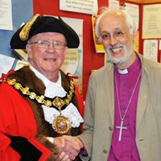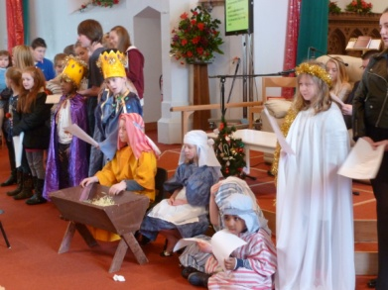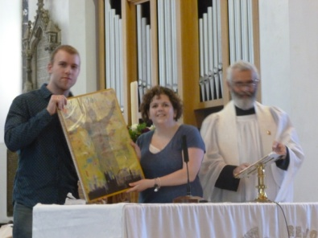
Bishop David with the Mayor Nativity 2016 Pray Love Manchester 2014
at St Paul’s 2017

7.Conclusion

This is a parish with much going for it, but with many challenges facing it. 38% of people in our parish still profess to be Christians, but relatively few of them attend our churches. What more do we need to do bring them in or meet them where they are to enable them to KNOW God through Jesus? Many of our members are older and single: more than 40% choose to travel to our churches, particularly St Paul’s, from outside the parish. How can we do a better job of helping our congregations to GROW in faith? Few of our regular attenders are from the traditional council estates, though St Andrew’s is situated within one, or from the new private developments within St Paul’s area. What more do we need to do to SHOW God’s love in our community?

Have we identified gaps in our mission? Are we listening to our wider community and networks? Is our vision for the future linked to the needs of our communities? What can we do to attract more young families? What else do we need to do to ensure we are reaching out to children and young people who know nothing of the Bible and with whom the Gospel is not being shared? We have firm foundations on which to build and progress has been made, but there is still much to be done if we are to reach out to, embrace and where possible draw in those with no experience of church, and thus fulfil our aim of walking in our Master’s footsteps and bringing his Good News to others. We look forward to the next stage and the person who will lead us in it, in faith and hope.
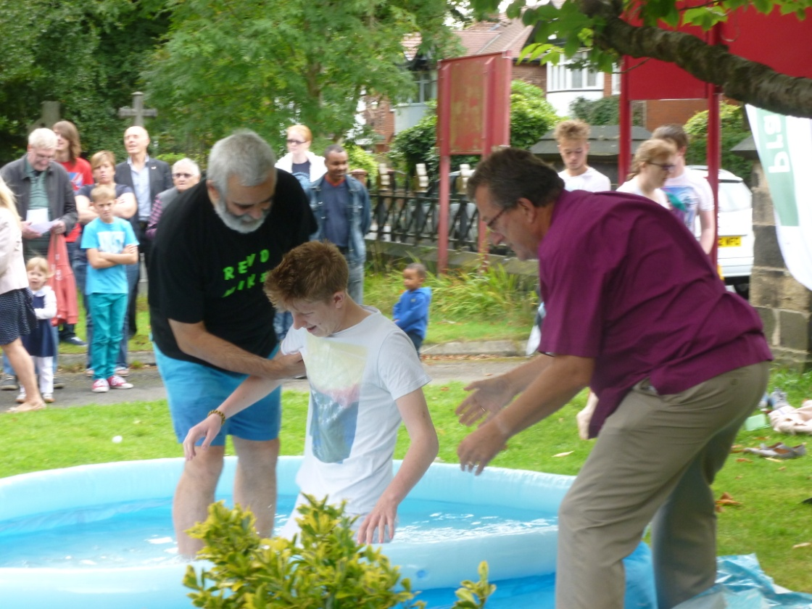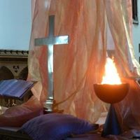
Renewal of baptismal vows 2015 Pentecost Sunday

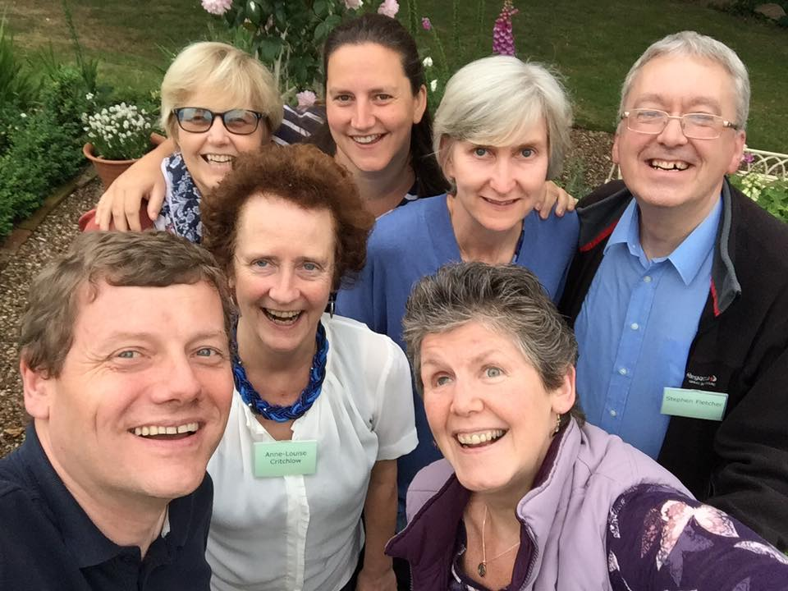

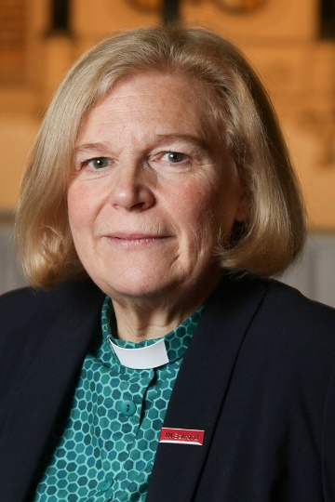

Canon Lisa Battye
Incumbent 2002-2017

Some of those called to serve as priests from or in
the parish in the past, with Revd Stephen Fletcher,
Incumbent 1988-2001, pictured at Swanwick 2017

