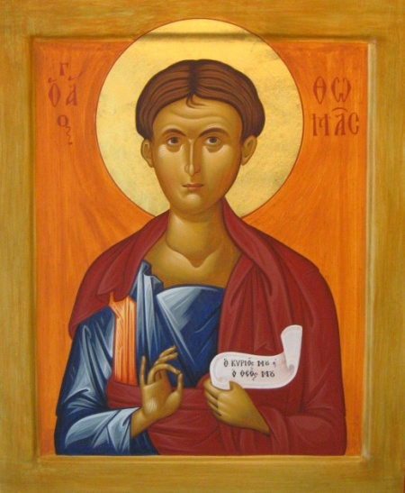
St. Thomas & All Saints
Bedford, Leigh
2019
Parish Profile
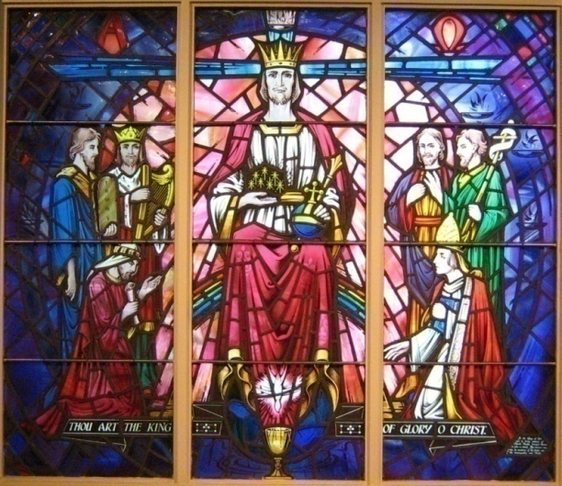
Christ in Majesty

The Parish is under the Episcopal care of the Bishop of Beverley
WELCOME

Welcome to this Profile of the Parish of St. Thomas & All Saints Bedford Leigh and thank you for reading it. We are very proud of our beautiful Church and of our town, and we hope that in the following pages you will find much to interest you in the possibility of becoming our new Parish Priest. We have an active Parochial Church Council comprising many talents, and we are all looking forward to welcoming our new incumbent in due course. We have a steady and loyal congregation who have supported previous incumbents and will undoubtedly offer our new priest a warm and hearty welcome.
So please read on, and decide whether the parish of St Thomas & All Saints could be for you
Pam Blackburn
Churchwarden
OUR VISION

Through prayer and the sacramental liturgy of our church at worship we aim to create an open, welcoming and inclusive environment to encourage everyone in our community to join us as pilgrims establishing the Kingdom of God.

OUR MISSION

It is our hope and intention to create a church full of the strength of prayer, the establishment of God's peace and the fulfilment of Christ's love. We look to welcome our new Incumbent to continue with our vision for the future.

BASIC INFORMATION

FULL NAME OF BENEFICE
St. Thomas and All Saints Bedford Leigh
Kenwood Avenue
WN7 2LL
THE PATRON
The Vicar of Leigh: The Reverend K D Crinks
ARCHDEACONRY AND DEANERY
Salford Archdeaconry: Archdeacon, The Venerable David Sharples
Deanery of Leigh: Area Dean, The Reverend Martin Cox

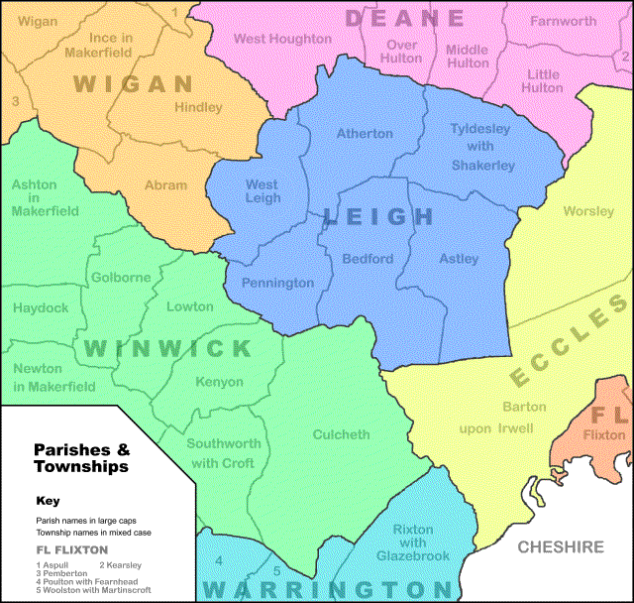

ANALYSIS OF STRENGHS AND WEAKNESSES

Strengths
- A committed worshipping community built around the Parish Eucharist.
- Our Parish has an embedded sense of community with a feeling of belonging. Very warm and welcoming to newcomers and outsiders, quite exemplary in this regard.
- A strong commitment to continue with plans and work towards a new church building.
- A frequent and active presence on social media to inform the local community of events/services.
- Sufficiently strong finances to pay the Parish Share in full.
- A thriving Community Hall ran by our Hall Manager.
- An excellent reputation for "Occasional Offices".
- Superb links with Thomas CE Primary School, which has a two form entry.
- Scout Groups and Cubs attend Church once a month for the Parade Service.

Weaknesses
- A mainly elderly congregation with few under the age of 50 years, although we are, happy to welcome new members in other age groups.
- Very few families and young people attend church Services.
- The size of the building limits us from hosting larger services.
- A building with limited facilities for the disabled and no baby changing facilities.
- Not enough time devoted to fundraising.
- Parking in the area is very difficult therefore we need a designated parking area.

ST. THOMAS & ALL SAINTS CHURCH
StThomas&AllSaintsChurch,Leigh
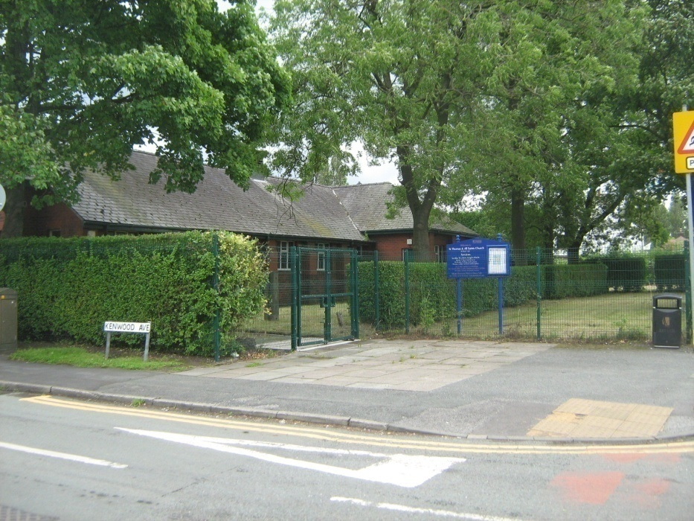

The present building was erected in 1938 as a Mission Church to serve the then new development of housing on Manchester Road and planned housing estates in the surrounding area, which was to include Higher Folds. The land having already been bought in 1908, and services having been held in Butts School for some fifty years, Bedford Church was deemed to be inappropriate for the numbers of new residents now living along Manchester Road.
On Monday, May 16th1937, the Vicar, the Reverend George Willett, cut the first sod on the spot where the Altar now stands, after praying that God would bless “the beginning, the increase, and the consummation of this work, which is undertaken to the Glory of Thy Name.”’ A month later the Lord Bishop of Middleton laid the Foundation Stone and on 29th October 1938, the Lord Bishop of Manchester ‘dedicated the new Mission Church to the Glory of God, and licensed it for the Administration of the Sacraments and the holding of Divine Service’.
Over the decades ‘All Saints Mission’ as it was once known, fulfilled an important supporting role for St Thomas Church, Chapel Street.
The closure of St Thomas Church, Chapel Street resulted in All Saints becoming the Parish Church of St. Thomas & All Saints Bedford Leigh.

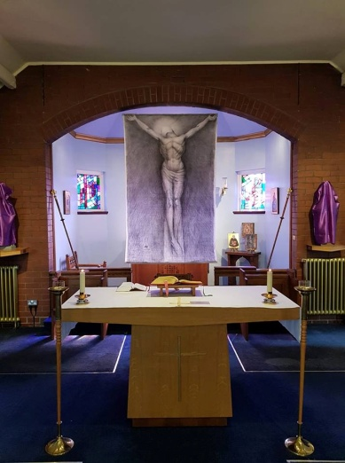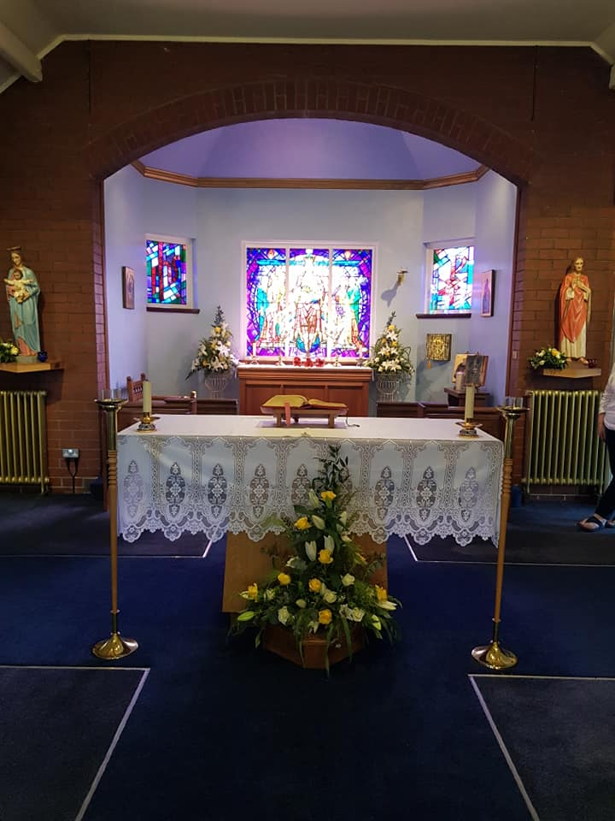
Holy Week Easter

Christmas
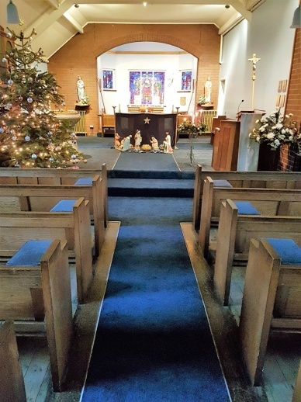

THE VICARAGE
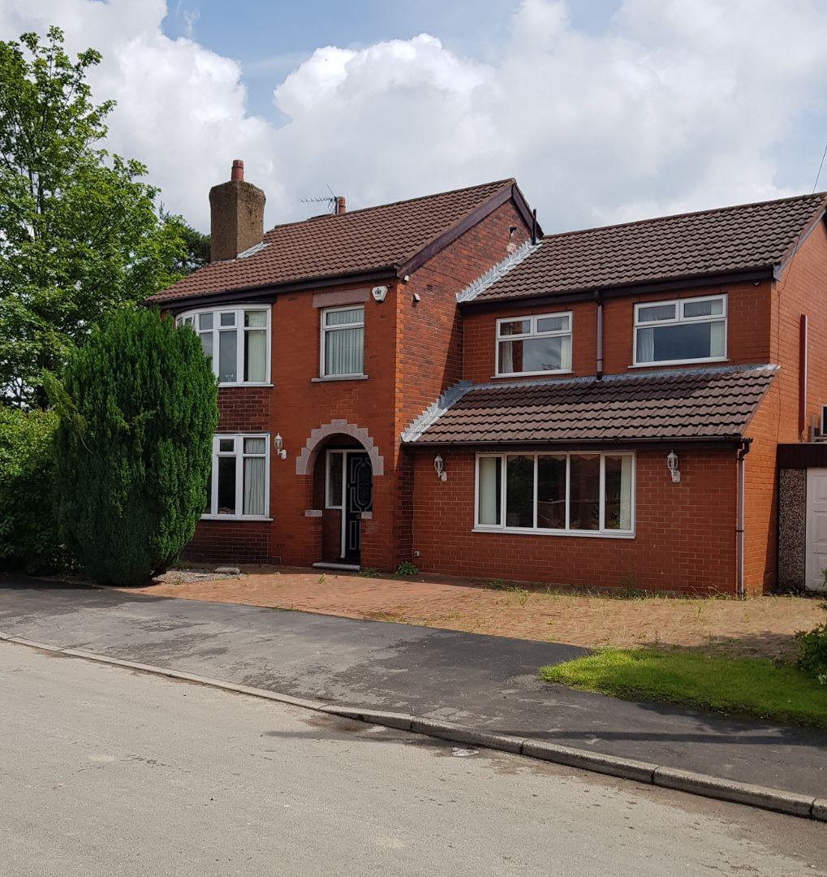
22 Kenwood Avenue
Leigh, Lancs
WN7 2LN
St Thomas Vicarage, 22 Kenwood Avenue, lies about 100m along the road from the church and stands as a detached house with garage and modest sized garden.
The front of the house has a large brick forecourt with ample room for two cars, three at a pinch, while the garage, with an up-n-over door, can accommodate two cars.
The house is on three floors with a Study separate from the living areas.
A new Combi-boiler was installed in December 2018 which provides for a very warm house and hot water. In the Living Room is also a built-in gas fire.
Ground Floor. The Study is on the right, inside the front door, with ample bookshelves, multi-socket points and ‘phone points. It is partially furnished with a desk, computer desk and printer stand, 2 x drawer filing cabinet, rug and two tub armchairs – we like to look after our Vicar!
Behind the Study is a second door which opens onto the smaller of the double-kitchens. Along the Hall is a small toilet under the main staircase, which also has the electric meter in, the gas meter is beside the front door.
The large through Living Room is on the left, which leads into a Summer/Garden Room which, in turn, leads into the garden.
The Double-kitchen is south facing, light and fully equipped with built-in Dishwasher, Electric Cooker, Gas Hob, a small refrigerator and a large double-door American-style ‘fridge. There is also a Washing Machine and Tumble Drier.
First Floor. There are three fair-sized bedrooms, a small box-room and, potentially, a bedroom in the attic room accessed by stairs from the back bedroom.
The main bedroom is large, with a dressing room and en-suite shower/toilet/washroom. (In the Dressing Room is a small wall-safe.)
The front second bedroom has a large bow window, with two fitted wardrobes.
The third bedroom has the stairs leading up to an attic room.
On the landing at the top of the main staircase is a bathroom/toilet suite.
A small box room is at the front of the house, between the Master and Second bedroom.
Second Floor. Attic room, suitable as a fourth bedroom.
Doors from the Kitchen area and Summer/Garden Room lead out onto decking and the garden, which is completely enclosed and adds to the security of the house. There is a second decking area away from the house, behind which is a shed.

LOCAL COMMUNITY
The Parish of Bedford, Leigh is primarily residential and varies from the large Estates of Higher Folds and Butts Bridge, through to the large new-build estate of Walmersley Park and smaller housing groups of Spinners Mill and Rowan Meadow. In the past 10 years the population has grown from approximately 14,000 to 16,000 - 17,000.
The general population comprises of a wide range of social housing and some private housing, which inevitably has led to the inclusion of unemployed and a higher than usual number of families living on Social Benefit.
Due to the social history of the area most of the large employers such as, Cotton Mills, Coal Mines and Engineering Companies have closed down. As a result, those who are employed often have to travel some distance, or take up employment at the Retail Parks and the like, which does not allow for much variation or choice.
Leigh suffers from an inadequate transport system, we do not have a train station which results in people using cars and buses.
The Parish has four schools:
- St. Thomas CE Primary School.
- St. Gabriels Catholic primary School.
- Bedford Hall Methodist Primary School.
- Bedford High School.
The Parish has four Nursing/Care Homes:
- Bedford Nursing and Residential Home.
- High Peak lodge Nursing and Residential Home.
- Lyndhurst Care Home.
- Brideoake care Home.
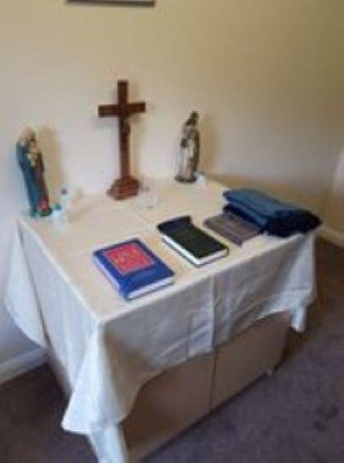

The previous incumbent was part of a Multi Faith group who set up a worship area in one of the Care Homes.

WORSHIP

Our liturgical tradition includes full vestments, Server, incense can be optional on high days and holy days, with a catholic order of worship.
We have music provided by our organist on a recently donated Church Organ and use Celebration Hymnal for Everyone and Hymns, Ancient & Modern, alternatively, on a three month cycle.
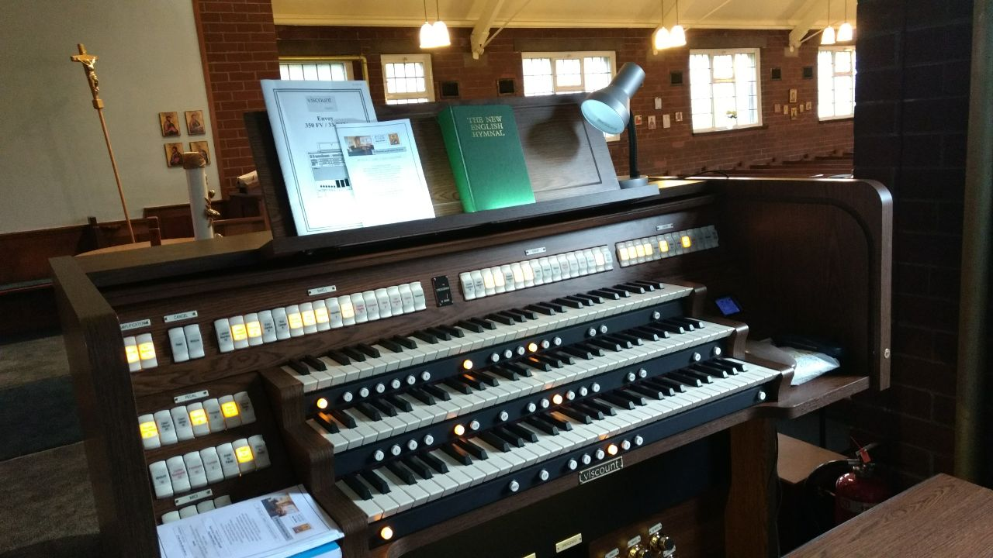

2 years ago we were given the permanent use of a new 3-manual Viscount digital organ to replace a faulty & failing 2-manual pipe organ. After some redecoration, it was installed on 24th February 2017 and has since been used for services. It is hoped that it might be possible sometime to re-instate organ recitals and organ masses which had been a feature of S Thomas. Also it is hoped that in the future an organ pupil might be encouraged to help with playing at services, though there are only 2 schools nearby -Bolton School & Bridgewater School.
The Mass Setting is currently A. Gregory Murray’s "New People’s Mass": Kyrie, Sanctus, Benedictus, & Agnus Dei; the Gloria was lost when the text changed; as was the Margaret Rizza "Missa Panis Vitae" setting.

(John Green- Organist)

Weekly pattern of services:
Sunday10.30am
Sung Eucharist
Tuesday 7.00pm
Said Mass
Wednesday 11am
Said Mass
Thursday 6pm
Said Mass and Compline

However during the interregnum we maintain the Wednesday Mass.
The Readings, Intercessions and Sacrament Administrators are taken by members of the Congregation.
On the First Sunday of the month we have a Church Parade for the Uniformed organisations of Cubs, Beavers and Scouts.
At least once a term, Years 5 & 6 from St Thomas CE Primary School join the Congregation for the Wednesday morning Mass, as well our Incumbent taking a termly Mass in School.
Other services celebrated with the School include, Harvest, Confirmation Service, Advent & Christmas, Ash Wednesday/Lent/Easter and the Prize-giving Leavers Service.
During Lent, the Parish join with St Joseph's RC Church for a weekly 'Stations of the Cross' meditation. On Good Friday there is similarly a joint Ecumenical Service which incorporates many churches of Leigh, after which is a Walk of Witness through the centre of Leigh to the Library where there is a short Service of Christian Commitment.

CHURCH HALL

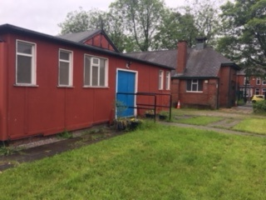
Our Community Hall at All Saints is very busy. We encourage and support all kind of Group activities. Both voluntary and professional. At this time our user Groups are Mother & Toddlers, Dog Training Support, Morris Dancers, Children with any Disability Support Group, Beavers and Cubs, a Dancing Class for children provided by Wigan Council, Pastoral Support from school to help and advise families needing support with issues better dealt with away from school, Chair Based Exercise for the Elderly or not very mobile. The Hall is regularly booked for parties and celebrations as well as tea/coffee and cakes arranged by Church ladies on a weekly basis. We are very open to any suggestions and strive to encourage all who come with ideas to try. Our problem is that the Hall is in real need of an update. We were awarded a 5 Star Certificate from the Environmental Health Inspection but the structure of the building is in real need of attention. We should have toilet access for any with a disability. There are many areas for improvement.
My hope is that whoever comes to work with us will put a lot of energy into keeping this Community base vibrant and remain a very important social outreach within our Parish. In recent years we have got used to our Incumbent calling in, on occasion, to 'meet and greet' the User-Groups - we hope this continues.
(Josie Smith-Hall Manager)
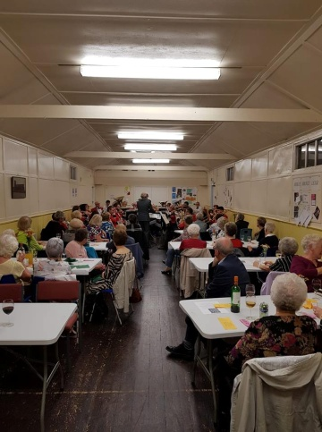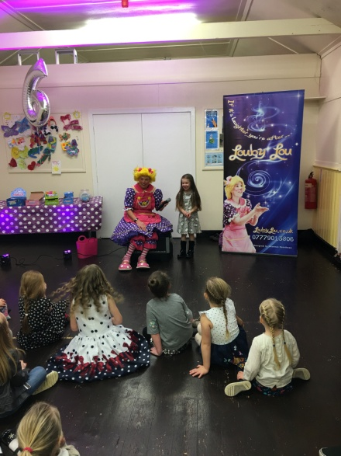
Church Functions Birthday Parties
Toddler Group
Our Mother & Toddler Group is the start of our relationship with families with very young children in our parish. The support and friendship offered in this group is vital pastoral work during a time when young mums need advice and friendship. We work closely with Startwell to ensure monitoring and advice is available. Continuing and ongoing care for these families through to school builds trust and confidence in our Church/School family. With the new housing estates within walking distance and young families coming into the area, we expect our group to grow.
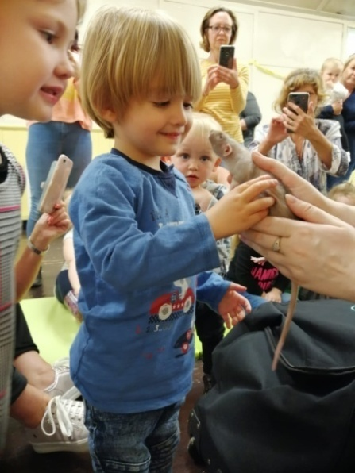
Toddlers Group meet the Zoo Man
LEIGH ST. THOMAS CE PRIMARY SCHOOL
www.leighsaintthomas.wigan.sch.uk
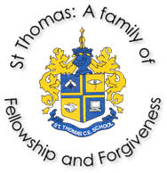
St Thomas’ School is one that has been on a journey over the last 2 years where the focus has been to re-establish its Christian roots, ensuring they go deep and provide a nourishment for all that is to come in life. Our vision demonstrates our commitment that all who are part of our school will flourish and succeed, irrespective of any barriers they may have. We work with dignity and respect and value everyone’s worth knowing everyone contributes positively to the school. Our Christian Values are the heartbeat of our school and what we do has real meaning for everyone within our community. We live out and see our values each and every day in everything we do. As Head teacher and Deputy Head teacher we are incredibly proud of everything we have achieved, not only for the children but the staff, Governors and the families of St Thomas. We really are ‘A Family of Fellowship and Forgiveness’.
The new Parish Priest of St Thomas and All Saints would, as Jesus said in Matthew 19, have children who will come to him and children who want to feel the joys of the Kingdom of Heaven.
As school leaders, we want our new Parish Priest to be warm, welcoming and a very present member of our school family. Someone who our children know and love and who knows and loves our children in return. A Priest who, if school cannot always access church, will bring the church to school. We would also like a Priest who shows and offers us answers to the question our school family asks in times of trouble or confusion ‘What Would Jesus Do?’ We would like the Parish Priest to continue and strengthen the links that school and church have and welcome creative and innovative ideas designed to engage pupils and their families in the life of the Church, as a part of the Church. Currently we celebrate major Christian festivals both in school and church where possible. We enjoy worship and communion regularly throughout the year and hold our July Leavers Service in church. Each year we confirm members of our Year 6 cohort, and wish for this to continue and grow in number and strength. As a school we wish for our children to be more actively involved in worship, planning and leading this with guidance from staff. We feel strongly that the Parish Priest of St Thomas and All Saints should play an integral part growing this.
Staff in school would benefit from the kindness, compassion and wisdom of a Priest who will support, guide, and enhance what they do in the teaching and shaping young minds who are ready to learn and eager to know more about the world in which they live.
Our parents would like for the new Priest to have a presence in school and who wants to watch our children grow and flourish. They would like someone with confidence to be involved in classroom lessons, watch sports day, set up a lunchtime group and come and speak to the parents on the yard before or after the school day. They feel strongly about having a Priest who will help children who are finding life a challenge, spending time with them to show them that God loves them.
Our children want to know how God can be a part of their individual journey, both now and in years to come. They will need somebody who will answer their big questions with a sincere respect for their inquisitiveness and who will treat them age appropriately. The need all things related to church to be fun, inspiring and irresistible and a member of Clergy who they love to see, hear and be with and who will work to ensure that they contribute to providing life in all its fullness for each and every member of the school community.
(Head Teacher & Deputy Head Teacher)
Neighbouring Anglican and Christian Churches

There are 10 churches in the Deanery of Leigh. Links are maintained by the Incumbent attending Clergy Chapter, Deanery Chapter, Deanery Synod and more recently Diocesan Synod. We have good historic links with St. Joseph's RC Church, one of the most important events being weekly Lenten services in the format of "Stations of the Cross". This culminates in a joint Good Friday service at 11am followed by a walk of witness through Leigh town centre and a final service with a broad Christian representation.

MINISTRY

The Church office is open every Tuesday at 6pm and baptisms and wedding are booked. Baptism Preparation by the laity supporting the incumbent is a successful ministry in this Parish. During weddings and funerals, Sidespeople are well prepared to minister to the bereaved. We regard Special Services as an important aspect of our mission to reach out and serve the community and Parochial Ministry as witnesses to Christ.

Statistics for Mission: January to December 2018

Funerals in Church 9
Funerals at Crematorium 14
Baptisms 20
Confirmations 5

Finance and Stewardship

The PCC take their financial responsibility very seriously. the Parish Share has always been paid in full, however, in 2012-2013 at the time of St. Thomas Church closing, the Diocese excused us from paying our Share to enable us to pay in full, the various bills to cover the cost of surveys, reports, and closing bills.

Clergy expenses are met in full with mileage according to Diocesan recommendation.

The outgoing incumbent brought in a system were all invoices are paid within 48 hours and we will continue to do so.

See appendix ( Financial Statement and Auditors Statement )

The Next Parish Priest

Could This be You?

We are looking and praying for someone:
- With energetic and enthusiastic Leadership.
- Who is warm, compassionate and ready to listen to those whom they meet, inside and outside the church congregation.
- Due to our exceptional bond with St. Thomas Primary School we need a leader who can engage the children and develop their faith in a light hearted manner whilst preserving the important factors of leading a good Christian life both within an educational environment and at home.
- Who prays for us and with us, because we are already praying for you.........!

Spiritual direction through life and doctrine:
- To encourage new Christians to baptism and confirmation.
- To bring God's forgiveness and healing.
- To be a Teacher of the faith and addressing all aspects of church, community and social life.

"Someone who will muck in".

"Must have a good sense of humour and able to engage with the Local Community and particularly the neighbours ".Cat lover preferred!"

"Friendly, approachable, someone to take an active interest in the community and help us in our endeavours for a new Church and Hall".

"Someone who will keep the Churchwarden supplied with gin".
"Someone with musical ability: i.e.Ability to sing responses at mass (Sursum Corda), "Christ our light" & Exsultet at Easter vigil &c."

"This is a vibrant, diverse Christian community. Good people who want the best for their community".
Appendix

INDEPENDENT EXAMINER'S REPORT
TO THE PCC OF ST THOMAS & ALL SAINTS BEDFORD FOR THE YEAR ENDED 31ST DECEMBER 2018
This report on the financial statements of the PCC for the year ended 31^{ft1} December 2018 is in respect of an examination carried out in accordance with the Church Accounting Regulations 2006 and section 145 of the Charities Act 2011.
Respective responsibilities of trustees and examiner
The church trustees are responsible for the preparation of the financial statements and they consider that an audit is not required for this year under section 144 of the Charities Act 2011, and that an independent examination is needed.
It is my responsibility to:
- examine the accounts under section 145 of the 2011 Act;
- to follow the procedures laid down in the General Directions given by the Charity Commissioners under section 145{5)(b) of the Act; and
- to state whether particular matters have come to my attention.
Basis of Independent Examiner's Statement
My examination was carried out in accordance with the General Directions given by the Charity Commission.
An examination includes a review of the accounting records kept by St Thomas' trustees and a comparison of the accounts presented with those records. It also includes consideration of any unusual items or disclosures in the accounts, and seeks explanations from the trustees concerning any such matters. The procedures undertaken do not provide all the evidence that would be required in an audit, and consequently no opinion is given as to whether the accounts present a "true and fair" view and the report is limited to those matters set out in the statement below.
independent Examiner's Statement
In the course of my examination, no material matters have come to my attention which give me cause to believe that in, any material respect: -
- accounting records were not kept in accordance with section 130 of the Charities Act or
- the accounts do not accord with the accounting records.
I have come across no other matters in connection with the examination to which attention should be drawn in order to enable a proper understanding of the accounts to be reached.
Signed;
Jenny Evans 6 Sunnybank Road Astley Manchester M29 7BJ

Income | This year 2018 | Prior year 2017 | Movement
Planned Giving - Tax efficient | £4 426,00 | 5 492,90 | -1066,90
Tax Recovered | £2 485,11 | 2 874,77 | -389,66
Other planned giving | £4 258,70 | 4 654,75 | -396,05
Donations (Incl collections on plate, at funerals etc) | £1 871,90 | 2 564,46 | -692,56
Grants - Unrestricted | £300,00 | 1 000,00 | -700,00
Fundraising | £4 292,60 | 3 598,60 | 694,00
Investment income (Incl Carrisbrook rent) | £0,00 | 0,00 | 0,00
Sale proceeds re Carrisbrook Rd | £0,00 | 0,00 | 0,00
Church activities (Newsletter, Hire of halls) | £8 919,10 | 7 102,85 | 1816,25
Statutory Fees (net re Weddings, funerals etc | £1 892,00 | 4 460,50 | -2568,50
Sub-total - General funds | £28 445,41 | 31 748,83 | -3303,42
Mission giving Restricted fund | £0,00 | 13,00 | -13,00
All Saints Organ Fund Restricted donations | £0,00 | 9,80 | -9,80
All Saints Flower Fund Restricted donations | £12,50 | 0,00 | 12,50
Other Restricted fund income | £0,00 | 0,00 | 0,00
Total Income - all funds | £28 457,91 | 31 771,63 | -3313,72
Expenditure
Fundraising costs | £1 387,66 | 1 274,24 | 113,42
Mission giving from gen funds | £36,97 | 0,00 | 36,97
Diocesan Parish Share | £15 500,00 | 15 000,00 | 500,00
Clergy expenses & vicarage costs | £4 269,92 | 4 001,64 | 268,28
Heat, light, water | £4 277,21 | 3 425,09 | 852,12
Insurance | £1 952,77 | 2 105,66 | -152,89
Other church building costs | £0,00 | 0,00 | 0,00
Hall running costs | £350,50 | 385,17 | -34,67
Repairs & decoration - General funds | £993,57 | 2 776,63 | -1783,06
Carrisbrook Road repairs & maintenance | £0,00 | 335,72 | -335,72
Church service costs | £557,41 | 1 231,35 | -673,94
Church Ground Maint | £2 260,00 | 6 270,00 | -4010,00
Parish newsletter costs | £0,00 | 122,60 | -122,60
Stationary, printing, postage etc | £1 897,61 | 1 785,90 | 111,71
Governance costs | £152,00 | 1 424,73 | -1272,73
Sub-total - General funds | £33 635,62 | 40 138,73 | -6503,11
Missionary / Charitable Giving (Restricted fund) | £0,00 | 1 679,99 | -1679,99
Other Restricted fund expenditure | £0,00 | 2 715,00 | -2715,00
All Saints Flower Fund Restricted exp | £145,00 | 88,00 | 57,00
St Thos Organ Fund Restricted exp | £0,00 | 0,00 | 0,00
Total expenditure - All funds | £33 780,62 | 44 621,72 | -10841,10
Net Income / (Expenditure) | -£5 322,71 | -12 850,09 | 7527,38
Bank Balances B/F | £70 273,27 | 83 123,36 | -12850,09
Bank Balances C/F | £64 950,56 | 70 273,27 | -5322,71
Check - should be zero | 0,00 | 0,00 | 0,00
St Thomas & All Saints Bedford

