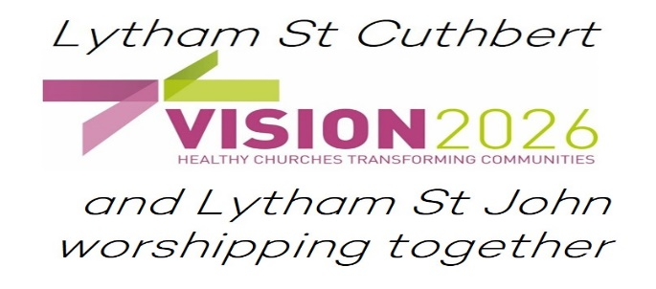
Mission Enabler

Introduction to Lytham and our new parish

Lytham is a coastal town on the Ribble estuary with a village feel. The town attracts daily visitors and is a place people aspire to live. Whilst the population is on the older side there are still many families and many activities for children. The town still retains a strong sense of community with an annual Club Day, a heritage group which manages Lytham Hall and other groups such as the Lytham Community Choir.
There is the feel of an older town built for the workers to the east. The west side was for several centuries the Clifton Family estate and has more recently has been developed as housing. The housing stock across the Lytham is a mix of terraced housing, semi-detached and detached housing.
People are proud to live in Lytham and there are long standing families here as well as people who have moved here for the attractions of the lifestyle it offers. This can create a tension as some have high aspirations and expect others to share those aspirations too.
Lytham proudly hosts both a major music festival and a 1940s weekend each year, both draw people from across the northwest and beyond. The town centre boasts over 40 eateries and coffee houses which is a major part of the local economy.
The two churches of St Cuthbert’s and St John’s are currently being pastorally reorganised to become a single parish with two worship centres. This single parish for the town will provide us with greater opportunities to offer outreach, pastoral care and discipleship.
The aim is for the churches to develop different flavours with the two-clergy working across them both. Both churches have explored varied styles of worship in the past and have retained choral traditions and we are in the process of starting a worship group. Nowadays St John’s has a more relaxed feel in worship whilst St Cuthbert’s appears to be evolving at present resulting from change coming out of the pandemic.
The two churches have shared Lytham Church of England Primary School for a couple of decades and this has proven the example for the new parish. We have strong links with the children and staff taking weekly collective worship, confirmation preparation and invitations to visit each class on occasion. Lytham Hall Park School also comes into St Cuthbert’s to mark the main Christian festivals.
We also enjoy strong ecumenical links with ‘The Churches in Lytham’ sharing worship together with an annual covenant service, Advent, Holy Week and other occasions.
The expectation is that the vicar, the Revd Nick Wells will be the lead and take particular responsible for the administration and pastoral care, the Mission Enabler concentrating on mission and outreach and together focus on discipleship and liturgy. Of course, these will all be shared with the PCC and congregations who are committed to discovering the new way to be the Anglican church in Lytham.

