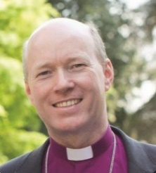
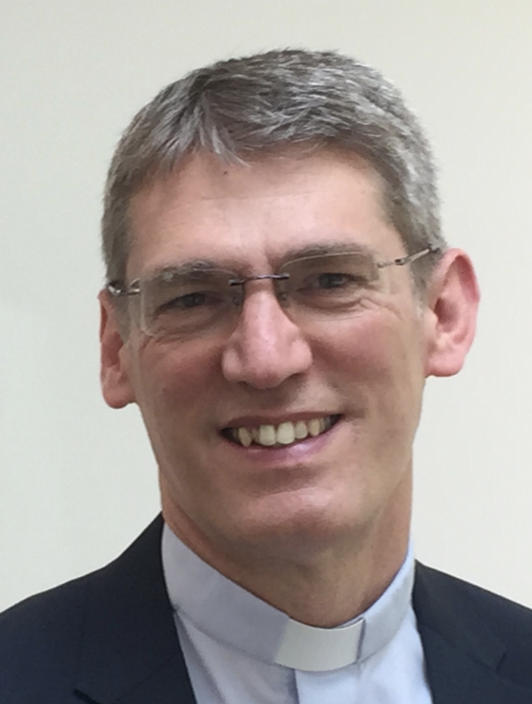
THE DIOCESE OF SOUTHWELL & NOTTINGHAM
GROWING DISCIPLES WIDER, YOUNGER AND DEEPER
A statement from
the Bishop of Southwell & Nottingham, the Rt Revd Paul Williams
and Archdeacon of Nottingham, the Ven Phil Williams

The Diocese of Southwell and Nottingham incorporates the City of Nottingham, the whole County of Nottinghamshire and five parishes in South Yorkshire. The population is 1.15 million – 51% live in the greater Nottingham conurbation, 31% in ex-mining areas and 18% in rural. There are 305 churches (252 parishes), served by 142 stipendiary clergy and licensed lay workers.

In 2016 a refreshed diocesan vision was embraced across the diocese, recognising the imperative for ‘Growing Disciples: wider, younger, deeper’.
• ‘Wider’ in that we will seek to grow disciples in every part of the diocese, with no retreat from any community: urban centre; outer estates; rural villages; or market towns.
• ‘Younger’ in that we will seek fresh ways to harness the boldness and creativity of children, students and young people across the diocese, not least in Nottingham which is the 4th youngest city outside London.
• ‘Deeper’ as we grow in knowing Christ, so that as his disciples we can be an increasing blessing to the people among whom we live and serve in the workplace, family and community.

The Bishops Senior Staff, Bishop’s Council and Diocesan Synod have demonstrated their clear commitment to sharing in all aspects of this vision and strategy. In autumn 2016 more than 1 000 PCC members attended 5 vision evenings around the diocese. We have discerned a series of emerging priorities that will facilitate growing new disciples in every parish across the diocese. Compelled by the love of Christ by 2023 we will seek to:
  - Welcome 7000 new disciples into the fellowship of Christ and his church
  - Commission 1000 younger leaders (especially 15-30 year olds) equipped and inspired to serve the purposes of God in the Church and society.
  - Plant or graft 75 New Worshipping Communities (NWCs) across the diocese to increase our reach in telling the story of Jesus to all.
  - Grow 25 larger Resource Churches with clear commitment to develop leaders, plant New Worshipping Communities, and disciple the young.
  - Serve and pray together as 1 Church contending for the gospel in every community and sphere of public life in our city, county and region.

In this new chapter every parish has an opportunity to review its role within the diocesan mission, so that it can play a significant part in the strategic commitment to ‘Growing Disciples wider, younger and deeper.’

Bishop Paul has said: “It is my hope that each worshipping community will develop a compelling picture of its own future in God’s purposes with an expectation of growing numerically and in the scope of its mission. It is my prayer that the new vicar will have the creative leadership and imagination to develop discipleship, plan for growth and reach out to the unchurched of all ages in its locality.”

March 2020

