

**Associate Priest (pioneer role)**

**St James’ Milton**

The Bishop of Portsmouth wishes to appoint a full time associate priest in a pioneering role who will play an active and key role in the encouragement of and nurture work with children, families and schools and build up fresh expressions in the parish. The successful candidate will also be part of the strategic leadership and development of the vision of the church communities in this corner of the city of Portsmouth.

The ER number is 152 and ASA is 100 within a parish of 25000. The post attracts a four bedroom house provided by the diocese and close to the church.

Informal enquiries welcome to the parish priest, Fr Paul Armstead.

For job description, background information and application form please contact the Archdeacon of Portsdown.

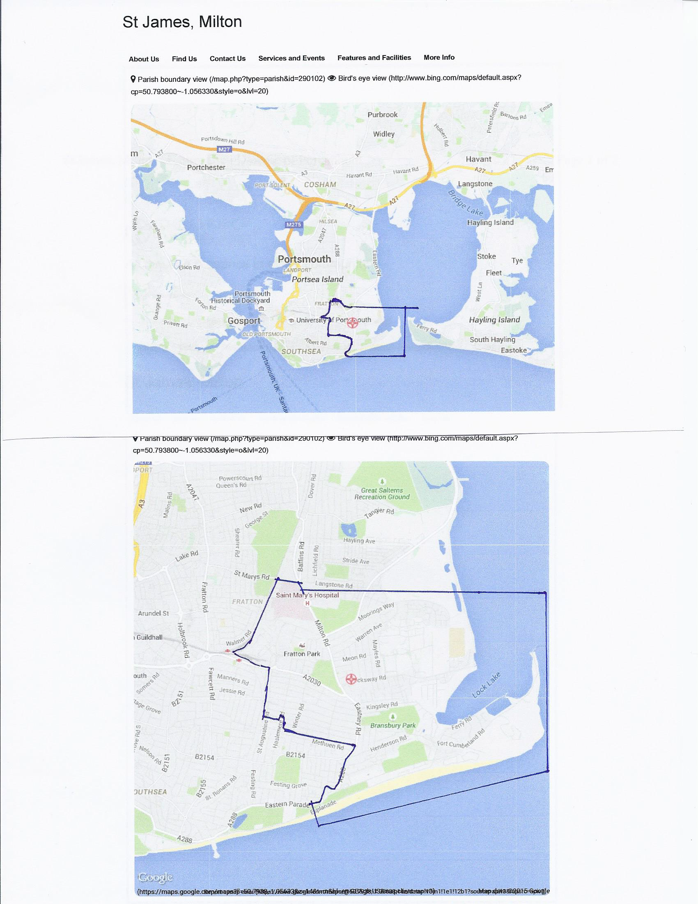



**Associate Priest (pioneer role)**

**St James’ Milton**

Portsmouth Diocese’s £2.3million Pioneer Project is committed to growing new disciples and new worshipping communities, with a particular focus on younger people, hard to reach areas, and new housing. We are assisted by strategic development funding under the Renewal and Reform programme. We are open to a creative variety of pioneering, church planting and fresh expressions approaches, supported by a milestones framework, which encourages pioneers to build up new worshipping communities.

**There is no job description as such as we would like to be brave enough to offer a blank piece of paper but in order to provide a basis on which to start we want to explore the following:**

* To go out and discern the spirit of the parish to find out what their needs, desires, hopes and aspirations are and how and where as ‘church’ we can meet them.
* To make introductions and build upon the existing relationships with the younger people, schools and other organisations, expanding the culture of church and family.
* Partner with other churches in the deanery and southern cluster in the provision of youth work where appropriate. Liaise with colleagues for shared opportunities and training possibilities.
* To share in the life of the parish assisting with services and occasional offices as required. Share in the pattern of daily offices.

**You will be**

* an ordained priest, male or female, within the Church of England, in sympathy with the Anglican catholic tradition. (Within these parameters the existing liturgy is catholic in ethos and well ordered, though with varying degrees of formality.)
* an inspirational person with energy, ambition, vision and ability to work collaboratively as part of a dedicated and enthusiastic team.
* a committed person able to play a part, with a wider pastoral team, in caring for the well-being of the worshipping community and enquirers with devotion, sensitivity and skill­

**Personal Competence and Vision**

* a person with proven ability and experience in working with children and young people, and capable of leading forward our ministry with children and their families, building consensus, and inspiring confidence in the process and outcome.
* a person able and willing to teach, encourage and foster the gifts of others.
* a person with the ability to relate to both sexes and to nurture and inspire them in the way of Christian discipleship.
* a person with an awareness of the way in which the contribution of the young may reach and enrich the wider community.
* a person who will develop our ministry to families, including those who are hard to reach, in ways that will facilitate growth within the Church community.
* a person who will engage with and celebrate the rich social and ethnic diversity of the area.