Profile for an

**Associate Minister**

**in the North Dartmoor Parishes**

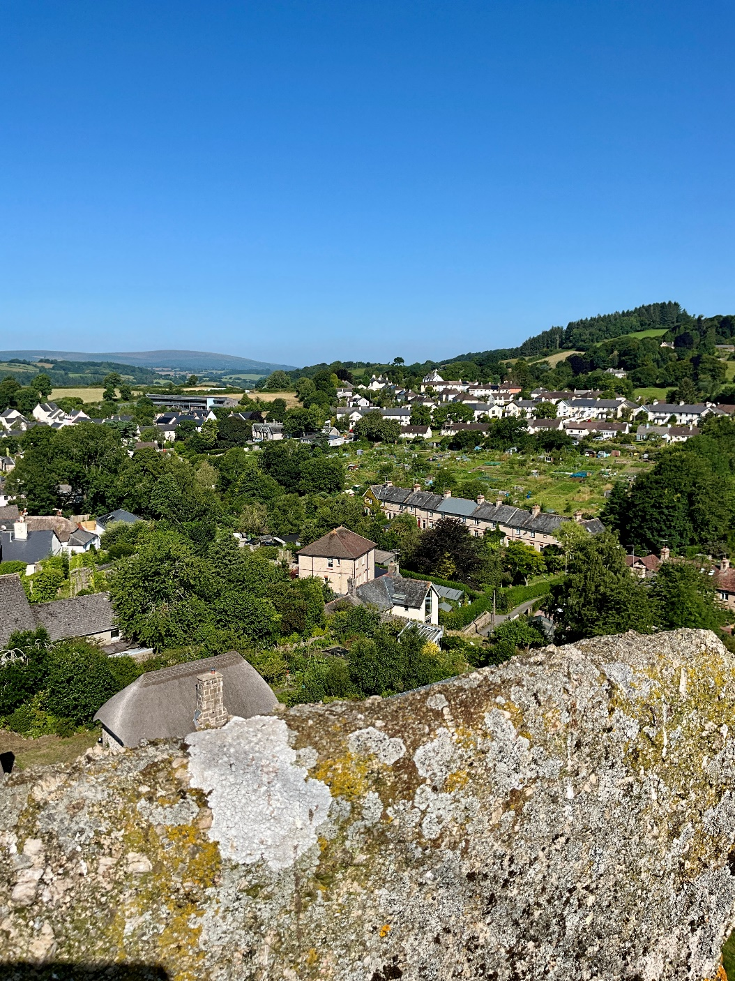

Communicating the Good News of Jesus and caring for the vulnerable, our communities and the wider creation.

**Associate Minister in the North Dartmoor Parishes**

We are looking for an Associate Minister (half time or on a house for duty basis*) to join the ministry team of the North Dartmoor Parishes.

The team shares responsibilities across the benefice of ten parishes, and the Associate Minister will live in Moretonhampstead Rectory, with pastoral oversight of the moorland town of Moretonhampstead and the Dartmoor villages of Lustleigh, Manaton and North Bovey. Each parish has a fine historic church, a local pub and its own community events and organisations.

The team is made up of a rector-designate who lives in Chagford, a number of retired clergy, five licenced lay ministers, two administrators, and some lay worship leaders, all of whom meet together on a monthly basis.

Full details of all the parishes and of the team can be found on the website: [www.northdartmoorparishes.co.uk](http://www.northdartmoorparishes.co.uk)

For more details, please be in touch with the Rt. Reverend Nick McKinnel, Priest in Charge of the NDP:

**07773 363330**

[Nick.mckinnel@gmail.com](mailto:Nick.mckinnel@gmail.com)

**Application Form**

Please contact The Ven. Douglas Dettmer, Archdeacon of Totnes for an application form:

**(01626) 832064**

[**ADT@exeter.anglican.org**](mailto:ADT@exeter.anglican.org)

Closing Date for Applications: 20th October 2025

Interviews: 6th November 2025

*In the Diocese of Exeter, the expectations of a 0.5 post are Sundays (up to three services) and a minimum of three days per week; six Sundays off per annum, not less than six weeks holiday; 0.5 stipend and house.

For a house for duty post, they are Sundays (up to two services) and two days per week; nine Sundays off per annum; not less than six weeks holiday; no stipend, only the house.

**THE PERSON**

We are praying for someone who:

* Understands and enjoys rural and community life
* Loves the Lord, people and the good news of Christ
* Offers thoughtful and biblical preaching
* Values ministering within a team, lay and ordained
* Appreciates the individual identity of each parish while encouraging helpful ways of working together
* Has a gentle style of leadership, expressed by consulting and serving

**THE ROLE**

Particular features of this role include:

* Leading worship in a variety of expressions
* Helping to nurture the spiritual life of the parishes, especially in Lustleigh, Manaton, Moretonhampstead and North Bovey
* Taking part in the life and events of the local community
* Developing contacts with Moretonhampstead Primary School and the families of children who attend
* Taking occasional offices as the need arises

**Some Observations**

The North Dartmoor Parishes is a new multi-parish benefice being formed out of parishes grouped around Chagford (the Whiddon group), and Moretonhampstead (the Moreton group), with the rector living in Chagford and a part-time post in Moretonhampstead. There is also a parsonage house in South Tawton, currently let out to tenants by the Diocese.

While some of the churches are stronger than others, all have warm-hearted and welcoming congregations. They vary a little in their liturgical traditions but on the whole services are straightforward, unfussy and much appreciated, with friendly gatherings for refreshment afterwards. Churchwardens and lay worship leaders ensure a full pattern of services.

Current priorities in our church life include developing the life of the benefice; deepening discipleship; work with schools, families and young people; strengthening local leadership; and encouraging outward looking, resilient congregations.

All of the churches are well integrated in their communities with many of the congregation having leading roles in their village. Most parishioners feel it is “our church” even when not attending, and the buildings are regularly used for concerts, lectures and other events.

The current Priest-in-Charge, (Rector Designate) Nick McKinnel, is on a 2-year (renewable) licence to oversee the pastoral organisation and develop the team. The intention is to avoid a long vacancy by giving extended notice of his plans to retire.

Administration is well looked after by two administrators, Heather and Maria.

**The Rectory**

The Rectory is a modern four-bedroom house in Moretonhampstead, with a southerly outlook over the town towards high moorland and Haytor on the horizon. On the ground floor the front door opens to a hallway with a study and a cloakroom, with a door leading through to the main downstairs living area, comprising a dining room/sitting room/kitchen leading off one another. There are also two bedrooms, one with an en-suite, and a separate shower. The kitchen has a separate utility area with an external door leading to the front driveway. The sitting room has a sunny southern aspect with floor to ceiling glass patio doors leading onto a small, sheltered patio and seating area, and a step down to the garden. Upstairs there are two bedrooms with hand basins, and a bathroom with a separate shower.

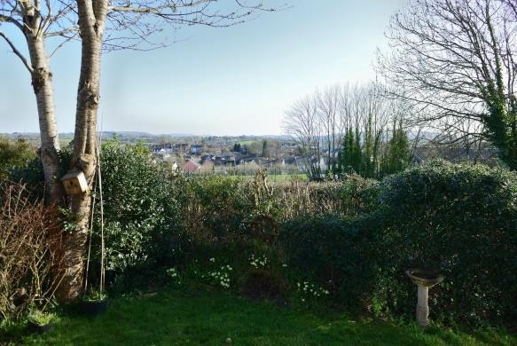Externally, the front of the house consists of a driveway with room for adjacent parking, and a garage. The garden surrounds the other three sides of the house and has a small vegetable plot, a spring garden, two apple trees and a strip of lawn. The southern and easterly walls of the house are extensively covered by the attractive foliage of Virginia creeper during the warmer months of the year. A combination of mature hedgerows, shrubs and trees ensure a good degree of privacy.

**From the Archdeacon of Totnes, The Ven. Douglas Dettmer**

Thank you for your interest in the appointment based at Moretonhampstead in the North Dartmoor Parishes. The northeast fringe of Dartmoor is an attractive place to live and work. Its thriving small towns and hamlets are set in a rural landscape of exceptional beauty, easily accessible to Exeter and beyond. The new Associate Minister will find a warm welcome from open-minded local churches and from gifted, supportive colleagues. He or she will have the opportunity to exercise a rewarding ministry in communities which highly value the presence of their parish churches.

](https://exeter.anglican.org/wp-content/uploads/2024/06/Bishop-Mike-1-scaled.jpg)The **Right Revd Dr Mike Harrison** became **Bishop of Exeter** in November 2024 and since his arrival has continued to develop our diocesan vision for mission and ministry. Bishop Mike says: “The Diocese of Exeter’s vision to grow in prayer, make new disciples and serve the people of Devon with joy has evolved over the last five years, with a widespread post-pandemic listening consultation leading to the development of the [‘Next Steps’](https://exeter.anglican.org/who-we-are/vision-strategy/) strategy to support mission communities to flourish and be sustainable for generations to come. It’s a vision that fits with Jesus’ commission in Matthew 28.16-20, which is authoritative for me and I’m sure for many.

“Putting flesh on the bones of the vision, I would like to articulate five particular priorities for this next season of our life together. First, **Missional Leadership**: equipping and resourcing the ordained and lay leaders of our Christian communities as best as we can to develop disciples and make new disciples. Second, developing a “**Missional DNA**” across our Christian communities, encouraging outward-looking, invitational churches, hospitable to outsiders and engaged with their wider communities. Third, cultivating an intentional **Vocational Culture** so that we are not asking *whether* God is calling me / us, but ‘*To what* is God calling me / us now?’ Fourth, **Children & Young People** being placed at the heart of our life, mission and ministry. And fifth, **a Mixed Ecology**: understanding that we need different ways of doing and being Church. Alongside time-honoured Church we need all sorts of Christian communities which can engage with the 95% of our population who are as yet unengaged. I hope that these five priorities will become embedded at every level of our ministry going forward.”

Further information about our Diocesan Vision can be found at:

<https://exeter.anglican.org/who-we-are/vision-strategy/>

In the diocese of Exeter we aim to be a diverse and truly representative diocesan community and particularly welcome applications from women and from people of global majority heritage. This diocese is a good place to be in ministry, and it is a particularly exciting time of growth and development in our diocesan life. May God bless you as you continue to discern whether you might be called to a ministry in the North Dartmoor Parishes.

With my best wishes,

*Douglas Dettmer, Archdeacon of Totnes*

[*ADT@exeter.anglican.org*](mailto:ADT@exeter.anglican.org)

*(01626) 832064*