# Hutton Cranswick with Skerne, Watton, Beswick & Nafferton with Wansford

**Gr**

**Interim Minister (Priest in Charge)**

St. Peter’s - Hutton

St. Margaret’s - Beswick

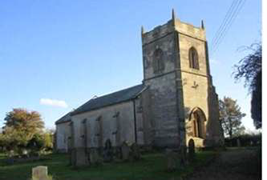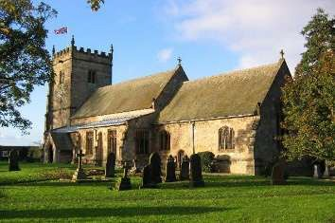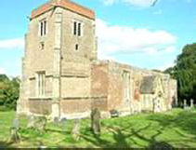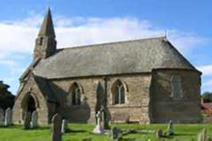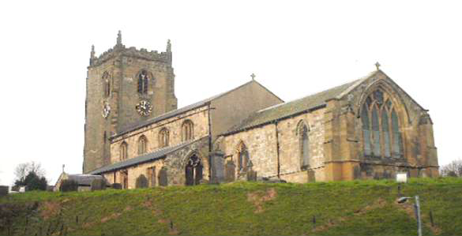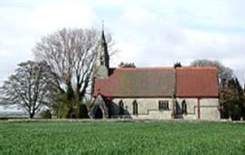

St. Leonard’s - Skerne

St. Mary’s - Watton

St. Mary’s - Wansford

All Saints’ - Nafferton

**Greetings in Christ’s name!**

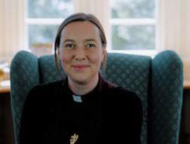Thank you for prayerfully discerning God’s calling to these two benefices and also to the East Riding Archdeaconry in the Diocese of York. We trust this profile will begin to give you an understanding of the churches and parishes, but above all, we welcome you to come and meet us here!

This post has become available at a very significant time in the life of the Diocese. We have committed together in *Living*

*Christ’s Story* to being people who tell the story of Jesus’ life death and resurrection and who also tell the continuing story of what Jesus has done through his church, which includes what Jesus has done and continues to do through each of our own lives. These are times that require us to be simple, humble and bold.

To make the vision of *Living Christ’s Story* a reality, our diocesan goals are:

* Becoming more like Christ
* Reaching people we currently don’t
* Growing churches of missionary disciples
* Transforming our finances and structures

You can explore this vision more fully on our Diocesan website.

This role is full of opportunities for someone who enjoys rural ministry and will bring enabling and strategic gifts to these parishes. Where benefices are not covering their ministry costs, the diocese is now appointing Interim Ministers to encourage a renewed focus and momentum. It is proving an effective model. Initially appointed for 3 years, all have stayed longer, either extending for a further 3 years or becoming permanent appointments. I am very encouraged by the way the parishes have already responded during the vacancy and have every confidence that this is a place where both the clergy and people will flourish. You will not be alone – there are existing ministerial colleagues, lay and ordained, plus supportive churchwardens and congregations.

As a Diocese we pray together the prayer of Teresa of Avila, “Lord, what do you want from me?” This is our prayer for *Living Christ’s Story*. We pray this prayer particularly for you in this time of discernment. Please do contact Archdeacon Andy Broom by phone (01482 881659) or email ([ader@yorkdiocese.org](mailto:ader@yorkdiocese.org)) if you have any questions or would like a fuller picture than the Profile offers. We want to do all we can to support you as you explore and discern this call.

With our prayers,

+Ele anor (Bishop of Hull)

## WELCOME..................

to the two benefices of Hutton Cranswick with Skerne, Watton and Beswick and Nafferton with Wansford. These are six rural parishes on the edge of the Yorkshire Wolds – a beautiful part of the County of East Yorkshire.

Thank you for taking an interest in becoming our next Minister. We recognise the need for change, and we are all anxious to grow our churches; we have been given the task of encouraging an Interim Minister to lead us into the future, hoping that the Interim Post will become a Permanent Post after three years.

In the Benefices we have two larger churches at Hutton Cranswick and Nafferton, along with the four smaller churches of Skerne, Watton, Beswick and Wansford. The churchwardens meet on a regular basis to share ideas and experiences as to what is happening in their church. You can see from the pattern of services that the larger churches each have 4 or 5 services each month whilst the smaller ones have two. A fifth Sunday is served by a ‘Benefice Service’ held in one of the churches in rotation, to which all six congregations are invited.

Each of the Church communities wishes to be a visible presence within their own village. We look for someone who is moved and called by the Spirit to lead us forward. We have active church members, particularly in the larger churches, who look to sharing your Ministry, as we all seek to ‘Live Christ’s Story’ in serving those we live amongst.

## Where next for our Benefices?

We recognise that decisions must be made in the next three years about the shape of ordained ministry to lead us forward. The churches are highly committed to working with a new Interim Minister as we explore more of ‘Living Christ’s story’.

Meeting between the church leaders, the Archdeacon and the Area Dean have noted challenges in growing our congregations, and as a result to grow the amount that we are able to contribute in the Freewill Offering. We very much hope that the post of Interim Minister will become permanent, and we look forward to being led forward in this matter by a new incumbent.

We have already identified changes that may help:

* Growing vocations – being open to seeing in people in our midst those who have a calling to Lay Ministry or to Ordained Ministry.
* Collaboration – we have two larger churches and four smaller churches in the benefices. There is a real hope that, by sharing ideas and insights, we may be able to help one another to thrive, possibly by some of the smaller churches combining their PCCs.
* Realistic expectations – because we comprise churches of different sizes, our monthly service pattern means that clergy time will differ from village to village.
* Future re-organisation – as we explain on the page for St Mary’s Wansford, there are some questions around its future and the possibility of combining its parish with All Saints at Nafferton

Our churches face the future, wishing to be healthy, growing and engaging with the communities. Our fervent desire is mainly to share the Good News of Jesus with those around us.

**Interim Minister Person Profile**

We are looking for a gardener to cultivate the land; fertilize the crops; sow the seeds; and grow top-quality produce for the future

### Vicar’s Personal Specification (Gardener)

* A Minister secure in the Christian faith and grounded in their vocation and calling; and looking to grow in personal holiness in dependence on the Holy Spirit
* A team player with a good sense of humour, and a vision for being part of a team.
* A knowledge of rural parish ministry

### Improve and prepare Churches of today (Cultivate the Land)

* A strategic and visionary thinker who will discern the way forward and establish a plan to successfully secure a new vicar
* Working with and helping the six churches come together ~~as one~~; and assisting them through change, by identifying strengths, weaknesses and opportunities
* A visible presence in the villages; able to build relationships in the Deanery, and with other churches of other denominations; especially the Methodists, with whom we share several services.
* Able to lead, build and grow the Ministry Team, utilizing gifts, planning rotas and preaching; and exploring innovative ways of delivering the Christian message.
* Encourage us to grow our income through greater generosity and more effective fundraising.

### Feed and help the congregations (Fertilize the Crops)

* A character with a good sense of humour, who enjoys people, getting to know them and care for them. Committed to pastoral care, and with a focus on meeting the needs of all parishes both inside and outside the church.
* A good communicator and excellent Bible teacher, with the ability to help the congregations explore more about their Christian faith and so grow in knowledge and understanding, applying this to their daily lives
* Confident in the use of Spiritual gifts and able to discern and grow gifts in others

### Touch lives of families, youngsters and children (Sow new Seed)

* Enjoys working with youngsters and children and will rekindle the work with schools and other youth organisations, encouraging them to explore their Christian faith, and ultimately encourage them into the Church family.
* A vision for families, with initiatives and events to nurture their talents and encourage them to become active Christians and take part in Church life.

**Build a thriving Church (Top Quality Produce for the future)**

### This is part of your spiritual journey, your vocation and calling, and this pilgrimage will involve retreats and study, for which we offer encouragement and love in prayer, praise and fellowship.

**We trust your ministry here will be fruitful, growing healthier churches and that you will be able to stay beyond the interim timescale.**

**Ministry Team**

The Ministry Team consists of one Licensed Lay Minister and one Authorised Lay Minister. There are three candidates presently in training to be Authorised Lay Ministers, who complete their course in April 2025. We are ably assisted by an active Area Dean and three retired vicars, one of whom has been licensed as Assistant Curate to help us through the vacancy.

We work across the six, very different churches, loving and encouraging each congregation, by joining with them in their events, and leading them in services of Holy Communion by Extension, Morning Praise, Choral Praise, Evening Prayer, Evensong, Songs of Praise, Pet services, Festival services, Taizé services, Celtic services and many others. The four smaller congregations receive two services a month and the two larger congregations receive four or five services a month.

There are good relationships with both of the Methodist chapels that are in the area, with a number of joint initiatives. Also taking monthly assemblies in school and the Residential Care Home; as well as sharing house-groups and studies.

We look forward to welcoming you and working with you, and to growing our church congregations for the future.

**MAP SHOWING LOCATIONS OF THE VILLAGES**

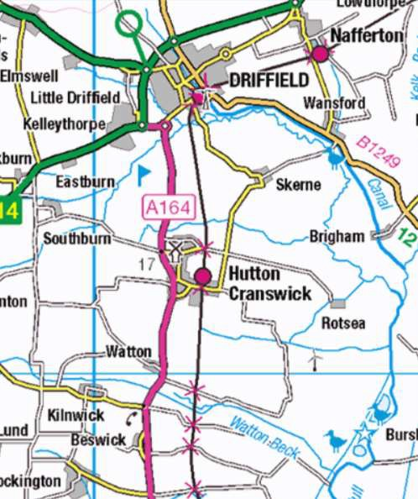

**St. Margaret’s**

**St. Mary’s**

**St. Peter’s**

**St. Leonard’s**

**St. Mary’s**

**All Saints’**

## Hutton Cranswick

Welcome to Hutton Cranswick; a large, busy, vibrant, and friendly village. Come and meet the community of approximately 1196 dwellings, 2251 people, including 372 under the age of 18, with 64% of them declaring themselves to be Christians (2021 census).

Hutton Cranswick, nestled in the heart of East Yorkshire. Originally two villages that have merged together to form a single village, as they’ve grown and expanded. The village is ideally located for access to public transport, with a Railway Station, and trains running from 7am-11.00pm weekdays linking Scarborough to Hull, and beyond to York and Sheffield. Also, an hourly bus service linking Driffield, Bridlington, Beverley, Hull and York. Hutton Cranswick has excellent walking routes and joins the extensive network of cycle routes around East Yorkshire.

Enter into Hutton, the smaller of the two villages, and here you’ll find St Peter’s Church. Also, the Sports & Recreation Association, and Gatehouse Lake. Enter into Cranswick, and a large village green centralizes the village, with a children’s play area on the edge. It is here that twice a year joint services with the Methodist congregation are held outdoors, along with a carol service round the Christmas Tree at Christmas and a remembrance service round the war memorial in November.

The village primary school is situated on the West side of the Green and caters for approximately 180 children from the ages 4+ to 11. For the older children there is a regular bus service to Driffield School. The village is also home to a Scouts, Cubs and Beavers Group, as well as Guides, Brownies and Rainbows.

Shopping facilities in the village are amazing, with a Post Office and general Store, a butcher, fish & chip/Chinese takeaway, a Farm Shop with café, a Garden Centre with café, and the White Horse Pub. There is also an industrial estate on the outskirts, housing over 40 businesses; and three garages selling cars. One of these, situated near to the railway station has become the ‘Village Hub’ for events; the Church is especially grateful to them, as we are able to hold village markets, fashion Shows, concerts and Burns Night celebrations for the Church funds, in the showroom.

Hutton Cranswick, two busy villages with an active community, having its own newsletter, “The Bulletin” to ensure everyone knows what and when events are taking place. The Sports and Recreation Association, on the outskirts of the village, caters for many sports, football, cricket, tennis, archery; and indoors, various keep-fit classes, table tennis, coffee mornings and quizzes and community events take place. It is here the Community Choir meets. There is a Bowling Club, a Village in Bloom Group and Women’s Institute. The village also has a residential care home for the elderly.

The village is also home to The Methodist Chapel on Main Street with whom we have strong links, sharing services and events several times a year.

Hutton Cranswick is a thriving community in need of a shepherd, to grow the people in the love of the Lord

## ST. PETER’S CHURCH

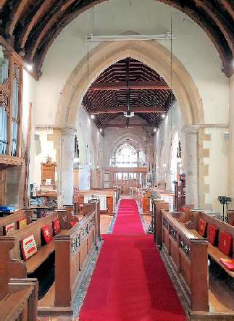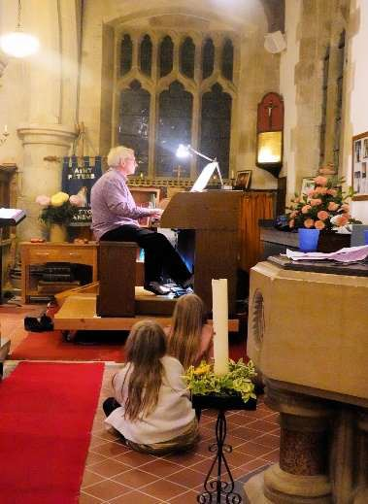St Peter’s Church, Hutton is a grade 2* listed building with remnants of Norman and Early English architecture. A huge restoration programme was carried out in 1875/6 and much more recently a re- ordering in 2017/8 when pews were removed at the west end and toilet facilities and a kitchen installed. At the present time we now have a building with mostly pews but with a large social space at the back along with a small meeting room, with available wi-fi.

There are at the present time 58 names on the Electoral Roll.

We have services each Sunday, the music being led either by the Choir and organist or by the Worship band. The robed choir and organist Alan enjoy singing in harmony to the Lord! It is affiliated to the RSCM and practises every Friday, leading the music in two morning services and a sung Evensong every month. The Worship band, also called The Revelation, leads the music for the other two services each month, a Family Service and a service of Family Communion. The band is led by Matthew and consists of 3 guitars, one trumpet, one flute, and one violin along with 4 singers.

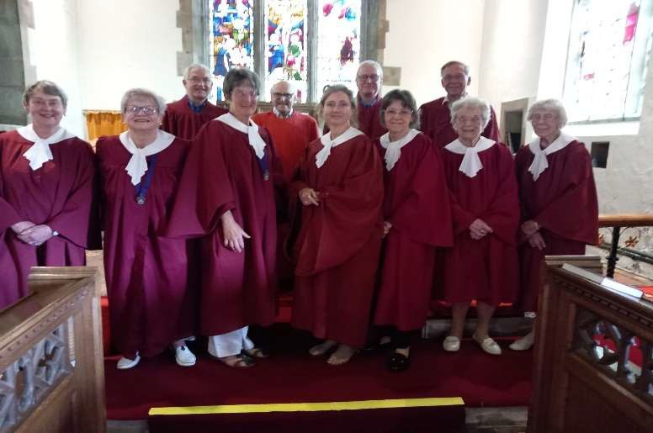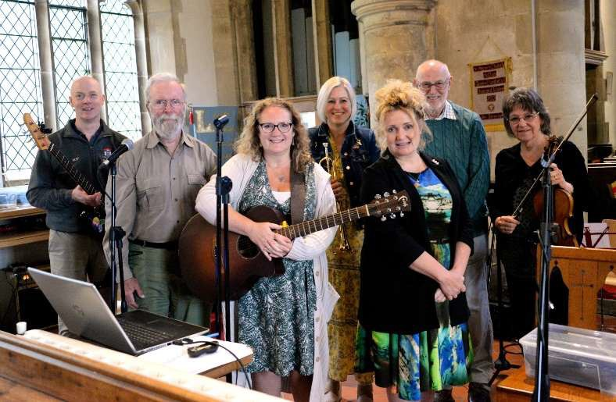

Services have an average attendance of between 30 and 40, sometimes using printed sheets and hymn books, at other times the service is projected onto a large screen. This is accompanied by a fine sound system which was installed with the more recent re-ordering. After morning services, refreshments are served to all who wish to stay and enjoy fellowship.

The Church is open daily during hours of daylight and this attracts visitors from not only the locality but from other parts of the UK and the world who come, very often looking for their ancestors. We are fortunate in having a team of people to clean the church on a rota basis, also flower arrangers who use their skills to beautify the church with flowers.

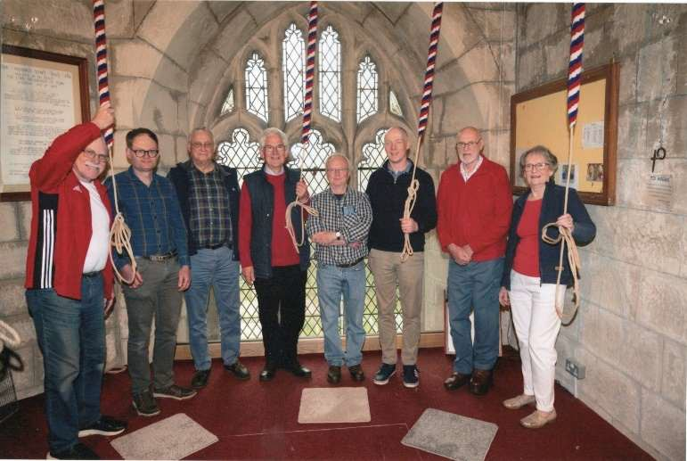We have a splendid ring of 6 bells but unfortunately at the present time, very few ringers. For special occasions such as weddings we are able to enhance the team with ringers from nearby towers. We do have an Ellacombe Frame housing bells ropes which can be rung for most services.

A Mission Committee looks at the short- medium- and long-term spiritual direction of St Peter’s Church. It meets monthly and the 5 year Strategic Plan which it has developed, is regularly reviewed and covers 5 Main

Areas. These are:- Spreading the Christian Message, Welcoming Younger People, Communications and Publicity, Community Hub, Life Events and Heritage. Any recommended proposals are submitted to the PCC for discussion, amendment and approval before implementation. Events which have taken place to bring non-religious people into the Church include Open Days, Musical Evenings, Cookery Displays and Harvest Suppers.

An active Fund-raising group works tirelessly in organising events to make sure that St Peter’s is on a ﬁrm ﬁnancial footing. Recent events have been Open Gardens, Burns’ Night Celebration, Concerts and visits to a venue in York that is available for stalls, refreshments, etc. Refreshments are also provided on a regular basis at the Village Market, and a Harvest Hoe-down is planned for the Autumn. Last year the group raised about

£15,000 to help to keep the church viable. During 2023, in total almost £50,000 was spent to provide the Christian ministry from St. Peter’s. This included Freewill Oﬀering to the Diocese of £16,000, which represented 33.33% increase on the 2022 ﬁgure of £12,000. The church seeks to keep increasing the Freewill Oﬀering over the next two years in order to cover its share of the total costs of the ministry to the beneﬁces by 2025.

Outside, the large Churchyard area is well maintained by a group of grass-cutters who work on a regular rota. A newly-formed small team also meets every few weeks, helping to manage the more diﬃcult corners.

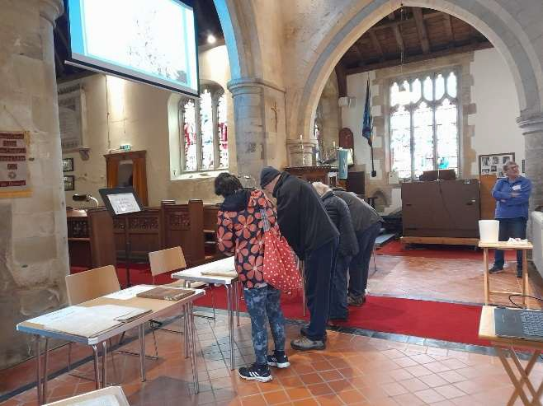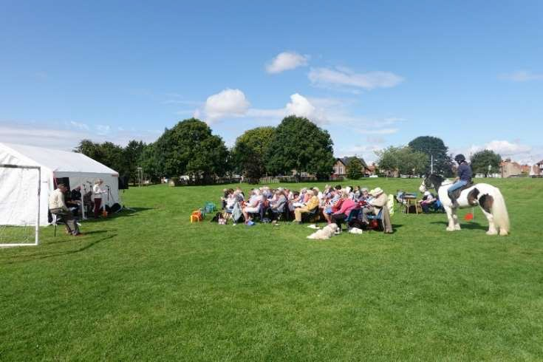

*Churchyard Open Day*

*Pet Service*

## St Mary’s Church, Wansford

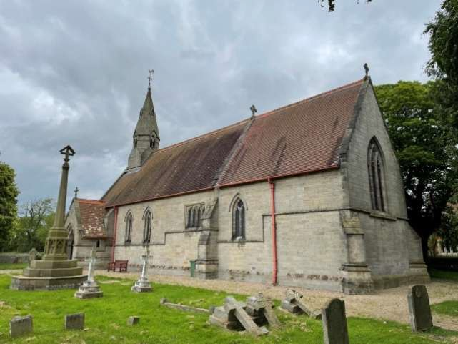

St Mary’s Church in the small village of Wansford is an architectural gem. The ﬁrst of the 18 Sykes Churches, it was commissioned by Sir Tatton Sykes, of Sledmere, who owned the village at that time, designed by G E Street, and opened in 1868.

It is a Grade II listed building, and generally in good order having been rewired and reroofed in 2007. However, it has no water supply and thus no community facilities; there is a rudimentary heating system (which doesn’t obviate the need for thermals in winter).

There is live music at each of the two monthly services, with the guitarist also being a ﬁne singer and a choir in himself. Currently three people regularly attend services with ﬁve or six on good days; the 60-year old songster brings the average age of attendees down to 73. There are 12 on the electoral roll with an average age of 75, many live outside the parish. There has been no churchwarden for four years and the PCC consists of three members.

There is some uncertainty about the future of the church and the earliest conversations have occurred about possible closure. We are also exploring the possibility of combining our PCC with All Saints’ Naﬀerton.

The village is part of the Skerne and Wansford civil parish, which had a population of 345 in the 2021 census, with more than 200 of those living in Wansford, the larger of the two. Of those 80 or so households, three, who have little or no interest in attending, support the church ﬁnancially. It is conceivable that there is more potential for pledged ﬁnancial support, given a persuasive argument, as there is much goodwill within the community for the church – as illustrated at the annual carol singing event when the ‘choir’ is well received on its tour of the village. It is hoped that this year, once again this will culminate at the newly re-opened and refurbished Trout Inn, which has in the past been a focal point for many church fundraising activities.

In addition, the village has a well-equipped hall; weekly coﬀee mornings oﬀer an opportunity for a new priest to engage with residents. The hall brings the community together in a craft group and for regular bingo nights.

The village is in the Naﬀerton Primary School catchment area and from there the children move onto Driﬃeld School. The youngsters look to Naﬀerton and Driﬃeld for sporting and social activities and membership of organisations such as the Scout movement.

This is where St Mary’s is at…and members are well aware that the current ‘business model’ is a challenge in itself. It is hoped that the right person would step up to that challenge with hope, optimism and realism and bring much-needed energy and enthusiasm to the role.

## St Leonard’s Church, Skerne

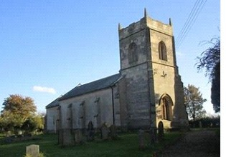

Skerne is a small village with a population of some 160. St. Leonard’s Church is the only public building available within the village and, although the lack of facilities tends to restrict its use, we use it to hold concerts and talks.

The Church is a Grade 1 listed building of Norman origins. A local amateur historian dated its foundation as 1150 and the windows were altered during the 14th to the 18th centuries. The tower was added in the 15th century. The traditional pews were removed and replaced with chairs in 2009 and the two bells, which are thought to date back to the 16th century, and the bell tower were refurbished and rehung in 2000.

We normally hold services, Holy Communion and Morning Praise each month. The average congregation is about seven or eight, with much higher attendances for special services such as Christmas and Easter.

The strengths of St. Leonard’s are a beautiful and well-maintained church and yard, a small but creative and active people, and a regular organist. We have an excellent record of meeting our ﬁnancial freewill oﬀering. Tea and coﬀee are provided after each service.

Our weaknesses are a PCC which is under strength in its numbers, small congregations and very limited facilities in the Church.

We aim to continue holding regular services, to try to increase the numbers who attend those services and to develop the Church as the community hub for the village of Skerne.

## St Mary’s, Watton

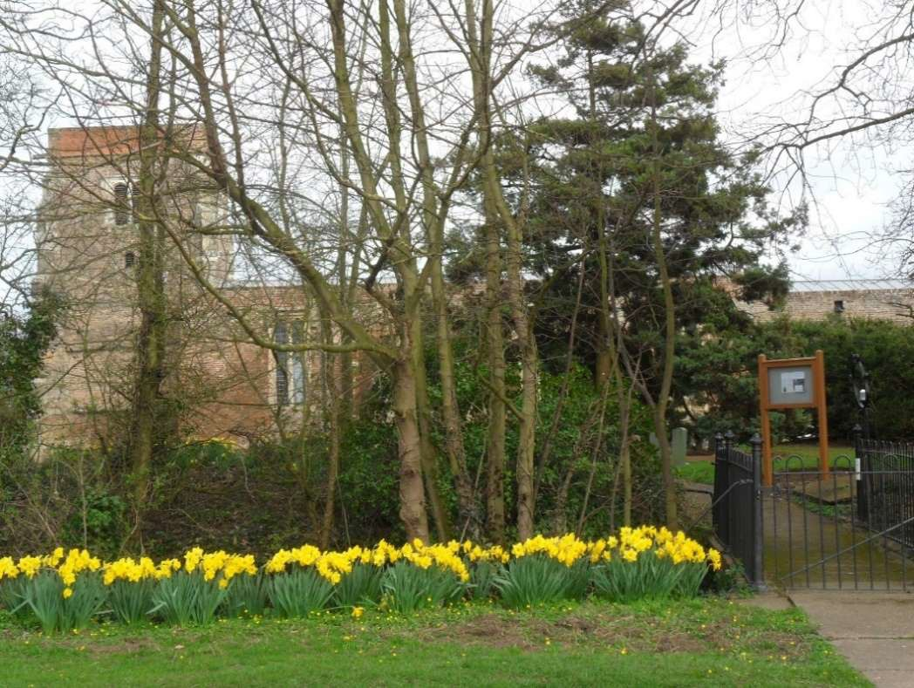

**Parish Profile**

Watton is a large, (5miles long, 1 mile wide) rural parish, with a population of around 260. Some 60% live in the village of Watton, with the remainder living at The Top Hill Low Nature Reserve and on farms around the parish.

The church of St. Mary is in the centre of the parish, though outside the village for historical reasons.

St Mary’s is a Grade 1 Listed building, built, we believe, in the early 16th century as a place of worship, to replace the nearby Abbey, a Gilbertine Priory. Many of the building materials used were recycled from the Abbey, and a recent ring-dating exercise dated the roof beams as coming from trees felled between 1465 and 1490.

A major restoration project was carried out some ten years ago, and the fabric of St. Mary’s is sound. Central heating and a water supply were installed at the time, and recently disabled accessible toilet facilities have been added.

Despite the major expenditure on restoration and installation of central heating and toilet facilities, the church finances are, through legacies, regular giving, collections and eligibility for grants, many from local charities, in a healthy state. We have regularly given a generous share of the costs of the incumbent in our Freewill Offer.

Services are currently held twice a month, and regular attendees number around ten, though special services, such as REME, Harvest Festival, Christmas etc, do attract a larger congregation. With such a small number of parishioners, weddings, funerals and baptisms occur infrequently.

There is no village hall in the parish, and St. Mary’s is seen as a community building, for use other than for church services.

Fund raising events, such as the village fete, craft fairs, lectures and concerts are held at St. Mary’s, and we envisage greater use by various bodies in the community now that there are toilet facilities.

Despite relatively low numbers at the regular services (though this is some 5% of the parish population, a fairly high figure!), there is interest in the community in the Church. On Saturdays before a Sunday service we run a “Warm Church” and regularly get around 10 attendees, many of whom are not regular church attenders.

The local school is the CofE Beswick and Watton primary school, with connections to both Watton and Beswick churches for visits, Harvest Festival, Carol Services etc.

There is a core of dedicated, involved, people at St. Mary’s, and a level of interest in the community side of the church which needs nourishment/ encouragement. Very few young, school age children in the parish, but plenty of active adults.

“Community” is where we see the potential for growth. The challenge is that very few are interested in the religious worship activities of the Church, but many are interested in involvement in community projects, particularly valuable in such a scattered community. An incumbent who could help to galvanise and involve this section of the community would probably help to increase interest, and involvement, in the Church.

## St. Margaret’s, Beswick

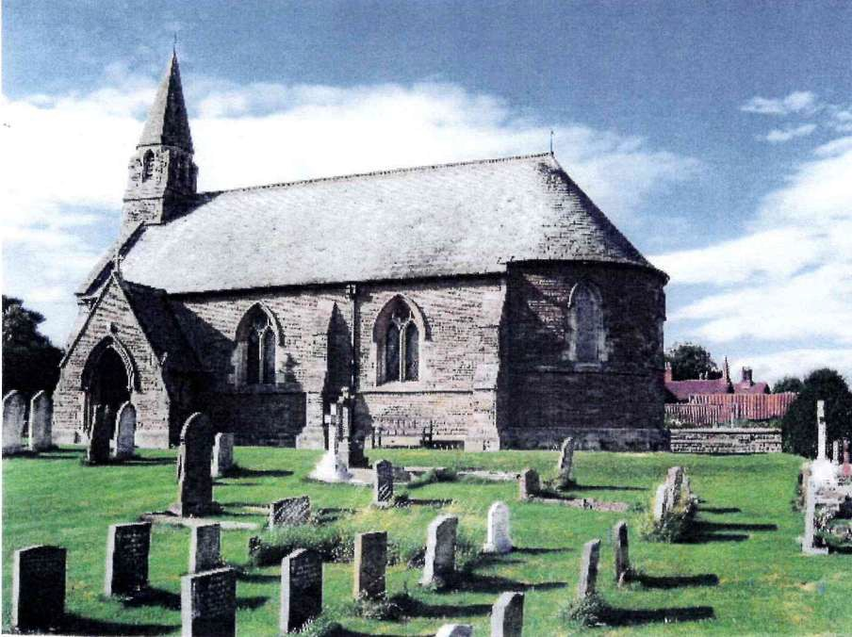

**Parish Profile**

Beswick is a small attractive rural village which lies on the outskirts of the Parish.

There is a population of around 300 in the village and surrounding area and agriculture is at the very heart of the local community.

St. Margaret’s church has an unusual circular chancel, can comfortably seat 90 and both building and grounds are well maintained by a small church team who work well together.

We currently receive two services a month, one communion and one family service, which traditionally has been held at 8.00am. Services are regularly attended by a small congregation including the organist.

Festival services, such as Harvest and Carol services are well attended and often the church is full.

Similarly, the music concerts, organised to raise funds, encourage musicians of all ages and stages of their musical journey to perform in safe and encouraging environment, is well attended.

We always aim to keep our funding raising going steadily over the course of the year and thereby ensure that we pay our promised Free Will Giving and general running costs when they arise.

We keep links (along with Watton Church), with our local Beswick and Watton CofE School as they use our church for their Harvest and Christmas Services.

Beswick would love a friendly Vicar who is happy to be visible within the community and be able to guide and support us when needed.

## All Saints’ Church, Nafferton Parish Profile

The Village: Has grown in recent years and now has a population of around two thousand. There are a couple of shops, three pubs/restaurants, junior school, Methodist Church, and a variety of small businesses. There are a lot of small bungalows which attract a good number of retirees but an advantage in that is that there always seem to be lots of people about - walking dogs etc, so people generally know each other quite well. There is a good range of social activities including uniformed groups; craft, art, writing, gardening, sporting and regular gatherings such as ‘tea and chat’ mornings.

The Congregation: Under the leadership of associate priest, Ian Holdsworth, the congregation has tended to grow and attendance at main services is currently usually in the mid to high twenties. The community spirit within the congregation is strong and visitors often say that they feel welcomed. While some of us are nearly as old as the church building there have been welcome additions of younger people as well. Ian has encouraged several members of the congregation to take up the challenge of developing skills in leading part of the services, and acting as acolytes, and participating in leading parts of the services.

The Services: The main Sunday services usually alternate between Holy Communion and Morning Praise. Liz Stothard Chew (in training as a Reader) has introduced monthly ‘Taize’ services and these have attracted attenders who do not come to other services. The special event services including Remembrance and Christmas ‘Crib’ services also attract strong support from people who are not regular church attenders. There is steady demand for weddings funerals and baptisms.

The Church Building & Grounds: The building is Grade 1 listed, in a prominent position overlooking the village mere. The pews at the back have been removed leaving an open space for a wide variety of gatherings as well as post-service mingling. We have received a recent quinquennial report and grants are being sought to help pay for the work identified – some of which is fairly urgent. There is a peal of 6 bells in the tower with ten ringers who are led by an enthusiastic Bell Captain who is also active in helping the church in a wide variety of ways.

The immediate graveyard has been ‘closed’ for many years but is maintained by a district council, on a monthly basis. In an adjacent meadow there is an ‘open’ graveyard which is maintained by our groundsman (when he is not wearing his Bell Captain hat!) supported by a couple of volunteers and a small grant from the Parish Council.

Finances: We are able to meet our Freewill offering (£8,500 pa.) but are conscious of the need to increase this as explained in the notes about the Benefice.

Opportunities: The junior/infant school (260 pupils) is close by and makes quite regular use of the church for various activities including special children’s services, nativity plays, and activities to help children learn about their cultural heritage – for example a ‘wedding’ service where the children acted out the various roles. Although it is not a church school as such both parties would like the link to be developed further.

There are friendly informal links with the Methodist Church with shared activities including a prayer group that meets weekly at All Saints and a Bible study group that meets in the Methodist Church Hall, plus occasional joint services. Again, further development would be welcomed on both sides

We have the advantage of a regular page in the village bi-monthly newsletter which has proved to be an effective way of attracting people beyond the regular attenders to things like Alpha and Confirmation preparation classes that Ian led last year.

Limitations: There is no church hall and the space at the back of the church offers only limited scope for food preparation. However, this has led to All Saints and The Methodists tending to develop complementary roles rather than competing. The Methodist have a very good hall and kitchen so they tend to lead on things like social gatherings while All Saints is better positioned for things like weddings, funerals, baptisms, work with the school and bigger set piece services like Remembrance services. This friendly working along-side each other is evidenced by the number of people who attend services at both churches.

Further Information: Church Warden, Barbara Fairfield and Rev Canon Ian Holdsworth would be happy to provide additional explanation.

Can you be the guiding light that leads, teach us to encourage & support us on our journey of faith.

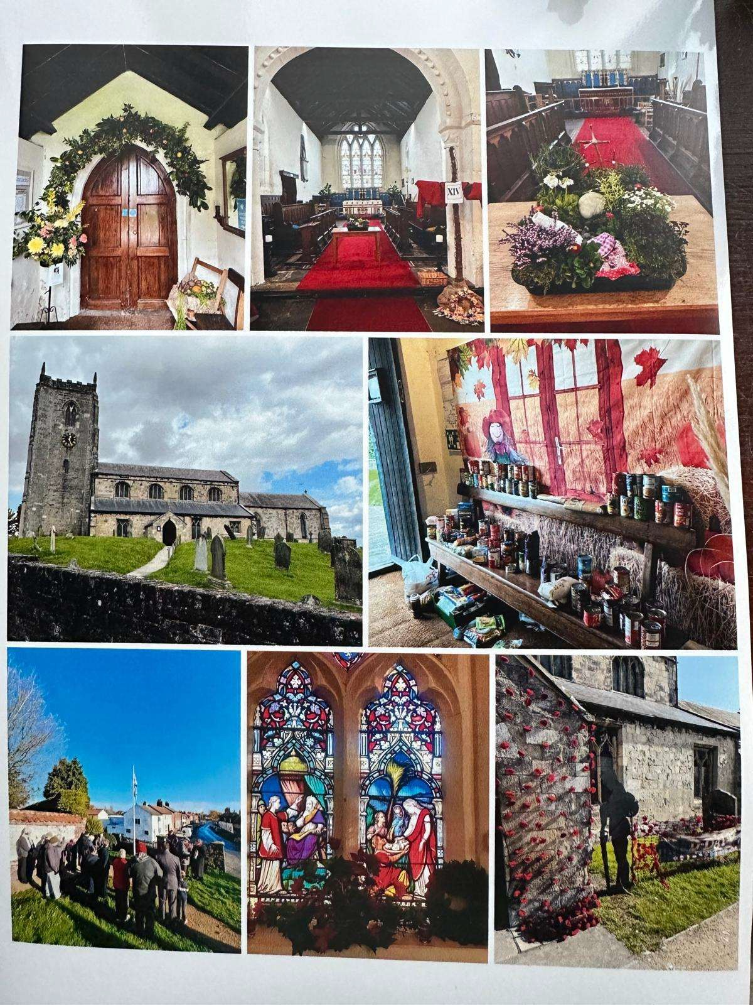

**TEMPLATE SERVICES**

|  |  |  |
| --- | --- | --- |
| **Date** | **Venue** | **Service** |
| **Week 1** | **St Margaret’s, Beswick All Saint’s, Nafferton St Peter’s, HC**  **St Mary’s, Wansford** | **8.00am Holy Communion**  **9.15am Holy Communion 10.45am Family Service (Band) 4.00pm Holy Communion** |
| **Week 2** | **All Saint’s, Nafferton St Leonard’s, Skerne St Peter’s, HC**  **St Mary’s, Watton** | **9.15am Morning Praise**  **9.15am Family Communion 10.45am Choral Communion (Choir) 6.00pm Evensong** |
| **Week 3** | **St Margaret’s, Beswick All Saint’s, Nafferton St Mary’s, Wansford St Peter’s, HC**  **St Peter’s, HC** | **9.00am Morning Praise**  **9.15am Holy Communion 10.45am Morning Praise**  **10.45am Family Communion (Band) 4.00pm Choral Evensong (Choir)** |
| **Week 4** | **All Saint’s, Nafferton St Leonard’s, Skerne St Peter’s, HC**  **St Mary’s, Watton** | **9.15am Morning Praise**  **9.15am Morning Praise 10.45am Choral Praise (Choir) 6.00pm Holy Communion** |
| **Week 5** | **All Saint’s, Nafferton St Margaret’s, Beswick St Leonard’s, Skerne St Mary’s, Wansford St Mary’s, Watton**  **St Peter’s, HC** | **Joint Benefice Service (on rotation)** |

**BAPTISMS & WEDDINGS IN THE BENEFICES 2023/4/5**

|  |  |  |  |  |  |  |
| --- | --- | --- | --- | --- | --- | --- |
| **Total** | **Beswick** | **Hutton** | **Nafferton** | **Skerne** | **Wansford** | **Watton** |
| **2023**  BAPTISM 21 | 2 | 7 | 9 | 2 | 1 | 1 |
| WEDDING 6 |  | 2 | 1 | 1 | 1 |
| **2024** |  |  |  |  |  |  |
| BAPTISM 9 | 6 | 3 |
| WEDDING 4 | 4 |  |
| **2025** |  |  |  |  |  |  |
| BAPTISM 5 | 3 | 2 |  |
| WEDDING 8 | 5 | 2 | 1 |

# The Vicarage, Hutton, YO25 9QA

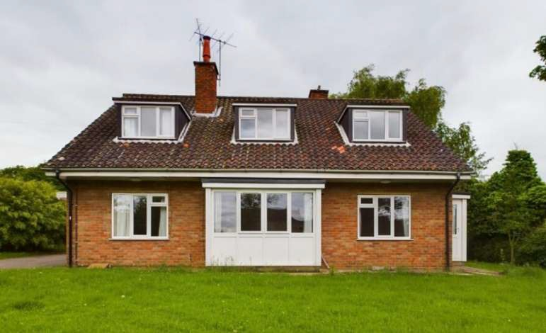

The Vicarage is an individual and spacious four bedroomed detached house with single garage standing on an elevated plot on Howl Lane, within generous gardens. It is situated approximately 100 m from St Peter’s Church on Church Lane. The property is in the popular and sought after village of Hutton which is only a short distance from Cranswick where you will find amenities and transport links. The accommodation which is both double glazed and gas centrally heated comprises; Entrance hall, WC, study, cloakroom, sitting room, dining room, kitchen, utility, four bedrooms (three double) and bathroom. Externally there are good sized gardens, driveway and integral single garage. The study/office and cloakroom are placed just through the front door and can be shut off from the rest of the house.

**FLOOR PLAN**

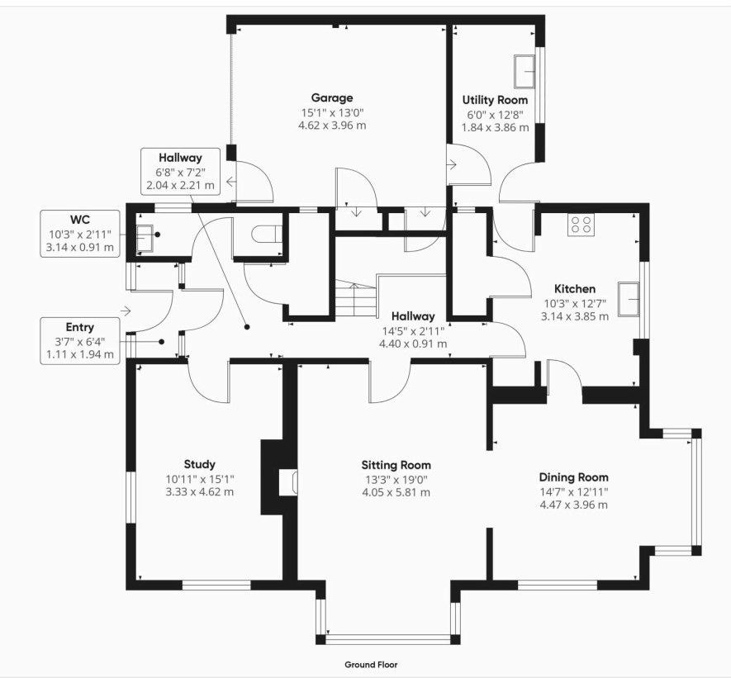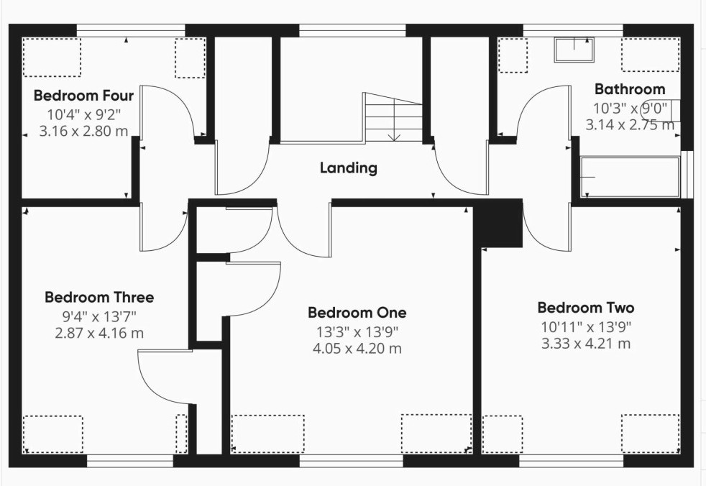

**Harthill Deanery 2024**

***Encourage, resource, enable.***

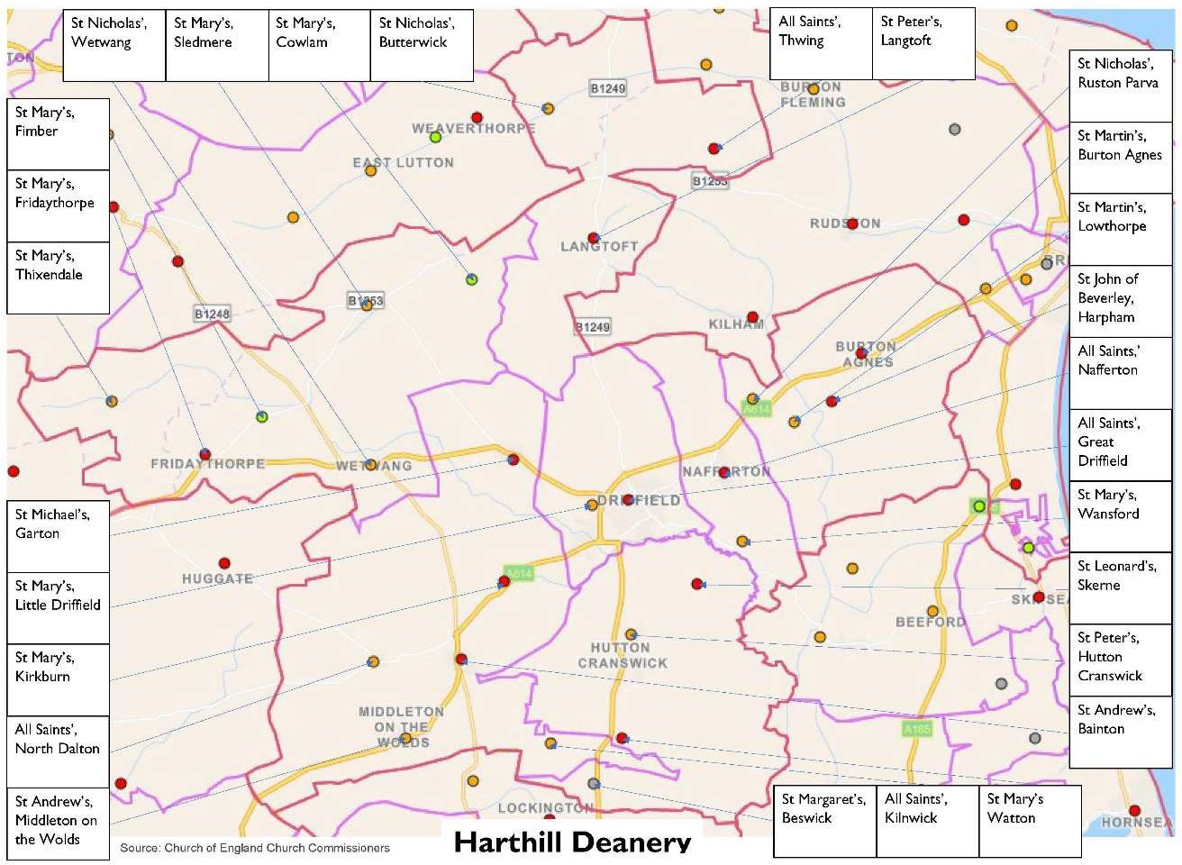

Harthill is a small, rural Deanery located mainly in the heart of the East Riding of Yorkshire, with two parishes in the County of North Yorkshire. The Deanery is centered around the market town of Driffield, known as 'The Capital of the Wolds' and also the host town for the largest one-day agricultural show in the country. We have in our midst the historic houses of both Burton Agnes and Sledmere, and we welcome a number of passing visitors and tourists each year.

At present, we comprise 26 parishes with 27 church buildings, and all except one are listed. We are also home to most of the well-known Sykes Churches, many of which are of strong architectural interest.

The parishes are split into five benefices, currently with two full-time stipend incumbents and two house for duty posts. All positions are currently filled except for this vacancy in the Hutton and Nafferton Benefices. We are supported by several retired priests on a regular basis, together with nine Licensed Lay Ministers (Readers) active across the Deanery and three Authorized Lay Ministers.

We seek to work together as a Deanery, offering support as required. Equally, we wish to see people flourish in their own ministry, and our Deanery strapline of 'Encourage, Resource and Enable' really does sum that up.

Our plans under the Diocese of York's 'Living Christ's Story' program focus on ministry teams that work together and fully support lay ministry in all its forms.

The Clergy chapter meets quarterly, and we are exploring how we can best enable our lay ministers to support and encourage each other.

We arrange a number of events across the year where we bring people together from across the Deanery, ranging from joint services for Epiphany, Easter Dawn and Ascension Day, and occasionally to leading worship on the main stage at Tribfest (reputed to be the largest tribute band music festival in the country) and having a stand at the Driffield show.

Above all is our wish to share God's love with those we encounter, attracting new people to our congregations. We look to deepen the discipleship of those who join our worship, to equip them for the work that God has called them to.

Ours is a Deanery that, whatever occurs, prays together, increasingly worships together, and occasionally plays together; we need someone to whom that is an attractive environment to come and join us.

One other point – did we mention that we are blessed to live in one of the most beautiful parts of the world? – come and see for yourself.

Rev Jacki Tonkin Martin Adams

Area Dean Lay Dean

July 2024

*\*the deanery boundary is outlined in red on the map*