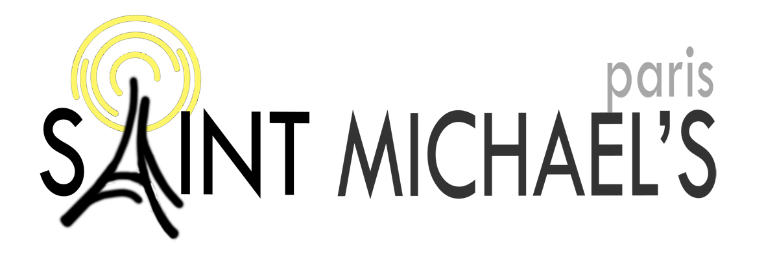
Parish Profile 2017

Our vision statement
In Christ Jesus and through the Holy Spirit, God calls us to:

- Intimacy with Him
- Deep commitment to one another
- Lives which show the fruit of radical obedience
- Be a beacon in Paris and to the nations

1. Introduction

Thank you for expressing interest in being the next Chaplain at Saint Michael’s!
In the ‘recruitment pack’ you will find, in addition to this Profile, the following documents:
1. Job description and person specification;
2. Reports on various areas of ministry and mission presented at our Annual General Meeting in April 2017;
3. Bishop’s Statement – from the Bishop of the Diocese in Europe
4. Standard Clergy Application Form and Notes 2017
5. Notes on the Diocese in Europe’s Terms and Conditions of Service, with country entry
requirements.
Another source of information is our website www.saintmichaelsparis.org
https://www.saintmichaelsparis.org/vision
Meanwhile, let us start by introducing ourselves.
Who are we?
We are …
- an Anglican chaplaincy in the Diocese in Europe, under the patronage of the Intercontinental Church Society;
- an international community of more than 25 nationalities;
- evangelical - strongly committed to Biblical teaching and preaching;
- fully Trinitarian - seeking to welcome and grow in the ministry and gifts of the Holy Spirit;
- missional – we want to play our part in giving every person in the English-speaking communities of Paris an opportunity to respond to the good news of Jesus Christ.
We …
- have about 200 people on the current Electoral Roll, and around that number coming to worship each Sunday;
- meet as two English-speaking congregations – our services are ‘in English, for everyone’;
- have one Sunday ‘pastorate’ (Tamil-speaking);
- have people who may have come to work or study in Paris for a short time, or may have lived in the area for many years;
- have people who maybe just want to meet some English-speaking people so that they can practise their English…
- … or simply may be seeking to test out the claims of Christianity.

The Diocesan survey summary from 2011 at the end of this Profile will give you more of a feel for our make-up.
Above all, we aim to be one church family, gathered from many nations and from many
backgrounds, but committed together to mission and ministry in Paris for however long the
Lord calls us to be here.

A little bit of history
Saint Michael’s was once the ‘British Embassy church’. Established in 1834, the church building was a Gothic - style chapel which had no meeting room or hygiene facilities. In the 1970s the chapel was demolished, and an office block built in its place, almost half of which houses our church premises.
Our patron society, the Intercontinental Church Society, owns the lower ground floor (where the main Sanctuary is located), the ground floor, first floor and half of the second floor. The other 57% of the building are offices, which belongs to two co-owners, who have major plans for bringing the building up to date and possibly converting their part into residences.

The building
Our building does not look like a church from the outside, but it is a much-loved ‘home’. The construction is solid, however after 40 years of heavy use the building is in a poor state of repair. A couple of years ago, we came to realise that the time had come to make provisions for large scale improvements over the next years. At recent thanksgiving and Gift Day we cast a vision for renovation, to which the congregation responded with generosity. Over a period of two years, we received a total thanksgiving offering of over €150,000. During 2016 and 2017, we have been able to carry out and complete the renovations, notably of the church entrance. This has given the entrance a whole new and welcoming feel attracting people into the ‘Father’s House’. For more on our finances, see the section on Finance, later in the Profile.

Where are we?
Saint Michael’s is located in central Paris (close to metro stations “Concorde” or “Madeleine”) with easy access by public transport lines, on a side street very close to the British and American Embassies, the Elysées Palace (residence of the President of France) and close to the major fashion houses!

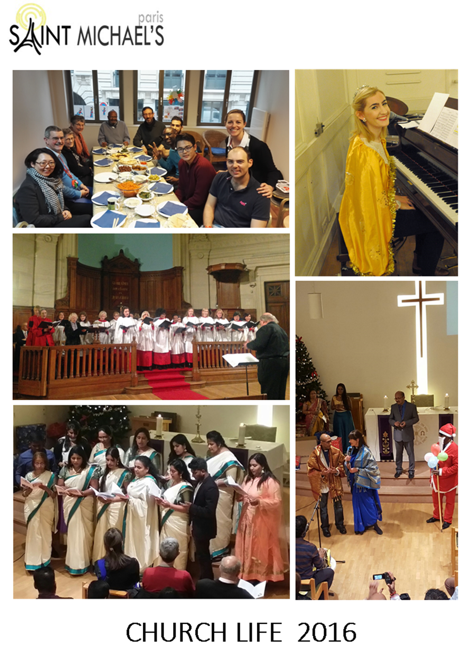

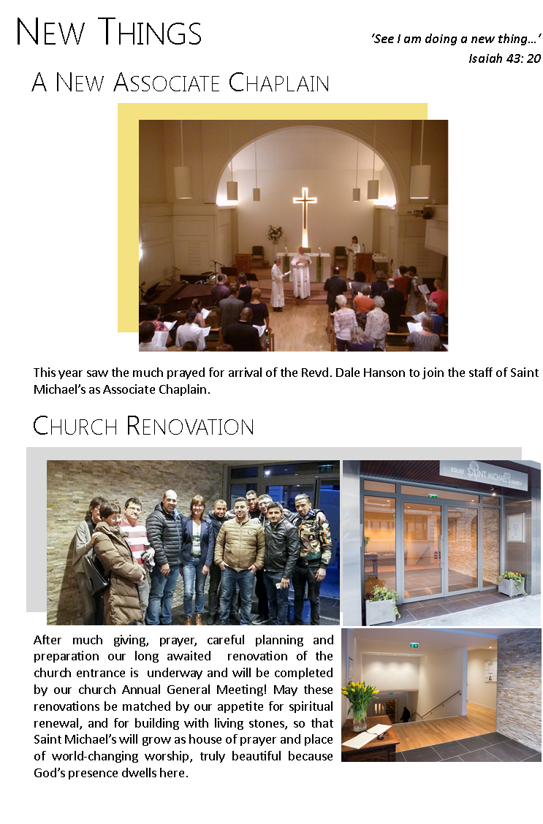
Tell me about the staff team…
The current team consists of
- The Associate Chaplain – Revd Dale Hanson has had over 30 years of experience in ministry in the Anglican church. Dale has been in post at Saint Michael’s since August 2016, moving from Hong Kong where he served for the prior 8 years.
- Administrator (Roberta Vellvé) – Roberta joined us in January 2015 and works four days a week.
- Children, and Family Worker (Claire Smith) – Claire arrived in August 2017 from Glasgow to take charge of this very important ministry in the life of our church. Her role is not only to build up and manage our children’s ministry, but also to run and support programmes put in place by her predecessors, which include leading the Tuesday small group for young adults (Focus); running the weekly café for au-pairs, and aiming to grow the work with young people.
- Part Time Administrative Assistant (Laila Eyegue-Nzome). Laila works two days a week to support the graphics, publicity and other services.
- Administrative Volunteer (Jennifer MacGillivray) – oversees the rotas for the Sunday readings and prayers of intercession, as well as coordinating the confidential prayer chain.
- Cleaners (We have 3 people who work part time).
Besides our chaplain, we also had the departure this summer of our Parish worker, who was with us for two years. Answering God’s call to ordination, she has just begun her training in the UK.
We recognise of course that the church’s mission and ministry does not depend only on its staff – rather they are there to equip the whole body to serve. Saint Michael’s has a good core of volunteers, with around 30 very committed leaders and helpers in various ministries. However, with a high degree of ebb and flow among the members (due to short-term placements and stays in Paris) achieving continuity and momentum is often challenging.
But above all…
We want you to know that we are passionate about being Church here in the heart of one of the world’s truly great (and most beautiful) cities. We love Paris, we love the people God has placed here, and we love God – and we want to bring them together. We do not see ourselves, or describe ourselves, as an ‘expatriate’ church.
Rather we are an international Church most of whose members are well integrated into French society. So, we have both a global and a local focus – and both of these are important to us.
We recognise that we are in a very strategic position, and we want to make of it the very best we can for the Kingdom of God and for his glory. As well as the material renovation of the building, we are seeing encouraging signs of spiritual renewal, including an increased appetite for prayer and prayer ministry and, frequently, a powerful sense of God’s presence with us.
We are excited about the future, and we need a Chaplain who shares the vision and will enjoy working in partnership with the staff and Council; someone who will be able to serve enthusiastically, caringly, passionately, energetically and prayerfully in the next phase of our life together.
If you think that person could be you, we would love to hear from you!
Read on to find out more.

2. Sunday Worship
In all our worship, we seek to provide strong Bible-centred teaching, which communicates the excitement of the Gospel in a way that is appropriate to the particular congregation. We pray continually that all our services will be places of encounter with the living God, and that our church family will grow to be increasingly expectant and thirsty for the transforming ministry of the Holy Spirit.
1. 10h30 Service
This service is a major source of energy and blessing for the church as a whole. It aims to attract people of every age and provide serious opportunities for engagement with God. It is distinctive for its flexible use of liturgical worship and aims to foster a joyful and worshipful atmosphere. Most services include Holy Communion, although once a month we hold a non-Eucharistic service (Morning Praise), which allows more time for sung praise, testimony and celebrating all that God is doing among us.
Prayer ministry is an established feature of this service.
The service attracts a large cohort of parents with young children, and is the focus for our children’s work.
Age-appropriate activities are led for children in 4 groups (0-2s; 3-6s; 7-10s; 11-14s). It is probably a long time since the profile of children in Saint Michael’s has been as high as it currently is.
Attendance by older youth has been sporadic over the past two years. Despite having invested in this area (with dedicated staff time) there is currently no established group for older youth (15+). However, we hope by attractive and creative programming to restart this important ministry.
The current staff member responsible for children’s work leads and supports a dedicated team of volunteer leaders and helpers. We have held occasional all age services (Ensemble), some made memorable by a number of young people playing in the band. We have also had some very popular Christingle services and Nativity plays.
The 10h30 service also sees a great number of visitors and regular newcomers. The Sidespeople team aims to ensure that from the first moment people arrive at the Church they are welcomed with care and concern. Coffee is served before the services, which allows the congregation to mingle to some extent with both members and visitors.
The average attendance is currently about 90 adults and 20-25 children. While this is the largest Sunday service, we believe that there is more potential for growth in numbers and impact.
We are always on the lookout for emerging leaders, and have been promoting lay leadership in the service. It has been encouraging for church members to see new faces at the front. A challenge for this service has been the limited number of regular musicians available; we’re always looking for new talent.

2. 18h00 Service
This is our most recognisably Anglican service, with more formal liturgical worship. The service is attractive for those who are seeking to experience the richness of Anglican liturgy and tradition.
Holy Communion (Common Worship) is celebrated on most Sundays, with BCP liturgy on the 4th Sunday of the month, Choral Evensong is held once a month. Service leaders and preachers include a number of lay people as well as clergy. Once or twice a month the service benefits from the contribution of the Choir, which is much appreciated.
As this service used to be at 09h15 until May 2017, there is still some adapting taking place amongst those used to go in the morning. We are sensitive to the issues and concerns raised by those who used to attend the morning services. However, we felt that God was calling us to make this change. It is still an area to be worked on.
The average attendance at this service is around 25 and up to 50 when the Choir performs.
Approximately once a quarter, the Chaplain holds a Welcome Apéro – cocktails to allow newcomers to discover more about the life of Church and meet some members of Council. It is a great opportunity to mingle and fellowship together.
There is a strong social element which means ad hoc events are also organised during the week via Facebook. Many of the members are Au Pairs or students who are only in Paris for a few months, so the challenge is to connect and build relationships quickly.

3. Sunday Pastorates
Saint Michael's hosts a Sunday 'pastorate' - lay-led, mid-size groups which operate with the support and oversight of Saint Michael's clergy.
The Tamil Pastorate
The Tamil ministry at Saint Michael’s has just celebrated 20 years of existence. Whilst there are dozens of Tamil Christian congregations in Paris, we understand that our Tamil community is the only one that is a full part of the church (as opposed to being hosted in a church building). The assistant Pastor is a member of the church Council.
The pastorate meets at 14h30 on Sundays, to provide worship and teaching in Tamil to members of the Tamil (mainly Sri Lankan) community in Paris. It reflects both the importance of Tamil language to Tamil culture, while also recognising that many, children and young people not least, are comfortable in French. Some members have been here for many years, while others are seeking asylum, and physical and spiritual security.
The pastorate is led by the Tamil Pastor and regularly attracts around 30 adults, around 12 under-16s, and a few older youths. Once a month, a member of the Saint Michael’s clergy team celebrates Holy Communion for the community.
There is a strong sense of community across the ages and this is manifested particularly in the post-service refreshment time. While it is a continuing challenge to ensure that the congregation is better integrated into the wider life of St. Michael’s, their Christmas Celebration deserves special mention. It is always a much-anticipated and well-attended event: part-service, part-party with a significant outreach edge to it, and a wonderful curry meal for all church members afterwards.
The Tamil Community also provide a ministry for Asylum Seekers. Every Thursday afternoon the Tamil Pastor and other volunteers see up to 50 people seeking asylum in France to help them through the process. Whilst Saint Michael's supports the ministry as a whole, we do not sponsor any individual through the system.
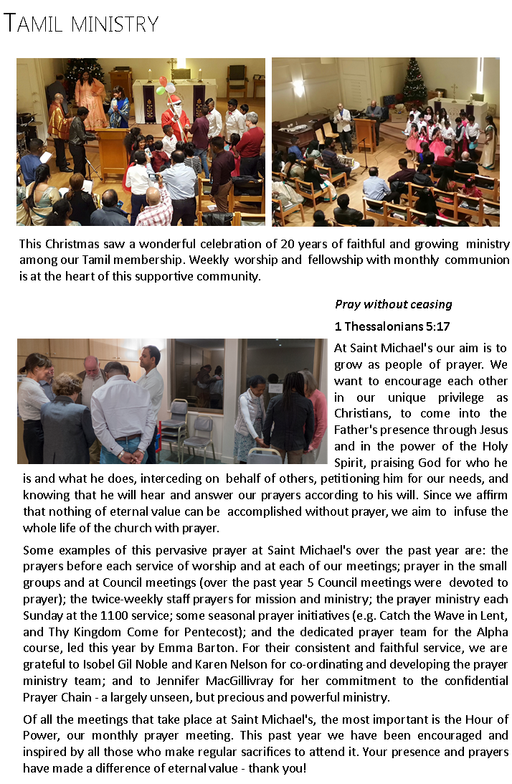
3. Ministry and Mission at Saint Michael’s

1. Evangelism and outreach
Our Alpha course continues to be the main flagship of the church’s public mission activity. The attendance varies from one year to another. In the past we have seen an encouraging increase in the numbers of francophones attending the French group. Attendants are helped to find their place after Alpha, whether in the context of a post-Alpha group, a small group or serving each Sunday.
2. Prayer and Hour of Power
At our monthly Monday evening one-hour prayer meetings, we pray about a wide range of subjects, concerning church life, events and issues.
Prayer Ministry features at the 10h30 service during the communion time. A group of mature Christians is currently looking together at Bill Hybels at ‘Too Busy Not To Pray ‘, which has helped to encourage deeper prayer lives and prayer support for the church.
We also have a Prayer Chain, with contact details in our church bulletin, which offers confidential prayer support.
3. Small groups
There are a lot of small groups at St Michael’s. They ‘re in the form of Home Groups, Eve –our women’s group, Men’s breakfast, Discipleship groups, Monday morning Fellowship, Tea and Listening, to name a few. Most of them meet at the church or at members’ homes for prayer, Bible study and fellowship.
Some groups like Eve organises a 10 week course by DVD with an opportunity to talk afterwards about the study or what they’ve heard.
4. Pastoral care
In parallel to the on-going general Pastoral Care provided by the church through our small groups, counselling, time that staff members and volunteers spend with people and the confidential prayer chain, there has been in the past a Pastoral Care Coordinator who worked with a pool of Pastoral Care volunteers. However, no volunteer coordinator has stepped forward in recent years. Support to people such as the elderly, hospitalised or parents to newly born babies is given in many different ways including phone calls, a visit, food chain delivery, a chat over a cup of tea or prayer together.
5. Mission partners
Giving to missions is a regular part of the life of St Michael’s. 10% of our income is set aside as the ‘first fruits’ of the monies received, and is given to local, national and international Christian mission agencies.
Our mission partners are Christian individuals or societies who:
- Look to the Bible for authority,
- Show a concern for the poor,
- have a primary focus on evangelism, and
- have a link with a member of St Michael’s.

We support our mission partners by
- regular prayer,
- maintaining contact with them to provide encouragement,
- financing their endeavours.
Some of our current mission partners are in Brazil, Mali, Malawi, South Africa. In France, our partners include Alpha France, the Salvation Army and in the UK, ICS and CPAS (Church Pastoral Aid Society).

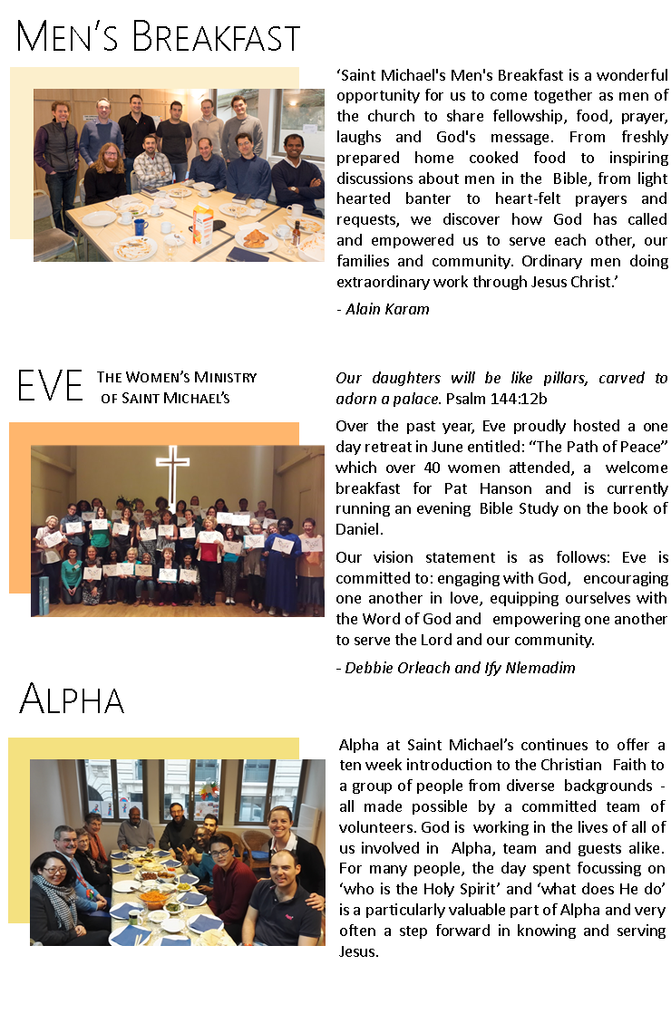
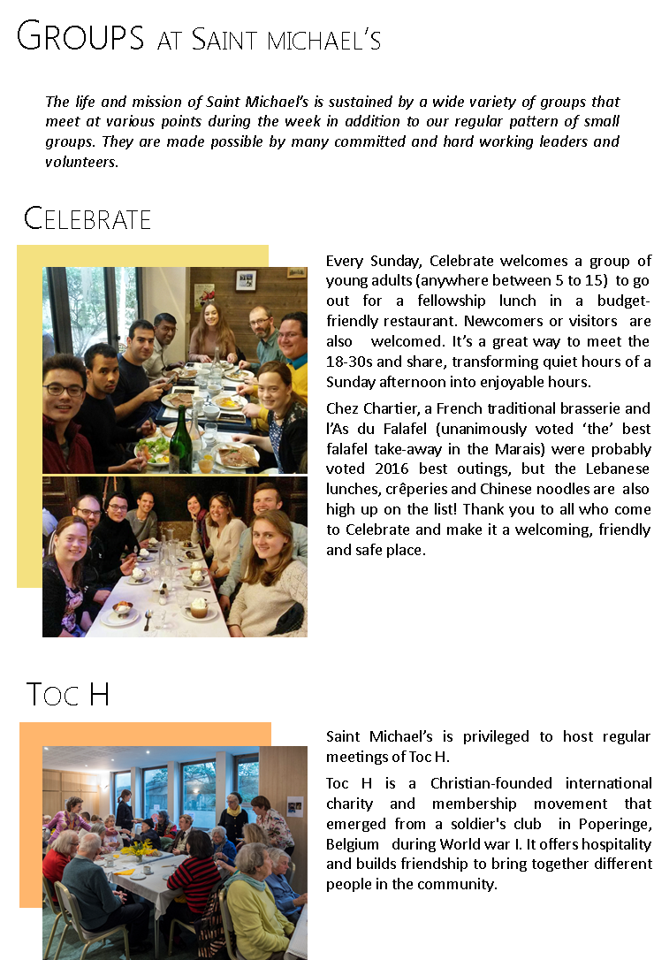

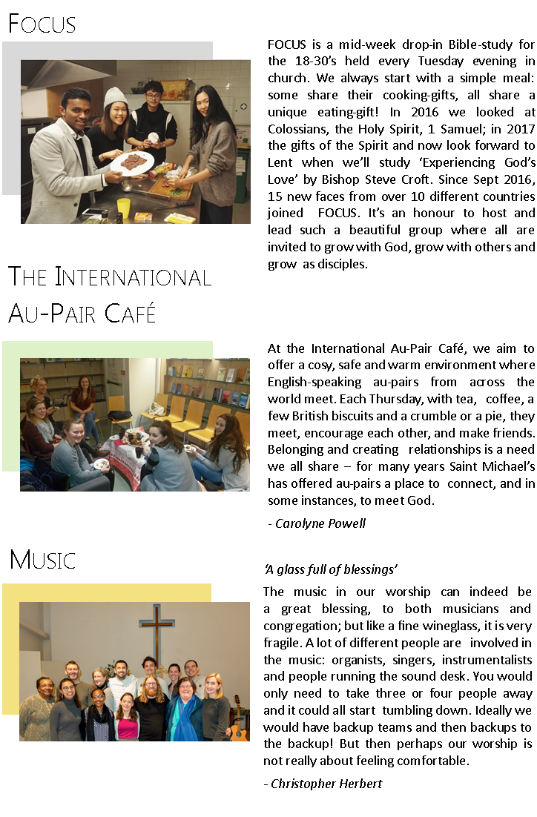
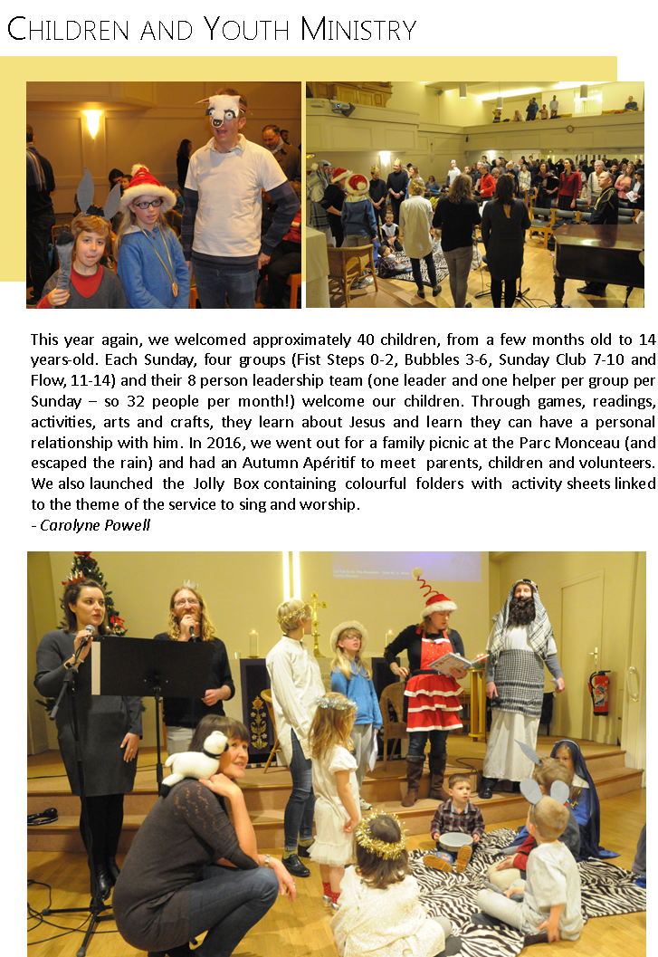

4. Governance
The Council
Representing the people of Saint Michael’s through its duly elected members, Council has a critical role to play. It is the ultimate decision-making body of the church. It has oversight over every area of the church’s mission and ministry, including the finances, with the responsibility of setting policy, budget, and monitoring income and expenditure. Regular ministry reports are brought to Council to enable it to fulfil this function.
According to the Diocesan handbook it has a duty of ‘co-operation with the chaplain in promoting in the chaplaincy the whole mission of the Church.’ Saint Michael's Council consists of:
- Members of clergy (and the leader of the Tamil community) all ex-officio.
- 2 x Churchwardens - elected annually.
- 1 x Chaplain’s Warden (appointed at the Chaplain’s discretion but currently vacant).
- 4 x Archdeaconry Synod Representatives - elected every three years; last elections 2017.
- 8 x members of Council (four are elected each year, to serve a two-year term).
- 1 Lay reader (ex-officio)
- It was agreed at the 2008 AGM that no one Council member should be allowed to fulfil more than six years in the same post.
Standing Committee
The Standing committee consisting of the Wardens, Chaplain and Treasurer, acts under the authority of the Council, and exists to serve Council. It has therefore more of an executive function. It expresses this specifically through the preparation of business and policy to be brought to Council. It also has a critical role to play in implementing policy agreed by Council. In the latter, a reasonable degree of discretion and initiative must be allowed.
Specifically, Council delegates responsibility for the specific recruitment and employment of staff (as opposed to the establishment of a particular post) to Standing Committee.
Council has given to Standing Committee limited budgetary discretion. Standing Committee will not commit the church to any unbudgeted expenditure of more than €5000 without the permission of Council, except in a case of clear emergency. In any event the Treasurer’s permission must always be specifically sought for any unbudgeted expenditure.
Only in case of clear emergency in which it would not be possible to convene a full meeting of Council in time, will Standing Committee act outside the parameters outlined above. However, Council delegates such powers to Standing Committee to allow it to do so should the need unambiguously arise.
The Church wardens have a critical role to play in the life of the church. According to the Diocesan handbook ‘they shall be foremost in representing the laity and in co-operating with the chaplain’. Standing Committee allows them a particular opportunity to fulfil these roles through its smaller structure. The Committee therefore provides an important less formal forum for the development of ideas, and the formulation of possible strategies.

5. Local Links
With the British community in Paris:
Because of our history as the British Embassy church, we maintain close ties to the British Embassy, and other British organizations in Paris. The Chaplain is asked to certain official functions and, aside from the diplomatic and representational aspects of these ties, they serve as a link to nourish Saint Michael’s outreach.
With other churches:
There are five other Anglican churches in the Greater Paris area. The local Anglican Clergy meet fairly frequently for mutual support and enjoy good relations with one another. Saint Michael’s has also historically had a good relationship with the American Church of Paris and with the American Cathedral (Episcopalian)
Relationships with French language churches are less well established but the Eglise Protestante Unie du Saint Esprit, which is close geographically to Saint Michael’s, lends us their (considerably larger) premises for our traditional Carol Service, which is very popular in Paris. Over this last year we have built closer contact with the clergy of the large and famous Roman Catholic church in whose parish Saint Michael’s is located, the church of Sainte-Marie Madeleine.
For several years we have participated in the week of prayer for Christian Unity involving Catholic and French and German Lutheran churches.

6. Finance
Saint Michael’s is financed entirely through voluntary giving. Over 90% of income is given directly by Saint Michael’s members and 10% by external donations. We receive no support from any government or organisation (the Intercontinental Church Society owns that part of the building in which the church is housed but does not provide financial support).
Saint Michael’s - Income and Expenditure for 2016 is shown in the summary table below.
We have a significant annual operating budget. A tithe of all income is allocated to mission and other outreach causes. As cab be seen, approximately 50% of the budget is used to finance staff salary and housing costs and about 18% goes to various building expenses.
The church manages its own finances, reliant on the grace of God and generosity of the congregation. Over the past few years the church has experienced some income fluctuation, linked in part to the global recession, and God has shown His faithfulness in meeting Saint Michael’s needs.
Due to the departure of a several key members of the church and the normal attrition during an inter-regnum period, the monthly operating income has been significantly less than the church’s monthly expenses during the last several months. This has however been largely compensated by a generous Gift Day offering as well as a bequest of a long-time faithful member.

2016 | €
Income:
Collections (plate & planned) | 395,890.00
Thanksgiving & Gift Day offerings | 109,830.00
Interest and Investment Income | 919.00
Fees, other donations & sundry income | 34,264.00
Total income | 540,903.00
Expenditure:
Chaplains' stipends and staff salaries | 194,590.00
Chaplain accommodation & expenses | 15,562.00
Upkeep of Services & Administration Costs (incl. locums) | 78,517.00
Upkeep of Church Fabric | 82,768.00
Diocesan & Archdeaconry Quotas | 28,604.00
Charitable Giving | 48,688.00
Exceptional items (separate note) | 5,818.00
Total expenditure | 454,547.00
Net surplus/(deficit) | 86,356.00
Balance Sheet
Fixed Assets: Church/Church Hall | -
Fixed Assets: Chaplain's accommodation | 456,390.00
Fixed Assets: Other & inventory | 64,322.00
Debtors & loans receivable | 25,545.00
Investments (Cost) | 38,148.00
Bank account(s) & Cash in hand | 356,003.00
Deduct: Creditors | (52,825.00)
Deduct: Loans/Mortgages repayable | -
Net Assets/(Liabilities) | 887,583.00

