

Growing Faith Lead
Plymouth 2035

Application Pack
July 2025

Application Pack
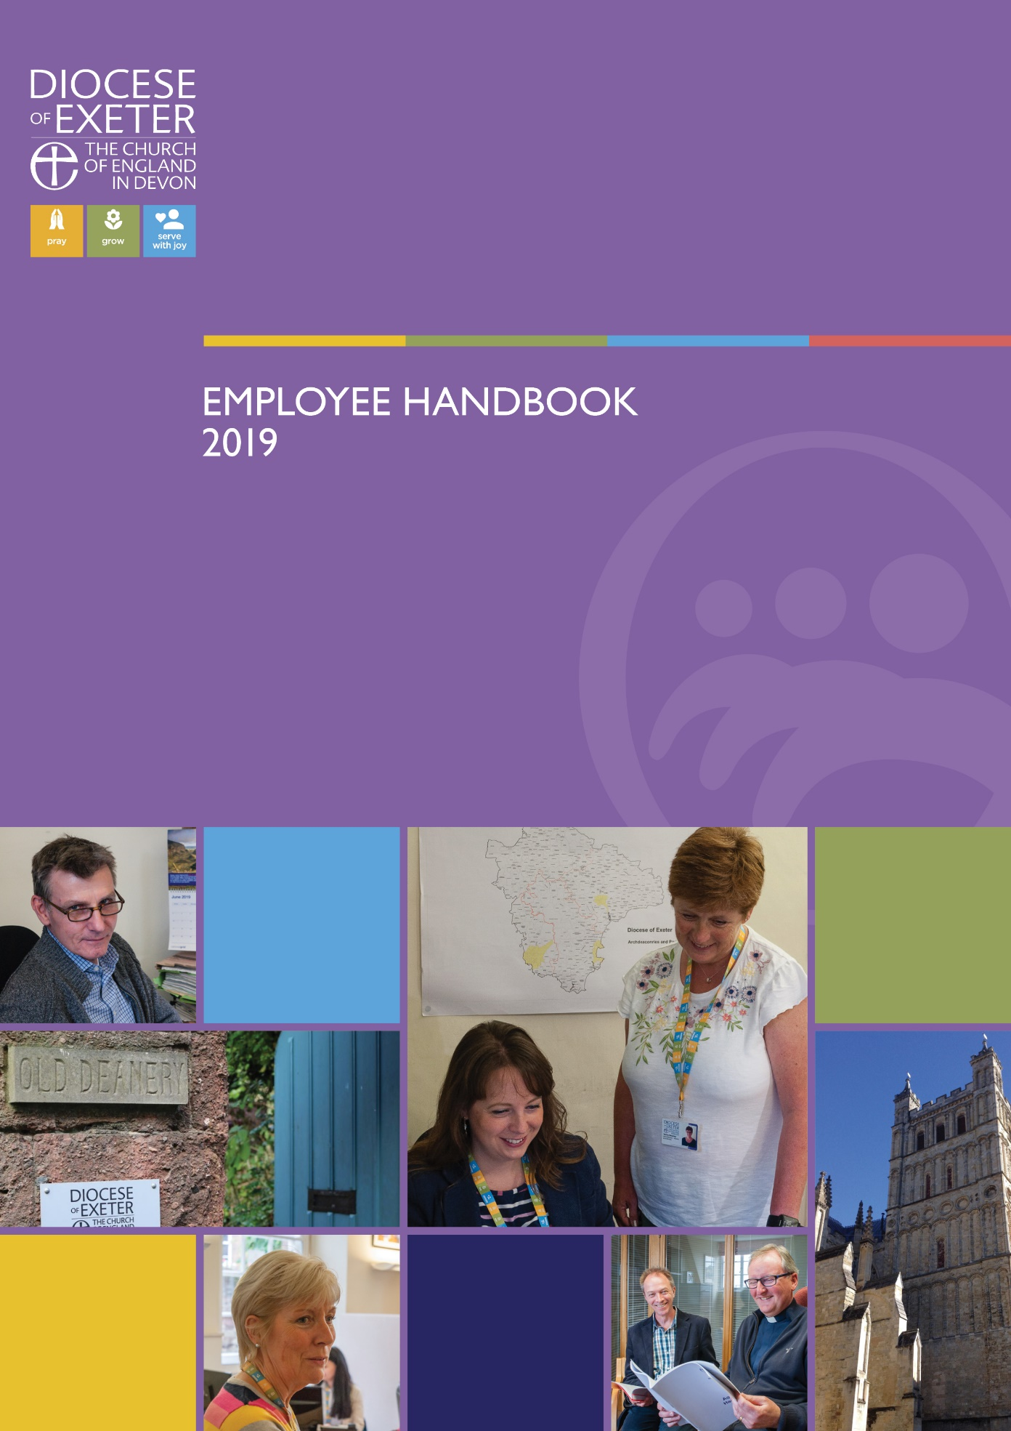

Contents Page
A message from the Bishop of Plymouth 03

Plymouth 2035 Prayer 04

Section 1: Diocese of Exeter | Pray – Grow - Serve 05
  - Diocese of Exeter | Vision
  - Diocese of Exeter | Strategic Priorities
  - Diocese of Exeter | Funding

Section 2: Plymouth 06
  - Plymouth City
  - Plymouth Deanery

Section 3: Role Description 07

Section 4: How to Apply 11

:
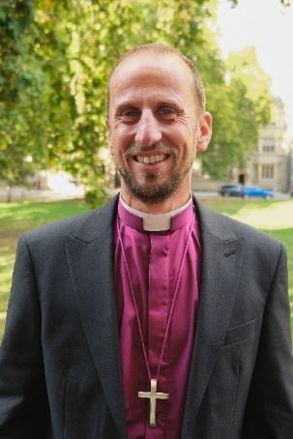
Right Reverend James Grier
Bishop of Plymouth

Dear friends,
We stand at a pivotal moment in the life of the church in Plymouth. The landscape of our city is changing – its communities shifting, its needs evolving, and its opportunities for mission growing ever more urgent. In this moment, we are called not to retreat, but to respond with courage, creativity, and faith.
Plymouth 2035 is our shared vision for renewal: a bold, Spirit-led journey to reimagine what it means to be the church in this city. It is a vision rooted in prayer, shaped by hope, and driven by a deep desire to see lives transformed by the love of Christ.
Central to the Plymouth 2035 vision is work with children, young people, families and schools and Growing Faith. Plymouth is a city of nearly 270,000 people with nearly 100 schools but church attendance amongst under 18s is low. One of the first things we are doing to begin Plymouth 2035 is to recruit a Growing Faith Lead. Someone who will formulate and spearhead our work with children, young people, families and schools. Children and young people need to be at the heart of all our plans, initiatives and mission within each church and across the city. This role is central to ensuring that this is the case. Please do read on to find out about the Growing Faith Lead role.
May God disturb us where we are too comfortable and embolden us to sail beyond the familiar shores. May he enable us to take the gospel to the rising generation that they may find faith whilst young and be transformed by it for eternity.
With every blessing,

Right Reverend James Grier
Bishop of Plymouth

Plymouth 2035 Prayer
Disturb us, Lord,
when we are too well pleased with ourselves,
when our dreams have come true
because we have dreamed too little,
when we arrived safely
because we sailed too close to the shore.

Disturb us, Lord,
when with the abundance of things we possess
we have lost our thirst
for the waters of life;
having fallen in love with life,
we have ceased to dream of eternity
and in our efforts to build a new earth,
we have allowed our vision
of the new Heaven to dim.

Disturb us, Lord,
to dare more boldly,
to venture on wider seas
where storms will show your mastery;
where losing sight of land,
we shall find the stars.
We ask You to push back
the horizons of our hopes;
and to push into the future
in strength, courage, hope, and love.

This we ask in the name of our Captain, who is Jesus Christ.
Amen.

(Attr. Sir Francis Drake 1540-1596)

2035 Bible Verse

“Now I commit you to God and to the word of his grace, which can build you up and give you an inheritance among all those who are sanctified… we must help the weak, remembering the words the Lord Jesus himself said: ‘It is more blessed to give than to receive.’ When Paul had finished speaking, he knelt down with all of them and prayed.” Acts 20:32-36 – with 20:35 at the centre.

Section 1: Diocese of Exeter | Pray – Grow - Serve
As God’s pilgrim people, we seek to share in the mission of God as revealed in the life, death and resurrection of Jesus Christ through praying; growing disciples and serving the people of Devon with joy.

Diocese of Exeter | Vision

Our vision is to be the living body of Christ, which is in every community and is connected, contextual, credible, called to go and pray, grow disciples and serve the people of Devon with joy!

Diocese of Exeter | Strategic Priorities

- Missional Leadership | Leaders (lay and ordained) equipped and resourced to develop and grow new disciples
- Missional DNA | outwardly looking churches actively hospitable and engaged with wider communities
- Vocations | Everyone asking “what is God calling me/us to now?”
- Children, Young People, Families and schools | placed at the heart of our life, mission and ministry.
- Mixed Ecology of Church | we provide and value different ways of doing and being church
- Plymouth 2035 | every community embodying the diocesan vision and with 2035 new disciples worshipping in Plymouth churches.

Diocese of Exeter | Funding

The Diocese of Exeter is preparing a major funding application to the Strategic Mission and Ministry Investment Board (SMMIB) in autumn 2025 to support a bold, ten-year vision for growth and renewal. A significant part of this vision is Plymouth 2035—an ambitious programme to refresh the Church of England in Plymouth. Plymouth 2035 will focus on revitalising congregations, planting new churches, and launching Fresh Expressions of Church, all with the aim of growing new disciples and serving the city’s various communities with renewed energy and hope. Central to Plymouth 2035 is work with children and young people, through the appointment of the Growing Faith lead and other workers as well as creating a strategic plan for work across the city.
The Growing Faith Lead is appointed by the bishop for an initial five-year period dependent on SMMIB funding. The position will then need to be reviewed, and continuation is dependent on securing ongoing funding.

Section 2: Plymouth

Plymouth City

Plymouth is a growing city. Recent years have seen significant changes in population, industry and economy. Infrastructure and expansion have changed the landscape of the city with communities divided by major roads and large housing developments. Smaller, urban centres have dwindled, causing isolation and decline. These recent changes have added to the war damage reconstruction and new estate development that has shaped the city over recent decades.
Throughout this changing landscape, the church has continued to serve local communities. The Church of England is dedicated to being a Christian presence in every community, committed to sharing Jesus in practical, life-giving ways. But we cannot ignore the fact that the communities our churches were built to serve have changed significantly. In effect, this means that there are whole communities in the city that have never been reached by their parish church. This must change if we are to take mission seriously. Our aim is to be the church for the whole city.

Plymouth City Deanery

Plymouth City Deanery includes 23 benefices and four pioneer initiatives under the Plymouth Partnership in Mission, plus a separate pioneer project in Sherford, to the east of the city. Plymouth’s unique geography—steep hills, rivers, and woodland—alongside a history of limited transport links, has shaped a patchwork of distinct and sometimes isolated communities, each with its own character and needs.
In Plymouth there are 98 schools and 174 childcare settings, including child minders, school nurseries and private settings. There are 9 Church of England primary schools in Plymouth and All Saints Academy is a Church of England secondary school, with many other schools in MATs with faith articles. At least 5 churches have employed children, youth or families workers. (St Andrew’s, St Matt’s, St Budeaux, Emmanuel, Elburton). 384 children (0-17 years old) regularly attend an Anglican church in Plymouth.
While there are real challenges—such as declining attendance, leadership gaps, and financial pressures—this is also a moment full of possibility. With a third of our clergy posts vacant across the Deanery, we have a rare opportunity to shape a new culture: one that’s rooted in mission, built on collaboration, and open to growth. By rethinking how we work together, investing in key churches and pioneer initiatives, and strengthening our partnerships with schools and community groups, we believe we can help reset the city’s missional direction. We can enable the church to present the good news of Jesus Christ in word and action throughout the communities of the city.
A central part of Plymouth 2035 is our work with children, young people, families and schools. We want to see 2,035 new children and young people crossing the threshold of faith. This post is a key part of this vision.
Section 3: Role Description
DETAILS
Role Title |  | Growing Faith Lead
Department
Reports to |  | Plymouth City Dean,
Salary/Rate |  | £32,000-£36,000 per annum depending on experience
Contract Type |  | Full-time, Fixed term for 5-year period  The Growing Faith Lead is appointed by the bishop for an initial five-year period funded centrally. This position will then be reviewed and continuation will be dependent on securing ongoing funding.
Hours |  | 36.25 hours per week
Location |  | Office provision will be made available in Plymouth  Plymouth provides a comprehensive range of facilities including various local and national shops, businesses, restaurants, pubs, and sports facilities. There are a wide variety of schools. Plymouth railway station runs regular services to London’s Paddington Station. Trains typically take 3 to 3.5 hours.
DBS |  | This role is subject to an Enhanced DBS check.
Responsible for |  | Any Children and Families’ workers employed as part of Plymouth 2035  MES candidates engaged under Plymouth 2035
Date of Issue |  | July 2025
NATURE OF WORK
Growing Faith

Growing Faith is the movement that exists to change the culture of the Church of England so that everyone instinctively puts children and young people at the heart of all we do as a church. It builds on previous work to encourage churches, schools and households to work together to nurture the spirituality of children and young people.

Growing Faith is a lens through which to see the opportunities in the local community and join in with what God is already doing there. Growing Faith prioritises under-16s because we want every person of every age, including the young, to know how much God loves them, how important they are in the family of the church and for them to have the opportunity to shape and lead the church for today and tomorrow. Simply put, research suggests that if under 16s aren’t made a priority, they won’t find a place or a voice in the local church.

When Jesus wanted his followers to understand what discipleship was all about, he placed a child in the middle of the conversation. The church and indeed the country needs children and young people to be at the centre of our thoughts and plans and hearts – for their sakes and for our own.

Growing Faith reaches out to children and young people where they already are—meeting them in their everyday spaces and experiences. It’s about creating safe, welcoming environments where they are truly heard and valued. At its core, Growing Faith is about building lasting, intergenerational relationships rooted in trust. It embraces the natural rhythms of school, home, and church, weaving them into a shared life of faith. What matters most is that children, young people, their parents and carers, and the adults around them—in both church and school—are all active participants in shaping the church. Together, they flourish and collaborate to grow the kingdom in every community.
The Growing Faith Lead is a key part of realising the Plymouth 2035 vision. It is a position of strategic importance and value, entrusted with helping to shape the future of engagement with children and young people in the city.

The Plymouth 2035 Growing Faith Lead will need to:
- be an experienced youth or children’s worker, either lay or ordained;
- have a proven track record of co-ordinating missional growth amongst children and young people;
- have managerial and visionary leadership;
- have strong people skills and high emotional intelligence;
- be able to inspire and coordinate others.
- Work with minimal supervision
- Self-motivated and innovative

Role Area | Main Duties and Responsibilities
Pastoral and Prayer | - Inspire and equip workers and church members to pray for Plymouth 2035, children, young people, families and schools.  - Provide support for children, youth and families’ workers.  - Be the first point of contact for churches looking for resources for children, youth and families.
Build partnerships | - Existing youth initiatives (eg Ignite, Youth and Children Worker gatherings)  - Children and youth workers in churches across the denominations in the city  - MATS and schools across the city  - Other youth and partner organisations  - Chaplaincy teams in Plymouth schools.
Administration and Governance | - Help recruit and coordinate a team of new workers and trainees  - Create policies and procedures  - Work closely with the Diocesan Safeguarding Team  - Ensure churches are safely recruiting volunteers, trainees and workers  - Attending regular meetings of Rural Deans with the Archdeacon.
Strategic | - Be the strategic leader of a Growing Faith initiative for churches across Plymouth seeking to bring 2035 new children and young people to the threshold of faith, whilst also serving in the youth and/or children’s work of an Anglican church in the city  - Develop a vision for work across the city which is embedded in churches and working in schools and communities  - Develop a leadership pipeline for children and young people (i.e. mentoring, leadership training and opportunities to lead) in partnership with SWYM and other partner organisations  - Create discipleship programmes for upper primary and secondary age children  - Provide training for children, youth and families’ workers  - Promote and develop volunteering in work with children and young people  - Create and host regular city Growing Faith gatherings for all involved with children, youth, families and schools work from Anglican churches across the city. These events would be to build relationships, inspire, encourage, train and resource people as well as ensuring city-wide collaboration
Community and Ecumenical Engagement | - Advocate for the church in the city amongst ecumenical and community partners, particularly in areas that are the hardest to reach or the most disadvantaged;  - Provide visible leadership on issues of social justice in Plymouth, especially amongst children and families, including close working with Transforming Plymouth Together;
Change Management | - Lead and support cultural change among church members and leaders by shaping and communicating the Plymouth 2035 vision for Growing Faith. This includes encouraging collaborative initiatives across parish boundaries and equipping children, youth, and families’ workers—as well as volunteers—to become mission enablers supported by strong lay teams.
Diocesan responsibilities | - Work collaboratively with Diocesan staff, especially the Mission and Ministry department, Board of Education and Safeguarding teams
Safeguarding | - Ensure all diocesan Safeguarding policies and procedures are adhered to.  - Complete safeguarding training to Foundation level.  - Safer Recruitment training and adherence to the Safer Recruitment policy and process.
Equality and Diversity | - Role model inclusive behaviours in day to day working practices.  - Work in accordance with diocesan policies of equal opportunity.

PERSON SPECIFICATION
The following areas outline what qualifications, training, experience and technical abilities the applicant will need to demonstrate.
It is an occupational requirement under the Equalities Act to be a practising member of the Church of England. The post holder must be an Anglican priest, already licensed and in good standing in their diocese.
 | Essential | Desirable
Qualifications and Training | - Youth or children’s worker who has worked at a senior strategic level
Experience | - Proven experience of leading children’s and/or youth ministry beyond the local church  - Experience of working collaboratively with clergy and lay leaders.  - Experience of managing or overseeing complex projects or initiatives.  - Experience of schools ministry | - Experience of working in urban or multi-parish contexts.  - Experience of engaging with ecumenical and community partners.
Knowledge and Understanding | - Understanding of Growing Faith, Fresh Expressions, church planting, and mixed ecology of church models.  - Awareness of the challenges and opportunities facing children and young people and spirituality development  - Understanding of safeguarding, safer recruitment, and good governance. | - Familiarity with the Diocese of Exeter’s vision and strategic priorities.
Supervision | - Have experience of supervising staff and volunteers  - Pastoral support of employees and volunteers
Skills and Abilities | - Strong leadership and strategic thinking skills.  - Ability to inspire, motivate, and equip others for mission across all church traditions.  - Excellent communication skills, both written and verbal.  - Ability to manage change and navigate complexity with wisdom and grace.  - Competence in using digital tools and social media for communication and engagement. | - Skills in conflict resolution and team development.  - Ability to evaluate impact and measure outcomes effectively.
Personal Attributes | - Spiritually mature and rooted in prayer.  - Collaborative, approachable, and emotionally intelligent.  - Naturally shares faith and draws people to faith in Christ  - Resilient, adaptable, open to innovation.  - A heart for mission and a passion for the renewal of the Church.
Other Requirements | - Enhanced DBS clearance.  - Full driving licence and access to a car.  - Willingness to work flexibly, including evenings and weekends as required.

Section 4: How to Apply
To apply for this role, please complete the application form. This will require preparing and submitting the following:

- The application form which can be downloaded from our website
- Please provide an up-to-date copy of your CV
- Please include a covering statement (no more than 2000 words detailing your reasons for applying, what you can bring to the role and how you meet its requirements).

Please send your application to: Mrs Debbie Delaney, Assistant to the Archdeacon of Plymouth debbie.delaney@exeter.anglican.org

If you have any questions, please do not hesitate to contact The Ven. Jane Bakker, Archdeacon of Plymouth on 01752 858382 adp@exeter.anglican.org or The Right Revd James Grier, Bishop of Plymouth on 07825 610288, bishop.of.plymouth@exeter.anglican.org

Closing date for applications | 20th August, 2025
Interview date with Selection Panel | 5th September, 2025

Confirmation of the appointment will be subject to satisfactory references and an Enhanced DBS disclosure.
The successful candidate will also need to have the right to live and work in the United Kingdom and undergo a pre-appointment occupational health clearance.
Thank you for your interest in our organisation.

