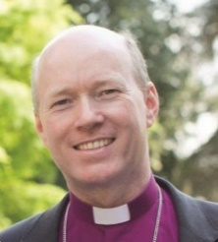
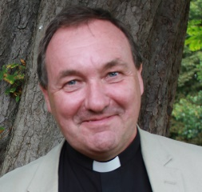
THE DIOCESE OF SOUTHWELL & NOTTINGHAM
GROWING DISCIPLES WIDER, YOUNGER AND DEEPER
A statement from
the Bishop of Southwell & Nottingham,
the Rt Revd Paul Williams
and the Archdeacon of Newark, the Venerable David Picken

The Diocese of Southwell and Nottingham incorporates the City of Nottingham, the whole County of Nottinghamshire and five parishes in South Yorkshire. The population is 1.15 million – 51% live in the greater Nottingham conurbation, 31% in ex-mining areas and 18% in rural. There are 305 churches (252 parishes), served by 142 stipendiary clergy and licensed lay workers.

In 2011 the Diocese reaffirmed its commitment to Joining Together in the Transforming Mission of God with a focus on three core strands: Living Worship, Growing Disciples and Seeking Justice.

A deployment plan for 2020 ensures that overall levels of stipendiary ministry are maintained at 2012 levels. The process involved wide engagement from clergy and laity, refocusing parishes on growth. Following the arrival of a new diocesan bishop in June 2015 we are now looking beyond 2020 at what kind of church we would like to be in 2025 and 2030. As a diocese we have made a renewed commitment to care for every soul in the diocese with an increased focus on growing disciples.

The Bishop’s Council and Senior Staff team have established the first stage of a vision for ‘Growing Disciples wider, younger and deeper’.

• ‘Wider’ in that we will seek to grow disciples in every part of the diocese, with no retreat from any community: urban centre, outer estates, rural villages or market towns.
• ‘Younger’ in that we will seek fresh ways to harness the boldness and creativity of children, students and young people across the diocese, not least in Nottingham which is the 4th youngest city outside London.
• ‘Deeper’ as we grow in knowing Christ, so that as his disciples we can be an increasing blessing to the people among whom we live and serve in the workplace, family and community.

As part of a renewed strategy for growth we aspire to be purposeful and imaginative in: welcoming new disciples into the fellowship of Christ and his church; commissioning younger leaders (16-30) inspired and equipped to serve God’s purposes in the world; resourcing new worshipping communities; and serving as 1 church united in contending for the gospel. We long to welcome new and younger disciples in every community across the diocese, aligning our energies and resources around this quest.

In this new chapter every parish has an opportunity to review its role within the diocesan mission, so that it can play a significant part in the strategic commitment to ‘Growing Disciples wider, younger and deeper.’ These parishes do have a sense of united identity whilst being very distinct communities. Their new Priest will be a person who enjoys working with variety but who brings creativity and imagination. There are plenty of opportunities to build on an inherited model of Church though there are also opportunities for developing new styles of mission and ministry.

Bishop Paul has said: “It is my hope that each worshipping community will develop a compelling picture of its own future in God’s purposes with an expectation of growing numerically and in the scope of its mission. It is my prayer that the new Priest of Blyth, Scrooby and Ranskill will have the creative leadership and imagination to develop discipleship, plan for growth and reach out to the unchurched of all ages in each community.”
September 2017

