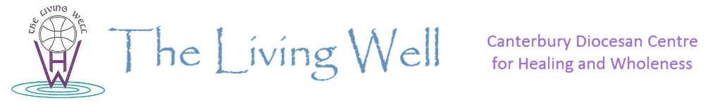

Introduction to The Living Well
The Living Well (TLW) is situated in an old vicarage in Nonington, 10 miles Southeast of Canterbury. It began approximately 17 years ago when a member of clergy recognised the need to offer Christian retreat, listening and prayer to aid healing and wholeness in individuals in a way that clergy and laity were often not able to offer in a parish setting. The ministry was initially centred in Nonington and had an external focus of bringing training in the healing ministry to parishes within Canterbury Diocese by invitation.
Canterbury Diocese partner with TLW charity working collaboratively in ministry and mission in a variety of ways: one is the provision of the property which is maintained and prayerfully cared for by residential wardens. The house and grounds offer a chapel, a library, lounge, kitchen, an Upper Room suitable for small groups and garden with labyrinth, rose garden and four heated garden rooms/cabins suitable for day retreat.
Our Core Team includes the chaplain, wardens, our administrator and assistant chaplains; beyond this we are able to encourage many volunteers who form part of our Wider Team to serve with us in this ministry of hospitality, healing and wholeness in Jesus Christ – for whom we are hugely grateful. We benefit from a Board of Trustees and a Treasurer who help with discerning the ministry and mission of TLW. We work within safe guidelines and good practice and our policies on safeguarding etc align with those of Canterbury Diocese.
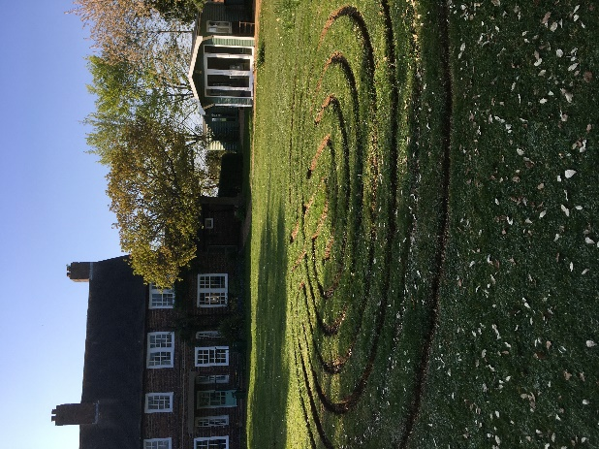
We hold an open, healing service midweek at Nonington and seek to respond to a wide range of requests from individuals and from groups. A 2024 programme including Deeper Healing Days, themed quiet days, prayer appointments etc can be found on our website www.the-living-well.org.uk
Our understanding of healing is holistic, we are body, mind and spirit; that healing may come over a protracted period of time or unexpectedly and suddenly, that our role is to provide a prayerful space, secure, welcoming, inspiring hope and with the freedom for God to be present. We are excited by this ministry and always reliant upon the eternal and creative breath of the Spirit of God at work among us, leading us forward in His beautiful Name.


The Living Well www.the-living-well.org.uk / Registered Charity 112379
Please contact 01304 842847 or contact@the-living-well.org.uk
www.the-living-well.org.uk

