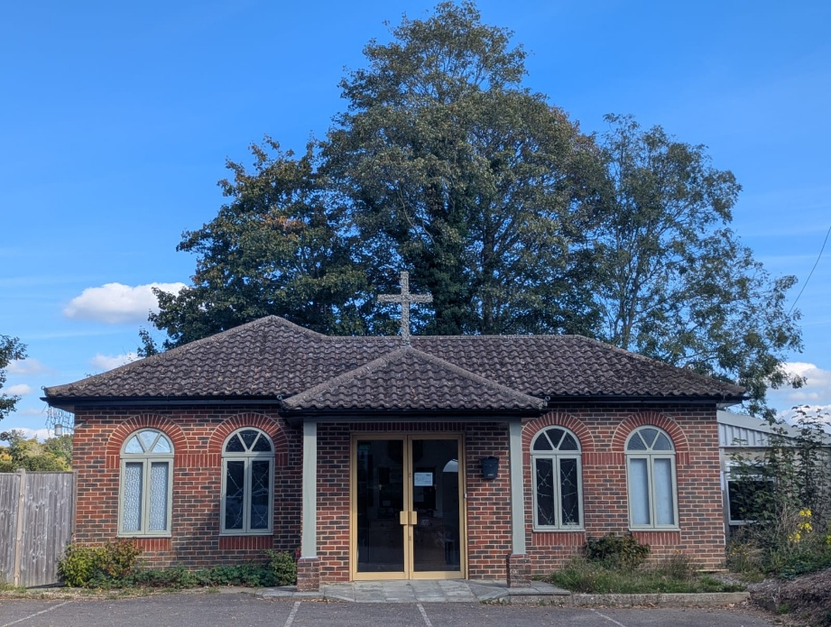
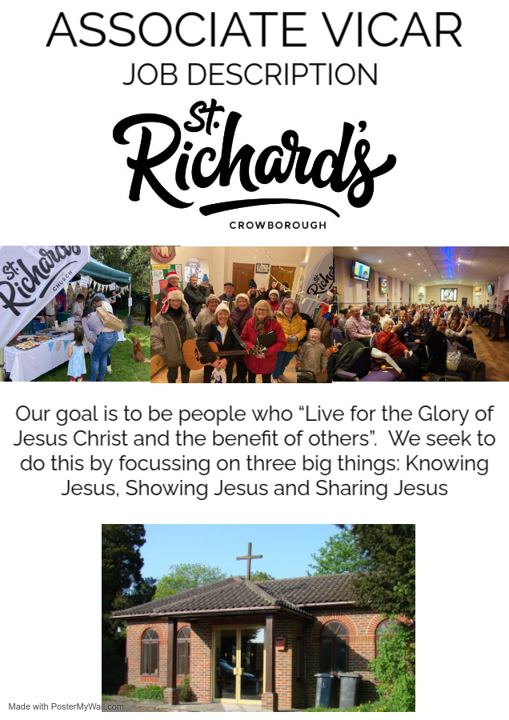
Associate Vicar of All Saints and St Richard’s Crowborough
Associate Vicar of All Saints and St Richard’s Crowborough
with responsibility for St Richard’s

House (3/4 bedroom house and stipend)

All Saints and St Richard’s are conservative evangelical churches in the Diocese of Chichester. There is one PCC for both churches but St Richard’s operates with its own management and leadership team under the support of the Vicar.

We are part of the Alliance, Sussex Gospel Partnership, Diocesan Evangelical Fellowship and the Church of England Evangelical Council.

The Associate Vicar will lead the mission and ministry at St Richard’s church in its next phase of growth with the support of the vicar of All Saints.

He will be …

- An ordained Anglican, committed to prayer who practices and models a dependent, joyful faith.
- A Pastor with a deep desire to care for and shepherd the church family.
- A gifted, faithful Bible teacher.
- Someone with a desire to see the lost saved, who will lead the church in outreach to the local area.
- Someone who can give a strong lead as well as working well as part of a team.
- A person who can relate easily to, and communicate well with, people from different walks of life and social backgrounds.
- A visionary practical leader who can shape future growth which will, God-willing, involve a new purpose-built facility for the church family.

Role
You will be licensed as Associate Vicar of All Saints Church, with particular responsibility for leading the church at St Richard’s through teaching, prayer, pastoral care and outreach. As part of the wider staff team, you will spend the majority of your time at St Richard’s - currently around 80% of the role - while also contributing to leadership and preaching at All Saints, which currently accounts for approximately 20% of your time. There is hope that this balance will shift in the future as the ministry at St Richard’s grows.
You will chair the St Richard’s Management team, helping to shape its future direction, and will also serve as a member of the joint PCC for All Saints and St Richard’s.
This is an ideal first post after Curacy, giving the successful candidate sufficient responsibility for leading and driving a ministry forward in a supportive team offering sacramental and missional leadership. There will be some shared team work across the churches including occasional offices and a working agreement outlining expectations of what this will involve.

Support
The Associate Vicar will be leading St Richard’s church with the regular support of the Vicar of All Saints and the wider team.
This will include:
- Regular 121 meetings with the Vicar.
- Support with preaching and leading from the Vicar, Associate Vicar and other lay members of the team as appropriate.
- Prayer and fellowship with the All Saints staff team.
There has previously been a paid administrator role to help with the running of St Richard’s. We expect it will be possible to shape and appoint to another role like this in the future.
In summary you will have space to run the church but you will be supported by a large staff team at All Saints - you won’t be on your own. We want our churches to partner together to see Crowborough reached with the gospel.

Background
St Richard’s was established nearly 70 years ago. The churches have worked in partnership throughout its history.
The church is placed in southern Crowborough, a mix of historically social housing, a 1970’s housing estate and currently a number of new build estates going up. The congregation and the missional field reflect a range of socio-economic backgrounds. With the growing population of the area there is great potential for growth.
We enjoy good links with the local community with various groups and ministries running in the church hall. The postholder is also actively involved with Ashdown Primary School, leading assemblies each term.
The land next to the church was purchased by Crowborough Weald Gospel Trust and there are plans for a building project. These have gone on pause due to recent disruption, but we hope to get them back on track in the near future.
In recent months, we have experienced some challenges that have led to a decline in attendance. The congregation is feeling bruised by this. However, we remain confident that God can bring renewal and growth.
The next stage of our journey requires a leader who is both resilient and forward-looking. We are seeking someone who can provide stability, inspire confidence, and guide our community with clarity and compassion. The successful candidate will bring their skills and vision to navigate recent difficulties and also to build on our strengths, fostering growth, unity, and renewed energy for the future.

What St Richard’s is like
Our activities
We gather for worship on Sunday mornings and run a weekly programme of outreach activities, alongside several home groups.
A busy week of activities strengthens the church’s life and mission. These include: Little Seeds – a baby and toddler group providing a welcoming space for families and carers. Friendship Hour – a time of fellowship, encouragement, and community building. Craft Group – a creative and accessible space for people to enjoy making things together. Men’s Sausage Roll Club – an informal gathering offering friendship and conversation. Weekly Table Tennis club and many other opportunities, including Prayer Meetings and evangelistic opportunities.
The church also has strong links with High Brooms Nursing home and a team go in to run a monthly service. The church partners each month with Forest Fold Baptist church to run ‘Connect’ an outreach event to the area for children and families as well as hosting two summer outreach events in Adam Field each year which reaches many local people particularly on the Alderbrook estate.
The post-holder will play an active role in supporting these ministries, working closely with volunteers, church members, and the wider community. They will help create a welcoming and missional environment where people can encounter friendship, belonging, and the hope of the gospel.

Our worship
Our Sunday gatherings are a mix of prayers, preaching and praise. Our worship style is informal and down to earth with a mix of modern and traditional songs, led by our band. The centre of our services is our time hearing the word of God read and preached.
For our younger members there is a crèche, Sunday Club (4-10yrs) and Lazers (11-16 yrs). After our more formal time together we are encouraged to stay for refreshments, fellowship, and further prayer.

Our Passions
Our passion is to live for the glory of Jesus and the benefit of others, which we seek to achieve through Knowing Jesus through his word and prayer, Showing Jesus through our lifestyle and community interactions, and Sharing Jesus through evangelism and using the gifts he has given us.

The church seeks to serve its members and local community, located in Southern Crowborough, but with many who also come from further afield. St Richard's has a reputation for being a caring church family, a smaller church with a massive heart! Where a warm welcome can be found each Sunday morning for worship together, and during the many varied weekly activities for all age groups.

How to apply
- If you’d like an informal chat with Steve, the vicar of All Saints & St. Richards, please contact his PA, Suzanne, on 01892 652081 ext. 1005
- Closing date: 31st October 2025
- Interview date: 6th November 2025

