St. Barnabas Parish Church

**West Street Crewe, Cheshire. CW1 3HX**

A Church In The Society Of St. Wilfrid & St. Hilda

**PARISH PROFILE**

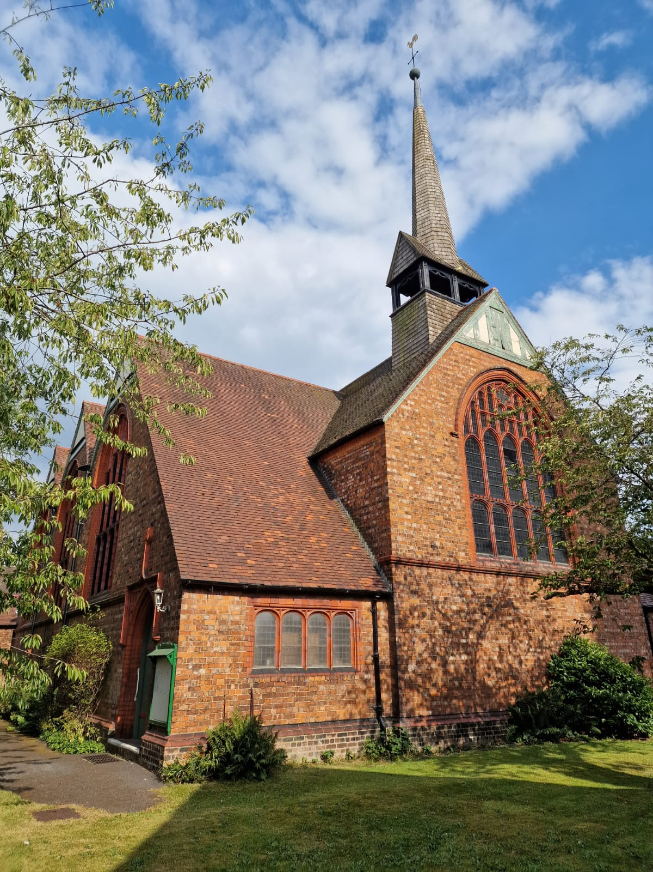

**CHURCH WARDENS**

**Peter Hart & Simon Roberts**

**Are YOU a candidate for this position?**

St. Barnabas Crewe, is seeking to appoint a Parish Priest of the Society of St. Wilfrid and St. Hilda, who is dedicated to the continuation of the Catholic tradition, well established in the Parish over many years. A Priest who emphasises the centrality of the Mass as the source and foundation of all our work in Christ’s name.

**Our Parish Mission, Working With Our New Priest Is;**

* To build upon the foundations laid over so many years by our previous long serving and dedicated incumbent.
* To reach out to the 13,000**\*** or so community of our Parish, spread the word and teachings of Christ in a way that enables our Church to grow and flourish in God’s name.
* To establish new links with the two Primary Schools within the Parish.
* To maintain and grow our involvement within the Deanery.
* To encourage all of the Laity to participate fully in the Church ministry.
* To work closely with the Safeguarding Officer & Wardens, to maintain a safe place to worship, meet and pray, for all of our congregation and visitors to the Church.
* Open to developing close links with other Christian bodies and other faiths whilst firmly maintaining our Catholic tradition.
* Encourage the Laity to recognise their talents and develop their own Ministry.
* Will nurture young people in the faith,
* Will, above all, be Mission – Centred.

\**See the ONS Census at the end of the profile*

**St. Barnabas Church.**

The church was built in 1884 – 85 to a design by the Lancaster partnership of Paley and Austin, and was paid for by the London and North Western Railway, being built near to its workshops. The church provided seating for 500 people at an estimated cost of £4,000 (equivalent to £600,000 today).

St Barnabas' is constructed in brick and red terracotta with red tiled roofs. The architectural style is Perpendicular. Its plan consists of a three-bay nave, north and south aisles, a single-bay chancel, and a southeast vestry. Towards the west end is a shingled flèche. On each side of the church are three cross-gables containing the aisle windows that are timbered at the apexes. The gables at the east and west ends of the church are also timbered, the west of the church houses the bell tower.

The arcades consist of terracotta arches carried on pink sandstone piers. Between the nave and the chancel is an open timber screen. At the west end of the nave is a glazed screen forming a baptistry. The reredos and the pulpit are decorated with carving. In the seven-light east window is stained glass dated 1901. The two-manual organ was built in 1887 by Wadsworth, and extended in 1957 by J. W. Walker.

The balance of our beautiful Church and its maintenance is constantly being assessed and reviewed to enable the church to grow and the community to continue to have this wonderful Church building at its disposal.

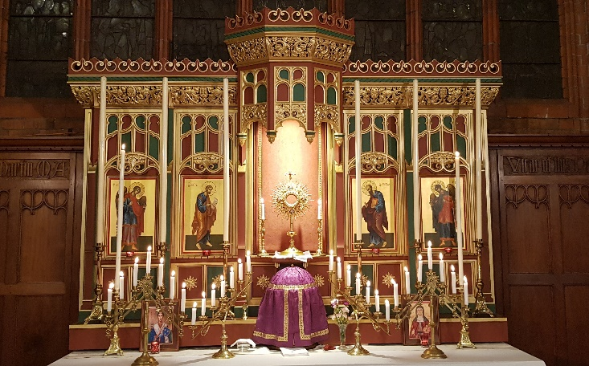

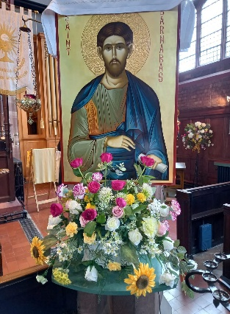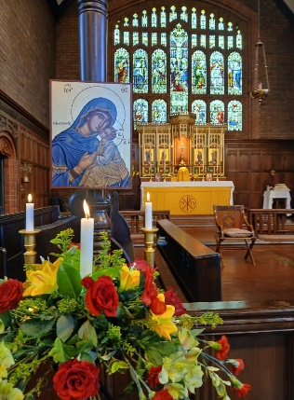

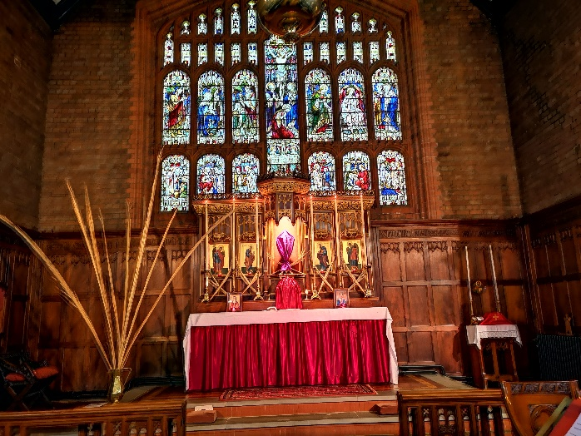

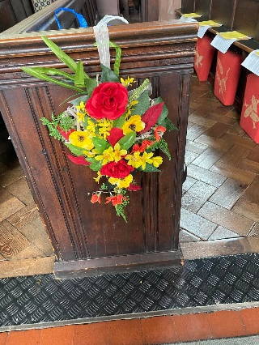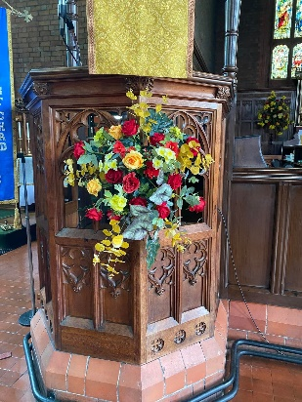

**Current Service Times.**

**Sunday**

10:00 Solemn Mass – Traditional Catholic Worship

17:30 Sung Mass (Live Streamed on Facebook)

18:15 Evensong (with Benediction every other week) (BCP)

**Tuesday**

19:30 Said Mass

**Wednesday**

10:00 Said Mass (Live Streamed on Facebook)

**Friday**

18:00 Said Mass with Hymns

**Saturday**

10:00 Said Mass

**Confessions:**

Before all major events, or at any time by appointment.

**Special services take place throughout the year.**

**A small example are;**

In Lent – Exposition of the Blessed Sacrament & Stations of the Cross (Weekly).

The Patronal Festival of St. Barnabas. At Harvest, a Thanksgiving Sung Mass.

Sung Masses for All Saints Day and All Souls Day

and at Christmas, a Crib Service and Carol Service with Benediction.

**Strawberry Tea – held in July this year.**

All sandwiches are homemade and the cakes are home baked by the members of our St. Hilda’s Guild

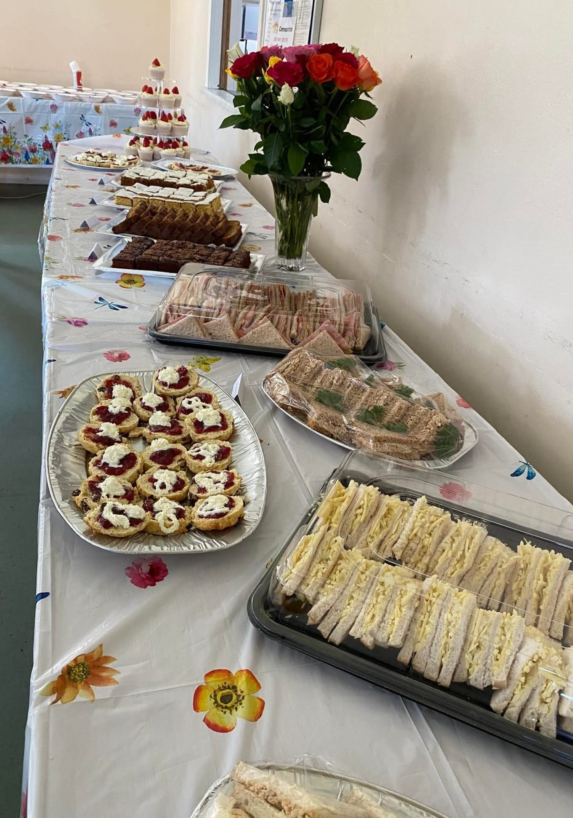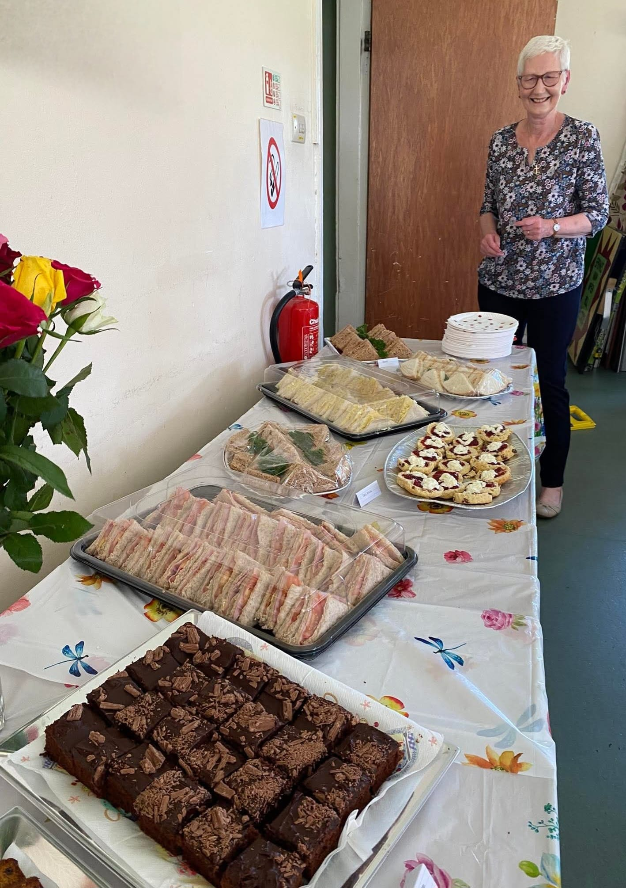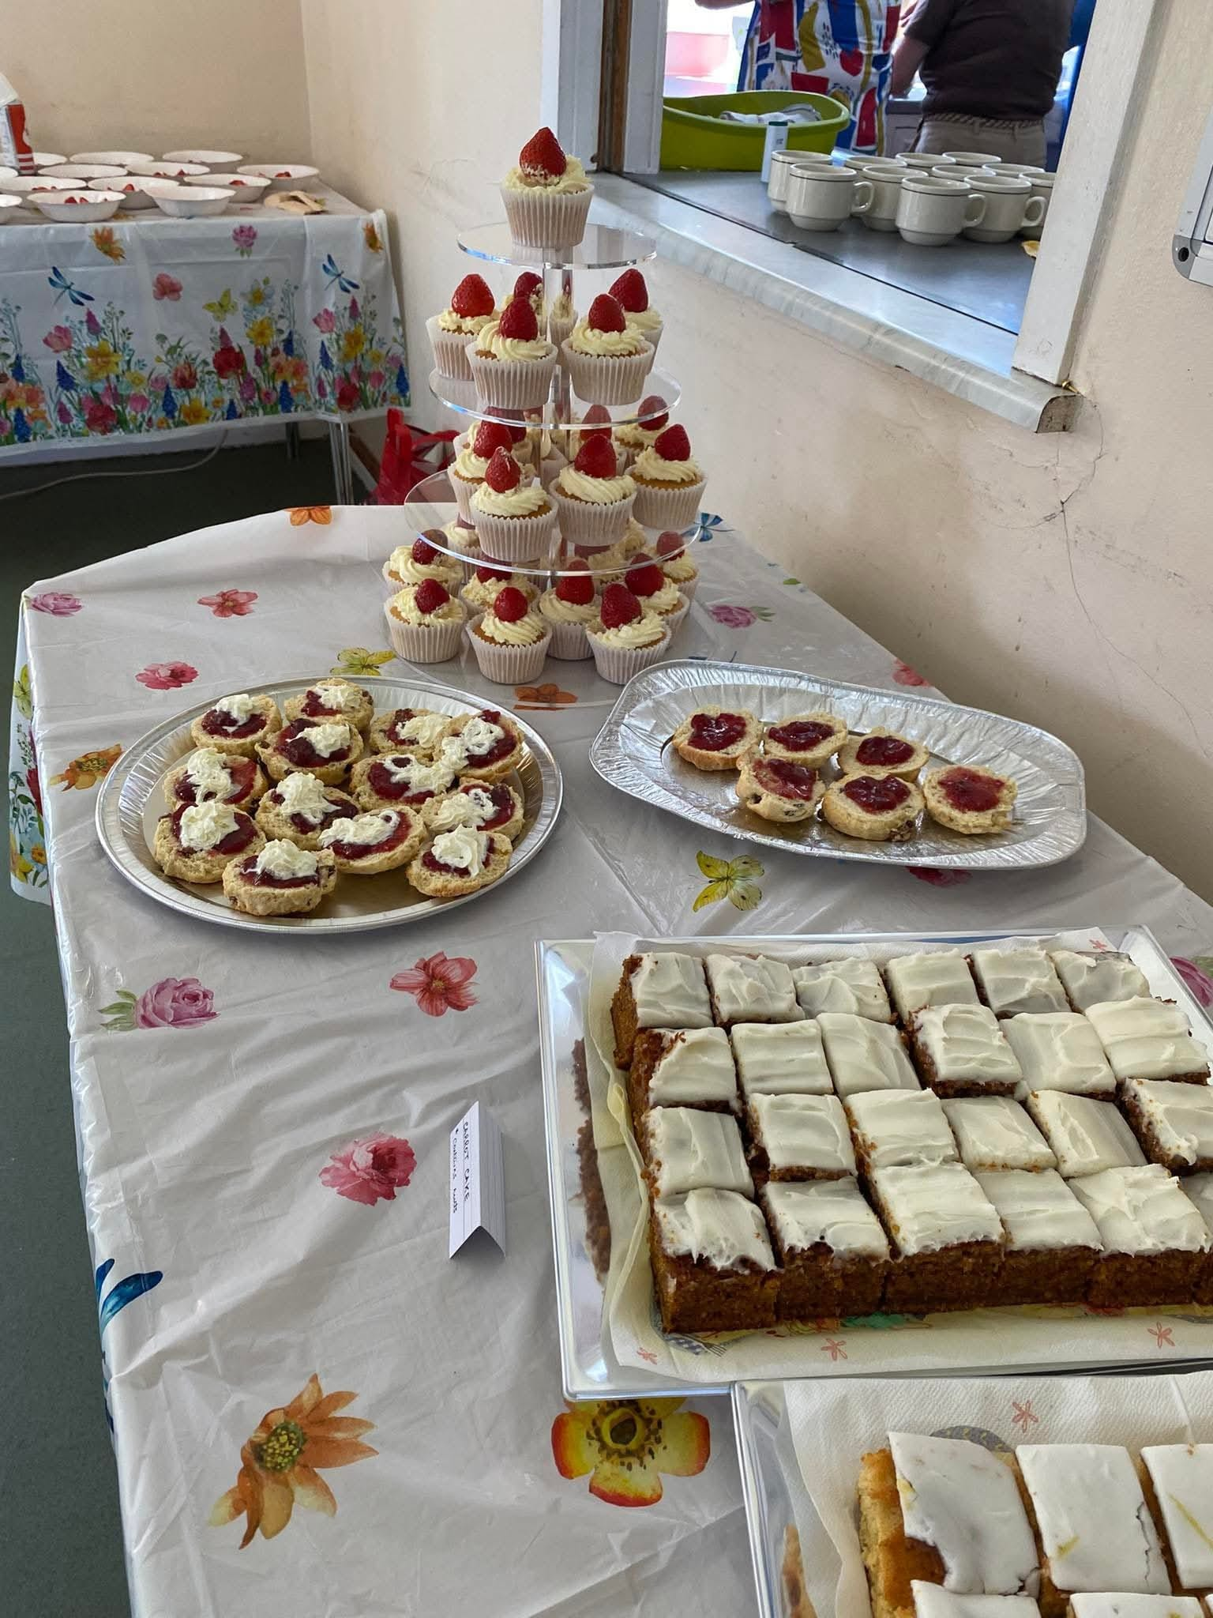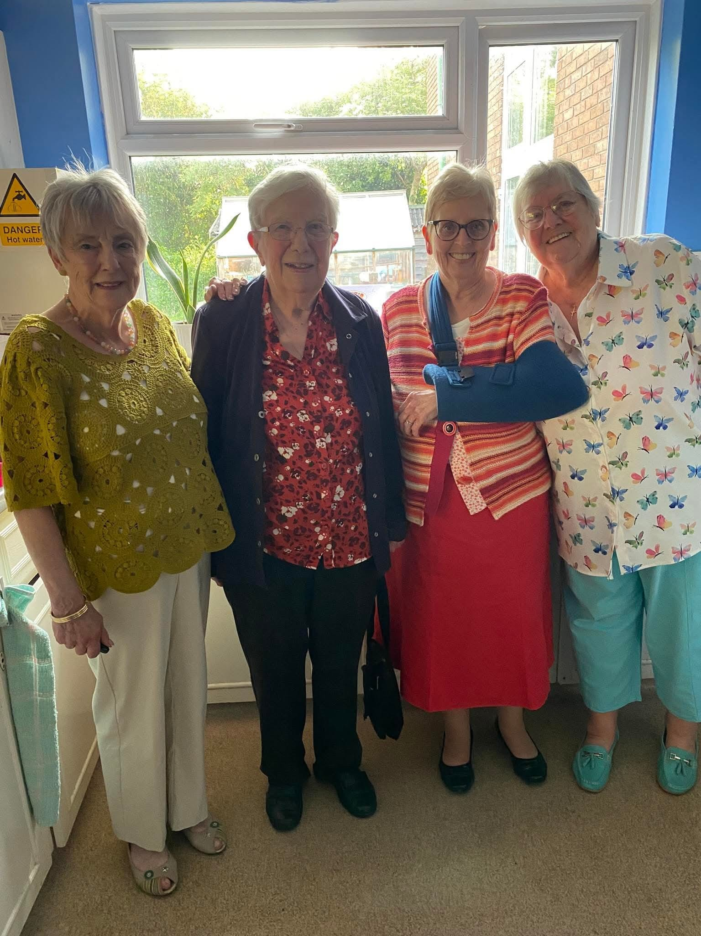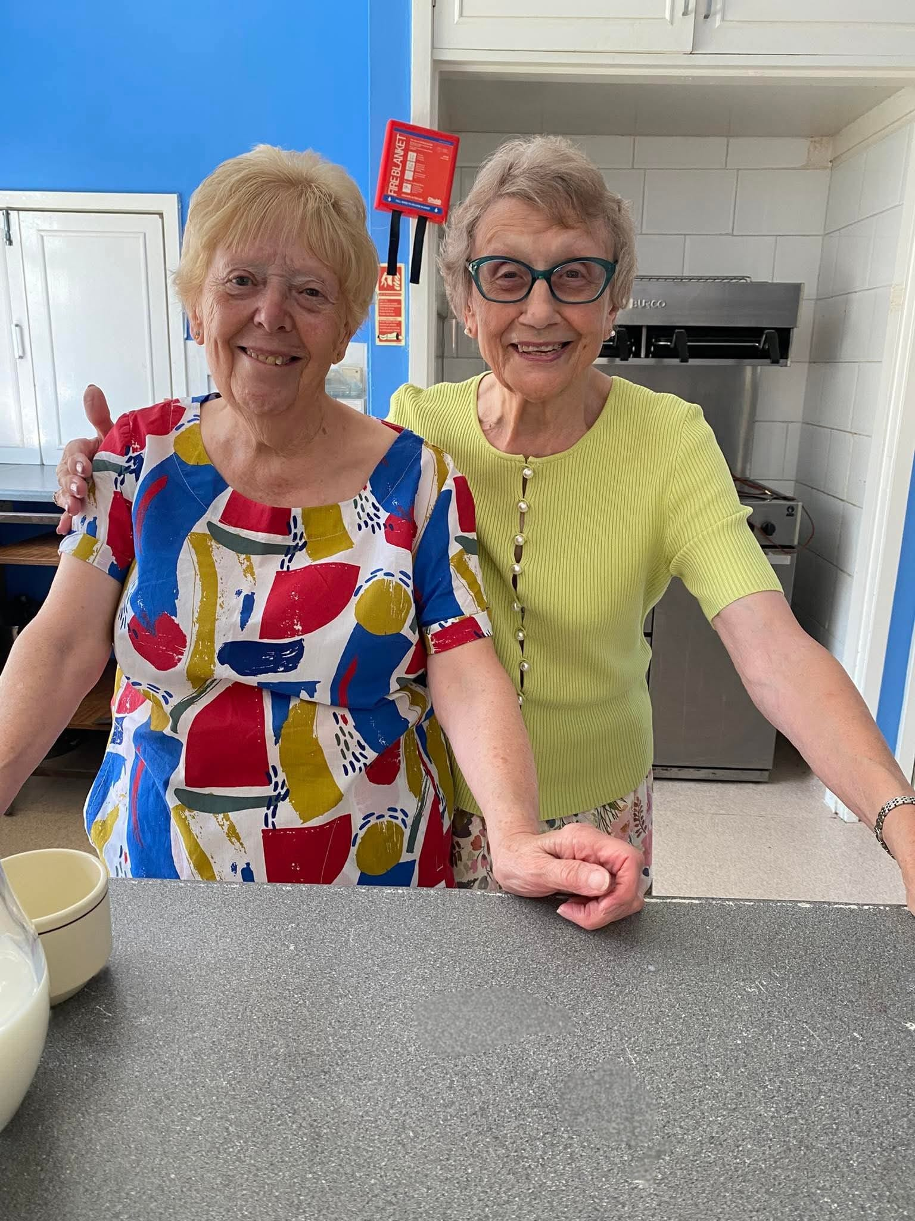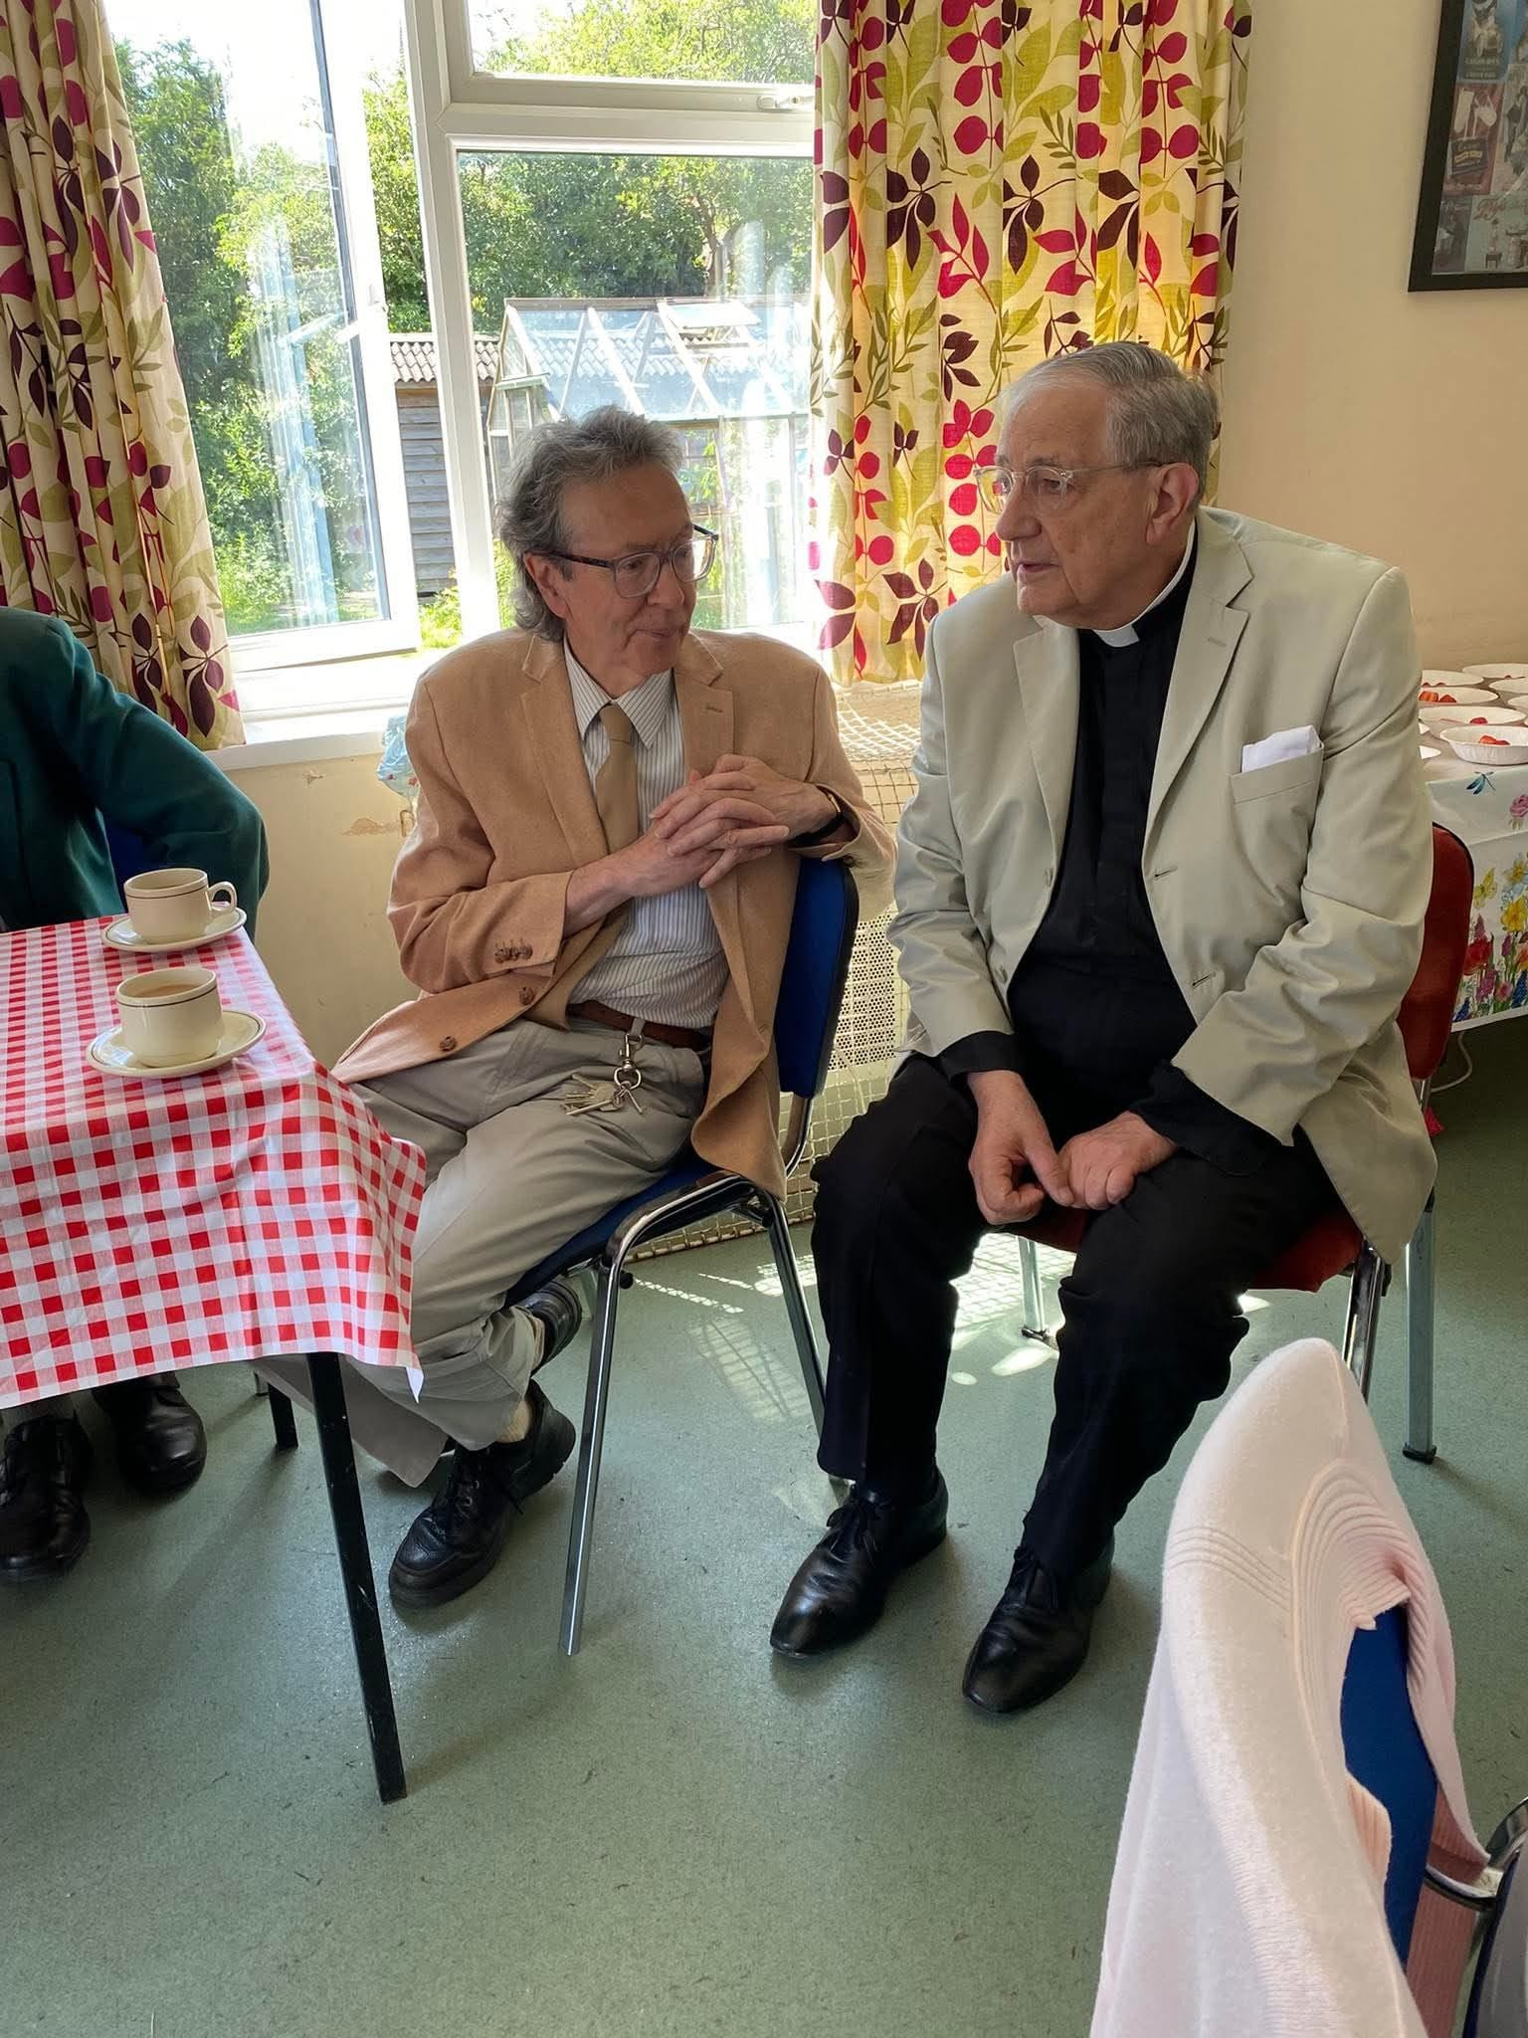

**Sunday Morning Coffee.**

Every Sunday morning after the Mass, we have tea, coffee and biscuits in the Small Hall, with juice for the children, who play outside in the garden, or in the Large Hall if it is wet or cold. If a member of the congregation has had a birthday in the week, we have a birthday cake that Sunday morning as part of our fellowship.

**WE HAVE;**

**A** strong congregation at St. Barnabas, with regular attendance on a Sunday morning of around 65 - 75 worshippers. These numbers can swell with special services. For example, Easter Day this year was 105

**A** small Choir with a resident organist. We use the New English Hymnal and the Laudate Catholic Hymn Book. The Choir sings small anthems on Feast days.

**A** serving team, affiliated to the G.S.S. Being part of the Guild of Ss. Francis & Chad, we have regular Guild Services, throughout the year at, St. Michael, Coppenhall, St. James the Great, Congleton, St. Andrew, West Kirby and of course St. Barnabas.

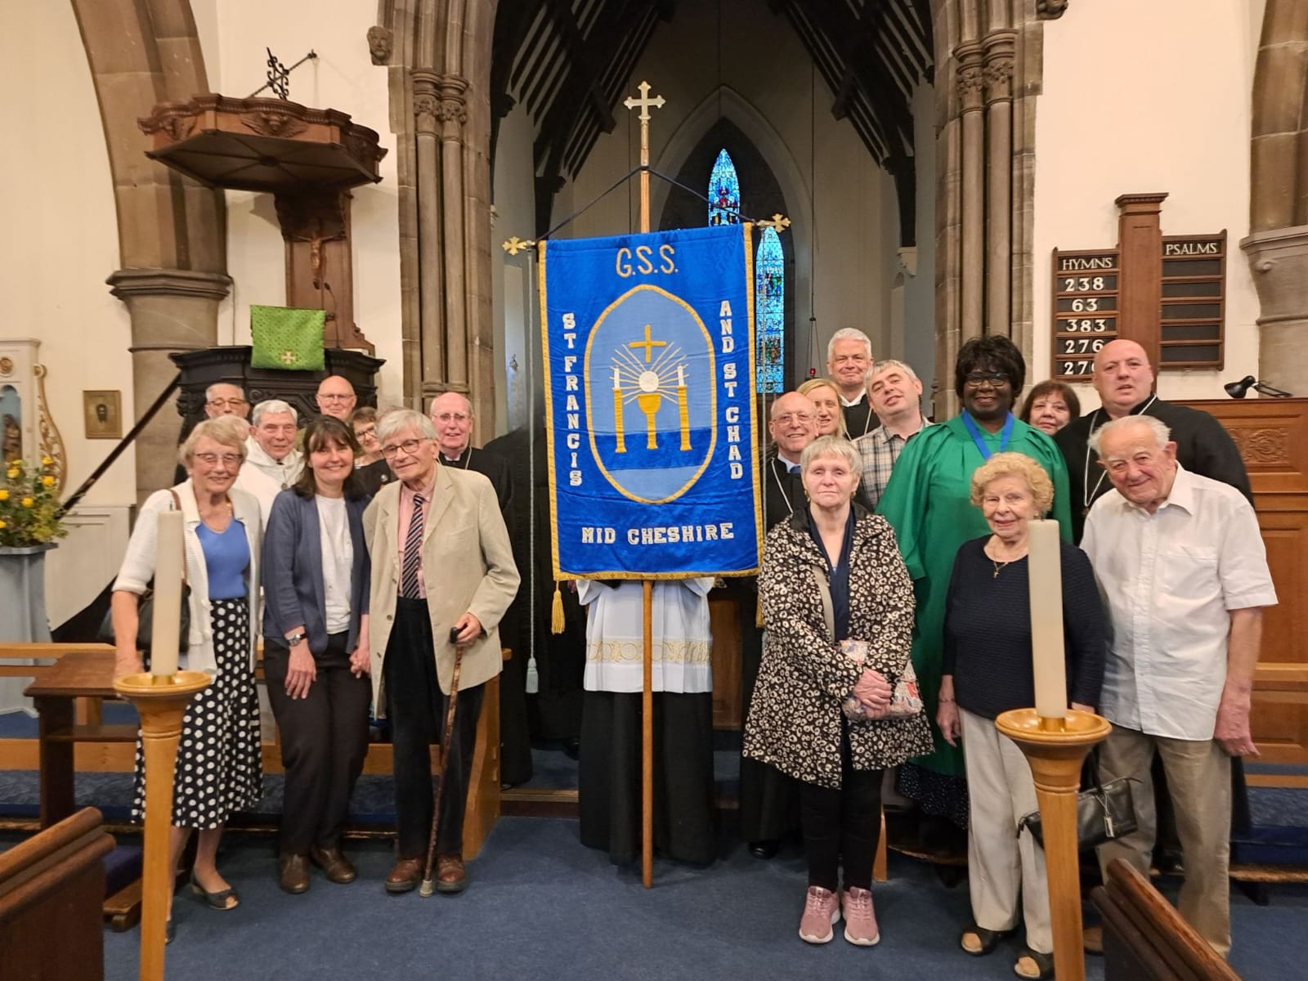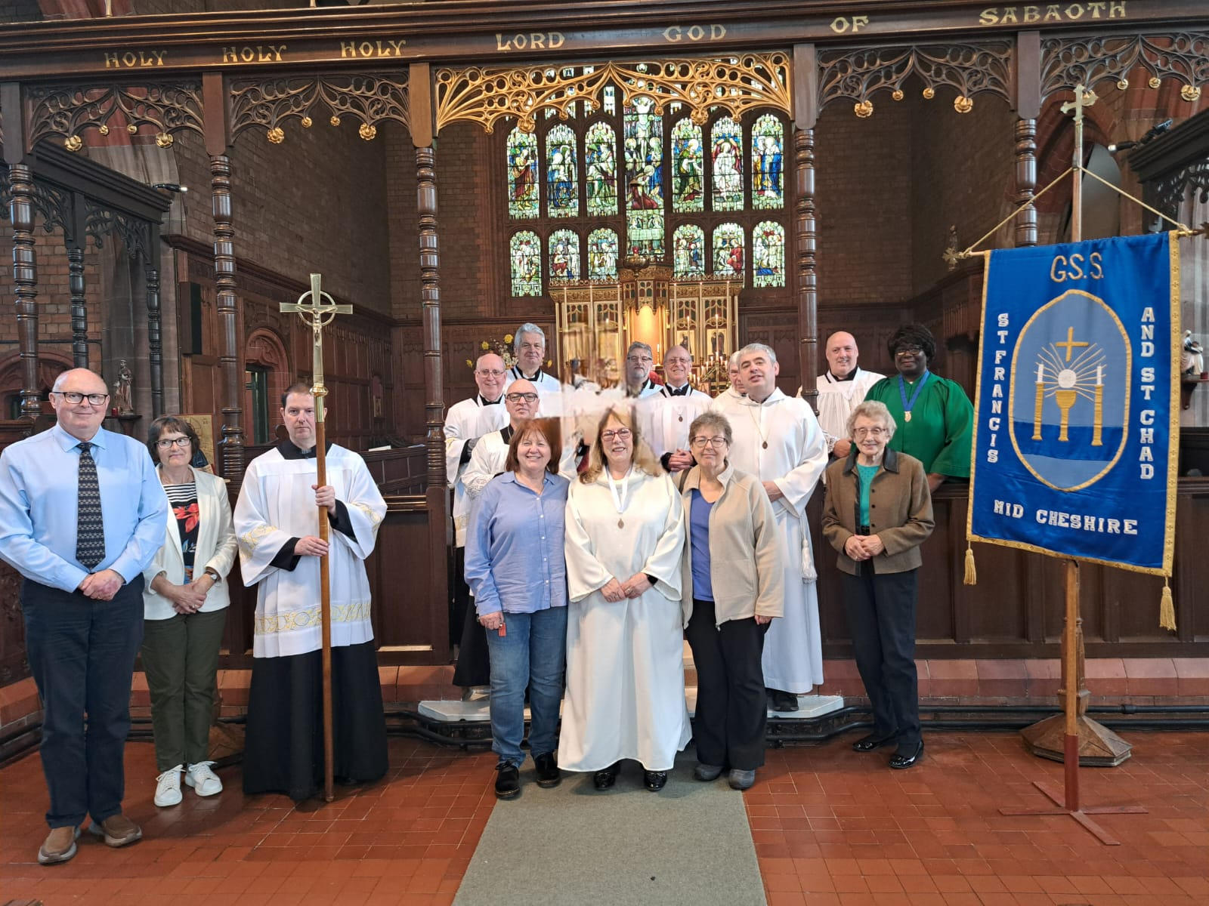

**A** Sunday School and Youth Club with around 8 to 12 children on a regular basis.

**A** Pastoral Worker, **Mike Almond**, takes communion out to the residents of the two local Care homes within our Parish. A policy to extend visiting with lay involvement would form part of the Pastoral Worker’s Role.

**A** strong collaborative team that have worked hard to maintain the Church. Like all old churches, it is a challenging and expensive building to maintain. Recently we have had a toilet built in the Church with fund raising and money from our reserves. There is still some outstanding work from the last Quinquennial Report that should be completed in the summer of 2025, before the next Quinquennial report in 2026.

**A** pilgrimage each year in August to Walsingham with the joint cell of Ss. Barnabas and Michael, Coppenhall. We have a 5 day trip, Monday to Friday with planned outings during our pilgrimage.

**A** Church Hall which sits next to the vicarage, which sits next to the Church. The small and large Halls are rented out weekly to various groups and bring in a good income throughout the year. See the financial part of the Fact Sheet and the attached accounts for 2024.

**A** small field at the south side of the Church running parallel the Vicarage garden. There are small gardens to the west and north of the Church.

**A** good financial position through good management of our investments and income by our Treasurer, **Brian Kerr**. Income includes regular planned giving, two Fayres a year, May and Christmas and occasional Spring and Summer Strawberry Teas. We also raise money through our Harvest Festival & Supper, with the perishable foods, while non-perishable foods are sent to St. Pauls Pantry, a food bank located on Hightown in Crewe, which we also support with donations throughout the year. See the attached fact sheet and accounts regarding Tithing and Charity giving.

With a large grant from the government, we have refurbished the Church Hall with new windows, heaters and LED lighting throughout. We also have a defibrillator on the outside wall of the Church Hall. This grant was received because of Barnies Cheshire Hub.

**We pay our Parish Share in full every year.**

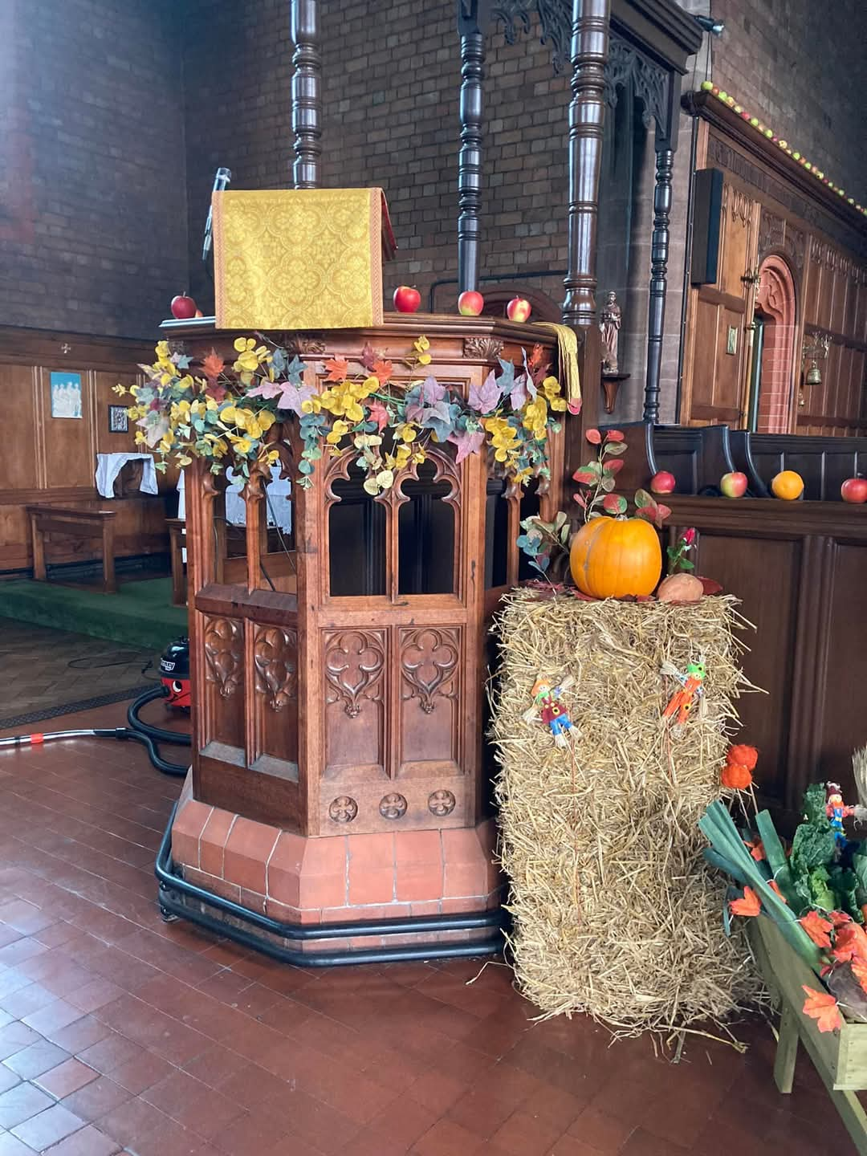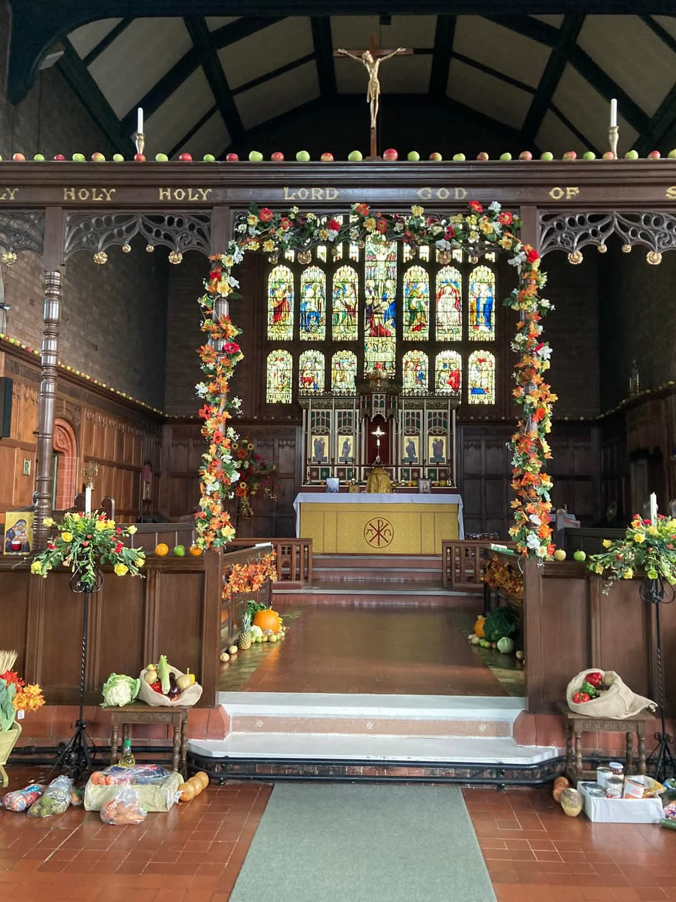

**Our Church is next to**

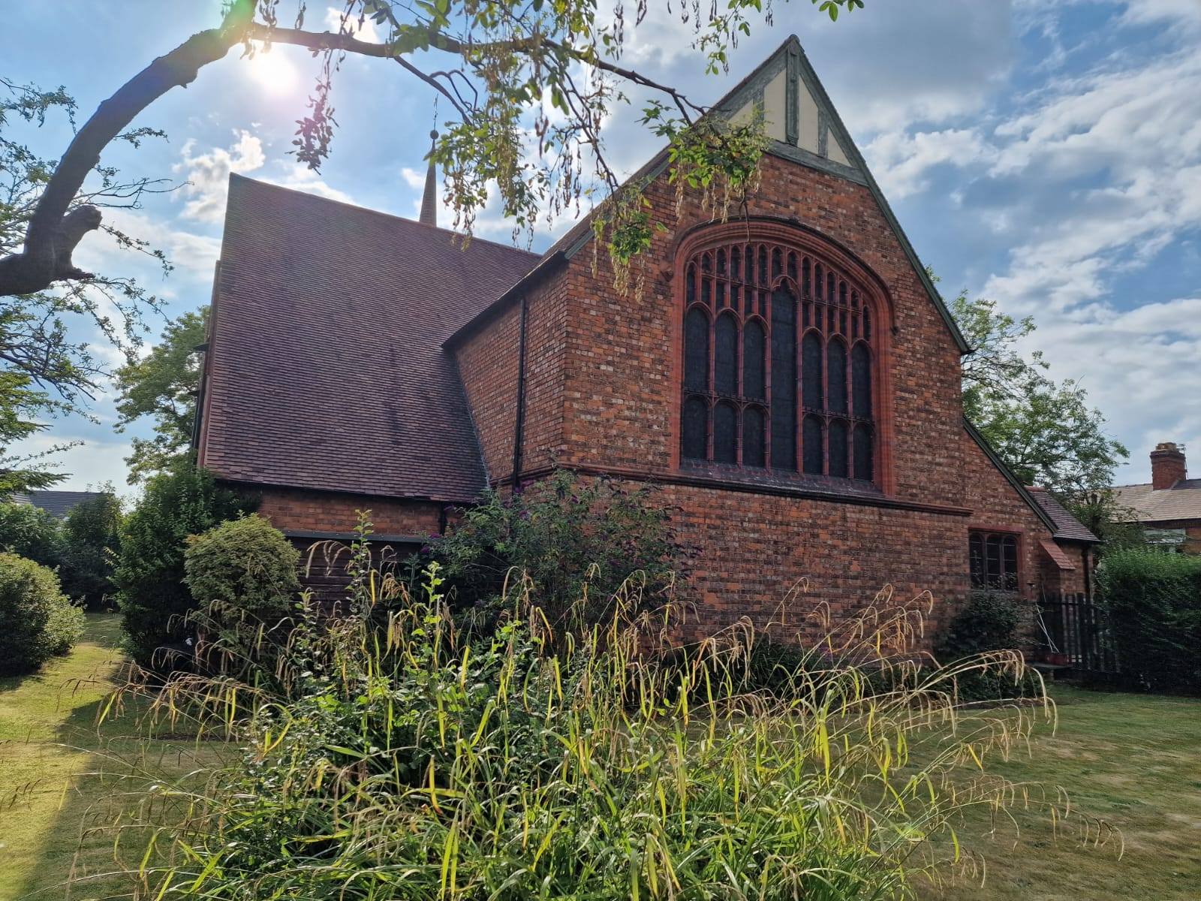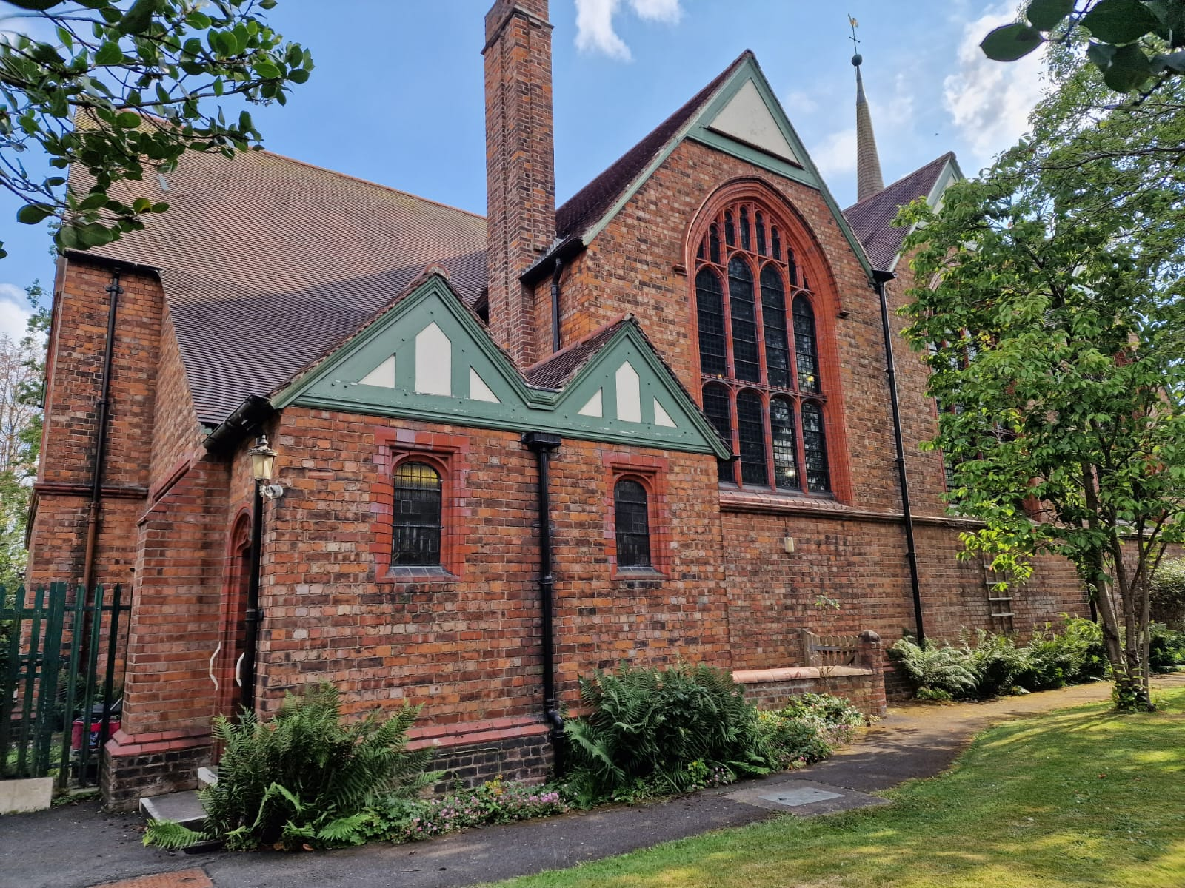

**the Vicarage, which is next to**

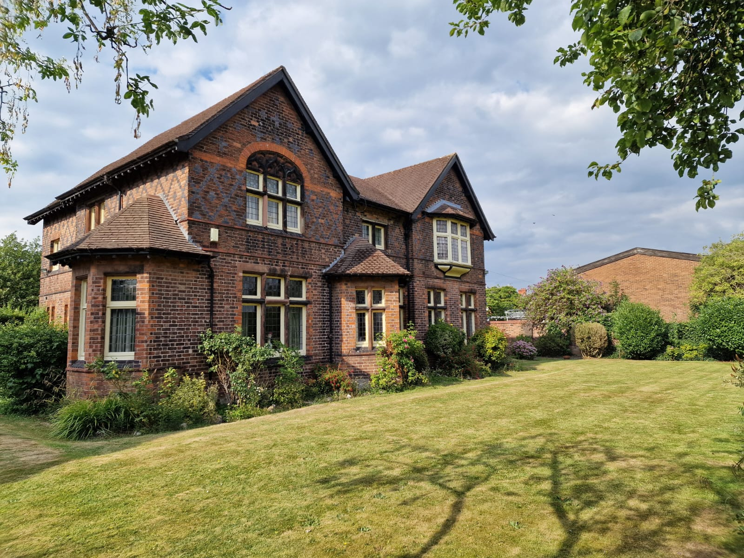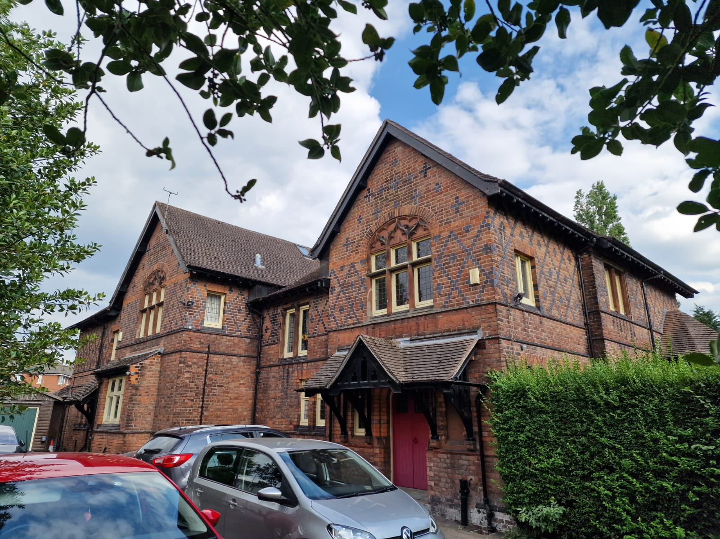

**the Church Hall**

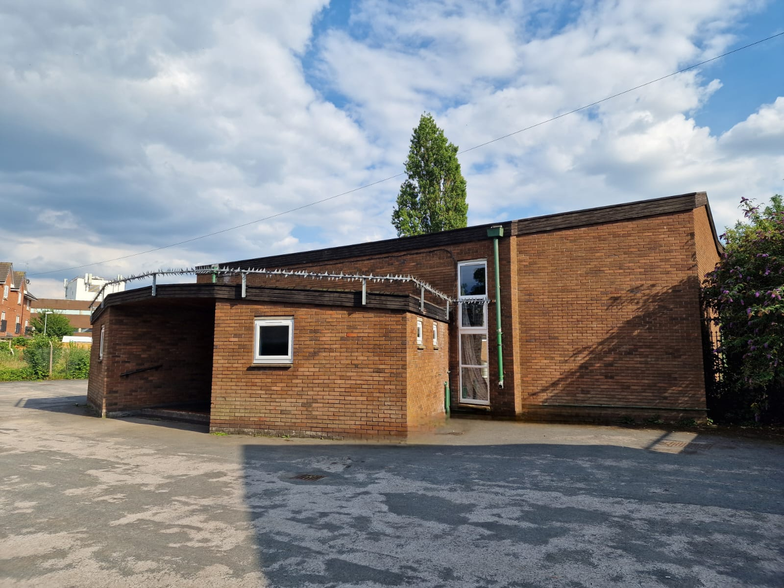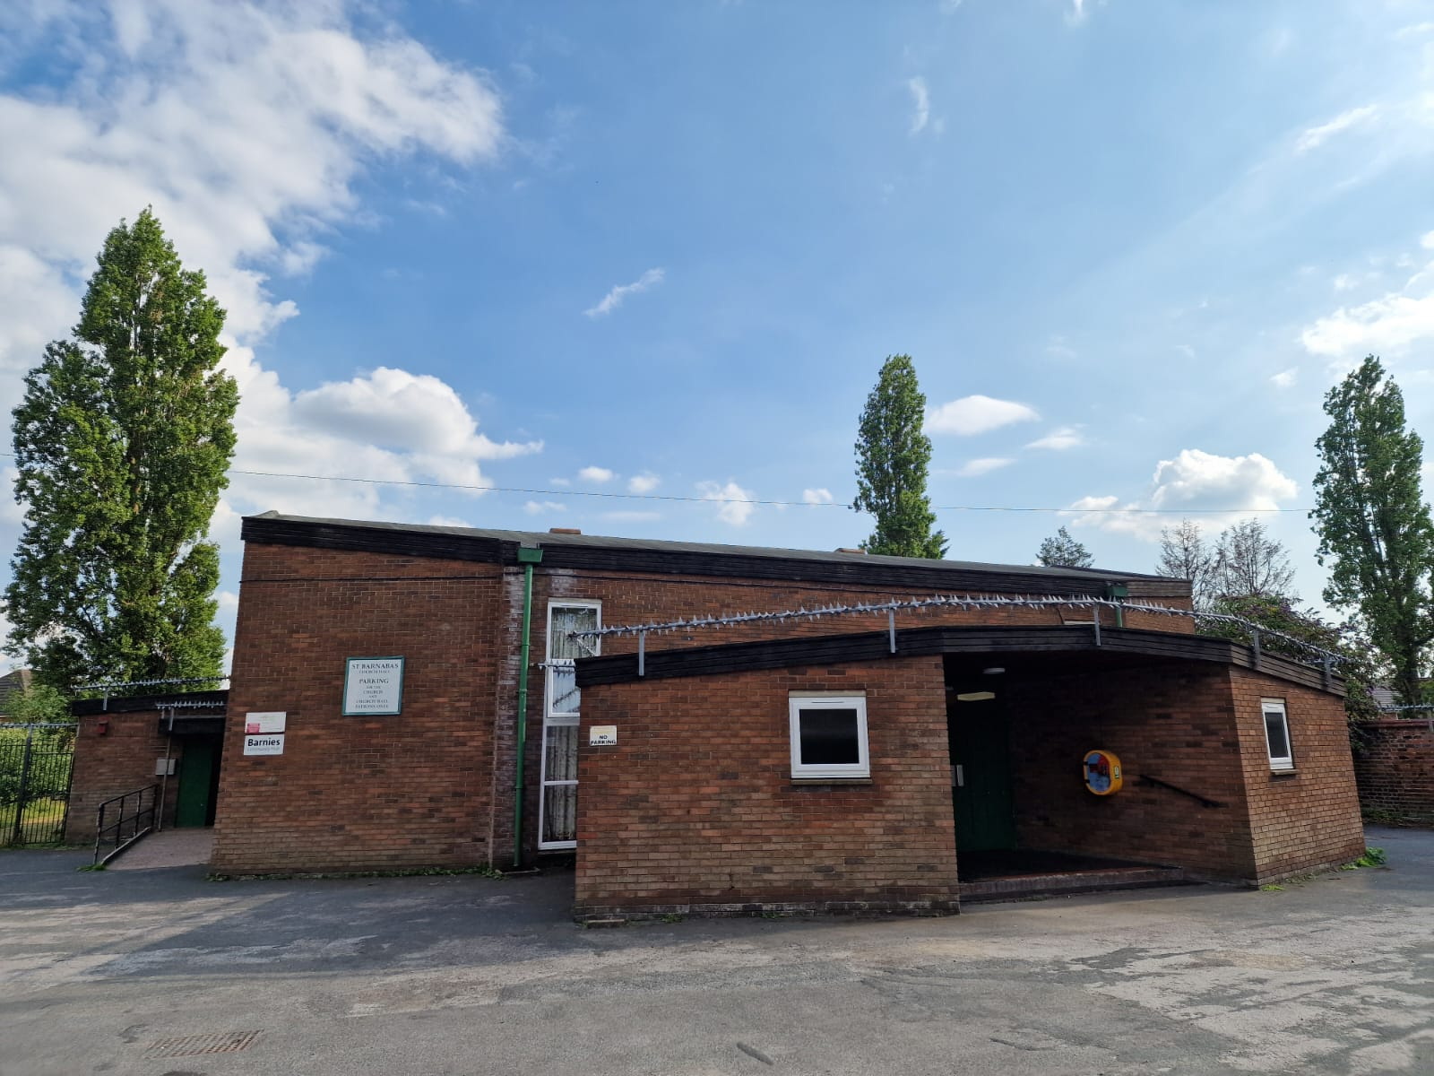

**SAFEGUARDING.**

We have an extremely dedicated Safeguarding officer, **Lesley Bostock**, who keeps on top of all related work. She has completed all of the training for her role. All of the PCC have carried out their 2 online Safeguarding courses. The Parish Priest and Pastoral Worker have carried out their Safeguarding courses and are up to date, the Wardens at present have completed the 2 courses with the PCC, but still have one more course to complete.

We promote the welfare of children, young people and adults in our Church by ensuring that safeguarding is integral to the life of the Parish.

Our Safeguarding Officer maintains the relevant level of safeguarding training and keeps it up to date, adding new people on to the training when they join the PCC or when working with children or vulnerable adults.

We use the Chester Diocese Parish Dashboard to record and inform our safeguarding practise.

All DBS checks are completed and are updated as and when they are required.

Website: https://stbarnabascrewe.weebly.com

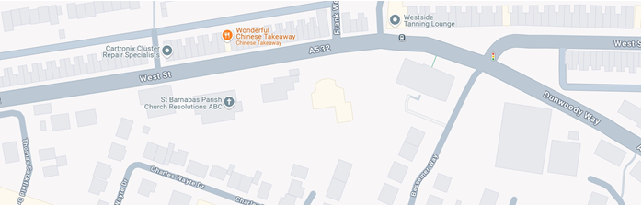

A map of the Church, Vicarage & Hall On West Street

**BARNIES**

A Cheshire East Hub meets twice a week in the Church Hall which is run on a voluntary basis, after its initial beginnings under the non-profit making E.E.A. Group.

This group has involvement of Church members, the Priest and some laity eg, helping with the blind and partially sighted bowling, or are just there to lend an ear and have a chat to those who want to. Greater links with the congregation are always being developed.

Officers of Cheshire East often call in to the sessions and in discussion with Lesley Christensen, refer people to the Hub. This maybe to help with social needs, medical advice, seeking employment or dealing with loneliness etc.

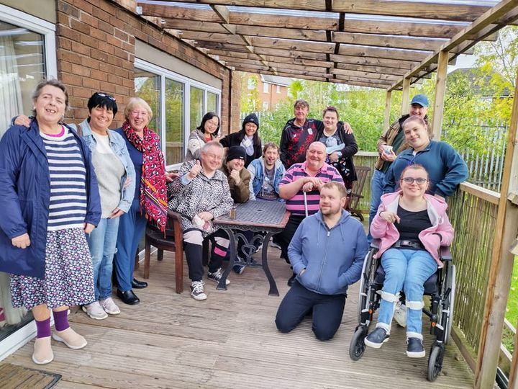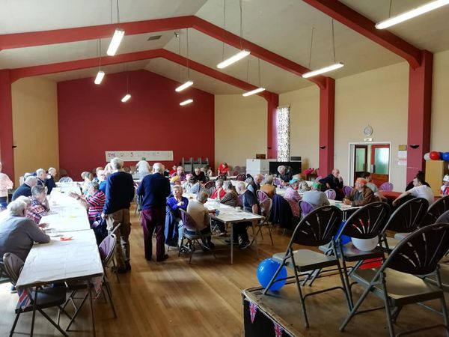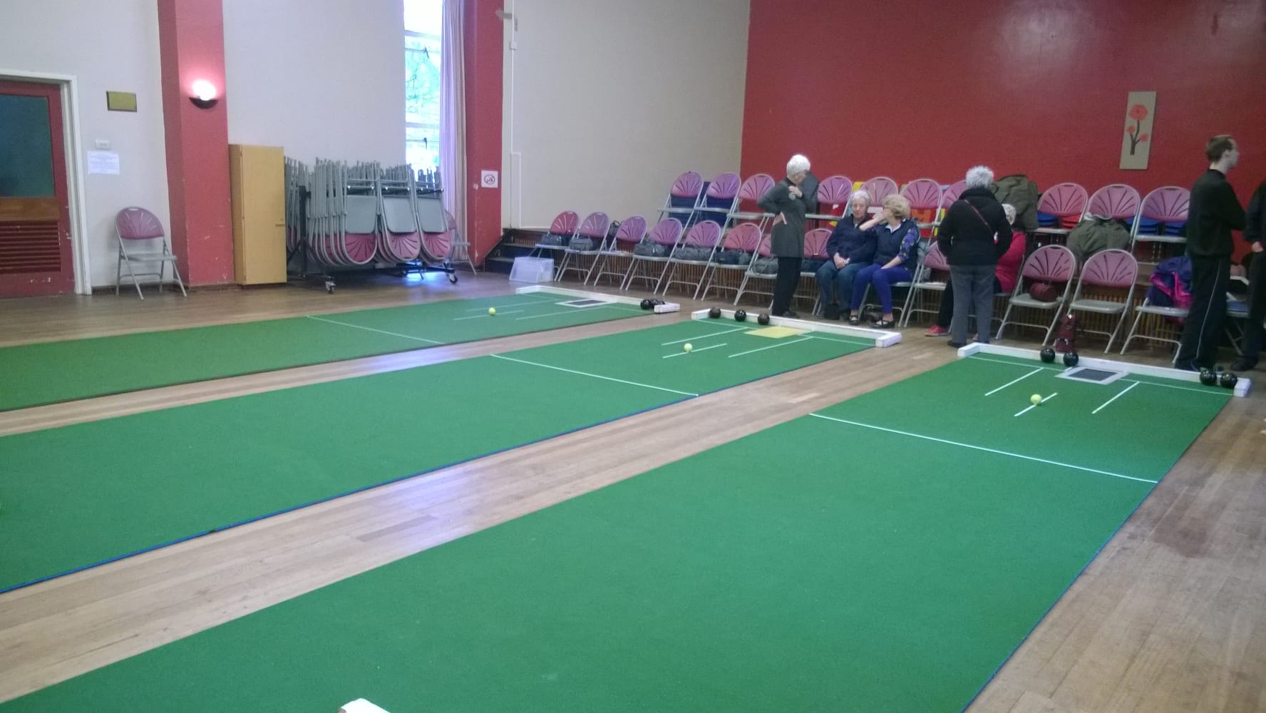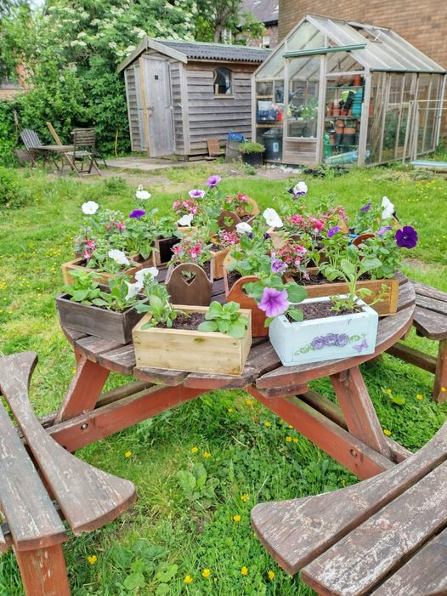

**OFFICE FOR NATIONAL STATISTICS**

**CENSUS 2021**

Output area: Crewe Coppenhall & Underwood

Resident for 12 months or more on the day of the census

Asian: British Bangladeshi 0.3%

Asian: Chinese 0.4%

Asian: Indian 1.6%

Asian: Pakistani 0.2%

Asian: Other 0.6%

Black British: Caribbean / African 0.8%

Black British: Other 0.1%

MIXED MULTI ETHNIC GROUPS

White Asian: 0.4%

White / Black African 0.3%

White / Black Caribbean 0.8%

Mixed Ethnic Group 0.5%

White: English, Scottish, Welsh 74.3%

Irish 0.4%

Gypsy 0.2%

Roma 0.5%

White Other 16.5%

Arab 0.3%

Any other ethnic group 1.7%