St John the Divine Sandylands

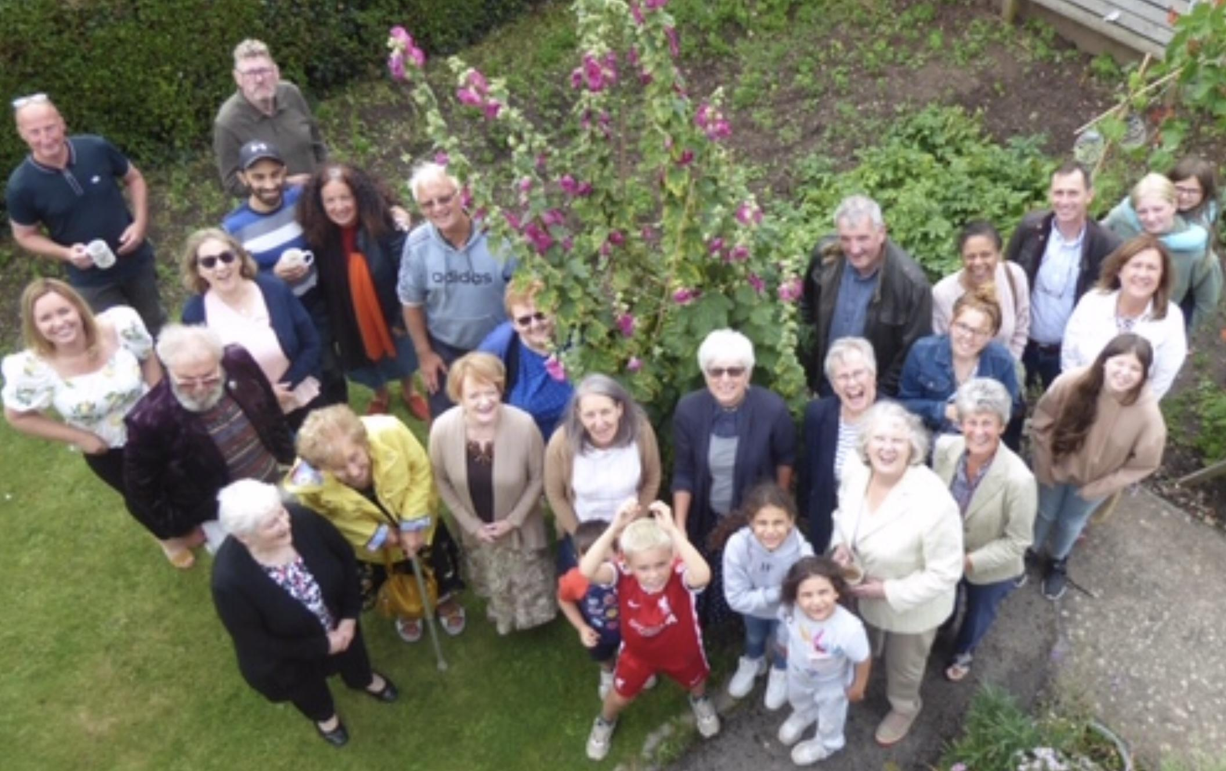

‘A Church for All’

Introduction
Dear Sister or Brother,
The Diocese of Blackburn is passionate about the renewal of Parish life. Vision 2026 sets before the churches of Lancashire a profound belief in the power of the Gospel to transform lives and communities and expresses a firm commitment to maintaining clergy numbers and investing in the mission of the local church. We therefore seek clergy with a personal faith fiery enough to make new disciples for Christ, with a sincere commitment to the Parish as the heart of the church’s mission and with the resilience and courage to bring growth and renewal to local churches. We don’t want superheroes. Rather we are seeking authentic, prayerful priests of all traditions who share our passion for confident proclamation and generous service.

Lancashire is a wonderful place to minister, without doubt the most diverse and beautiful county in England. We can therefore offer an extraordinary range of contexts for ministry: from areas of great opulence to the most income deprived communities in the UK, from remote countryside to densely populated former industrial communities and from brightly lit coastal towns to elegant university cities.
We have the most wonderful and precious family of church schools (95% of our headteachers are practising Christians) which offers both an evangelistic opportunity and the best possible start for clergy children.

People in Lancashire have high expectations of their priests who play a key role in the communities they serve. Ministry can therefore be hard work and so this is a Diocese which will offer all the support it can to its parish clergy. Bishops, Archdeacons and Area Deans do their best to know their clergy well, we offer supportive programmes such as our new five year Start of Ministry Course and the Parish Renewal Programme and there are close friendships and strong networks between clergy of all traditions.

We really hope you enjoy reading this profile and that it provides all the information you need. If this particular post does not feel quite right, please do get in touch about other parishes in the Diocese that are vacant.

Most importantly of all, please be assured of our prayers as you discern the will of God for the next stage in your ministry.

The Bishop of Burnley The Bishop of Lancaster
The Rt Revd Philip North The Rt Revd Dr Jill Duff
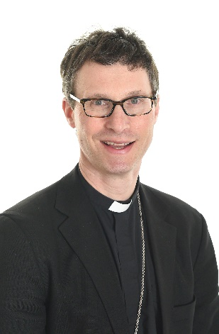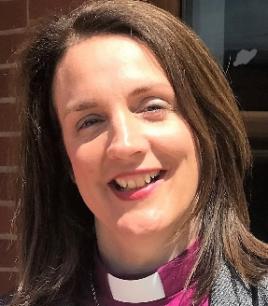
Diocesan Vision

Vision 2026 is an agenda for growth and change agreed by the Blackburn Diocesan Synod in 2015. It challenges our parishes to be healthy churches that transform their communities as we look ahead to our diocesan centenary in 2026. It also lays out four ways in which this over-arching goal can be achieved: Making Disciples, Being Witnesses, Growing Leaders and Prioritising Children and Young People.
All that we do as diocese is focussed on the delivery of Vision 2026. To make disciples we are raising levels of prayer, helping regular patterns of bible reading to be established and encouraging generous giving of time, talents and treasures. To be witnesses, many parishes are setting up new local congregations at different times and in different places to reach out to new groups of people as well as showing God’s love in action through projects that meet a local human need. New leaders are emerging as we seek to enable and equip those God is raising up in our midst for lay and ordained ministry. And our focus on children and young people is enabling creative thinking to raise up a new generation for Jesus Christ.

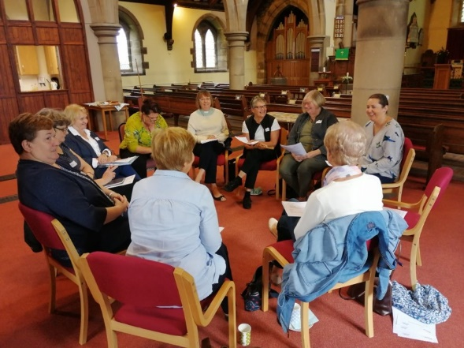
Over 85% of our parishes have a ‘Vision Champion’. This is usually a lay appointment and the Champions’ role is to encourage and support their parish leaders in pursuing the goals of Vision 2026 in a way that is appropriate for their local community.

Vision Champions from different parishes meet to
share ideas and pray together

In the Diocese of Blackburn we are inspired by confidence in the Gospel and are ambitious in our desire to make new disciples for Jesus Christ. We are committed to mutual flourishing, to maintaining clergy numbers and to investing in training for new curates.

Through prayer we see the grace and power of God who can alone bring renewal and growth. Our Diocesan Vision Prayer is:

“Heavenly Father, we embrace Your call for us to make disciples, to be witnesses,
to grow leaders and to inspire children and young people.
Give us eyes to see Your vision, ears to hear the prompting of Your Spirit
and courage to follow in the footsteps of your Son, our Lord and Saviour Jesus Christ. Amen”

You can find out more by visiting the Vision 2026 pages on our website: www.blackburn.anglican.org

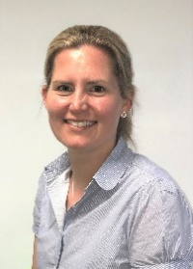

Carolyn Barton,
Director of Vision Delivery

We Look After You
If you come to Blackburn Diocese we will look after you…

- We have a great property department, who will do their best to ensure your house works for you and your family and is well maintained.

- We encourage all clergy to take their full annual leave entitlement, and also to use creatively the overtime we all put in to take an extra day off once each month, to enable you to have a midweek ‘weekend’ away.
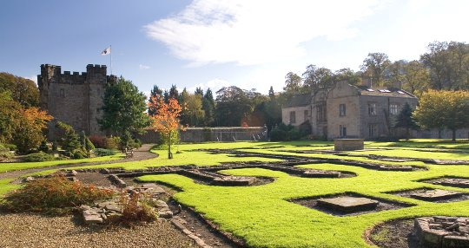
We have a beautiful diocesan retreat house in the grounds of a ruined Cistercian abbey, where clergy are welcome to have personal reading days without charge (bring your own lunch).

Whalley Abbey Centre for Christian Discipleship
and Prayer

- We encourage all parishes in vacancy to consider how they will ‘pastor’ and support their new priest. The diocese has an anti-bullying and anti-harassment policy.

- We offer an Annual Conversation in which every licensed priest spends 90 mins with a Bishop or Archdeacon discussing ministry and wellbeing.

- If you are looking for a spiritual director or a mentor we have an excellent Warden of Spiritual Direction and have networks of people with whom we can put you in touch.

- We are always looking for ways for clergy to mix apart from work – including reading weeks, regular hospitality, a cricket team and a clergy walking group. Further suggestions are welcome.

- We offer first incumbents a mentor and participation in our 5 year Start of Ministry Programme.

Bishop Philip leads a clergy walk

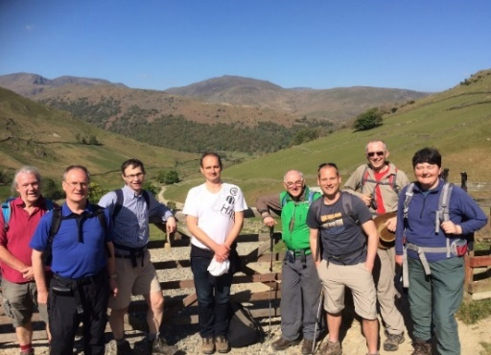

St John’s the Divine, Sandylands
‘A Church for All’

Who we are

St Johns is a single church parish, one of four Anglican parishes in Heysham and Morecambe. The parish of Sandylands sits in the area of north Heysham. St John’s is situated in a suburban area just a few hundred metres away from the coast.

We are a welcoming, friendly and happy congregation who love to worship together but who enjoy welcoming new people to our church family. A big plus at St Johns is the willingness of the congregation to contribute to the life and running of the church, people work tirelessly behind the scenes. They are the unsung heroes who are the foundation stones of our church. Their work, faithfulness, dedication and willingness to help and to give, have cemented the foundations upon which our church can be healthy and can transform communities. We are a parish which fully affirms the ministry of women at all levels in the Church

Our church members range in age from birth to over 90. There are 81 names on our Electoral Roll and we currently have on average 65 people attending our weekly Eucharists. We gather to worship on Sunday at 8 am for a BCP Eucharist, followed by a 10.30 service, which varies through the month. We have a variety of worship styles for our 10.30 service, including monthly All Age Family services and had Parade Services pre lockdown as well as Common Worship Holy Communion. We also gather for BCP Eucharist on Wednesdays at 11am. We have a style of worship which embraces both sacramental and word based styles; this gives us, we believe, a nice blend of small catholic evangelical spirituality. Being an active, inclusive Christian presence in our wider community is a very important part of our mission but we would like to do more. Everyone is welcome and everyone is valued without exception.

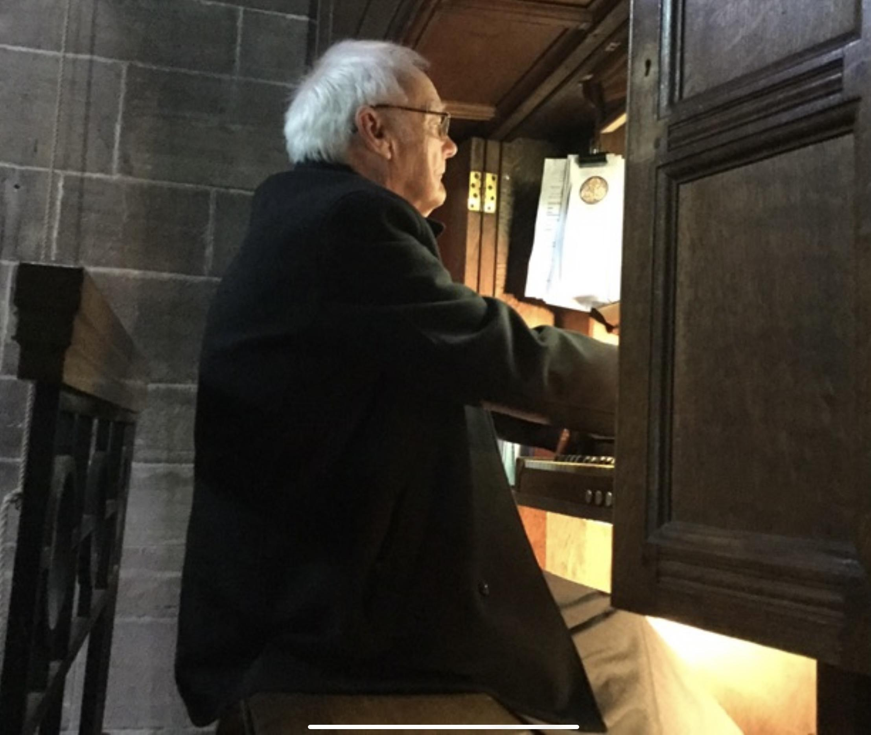
We have a small but committed choir at St John’s which is augmented by the Bay singers, a local choir, who sing for special services and weddings and funerals as required and who also sing at our Lyrics and Lunch sessions. We have a two manual pipe organ at St. John’s with a regular organist and a new sound system that provides opportunities to use other musical options in the building.

At St Johns we embrace new ways to worship while still maintaining traditional services. We have had ‘Carols for fun’, a pet service, and also participate in national initiatives such as the annual Christingle service, and the Christian Aid ‘Big Breakfast’, supporting Christian Aid week.
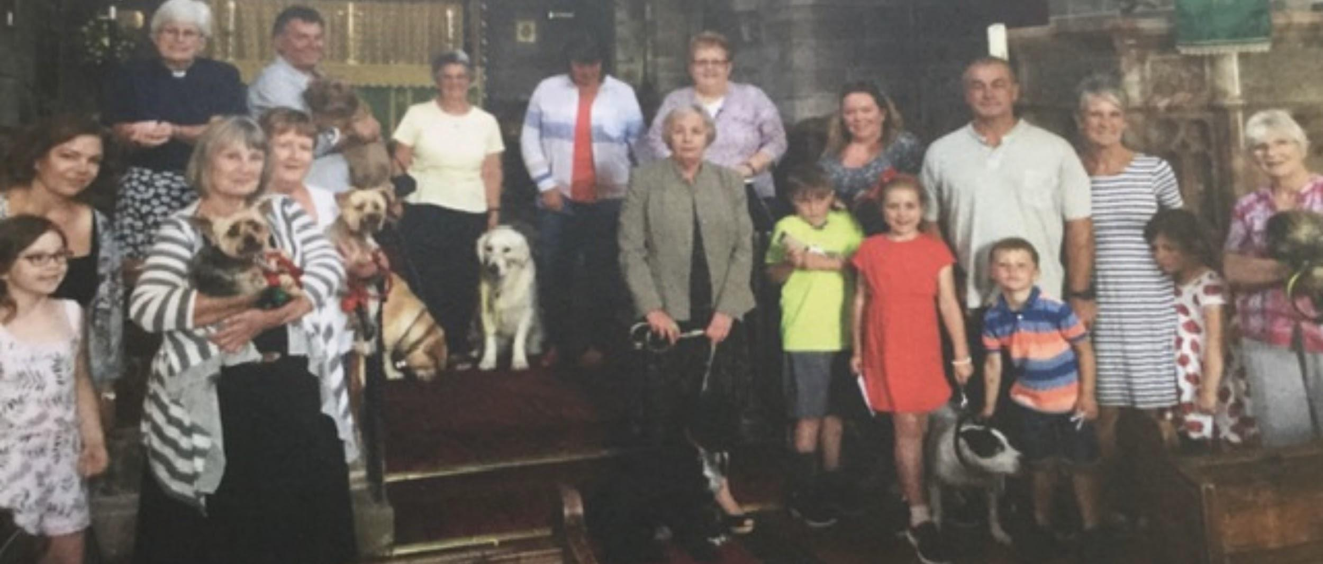
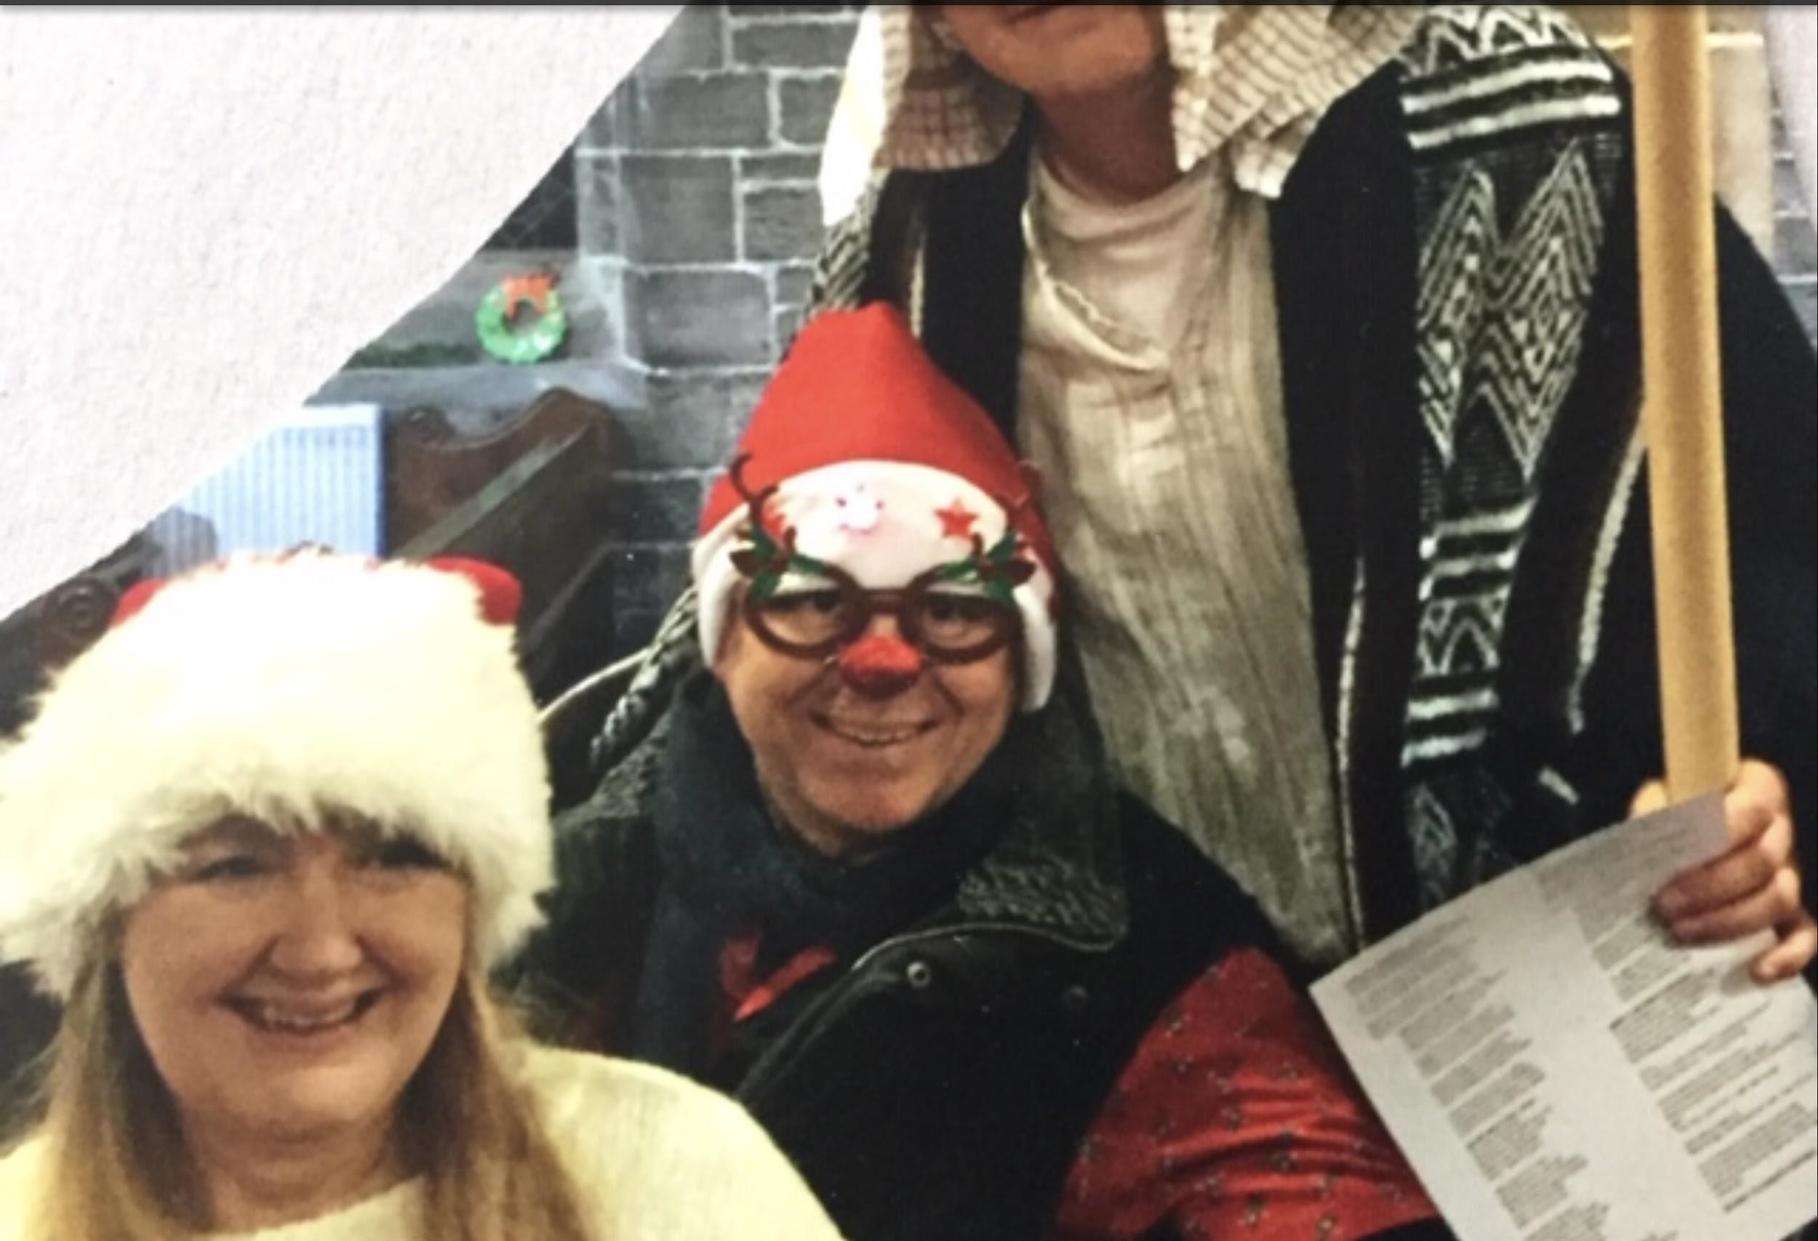

Carols for fun
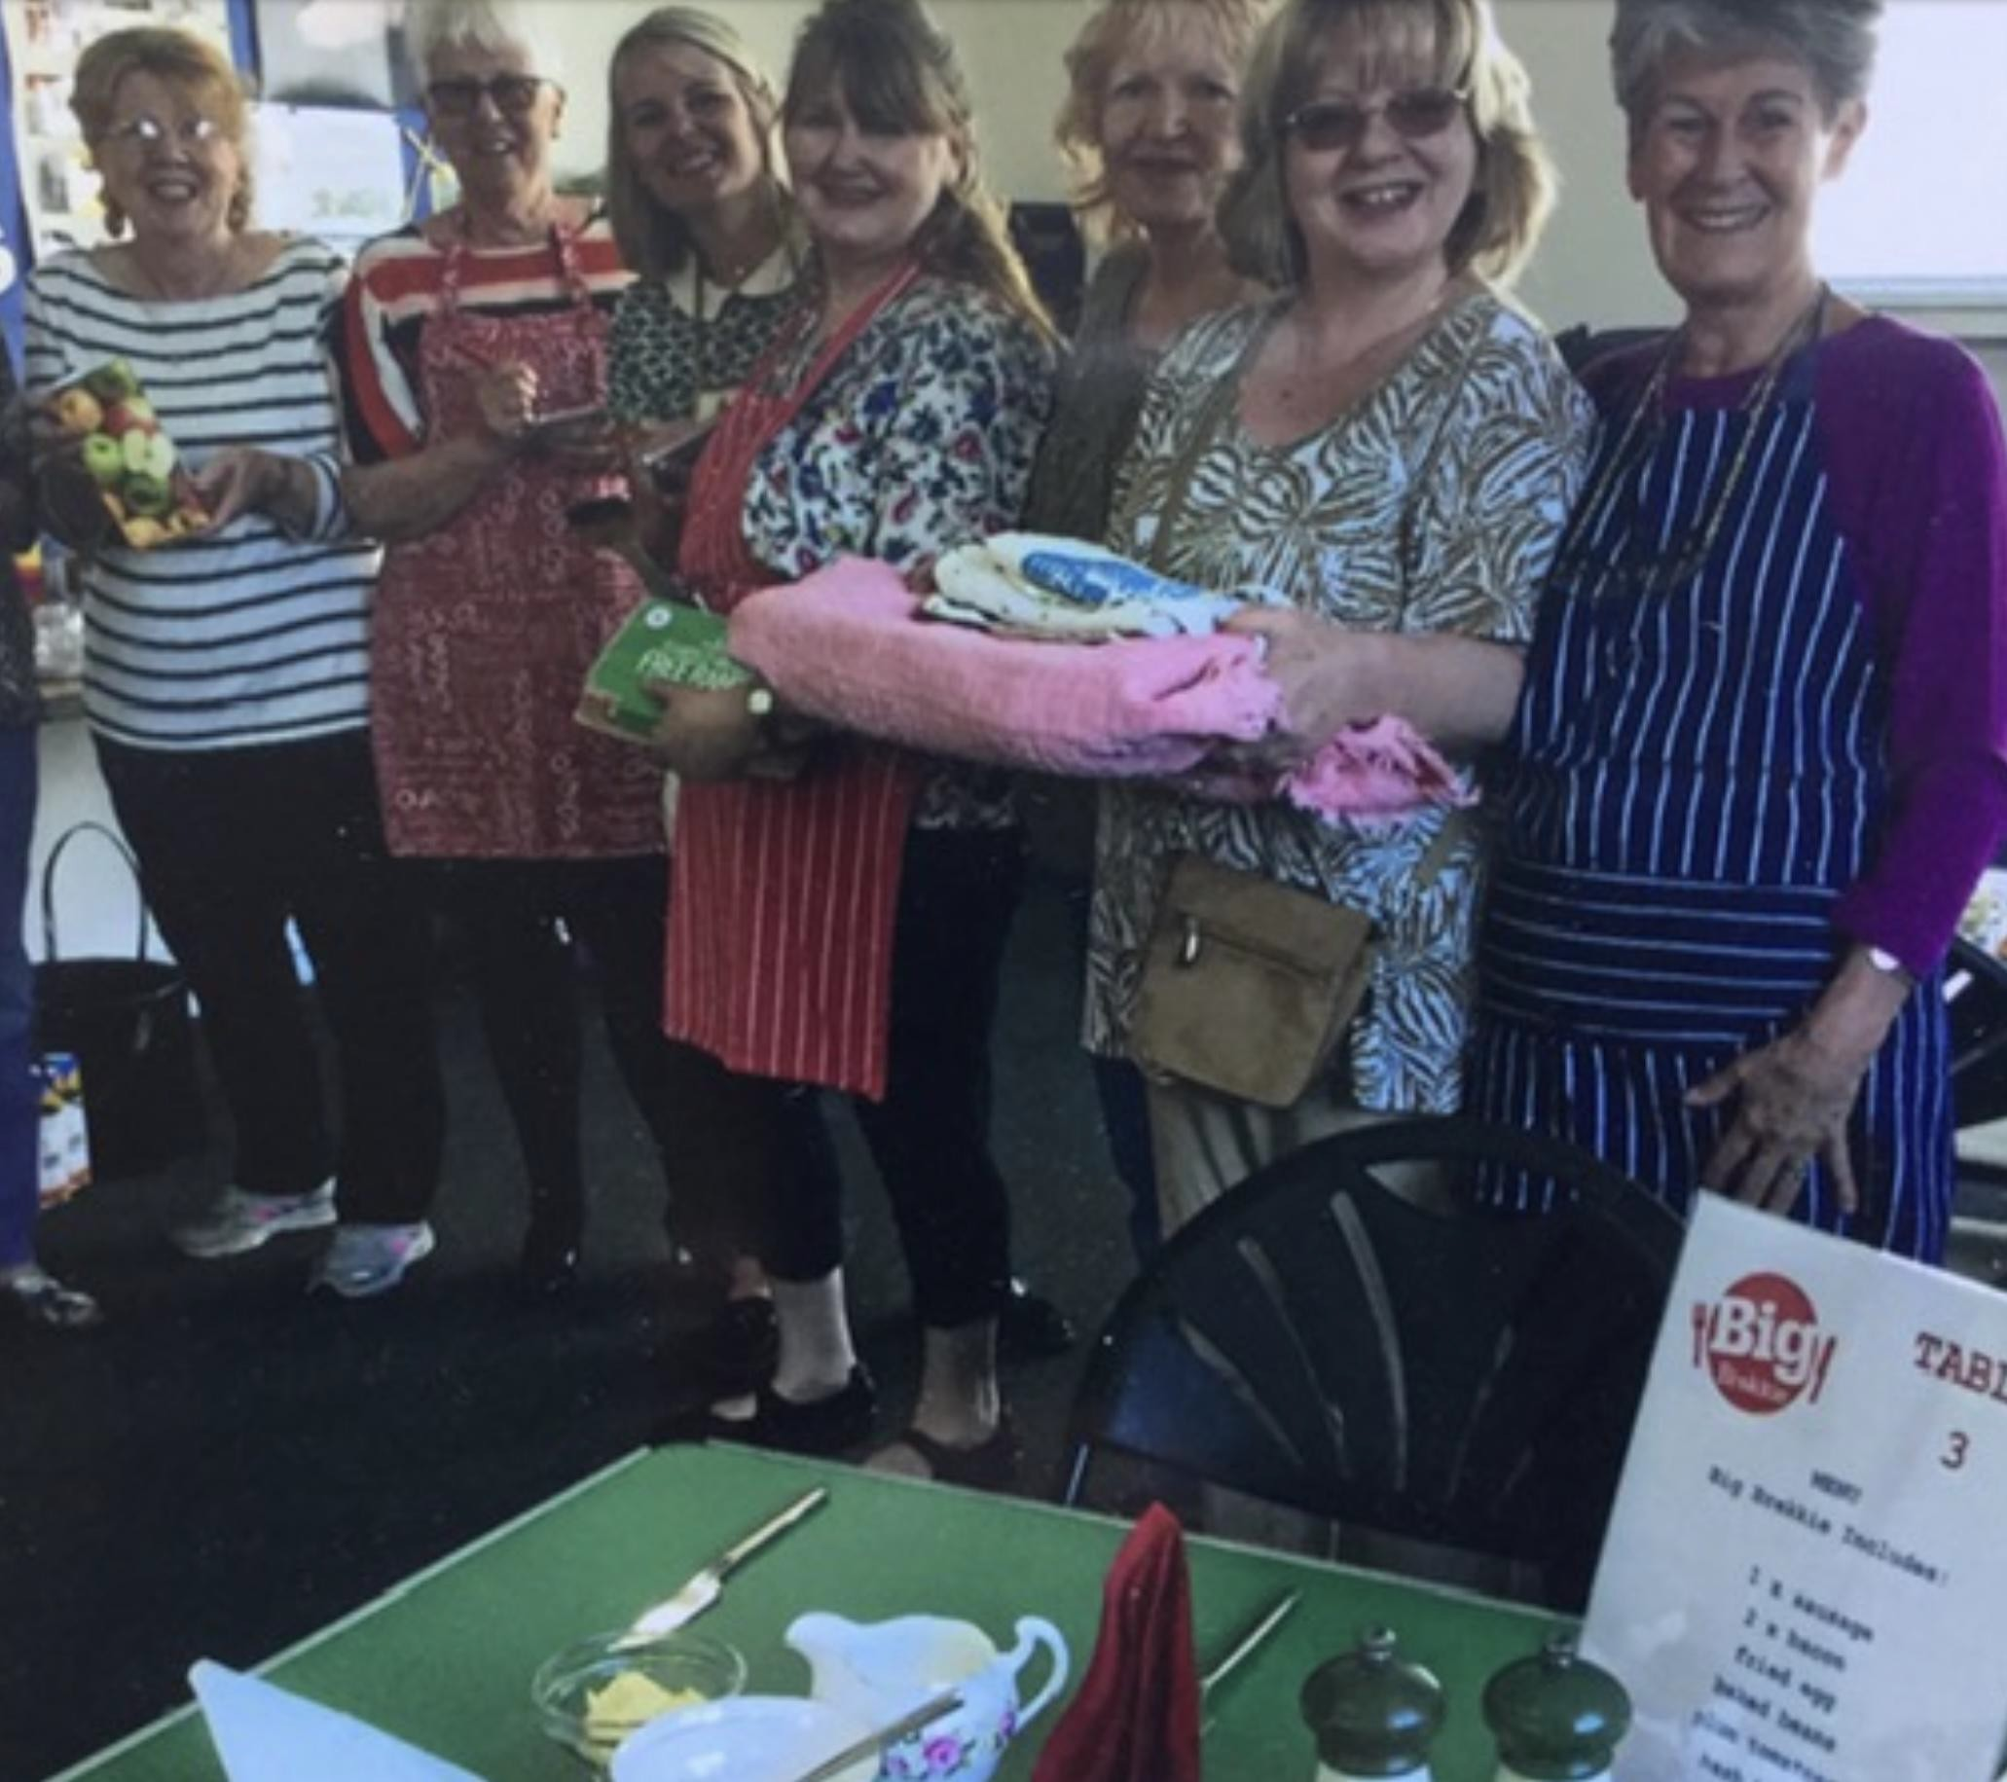
Our pet service

Big Breakfast supporting
Christian Aid Week

Our Junior Church has an average of 15 children a week ranging from 0 - 11 which meets most Sundays and is run by leaders, who are also parents, following the lesson plans from ‘weekly @‘ from the Blackburn Diocesan Board of Education. Junior Church uses these fun lesson plans so they follow the lectionary; when they head up to church for the last part of the service, the children share with the congregation what they have learnt and what they have made, echoing what has been the lesson in church. The group are usually in time to share in the Eucharist.
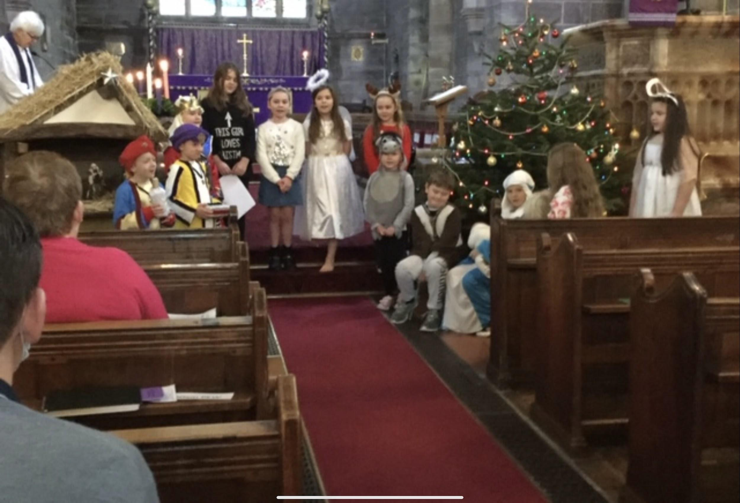

We hold confirmation classes bi-annually for both adults and children who wish to be confirmed. We have recently welcomed candidates from other churches. Last year we were blessed when Bishop Jill presided at the service and likewise this year when Bishop Julian presided. The extra year was so those candidates who missed out last year due to covid could still be confirmed.
Junior church nativity
There is currently no provision for youth within the parish, however…..we did have links with the uniform groups who meet in our parish and hope to reconnect with them again in the future

Before lockdown a regular bible study group met weekly. It is hoped to continue this in the future.

The local community and the church

St Johns lies between the old village of Heysham and Morecambe's West End and the parish comprises late Edwardian boarding houses and terraced property and a mix of fine detatched residential property. This is a parish of mixed home ownership and rental properties. Since the opening of the Bay Gateway (dual carriageway) the M6 north or south is about 15 minutes away thus providing easy access to the Lake District in the north, the Yorkshire Dales to the east and Manchester in the south. 90 minutes away lies the Scottish border. We are truly blessed with our surroundings.

Like most English seaside towns Morecambe and Heysham have faced challenging times but the area has recently benefited from regeneration with new promenade areas.

There is the strong possibility Morecambe will have Eden North built on an area of the promenade, which will attract much needed visitors to the town. There are a few more hoops to jump through but it is looking positive.
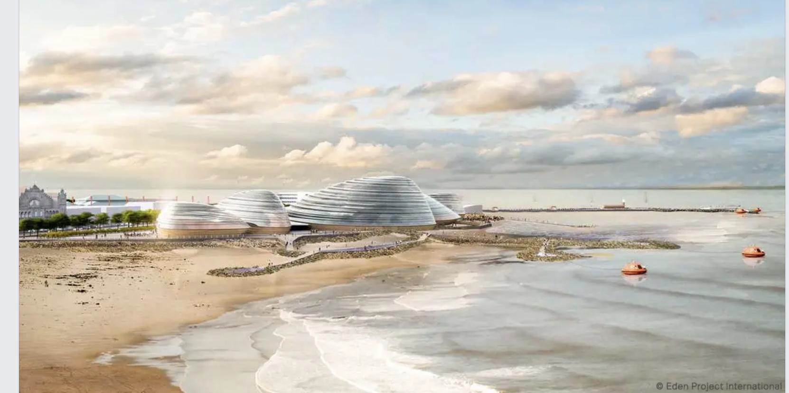

There are two schools in the parish, Sandylands primary school and Bay Leadership Academy (high school). These are not church schools but links have been established. The high school held a remembrance service and a carol service in the church during 2021. There are opportunities to be involved with the primary school, some classes have been round the church and the current incumbent has led an assembly in school. Although the schools in the parish are not church schools, many of the children that attend Junior Church go to one of the local faith schools such as St.Peters of Heysham, St.Helens of Overton, St Marys of Morecambe. The majority of the children take confirmation and go on to the Church High School – Ripley St Thomas.

There are 4 rest/ care homes in the area. The vicar has links with the homes and there is also a link through the group ‘Lyrics and Lunch’.

Our parish borders an area of extreme deprivation and through our support of homeless action people living on the streets are provided with a hot meal. In the local community there are many people requiring support including those with dementia. Many social groups closed during lockdown and our lyrics and lunch group provides food and fellowship for people living with dementia and their carers.

Outreach support is an important part of our church mission, and here are some of the ways that we seek to share the love of God with our local community.

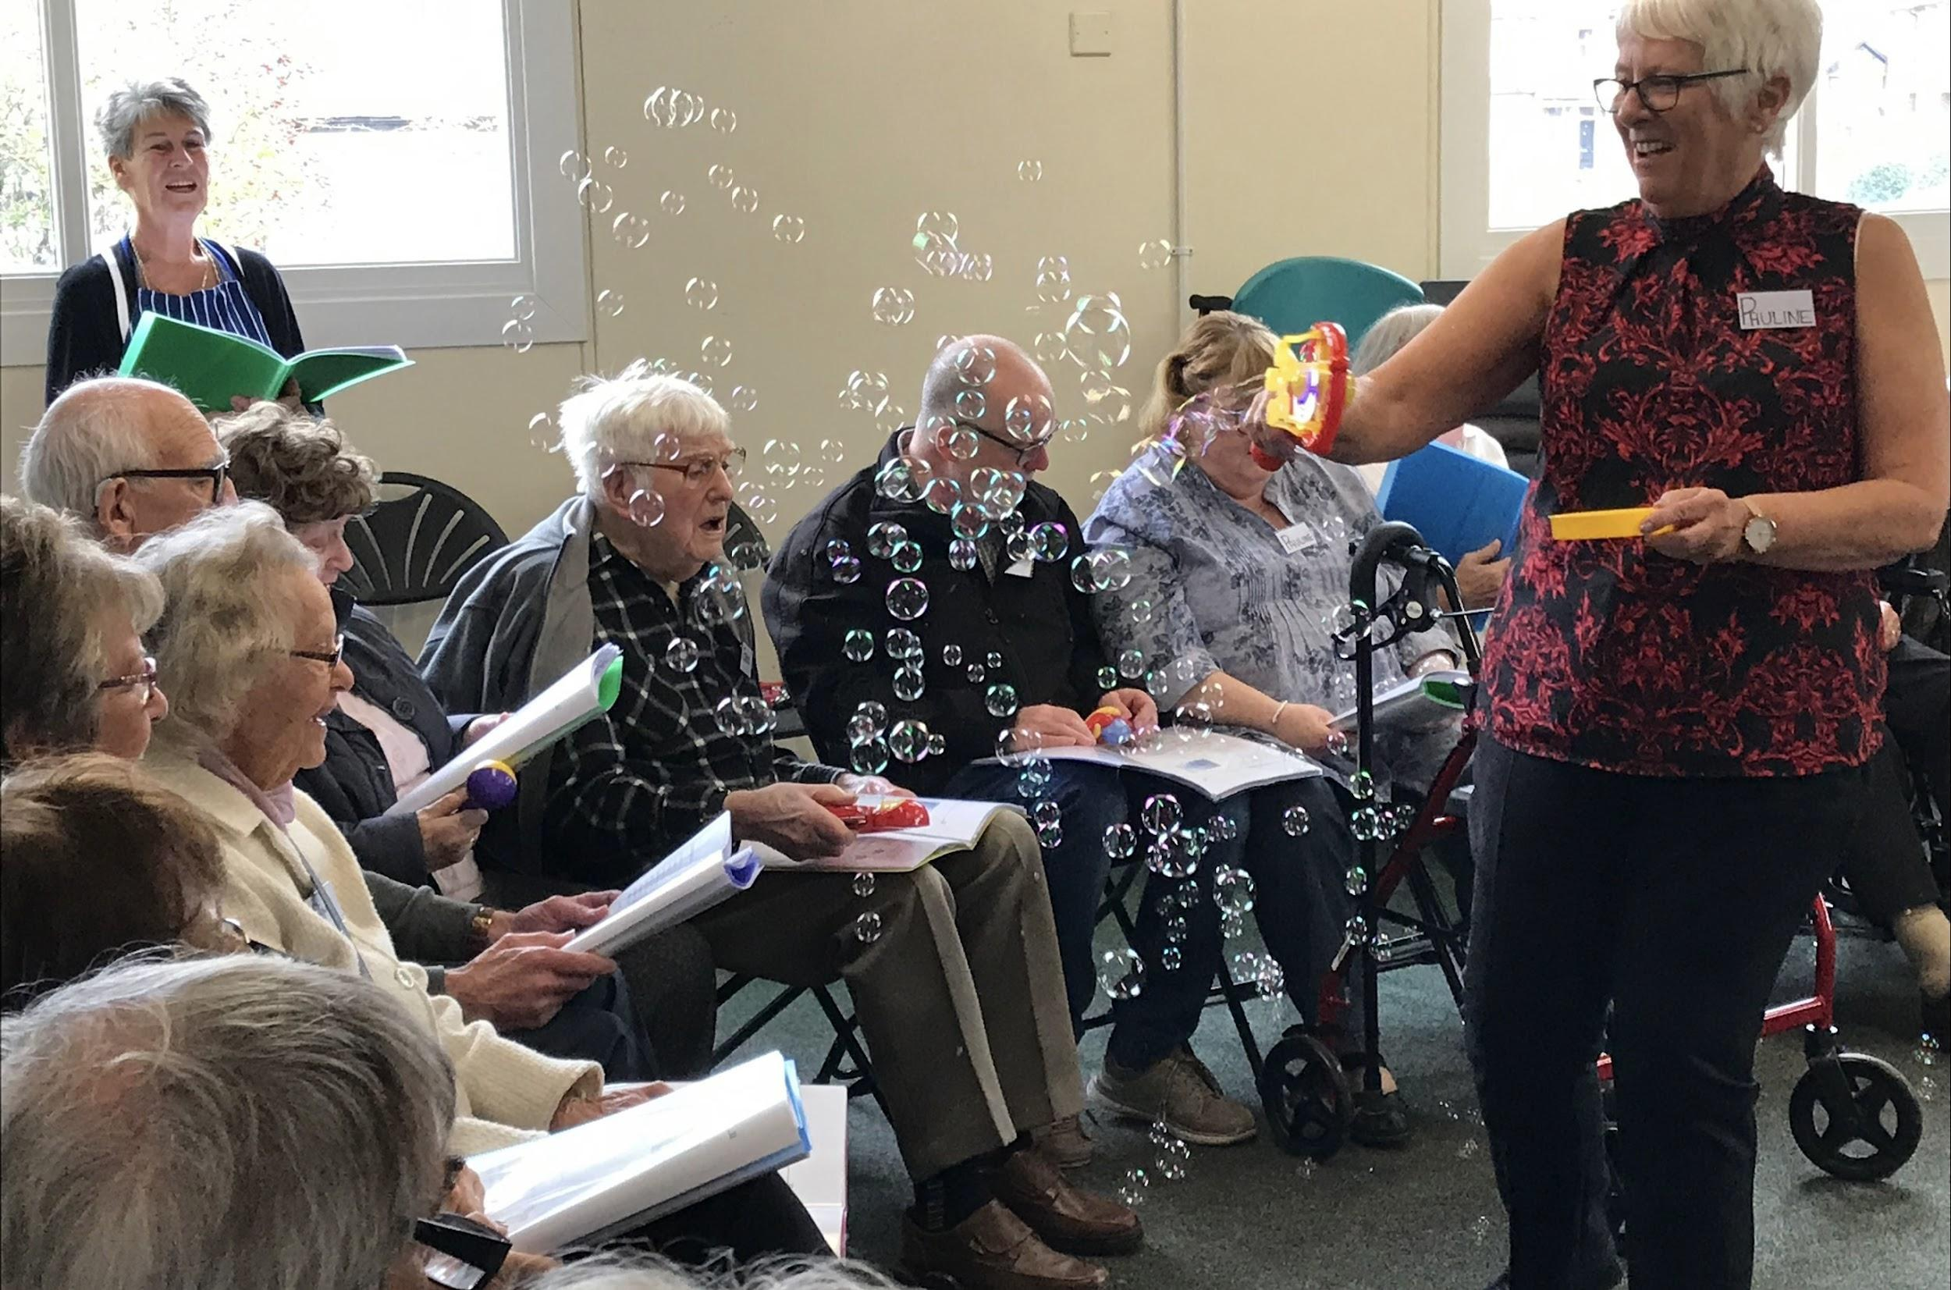

Lyrics and Lunch is a group that meets fortnightly for people with dementia and their carers where the guests enjoy an hour of singing with a slot for worship followed by lunch. Before lockdown our guests included those from local nursing homes and some of these are making enquiries about returning. Music has been shown to be beneficial for people coping with dementia and our group was recently shown on the channel 5 news.
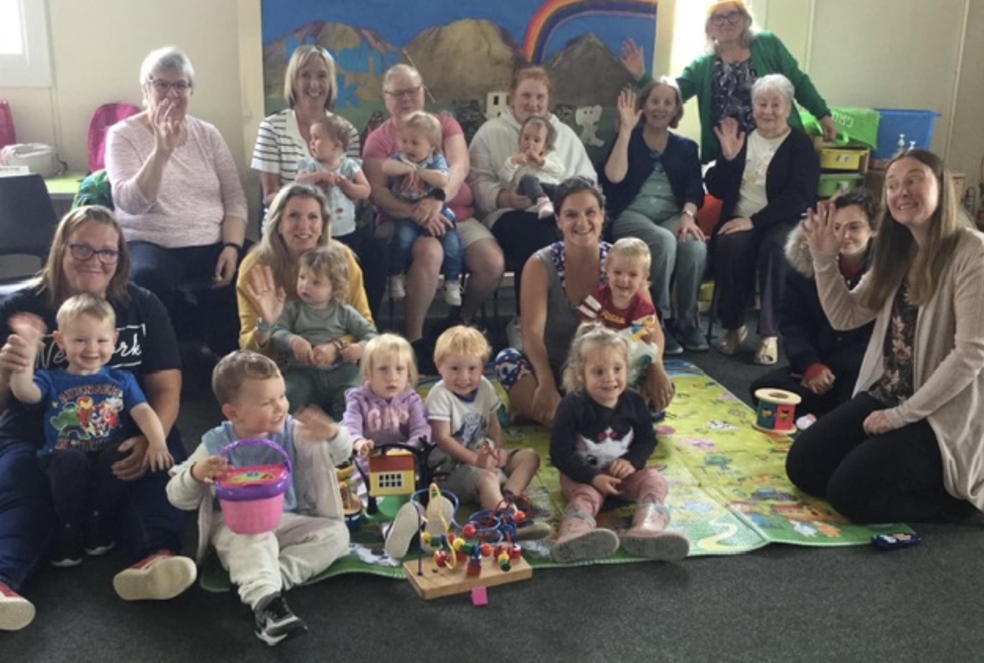
Toddlers group which runs every Monday morning from 10am to 11.30am and is very well attended. We welcome several childminders, mums and grandmothers who bring a diverse range of ages. It is lovely to be part of the children’s lives. We see them first as tiny babies and bid farewell to them as children starting school. We love being together and seeing all our friends

The M. U. at St John’s is a friendly group of ladies who enjoy helping out at all church events and can turn their hand to most things. We do encourage men to join our meetings too. We are divided into two groups, the Afternoon group meet monthly in the Church Hall and welcome members from three local churches who don’t have a branch at the moment. The Evening Group, set up for mums who work, also meet monthly in each other’s homes. We have 40 members in total. We join together for fundraising events, lunches etc. We have also supported various Deanery and Diocesan appeals including supporting young offenders and their families in the previous Lancaster Farms, the City of Sanctuary for refugees and the Toy and Easter egg appeal for children of prisoners in Preston Prison. We are also supporting ex-offenders in approved premises (half way houses) run by the probation service by supplying packs of much needed items. We are always generously supported by members of the Church in whatever outreach programmes we are involved in.
Mother’s Union ‘Wave of Prayer’ held in the church
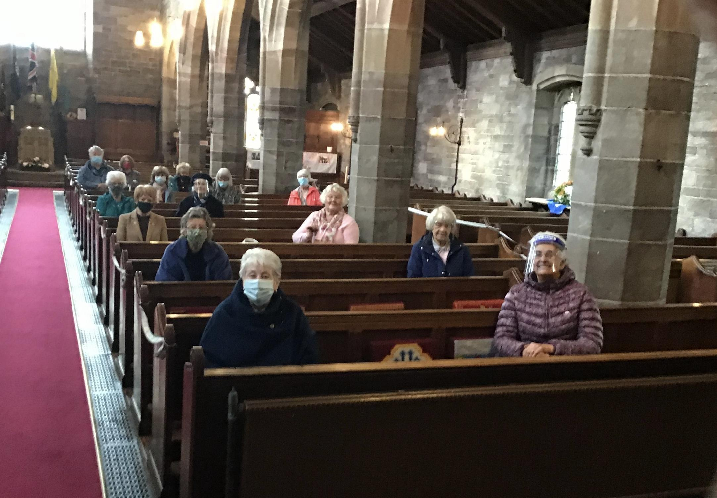

The Prayer Shawl Ministry
This is a group who knit or crochet shawls and blankets. It continues to be a real blessing and gifts are sent out to the elderly, sick, new-born babies as well as given to all being baptised with an accompanying prayer card.

All of the above groups are run by church members and are attended by many from beyond the parish boundary.

As a church we also support groups in the community, such as Morecambe homeless action, by donating the use of the church hall and collections in church. The congregation also collects for the local food bank and supports MU initiatives.
At St Johns before lockdown we had ecumenical links with neighbouring churches as part of the Morecambe Churches Together.

There are several occasions when St. John’s church is used for worship by local organisations; Merchant Navy, High school carol and Remembrance day services and the annual Bereaved parents service.

During the pandemic we had to find a new way of working and still connect with the community. It began with live streaming on facebook from the Vicarage, then some in St. Johns Church and more recently the live streaming of the 10.30 service with the full congregation and an average of 20 people joining for worship from various locations in the UK. The live streamed morning and evening prayers are also popular. The PCC held meetings on zoom, once again this has been a success and a popular way to meet although we now have face to face meetings again. These online services help to relieve the loneliness some in the parish feel. During lockdown many of the congregation were telephone buddies who rang those who lived alone or who were elderly. These were a great outreach tool and meant everyone stayed connected to the St John’s family.

Our hopes for the future

Vision Action Plan
The Church of England in Lancashire desires to make the Good News about Jesus Christ more widely known, because we believe:
- He is the One who brings ‘life in all its fullness’. Healthy church communities have a positive and transformative impact on our society We will work together to achieve this by:
- Making disciples of Jesus Christ
- Being witnesses to Jesus Christ
- Growing leaders for Jesus Christ

We will prioritise work among children, young people and schools to raise up a new generation for Christ.
Our vision for the future is to encourage new people to join our congregation and to develop leadership by training and supporting them in roles within our church.
We also wish to encourage our younger church members to play a more active role. We would like to provide more opportunities for our young people to meet socially, worship together and develop their faith.
In order to make the church more accessible and to provide more flexible accommodation for church and community events. Ideally this would include new kitchen provision, new accessible toilets, Wi-Fi installation and projection facilities.
We have begun to work towards being an Eco church and we would like to achieve our bronze award.
As a church we are keen to combine our knowledge and experience of our church and community with the enthusiasm and vision of a new incumbent.

The Church Buildings
The Church building
St John’s church was built to take the overspill from St Peters church Heysham. It was consecrated St John the Divine Sandylands as a daughter church of St Peters on Thursday 17th October 1901 by the Lord Bishop of Manchester the Rt. Revd. James Moorhouse. The building was constructed from attractive local red sandstone and the roof ceiling and pews from English oak. The church building is set in a fairly large garden thus acquiring the name "The Church in the Garden by the Sea"
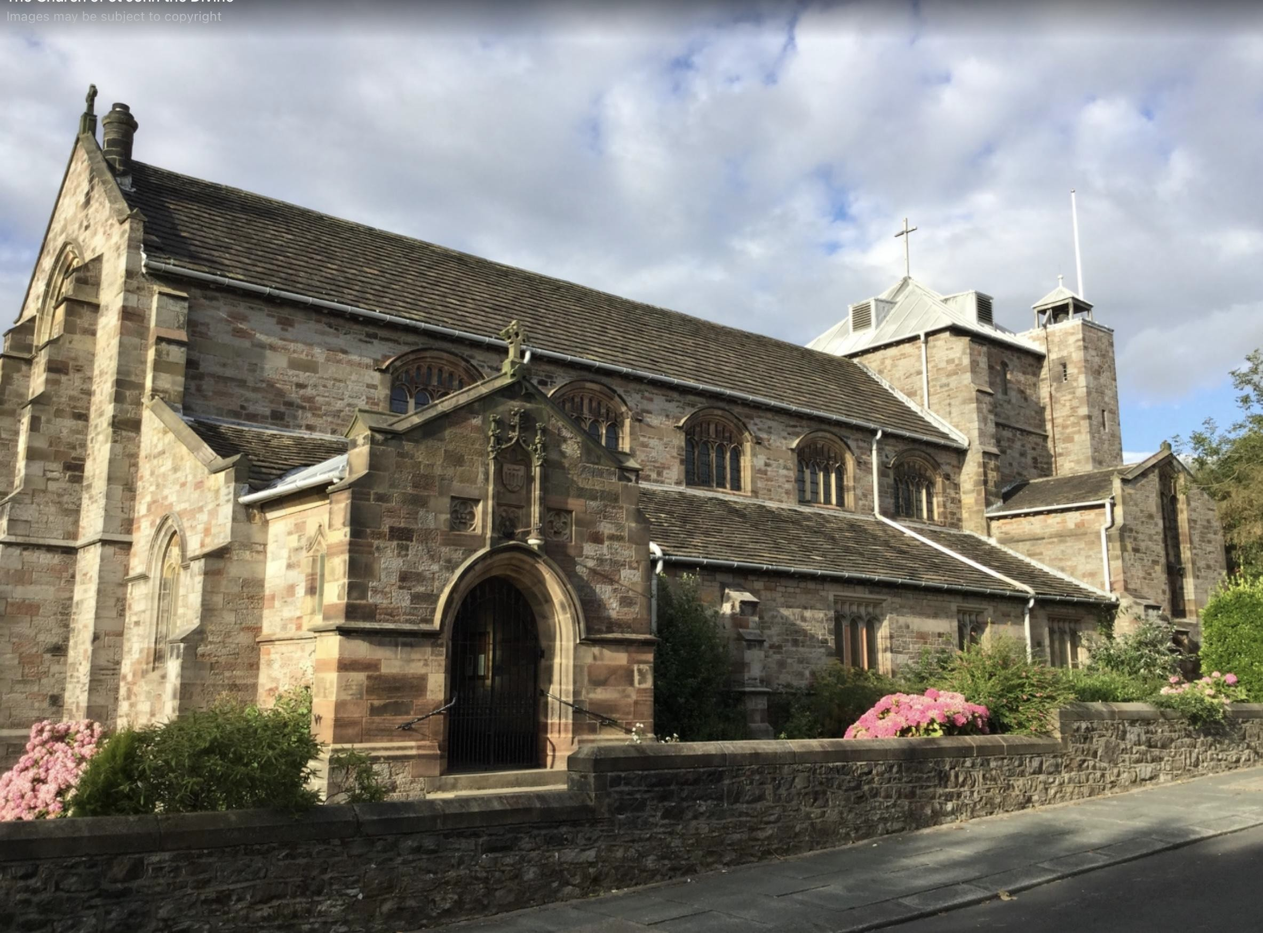

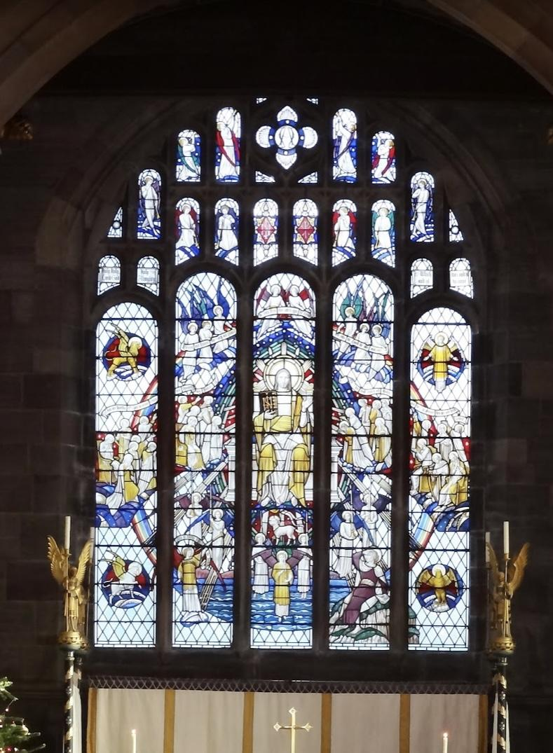
Since its foundation the church has been enhanced by gifts of great beauty, notably the Wareham Guild Altar with its magnificent frontals, the chapel of All Saints and eleven beautiful stained glass windows.There is seating for around 450 people with a central aisle and 2 side aisles, one of which serves as seating for a side chapel. As with most older churches today there are issues with the fabric of the building which were highlighted in the latest quinquennial, none of which were unexpected as the building is sandstone and we have rain in the north west! The roof has recently been repaired so at the moment there are no water ingress problems. The next quinquennial is due in 2025.

We have a dedicated cleaning team who clean on a rota system.
Accessibility. There is a permanent ramp to allow access into the church, and an accessible toilet. There is a movable ramp from the main church body to the toilet area.
There are definitely challenges with an old building, we serve refreshments, again on a rota, but the kitchen is totally inadequate. We have architect plans for a kitchen “pod” at the rear of the church and an accessible toilet.

The Hall
The church hall is situated about 400 metres from church. It is a wooden building and is used by many church groups eg: M.U., Lyrics and Lunch, toddler group and Junior Church. It is also used by Morecambe homeless action and is hired out for parties etc.
It has a generous kitchen area, a large main area and separate male and female toilets. The utilities are well maintained but the building itself is in need of upgrading. For many years there have been committees created to tackle the church hall. St.Johns owns a big foot print of land on which the church hall and also a scout hut are situated. There is ample potential to build a community hall that would be desirable and serve the community better and provide an income for the church.
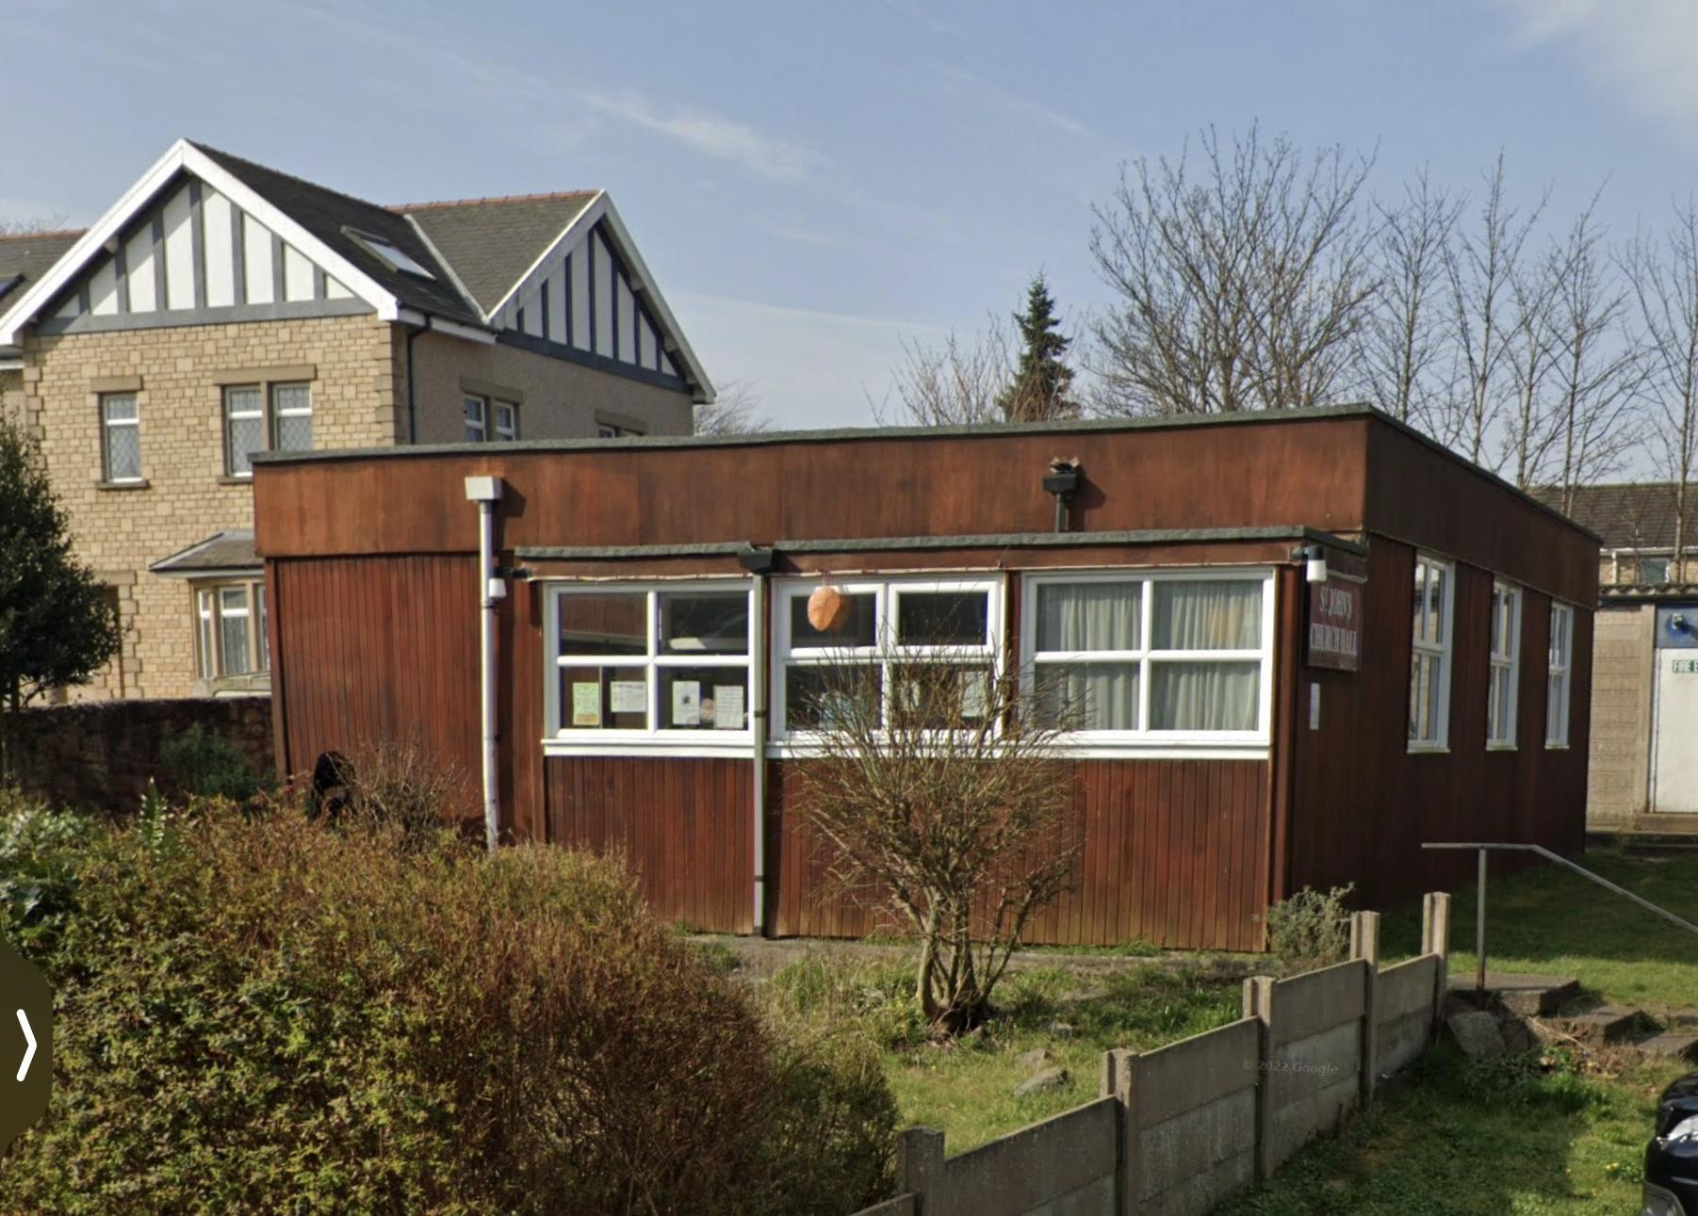

The Church Finances

To date the parish has paid our Parish Share in full. The Parish Share is lower than it would otherwise be because the parish is in the Church’s deprivation ranking (LICF) and so receives a discount.

Income is generated via the following methods:
- Cash offerings during regular services
- Envelope giving during services
- Direct Debit/Standing Order income
- Ad-hoc donations from occasional services such as weddings and baptisms
- Reclaiming VAT through Gift Aid
- Church Hall hire
- fundraising events, such as Christmas & Spring Fairs

Planned giving amounted to £19,676 plus collections of £4,581.67 and tax recovered £5,109. The plate offerings were down due to covid, normally they are over £8,000.
- A copy of the Parish’s latest audited accounts can be provided for potential applicants

Fundraising and social events for the parish (in recent years pre lockdown)
- quiz nights, games evenings, film nights, and concerts including our own ‘Last Night at the Proms’ and Mardi Gras were held.
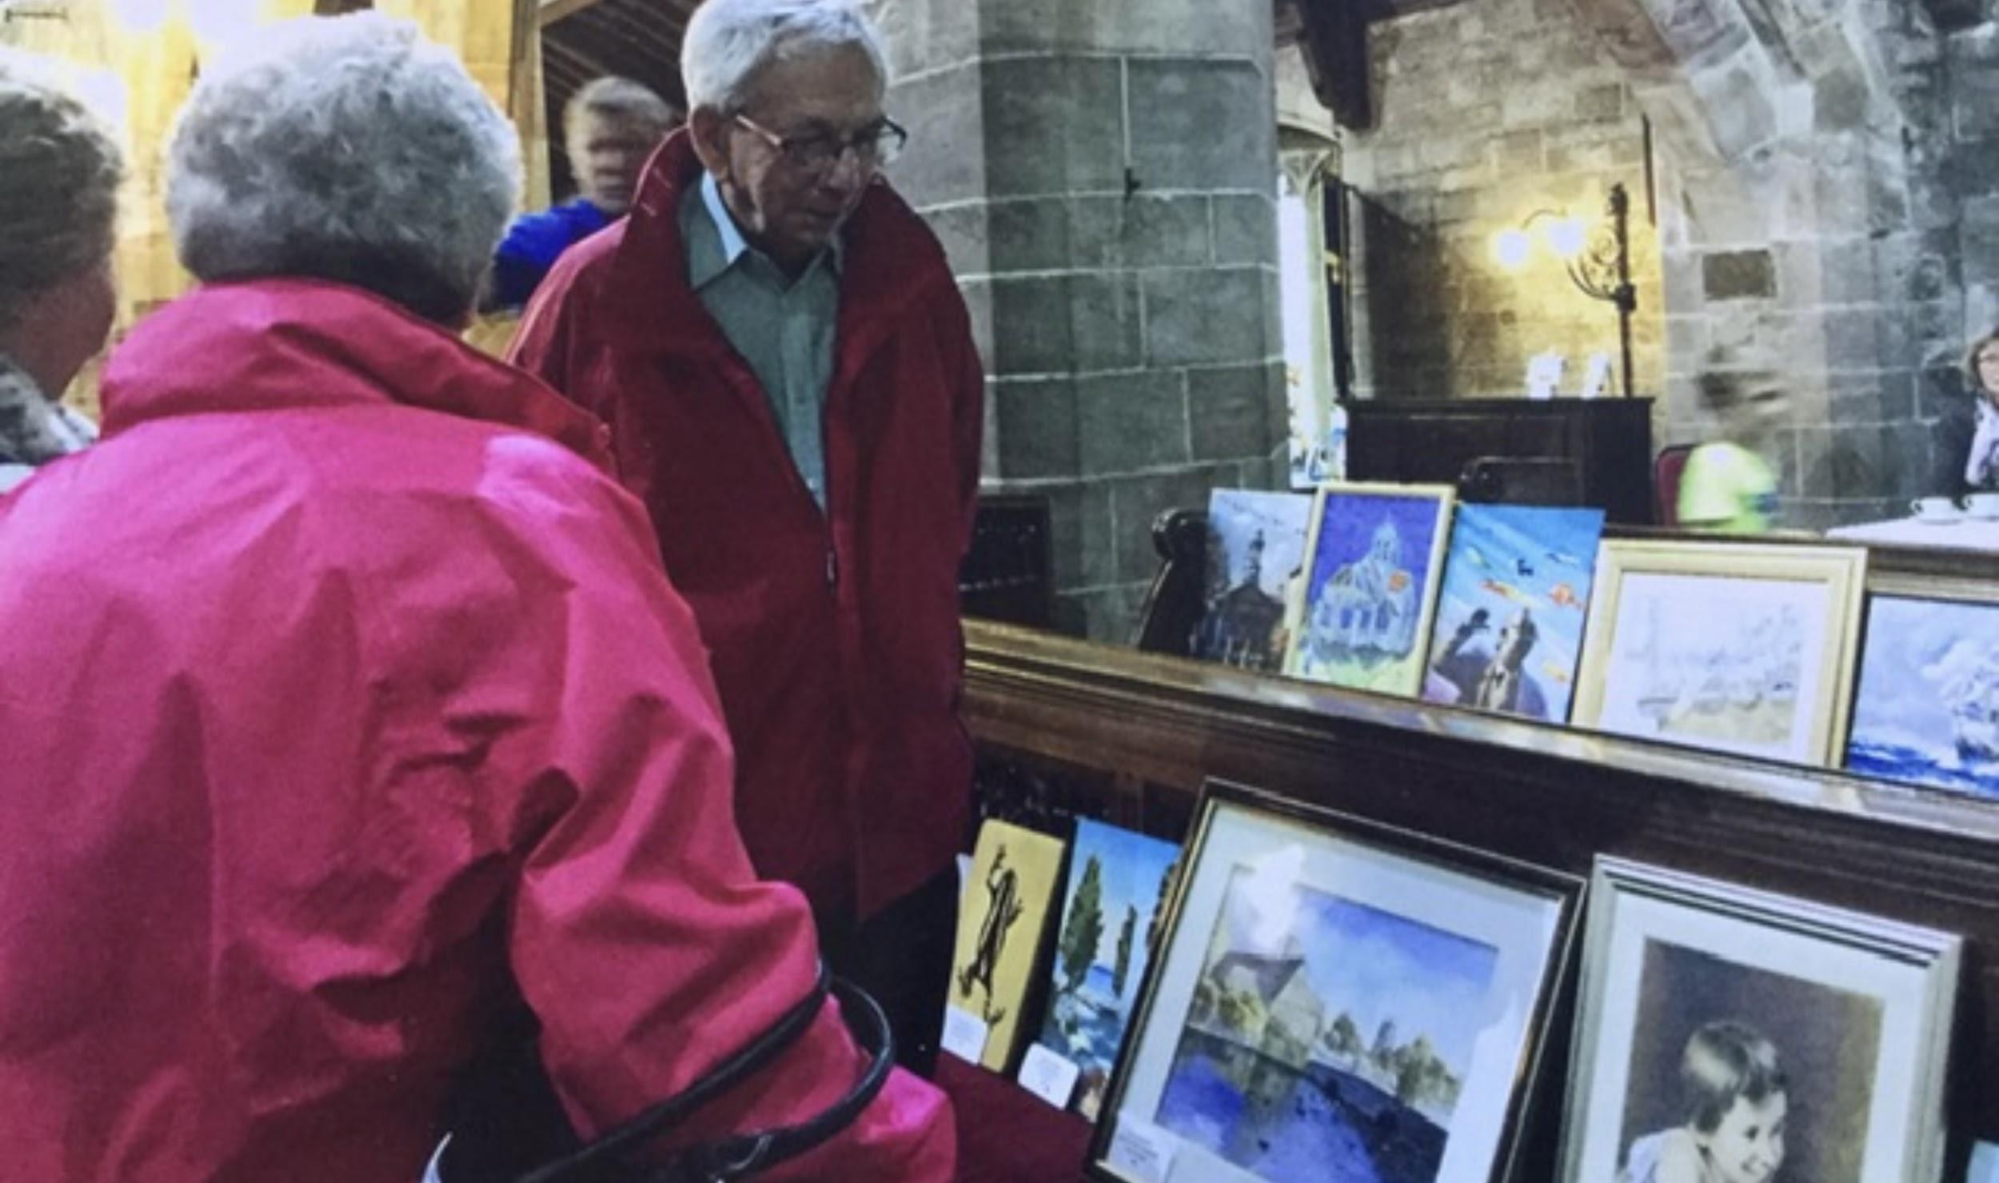
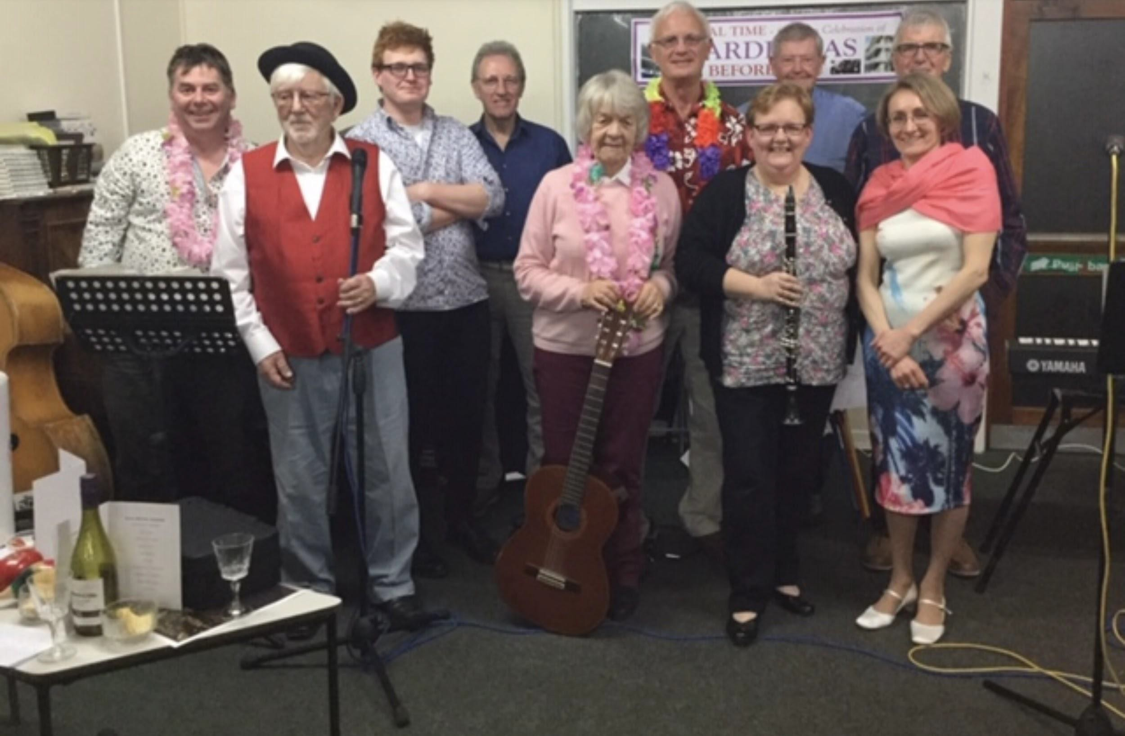

- Spring and Christmas Fairs and garden parties, art exhibitions and craft fairs celebrating local talent have in the past been well supported.

- Up to March 2020 the parish received income from weddings and funerals, with the fees for these being set against the Parish Share:
- As the situation moves closer to normal, we should be able to drive a new stewardship campaign.
- Additionally, the volume of funerals/weddings is beginning to return to pre pandemic levels which will contribute to the church’s income.

Pastoral and Special Services
in 2022 there have already been 14 baptisms with a further 13 already booked. There have been 4 weddings with a further 3 booked. In 2021 there were 6 funerals in church and 25 funeral services at the crematorium were booked through our church.

Who is God calling?
We are looking for a priest who will;
- show spiritual and pastoral maturity in leading worship and serving our community
- be committed to encouraging and developing our vision for a healthy and growing church which includes all ages and members of the community
- enjoy and promote a variety of worship styles, whist acknowledging that the Eucharist has a central place within our life as a parish
- possess good communication skills with both children and adults
- work with lay leaders
- be willing to work with the parish to help us consolidate the achievements and good aspects of the past but also to inspire and assist us to move forwards and grow in faith, service and love especially in our outreach mission.
- regard working with our children and young people and schools as a priority: who will listen to and encourage them as they share their worship with the congregation during the services.
- lead by example, and bring out the best in other people in the service of God; and who will encourage church members to use their various gifts to become further involved in the Church and activities in the Parish
- ideally, be a person who is willing and able to keep our social media posts and messaging up to date, or at least be prepared to learn how to do so.
- be interested in helping us to continue our journey towards becoming an Eco church
- someone who will help us to formalise our Vision plan and then implement it;

What we offer:

- opportunities to develop their own ministry

- An open and friendly church where everyone feels welcome

- A loyal, supportive congregation

- A small choir, with regular organist.

- A beautiful place to live. On the doorstep are the beautiful beaches of Morecambe and the hills and lakes of The Lake District national park.

- Work life balance, we feel it is important to allow time for the incumbent to further their own personal growth.

- There are enthusiastic people ready and willing to help run and organise so many aspects of church

Lancaster and Morecambe Deanery

Lancaster and Morecambe Deanery contains a wonderful variety of contexts and missional opportunities. Some local incumbents serve in parishes in the Trough of Bowland, with all the challenges and opportunities of rural ministry. Others serve in parishes at the heart of some of the more economically deprived areas of our diocese. There is a huge variety of experience, of context, and style of ministry, but we share a commitment to work well together and honour one another. In recent years several new clergy have joined the deanery, and there is a real desire to make sure that new incumbents are welcomed and supported at the deanery as well as the diocesan level.

The Vicarage
The Vicarage is situated a few hundred metres from the church and is also a few minutes walk from the church hall. It is within a couple of minutes walk to local shops and less than a 10 minute drive from 2 of the large supermarket chains. Within the Parish boundary there is medical practice, a community primary school (with a large nursery) and a secondary school. The accommodation consists of kitchen, 2 reception rooms, a breakfast room and a study, 4 bedrooms, a large bathroom and a garage. There is a wrap around garden which gets the sun all day. The church typically reimburses the vicar’s expenses and pays the Council tax and water rates on the Vicarage.
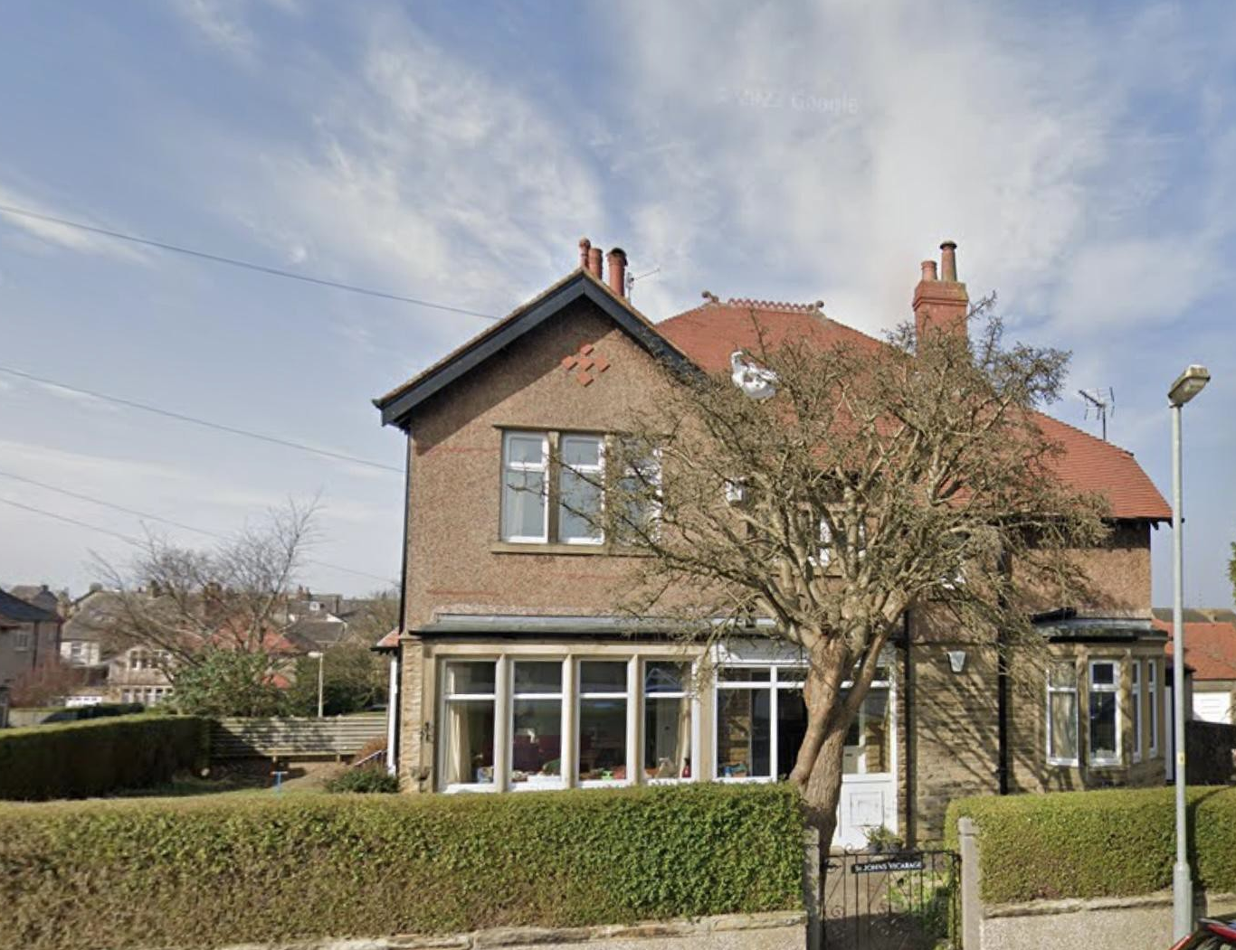
Appendix A
The Team

Margaret Carr who takes morning prayer services is working through a Licensed Lay Minister course. Margaret is a blessing to the parish and a willing and tremendous support to the vicar and also takes home communion. She has led Evensong, prepared and led Parade and All Age Services and has preached at both 8am and 10.30am services of Holy Communion.
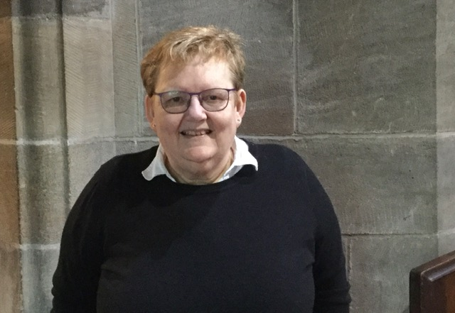
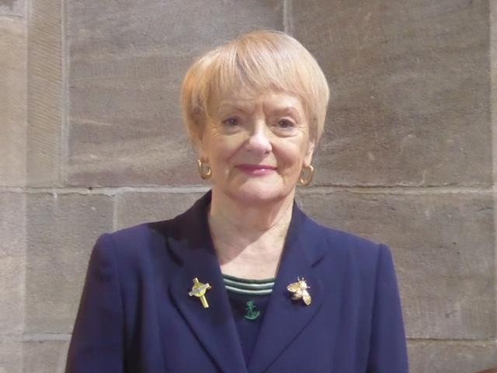
There are 2 churchwardens:

Jane Brown who is also the MU branch leader and takes home communion to those in the parish who are housebound.
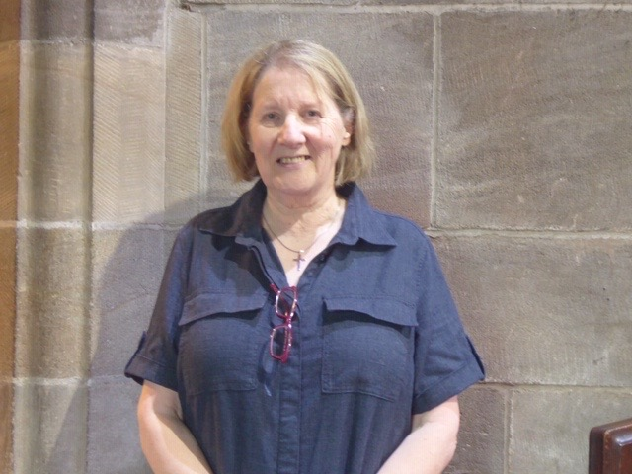

Anne Millar who also helps to run the Lyrics & Lunch and toddler groups.
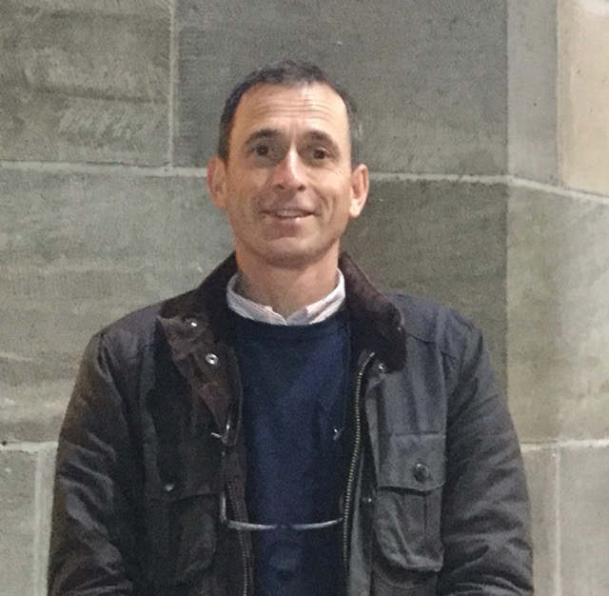

Michael Knight our stewardship officer and “go to” handyman,
and Ruth Morris who also helps to run the toddler group.
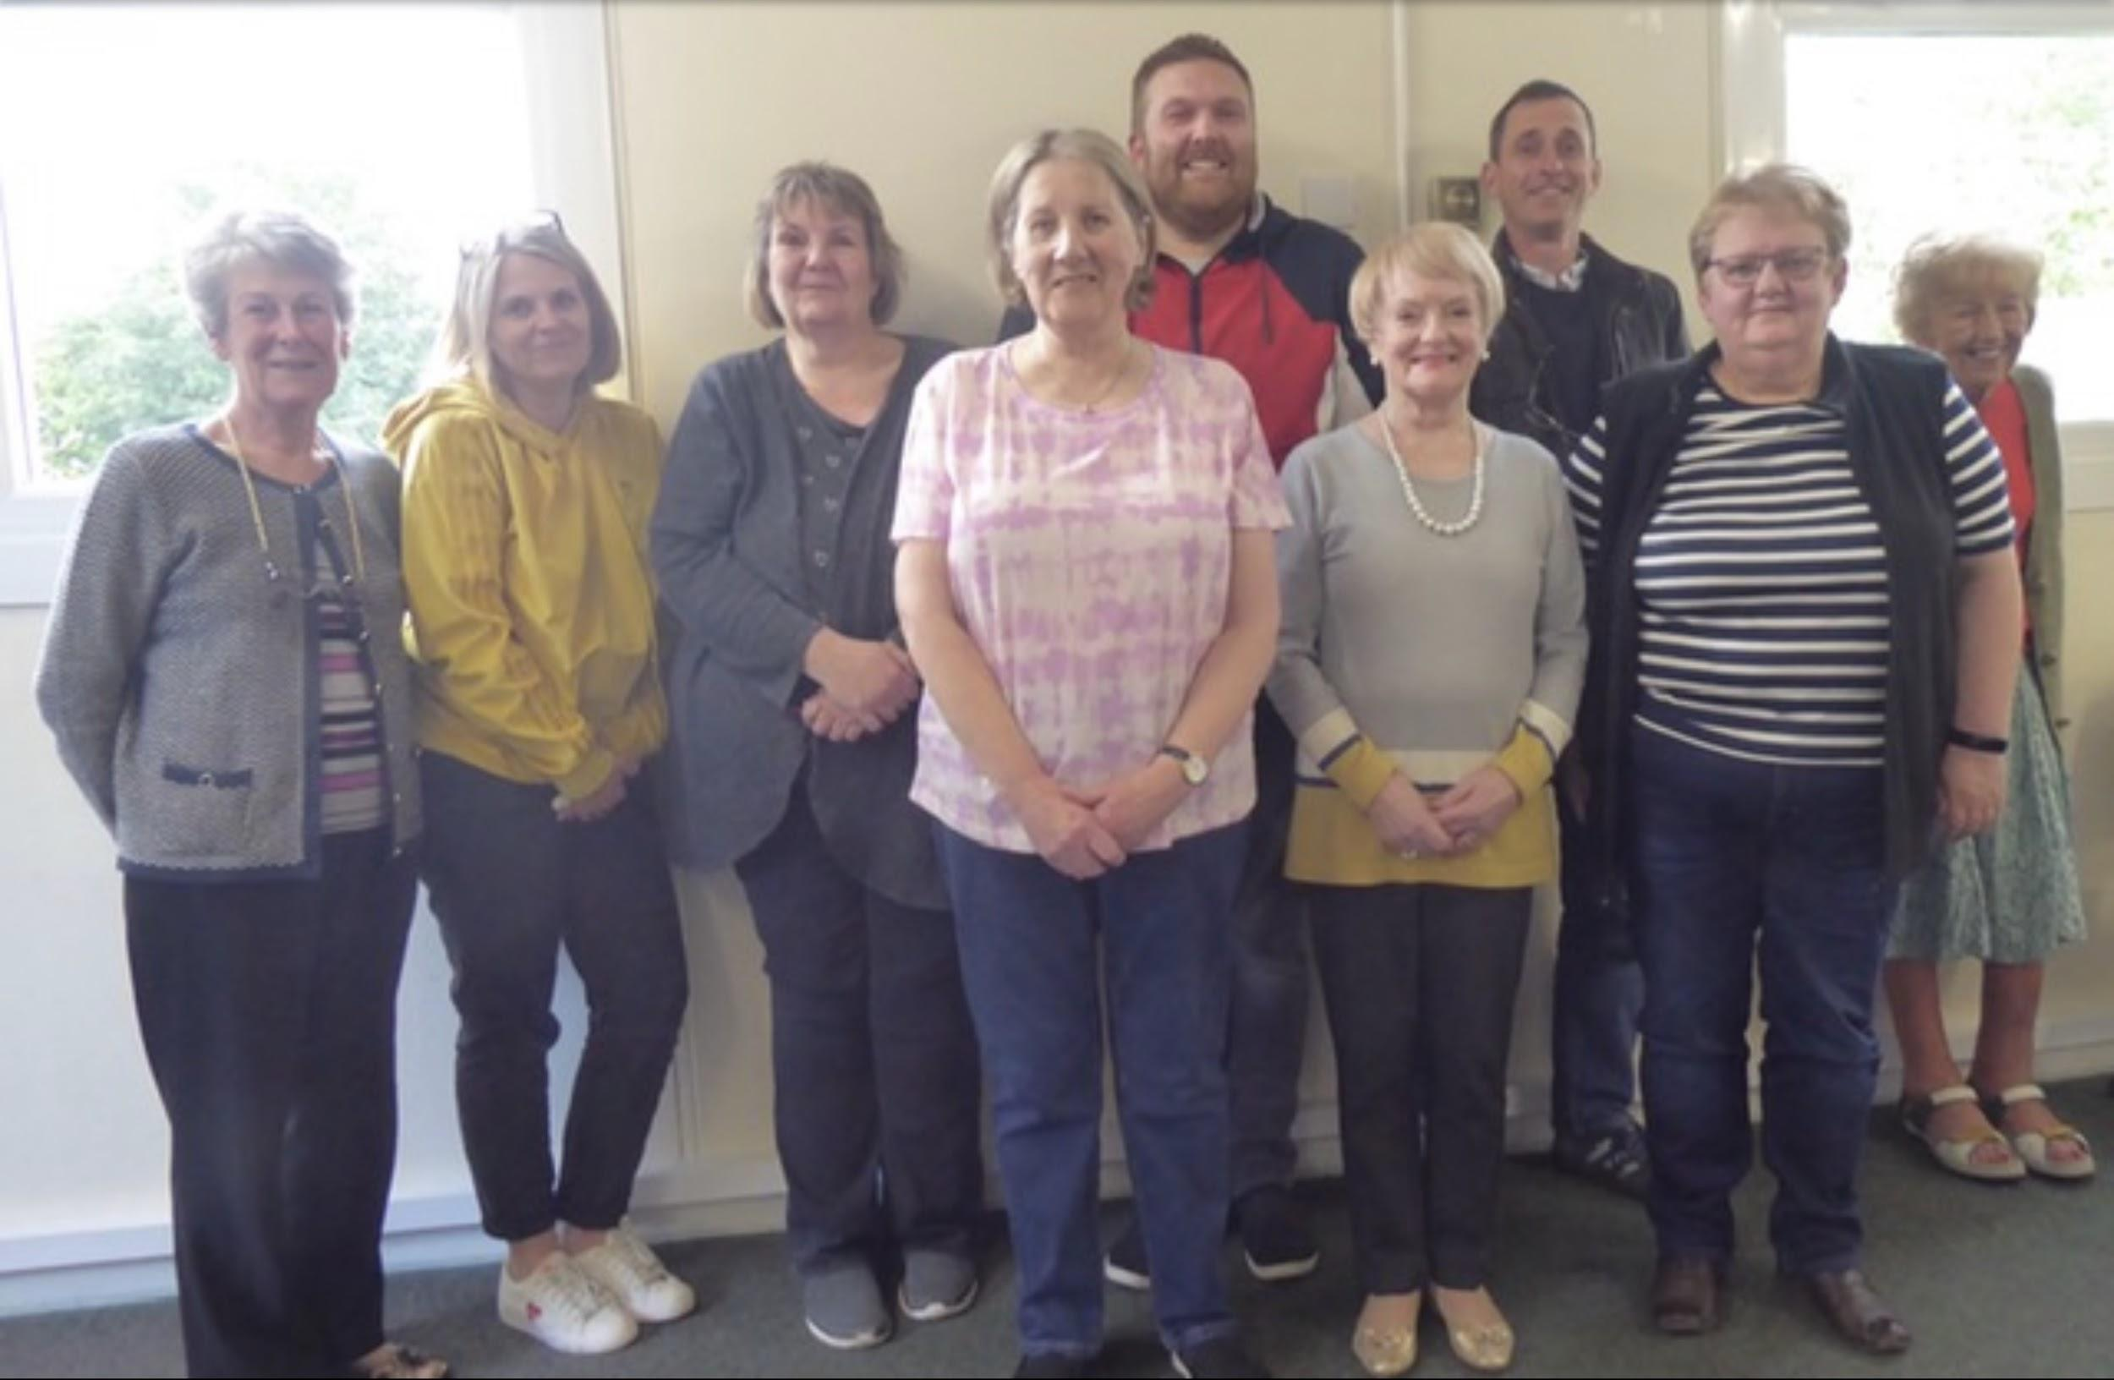

Our church is blessed to have a committed PCC, who not only cares for the church community and parish, but also for the clergy team, the lay leaders, volunteers and the wider congregation.
Junior church coordinator Natalie Duffin is ably supported by the parents.
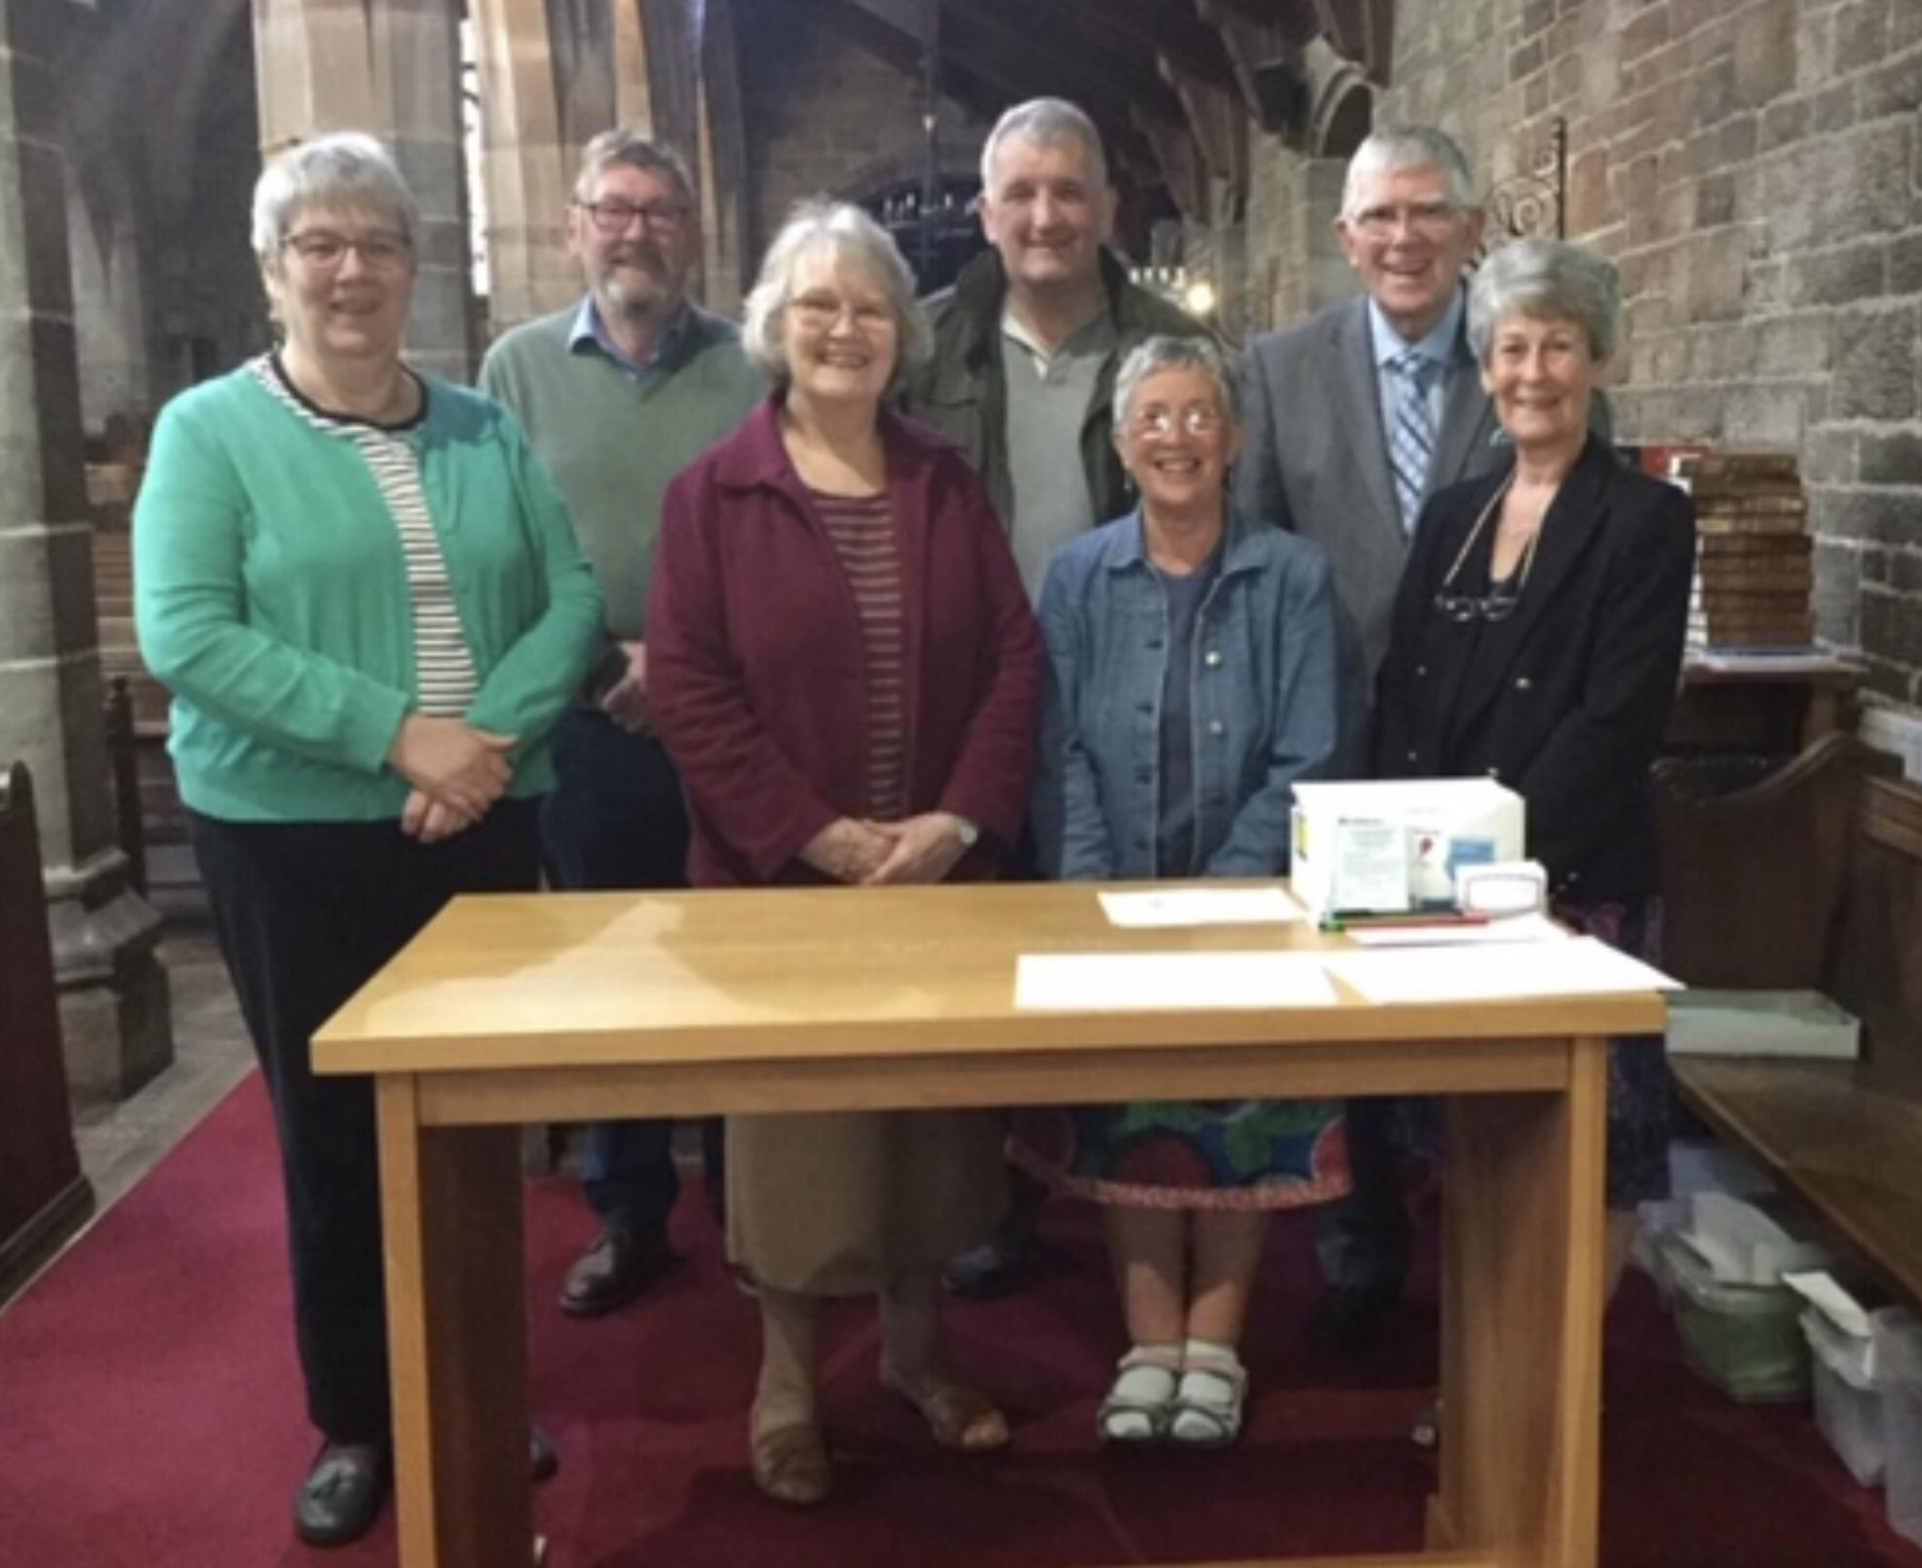

There is a team of 11 sidespeople who step up to do other things, willingly sharing their time and talents in any way needed around and within the church.

APPENDIX B

CHURCH AND SERVICE
Patron
Bishop of Lancaster right Revd Jill Duff
Electoral Roll
Year | 2021
Number | 81
Age Profile of the Church
0-17 | 25
18-69 | 29
70+ | 27
Normal weekly attendance | adult | 40
 | under 16 | 7
Festivals
Easter Sunday 2022 | Communicants | 56
 | Attendance | 63
Christmas Day 2021 | Communicants | 16
 | Attendance | 18

Appendix C: Parish Demographics

PARISH DEMOGRAPHICS
Population
according to 2011 census 5,515
Age spread
0-4 | 6.2%
5-15 | 13.4%
16-64 | 60%
65+ | 19%
Ethnic Mix
British | 97.7%
Minority Ethnic | 2.2%
Other Faith Mix
Christian | 65.9%
Other | 1.3%
Major Employer(s). EDF

