team profile

july 2019

aPPOINTMENT OF TEAM VICAR

‘A worshipping, growing, and transforming Christian presence
at the heart of every community.’

The three parishes of the Astley, Tyldesley and Mosley Common Team in the Deanery of Leigh are quite distinct and the parish churches that serve them are different too. This Team profile reflects the character of each parish and church, which are seeking to grow and minister together as a team encouraging the mission and ministry of each.

For an informal conversation please contact the Revd Martin Cox, Team Rector at: atmcteamrector@gmail.com who will be pleased to answer any questions.

Our team Mission Action Plan is available on request.

Closing date for applications is Friday 13th September 2019 via the Church of England Pathways portal.

St Stephen’s, Astley

1.Current Church Building and Team
The current St Stephen’s Church in Astley, part of Leigh Deanery in the archdeaconry of Salford here in the Diocese of Manchester, was built in 1968. St Stephen’s is one of three parishes churches in the United Benefice of Astley, Tyldesley, and Mosley Common.

2. Origins
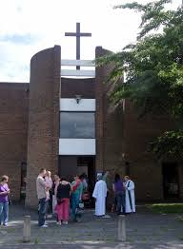
Astley chapel was built in 1631 by Adam Mort, Lord of the Manor, and was originally situated on Church Road to the side of Ellenor Brook. It fell into disrepair in 1760 and was rebuilt.

This second chapel was destroyed by fire 18th June 1961 and it was decided to relocate and build on a site on Manchester Road.

The 3rd St Stephen’s (our present church) was consecrated 26 October 1968. St Stephen’s primary school was also built that year and stands adjacent to the church. There are approximately 200 pupils in the school. The Team Rector is an ex-officio governor of St Stephen’s School.

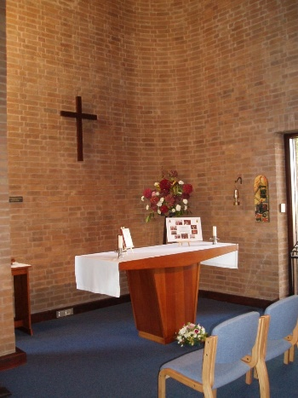
Great consideration was given to the design of the new church, both the image of what a church building should look like and its function and purpose. Emphasis was placed on the congregational worship and Holy Communion. Other uses of the church were also taken into account, namely for concerts and musical performances etc. therefore fulfilling the wider needs of the local community, as an everyday centre of Christian life, worship and activity. All furnishings, including altar and pews were designed to be portable giving greater flexibility to a variety of uses.

Other features in the church are the Lady Chapel, used for smaller mid-week services.

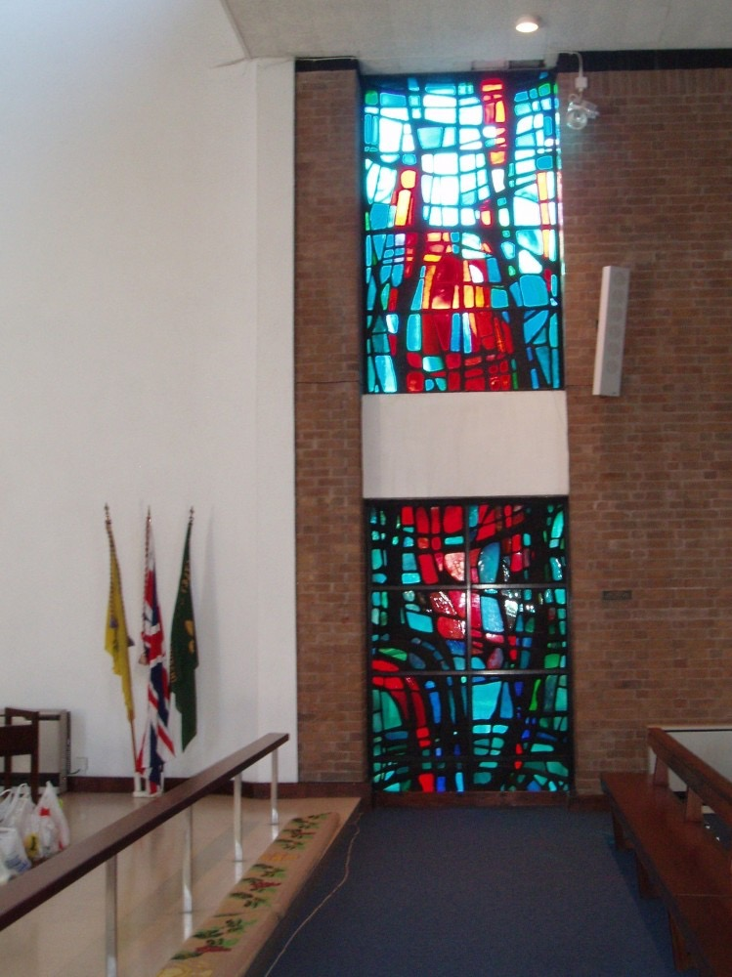
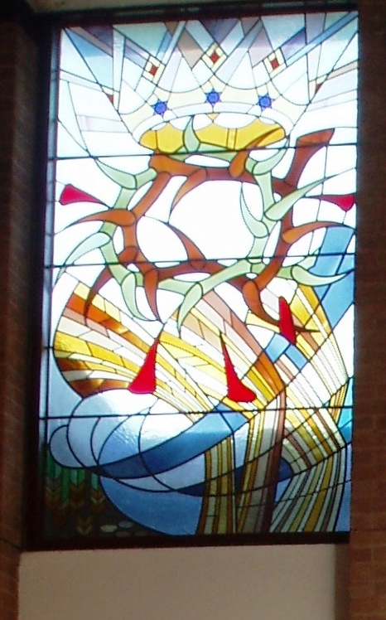
St. Stephen’s Window Charles Tonge Window

St Stephens stained glass window, designed by Hans Unger & Eberhard Schulze and the Charles Tonge Window designed by Paul Crook, are situated on the south and north walls respectively.

Over the west window in the gallery is a tapestry, Jacobs Ladder, made in memory of Amy Williams.

More information concerning the church can be found in the booklet,

“A Guide to St Stephen’s Church”

3. Areas of Church Involvement

St Stephens Church is a multi-functional building opening its doors to both internal and external groups, which are weekly or monthly in rotation. For instance-
Internal Groups which are well established and run successfully are:

The Stepping Up Saturday Team, held monthly - which encourages young families into Church and promotes faith and Christianity.

Meeting Point is held on the 3rd Thursday of the month to provide transport for those who find it difficult to attend Church for the usual Sunday services.

The Mother’s Union and The Men’s Group are also held monthly-attended by the more mature members of the congregation whose heart is in their ongoing Christian beliefs. Both groups encourage speakers and enjoy pre-arranged outings and social events to which all are welcome. The Men’s Group hold a BBQ each September which takes place in the school grounds to raise money for 2 local charities.

The Church hosts a Praise-On Team Service on the fourth Sunday of each month, usually attracting 40-50 people in Praise and Song

There is an excellent relationship between The Music Group and the Organist/Robed Choir. Co-ordination between the two provides continual musical support to the Church which is an important element in the worship of the Church. Both groups offer a broad range of both traditional and more recent worships songs and hymns.

The Church has an excellent relationship with St Stephen’s CE Primary School. The Head Jill Southern ensures she promotes joint Christian beliefs and faith. She is keen to integrate school groups into the Church; joint ventures include weekly assembly’s held in Church, Spring and Christmas fayres to the financial benefit of both and more recently with funding from the Diocese an extension to the Church owned car park has greatly assisted both the Church and School with added spacing and lighting.

External Groups which again are well established and run successfully are:

‘Little Angels’ – a parent and toddler group hosted in the choir vestry on Tuesday and Thursday mornings.

The Astley Unlimited Choir and Astley Youth Band who perform their practice sessions in the Church each Monday morning. The relationship between the Church and the two groups cannot be understated.

Each Thursday evening, The Weightwatchers Group hold their weekly meetings in Church.

The Church is now a base for Polling Day Ballots and a good relationship with Wigan council exists.

In February 2019 a newly formed ‘Friends of Astley Memorial’ was established following consultation between the Church and Wigan Council, resulting in a monument in memory of all those who have died in service being erected on the Bullcroft in Astley. This will be a centre of continual reflection for those living in the area and a means to hold worship on the Bullcroft at important times of the year. The memorial now forms part of a constitution which will conserve, maintain and improve its installation.

The Church has links to the Astley Scouts and Guides Groups who run their meetings at Ellesmere St HQ. This uniform organization holds an annual fun day with support from the Church and use of the building. Uniformed organizations attend the Church on a Parade Service once a month.

Over a number of years, St Stephen’s has supported the work of Isobel Booth-Cliborn and her works in Africa. We continue to support CMS.

We are a Fair Trade church, using and selling their products.

Other Areas of Church Involvement
Church Schools | Churches Together in Astley.
Open Church Policy | Supporting Mission through CMS
House Group | Team Weekends-Scargill House. Yorkshire.
Food Bank. | Lent Programme
Administration | Treasurer
Junior Church | Prayer Group.
Sick visiting with Holy Communion | Baptisms
Joint Services for some festivals | Church website
Magazine Team | Flower Team
PCC | Christian Aid.

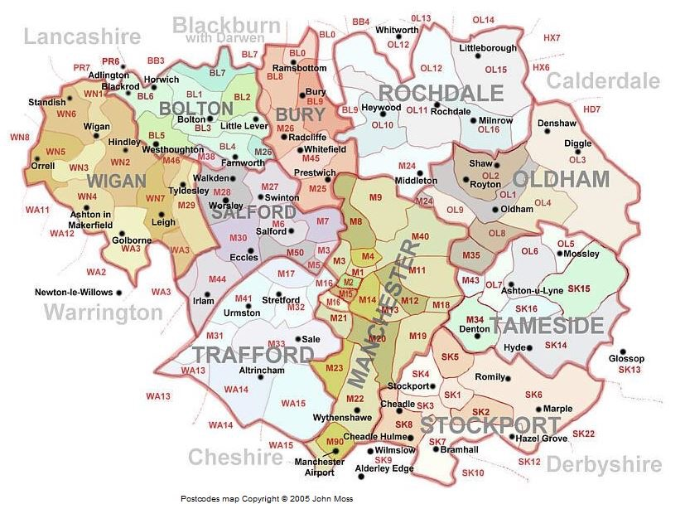
4. The Greater Manchester area

Situation in the Greater Manchester Area
Astley is situated 1 mile each from Tyldesley and Mosley Common, 10 miles from Wigan, 10 miles from Manchester, 6 miles from Bolton and 30 miles from Liverpool.

There is a good motorway network which allows easy commute to places such as Yorkshire Dales and the Lake District. Southport and Blackpool beaches are 30 and 50 miles away, respectively.

Entertainment can be found in all of the above-mentioned towns, as well as locally. e.g. theatres, cinemas, sports facilities, primary and higher education schools and colleges.

There are 4 GP surgeries in Astley , 1 clinic and 5 pharmacies.

Dam House, on the site of the Old Hall, where Adam Mort resided, and was once a small community hospital, is a listed building, which has been refurbished and is used for the benefit of the community. It contains a café area, function rooms, various health care facilities including a phlebotomy clinic

5. Accommodation

The Team Rector, Revd Martin Cox and his wife, Heather live at 7 Holbeck, Astley, Tyldesely, M29 7DU. This was home for a number of Vicars of Astley and the former Team Rector. The person invited to become Team Vicar will live in the Vicarage in the parish of St John’s, Mosley Common.

6. Congregation

On average there are 60 parishioners who worship in church weekly at 9.30am service, plus 12 – 15 at the 8 am service.

There are 88 people on the electoral role and 17 members on the PCC.

7. Churchmanship
The greater part of the congregation has come to live in Astley over a number of years from many backgrounds and types of churchmanship, ranging from Evangelical to Anglo Catholic. Our church has always endeavoured to cater for them all and bring them together as the worshiping body of Christ. The norm is a central form of Eucharistic worship. The President normally wears Alb and stole with a chasuble for the main services. We have a crucifer and servers who normally act as acolytes at the Eucharist and a number of Lay Assistants who help distribute Holy Communion.

8. Ministry Team
The Team Rector, a licensed OLM, two retired priests, two Readers, one NSM ordinand and one Reader in training minister at St Stephen’s and as part of the wider Team Chapter in the other two parishes of the ATMC Team. There is a dedicated church warden in post who is supported by former church wardens. St Stephen’s contributes to the costs of the ATMC Team Clerk post, which was established in December 2018 to assist in the coordination of ministry across the team. The Team Rector convenes meetings of the Team Chapter and meetings of Churchwardens. In 2018 there were the following occasional office services at St Stephen’s:
On average, per year, there are:
4 Weddings
13 Funerals
36 Baptisms

St Stephen’s has a long-standing Open Baptism Policy.

9. Building and Projects
Recently a new sound system has been purchased which allows improved audibility everywhere in the church. As with all building, there is an amount of ongoing maintenance, the smaller jobs are mainly undertaken by willing members of the church congregation.
In 2017 the Church had a new roof using funds raised by the congregation and external bodies. We are now looking to repair the inner ceiling and update the electrics with the keen intention to introduce projection screens for worship. This is a work in progress

Another project the PCC are looking at is the changing of the pews for chairs, making the space in the church more flexible for different activities.

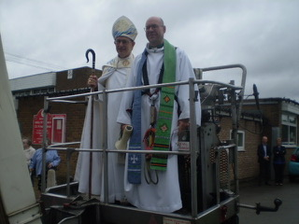
October 2017: The Bishop of Bolton and Team Rector in a hopper before they are ‘elevated’ to bless the new roof!
The old church yard - the site of the former St Stephen’s Church on Church Rd has been renovated by St Stephens Men’s Group and an information board has been erected with the history of the Church.
The Church owns a building in Ellesmere St, Higher Green, Astley situated on the south side of the A580. This is currently used by Astley Scouts and Guides, but can also be used by the wider community. The uniform organizations pay an annual rent to the Church.

10. Finance.
We are moving to a system whereby all clergy expenses, including housing costs, are to be paid by St Stephen’s and the costs dispersed across the three parishes.

The PCC income for 2018 was £65.845 this figure includes grants of £5,200 received from Grantscape and Wigan Council. The Parish Share for the year was £31,799 that was paid in full. The General expenditure for 2018 was £71,888. This figure includes £4,200 as the final payment for the new roof and £4,320 for general repairs.

There is a total of £38,993 in the No 2 Account for the building and major repairs. The Church is currently seeking advice and quotations for replacing technology and lighting systems within the church. The ceiling will require refurbishing once the re wiring is completed. We are continuing to raise money for the improvements and repair work and are hoping to launch a campaign in autumn 2019 with full congregation participation.

The Church receives income from Mort’s Charity on an annual basis. No income was received in 2018 due to changes beyond the control of the Trustees.

The PCC is committed to supporting charities and in 2018 contributions were made to Barnabus, Tear Fund and the homeless in Leigh.

EPD June 2019

ST GEORGE’S, TYLDESLEY

The Township of Tyldesley

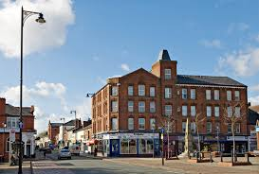
Tyldesley was transformed from a small village into a thriving industrial town as a result of the Industrial Revolution, with the textile and coal mining industries playing a major part in its growth.

Currently the population of the town is well in excess of eighteen thousand people. It is an urbanised dormitory town of Greater Manchester.

The majority of adults living in Tyldesley work outside of the town; and use private vehicles to drive to and from work. Congestion is an issue, and as a result TfGM with support of Wigan Council completed a guided ‘busway’ utilising part of the old rail ‘Tyldesley loop-line’ that opened in 2016. This allows fast transport from Leigh or Atherton, via Tyldesley along the East Lancashire Road with connections to Salford and Manchester city centres, universities and major hospitals and has proved extremely successful. Outlying parts of the town however, suffer from poor public transport outside of peak periods.

As the town provides good access, via the East Lancashire Road (A580) corridor and the motorway network, to locations across the north-west and beyond, it is clearly regarded as somewhere desirable to live. Extensive new housing provision has proliferated and the last thirty years have seen a major expansion in the provision of new private houses and apartments; a trend which is set to continue.

Alongside the new properties stand much older ones, traditional terraces built for miners and cotton workers, with social housing built by the old Urban Council before or just after the war, on its arterial roads, and on the Shakerley estate in the north-west corner of the town.

The demand for rented accommodation is high and its availability is limited. Housing benefit levels available locally do not always cover housing costs; and people in need of social housing frequently have lengthy waits, or are forced into moving elsewhere in the borough or to neighbouring authorities. Inevitably this leads to a more transient local population.

It is 50 years since the mining and textile industries disappeared and there are few non-retail employment opportunities left in the town.

Retail, in itself is problematic. Many of the traditional shops have closed due to supermarket competition including a long-established town centre co-operative store. The last major retail supermarket provider closed its store in November 2015, leaving just discount stores. Tyldesley town centre traders have banded together in recent months to lobby Wigan Council to improve the local environment and work together co-operatively on community initiatives. The Parish seeks to be supportive of these initiatives.

Tyldesley – By Night and By Day

Tyldesley becomes a destination town again in the evening, when its multitudinous take-away establishments come into their own. New bars and restaurants open from time to time, but one pub with a 100-year-old history and the local Conservative Club are currently closed and boarded and having a detrimental effect on the town centre appearance. The economic downturn has also had an unfavourable impact on Tyldesley’s once thriving night club scene.

Tyldesley’s public facilities have mirrored the decline in the town, but still include sports fields, a public park, and a library. Both the latter have thriving ‘friends’ groups. The old Town Hall is currently unused, the council social care team formerly based there having been moved elsewhere.

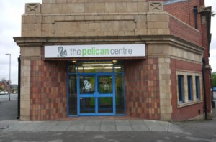
To counteract this diminishing public sector, there has been a recent growth in voluntary effort and community initiative. The former council swimming pool has become a community managed facility and is flourishing. Attempts in the last few years to re-form a Tyldesley Town Partnership have had limited success; and an upsurge of Community Interest Companies and other community partnerships seem forever to be struggling for funding. These initiatives may be advanced by a more concerted approach towards community planning in the form of a more formalised ‘Neighbourhood Plan’; (can the parish support - or take the lead in developing such an initiative?)

Tyldesley’s oldest public building, the 18th century ‘Top Chapel’ centrally situated to the south side of Tyldesley ‘Square’, is once again empty and subject to vandalism and petty theft. Social media reflects the esteem this iconic building is held in by townspeople, and the frustration felt by its recent history and changes of ownership. Top Chapel is a Grade ll listed building in need of significant restoration.

Parish officers work hard at developing relationships with elected members of Wigan Council. This bears fruition in many ways, not least being financial support for community activities in Shakerley and support for projects initiated by parish volunteers such as ‘FurClemt@Tyldesley’ a pay-as-you-choose ‘junk’ food café, operating three days a week in a family centre.

More substantial funding opportunities exist from Wigan Council’s ‘The Deal’ should more voluntary energy become available within church to generate ideas and planning groups.

The Fred Longworth High School, now an academy, is probably the biggest economic generator in town, with its 1200+ students. It is an outstanding ‘Arts and Applied Learning College’, a venue for all age learning, with a well thought of teenage project ‘Nowt to Do’, and a location for lots of sporting activity.

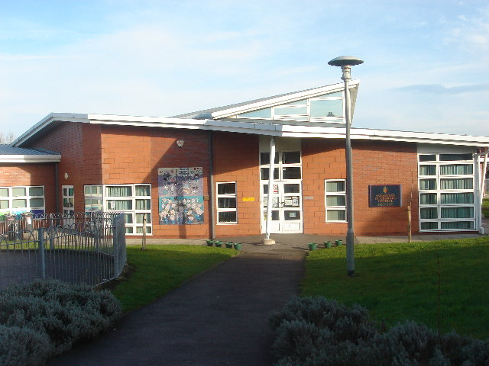
Our parish primary schools amalgamated in the late 1990s on a historic site with a new building for ‘St George’s Central CE Primary’ opened in 1999. Despite its location being approximately a half mile away from the parish church, strong links between school and church are maintained, and energy continues towards a concept of ‘church in school’ and ‘school in church’. A recent development has seen St George’s Central assume responsibility for a former community led nursery on the Shakerley Estate that received poor Ofsted ratings.

Additional to our own school, there is a second primary school (also an Academy) with a further community primary school and two other faith schools on the borders of the parish.

The principal areas of deprivation we have identified are worklessness (and its consequences) on the Shakerley estate, and significant loneliness and isolation amongst some of the older residents of Tyldesley generally. Dementia and other mental health issues are becoming more prominent, particularly the often-hidden needs of carer support. Asylum seekers and refugees continue to be accommodated in the town, often in poor quality private rented accommodation.

Anti-social behaviour rears its head from time to time and young people tend to complain of a lack of opportunity and a lack of youth-oriented provision. Public spending cuts have impacted negatively on the town; police presence is considerably reduced

Hillcrest is a 17-bed nursing home to the immediate west of church occupying the former (extended) vicarage. Holy Communion services are offered here on a monthly basis.

Good relations are enjoyed with Astley and Tyldesley Methodist Church a hundred metres or so away on the north side of Elliott Street. Two other churches remain in Tyldesley – a long established Independent Methodist fellowship and a newer evangelical ‘King’s Church’ that occupies another iconic building – the former Tyldesley Technical School.

Although the parish is more-or-less self sufficient and enjoys good supportive relationships with the parishes of Astley and Mosley Common in the united benefice, there is nonetheless lingering regret at the loss of our own incumbent several years ago.

The Parish Church and Church Yard

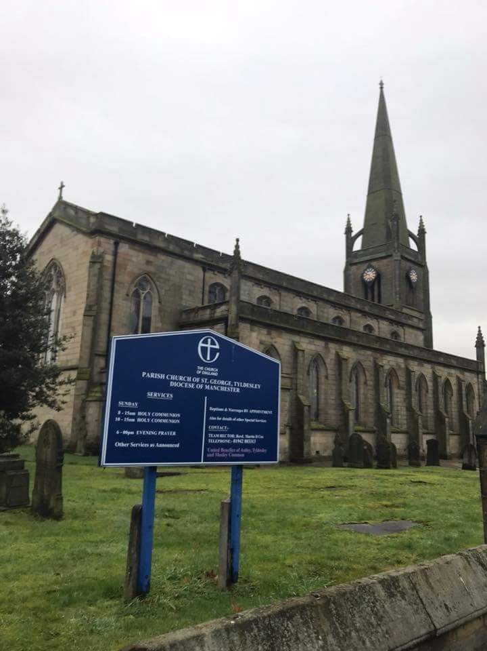
Our parish church was planned some 200 years ago, fairly soon after the Church Building Society was inaugurated and endowed with £1million from the government of the day in thanksgiving for the end of the Napoleonic wars.

In 1820, £17,000 was promised by the commissioners of the CBS as Tyldesley, growing phenomenally with new mills, new mines and associated industry, had no ‘chapel’ of the parish church in Leigh, as neighbouring Astley and Atherton had.

By 1821 a site had been gifted by Thomas Johnson, owner of the “Tildesley” Banks estate and work began to prepare the land for building on November 6th 1821 after
Thomas Kearsley of Fulwell House (an industrialist with shares in the Resolution Mill and other local concerns) had ceremonially cut the first sod. With the patriotic origins of the Church and the decision to name it after England’s Patron Saint, it was fitting that the laying of the Foundation Stone was on St. George's Day 1822.

The architect was Sir Robert Smirke R.A. and unlike his more usual Italianate ecclesiastical buildings, St George’s was a late Georgian mix of gothic and perpendicular styles. It was originally designed with a cast iron roof, but this was an early casualty as it was deemed too expensive!
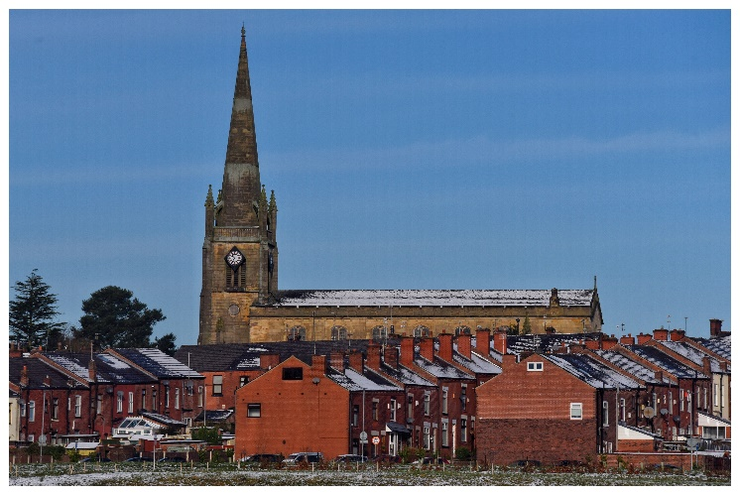
Consecration took place on 19 September 1925 by the Bishop of Chester and the building was originally known as St George’s Chapel, a daughter church of the parish of Leigh. After the consecration, the Bishop confirmed a large number of children and adults.

The Reverend Jacob Robson M.A. the first minister of the Church, was appointed by Lord Lilford, the patron of Leigh Parish. Jacob Robson was licensed as a curate on November l5th 1825. After lengthy legal formalities, the formation of a new parish was agreed and these were finalised on 29 August 1929 with Robson staying as ‘curate’ for another 13 years before assuming the title of vicar.

It was during Robson’s curacy that the spelling of the village name was changed from Tildesley to Tyldesley. Tildesley was never used again in the Church registers after the last day of 1833. Robson explained this with the following note in the register of baptisms:
"In accordance with what I conceive to be the general usage of the neighbourhood and more particularly of the Courts of the County and diocese I now intend to write Tyldesley and not Tildesley. Signed J. Robson".

Jacob Robson was followed by George Richards, John Lund and Samuel Fleming – who was the one, newly arrived in the parish in 1924, who celebrated the centenary a year later. Fleming delayed his retirement until 1947 and the cessation of wartime hostilities – completing almost a century and a quarter of worship and service from just four clergy members!

In the latter half of the twentieth century some seven more vicars were installed in St George’s until on 14 June 2000, the last incumbent Rev Christopher James Straton was licensed as Priest in Charge, becoming a Team Vicar in the newly constituted United Benefice of Astley, Tyldesley and Mosley Common in 2005. Chris retired in 2011 and was not replaced.

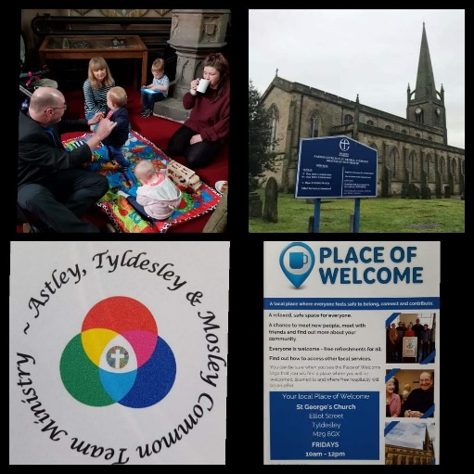
The contribution of self-supporting ministers, retired clergy, ordinands and lay ministries has been encouragingly positive, and operationally effective with many routine tasks shared cheerfully, new ideas tested and risks taken, and new ventures planned and successfully managed.

Church membership has been declining for many years with a noticeable loss of young families. A small stalwart band of parishioners regularly turn out for traditional prayer book services each week at 8.00am; congregations of between 35 and 55 are more normal at the main services, whether Sung Eucharist or Morning/All Age Worship.
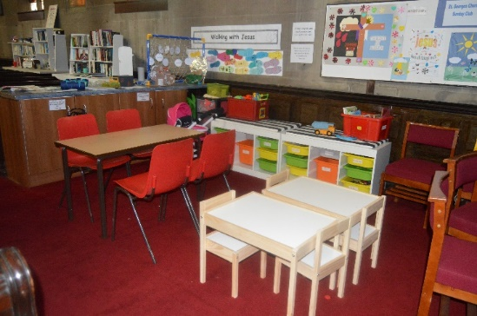
Children’s work is ongoing with dedicated volunteers working extremely hard to both engage children and offer them sound teaching.

New initiatives, such as Place of Welcome and a focus on hospitality and welcome whenever people come into church have led to small numbers of new families attending worship more regularly.

A lack of an effective heating system and uncomfortable hard pews are issues to be overcome in the near future.

Up to 2000 people have been recorded as attending services of Holy Baptism in a single recent year. Consideration continues to be given to how these families can be engaged and invited back to both other services and social events.

Numbers of funerals seem to have reduced, but this is being combated by strengthening relationships with local funeral directors, who promote church funerals whenever they are able.

The number of weddings has also declined, as more exciting destination wedding venues are currently fashionable.

Externally, parishioners constitute the majority of foundation governors at St George’s Central Primary School and their two nurseries. Several members also volunteer regularly in school.

Within the community key positions are held by parishioners as trustees at Shakerley Community Partnership, as officers of the Tyldesley Branch of The Royal British Legion, as volunteers in a community café, with a monthly dementia luncheon and activity project and in many more ways.

Fabric and Finances

Throughout the last two centuries extensions, repairs, restoration and reordering has occurred at regular intervals. Mining subsidence in the 1940s/1950s became an issue and although now stabilised led to the need for a new East Window in 1958.

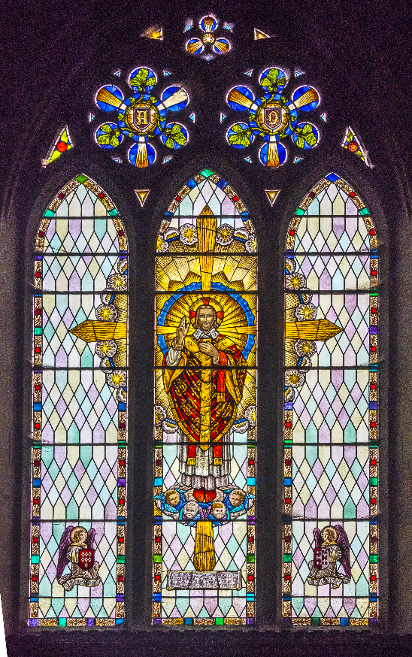
Although generally the fabric is in reasonably good condition, substantial sums have been spent in recent years – some as a result of general wear and tear, and some as a result of metal theft; and more expenditure is needed on the spire, roof guttering and slate repairs and clerestory window fixings.

Recent internal re orderings have included the removal and storage on a temporary archdeacon’s licence of several pews to allow for a central dais and communion table and a small café and social area.

A new church heating system is to be installed in the summer of 2019 at significant cost and new electronic door-entry systems are being considered for the vestry and west door.

Part of the shift towards developing a multi-use building has been the recent creation of a team office base with modern communication and reprographic capabilities in the minister’s vestry.

Similar developments will continue sequentially as funding allows and as the parish agrees on changing priorities. Future changes could include the removal of more pews, consideration of new stacking pews to replace the existing, a new creche area in the north porch with audio or visual links to church services, improved energy efficient lighting, the flooring and creation of storage space above the north porch and many other initiatives.

Externally, the churchyard is maintained by Wigan Council. Some thought is being given to developing a somewhat bare expanse of grass into a more environmentally friendly space with areas for wild flowers, perhaps apiaries, as well as the creation of seating and social areas.

Car parking is an issue, as only on-street parking is available, sometimes necessitating a considerable walk – an issue for those with mobility difficulties.

In 2018 St George’s received a bequest of nearly £720k. This was an unrestricted bequest, although the terms of the benefactor’s will stipulate that expenditure is restricted to St George’s parish within the team. We are mindful of the responsibility that such a bequest places on the officers and PCC of the parish and are conscious that whilst we could spend most if not all of the money on the church fabric it would be wrong to do so; we need to invest in the mission of the church as well as securing the longevity of the church building.

People
St George’s provides the office space for the recently appointed Team Clerk. We are also host church to a St Mellitus ordinand, who joined us in September 2018. We are seeking a priest who can contribute to the mission and ministry of St George’s, who is comfortable with our Eucharistic tradition and who is keen to develop the team ministry to which we are committed.

Photographs:
Marklands Building and Tyldesley Square approx. 2015
Pelican Centre (Tyldesley pool)
St George’s Central CE Primary School and Nursery
St George’s from NE
St George’s from the south
Composite showing logo, coffee area, Place of Welcome etc
East Window 1958
Fairey Band Concert June 2019
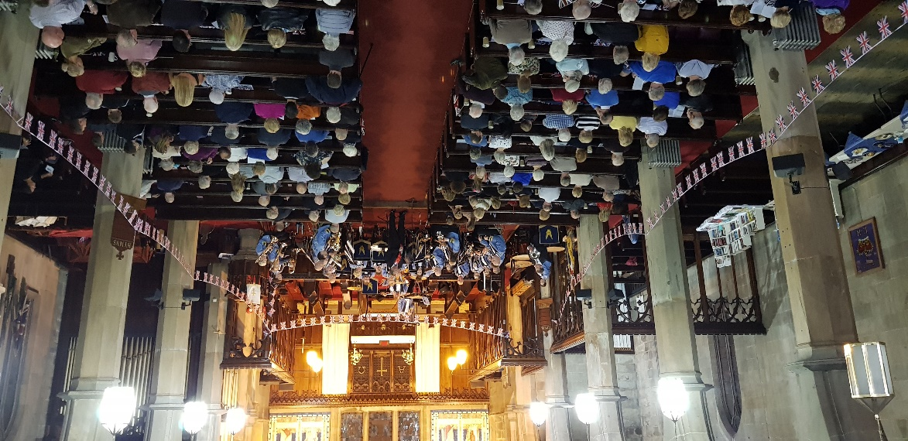

St. john’s, mosley common

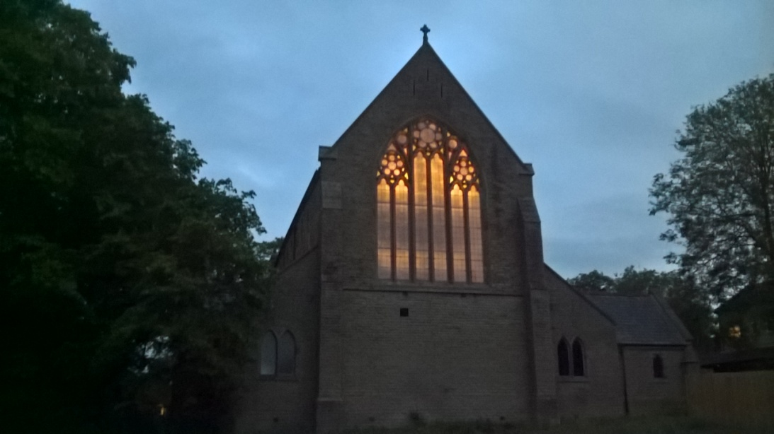
The Church

St John the Evangelist is part of the Astley, Tyldesley and Mosley Common Team Ministry, it remains a distinct parish with its own Team Vicar and PCC. The church was opened in 1887 and although there have been some changes to the building the main structure is now 143 years old with problems associated with buildings of that age and consequent financial implications.
One of the main changes to the church was to create a lounge at the back of the church (1970), this has provided a very useful space for social occasions as well as wider community use. The main worship area was reordered in 1992 with the installation of new heating, music system, lighting, platform and complete redecoration. In 2008 the lounge, kitchen area and the toilets, including disabled, were refurbished with some of the finance provided by Viridor Credits through the Landfill Communities Fund.
We have a monthly Working Party who deal with repairs and maintenance around the church and its grounds. The church has a very active group who organise social fundraising events, such as concerts, to raise money for the Restoration Fund to support the upkeep and use of the church building. At the moment St. John's are investigating developing the land north of church to provide permissible footpath access from the new housing through to the main road along with educational resources and a wellness woodland.
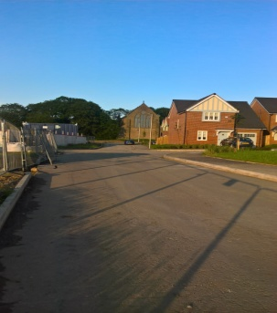
The parish straddles the Wigan and Salford border and the church is within the Wigan area. The houses in the parish are largely privately owned and of mixed sizes and ages. There is an area of social housing in Mosley Common (Wigan and Leigh Housing) as well as a complex of sheltered/retirement housing consisting of flats and bungalows, known as ‘The Rowans’. The Team Vicar regularly takes a Communion service in the lounge at the Rowans. Currently over 2000 houses are being built on fields adjacent to the church. We are contacting all these new residents with ‘Church Welcome’ packs and planning a Church Open Day in September.
At St John’s we have a vision statement that confirms our objectives and mission to proclaim the Gospel of our Lord Jesus Christ. We have a tradition of bible based evangelical worship with a mixture of hymns and modern worship songs. We are a most welcoming church and everyone who visits remarks how friendly we are. We believe we are a close fellowship whose members support each other, with all those on the electoral roll taking an active part in the life of the church either ‘up front or behind the scenes.’
We feel we have good links with our community as many of our members volunteer in the community either regularly or for one off events. We meet for Team Events both social and worship throughout the year and enjoy fellowship with the other churches in our team. In recent years we have enjoyed Team Weekends at Scargill House in Wensleydale. We are also a Fair Trade Church. The church has strong links with the local Ward Councillors, one of whom is on the electoral role.
St John’s is a member of ‘Churches Together in Boothstown’. This has been a feature of our church life for many years, and consequently we have strong links with the Catholic, Methodist and the other Anglican Church (part of Eccles Deanery) in our community. Regular services and activities such as picnics, visits to cathedrals and an annual outdoor carol service at the shopping centre are links that have developed and been much valued over the years.

Vicarage
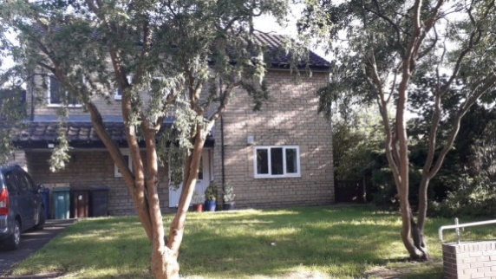
The modern Vicarage is situated next to St. John's in what was the orchard of the Edwardian Vicarage which is now a private residence. It is a 4-bedroom detached property with study and a garage with additional parking for two cars. It has gardens to the front, one side and rear with a number of mature trees, bushes and lawns.

Worship
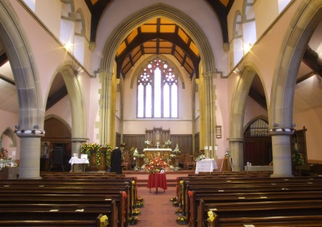
We have one regular Sunday service at 10.00am with an attendance of 35 – 42 people and other services as announced. On the 2nd and 4th Sunday of the month there is a Holy Communion service, on the 3rd Sunday there is an All Age Service and the 1st Sunday alternates between a Baptism Service and Morning Prayer.
The style of worship is a mixture of traditional hymns and worship songs. We have an organist and a singing group.
There are four Healing services per year during the Communion service. There are two Readers based at St. John’s who take an active part in the services. Lay assistants help to distribute Holy Communion.
We have just appointed an Authorised Lay Minister. There are 2 parish house groups which meet regularly throughout the year. There are 2 dedicated church wardens in post.

Women’s Fellowship
There is an active Women’s Fellowship which has been a part of St. John’s for many years. This meets fortnightly to provide worship, a social activity, activities for fund raising and an outreach to the community.

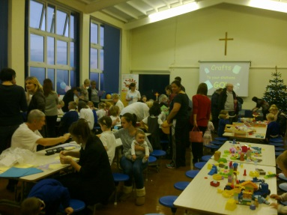
Messy Church
Five years ago we began ‘Messy Church’ which has been very successful. Messy Church takes place in the school hall on a Friday afternoon as soon as school finishes. The sessions are held roughly once every half- term and this continues to strengthen our links with the school community.

Mission Links
St John’s has strong links with overseas and local mission. We support two organisations in India and one in Croatia, members of these organisations visit us on a regular basis and help us to focus on their work. The church supports the Barnabus project in Manchester, which works with the homeless and vulnerable on the streets of the city. Members of the church donate to the charity and several members actively participate in its running either on a paid or voluntary basis. We support the Children’s Society's ‘Safe in the City’ Project, The Samaritans Purse, Safe Families and we collect food for our local Food Bank.

Brownies
Brownies meet on a Tuesday evening in the school hall, the pack has been established for over 50 years. Again, there are close links between the pack and our church.

Wider Team
St John’s contributes to the costs of the ATMC Team Clerk post established in December 2018 to assist in the coordination of ministry across the team. The Team Rector convenes meetings of the Team Chapter and meetings of Churchwardens.

St. John’s CE Primary School
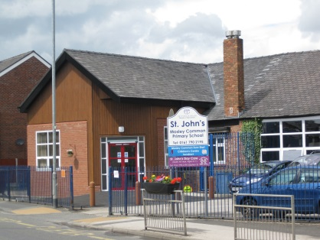
The church school predates the establishment of the church, being built in 1822 as a Sunday School; and it was here where the church services were originally held. The school is thus approaching its bicentenary. The school has a strong Christian ethos and the Team Vicar is an ex-officio governor of St. John's School. The school is a Voluntary Aided School with very close links to the church. One assembly each week is led by the Team Vicar and every half-term the children come to a service in the church. The school is currently rated good with some outstanding features, (Ofsted 2017) and members of the church are on the Governing Body.
The church is jointly involved with the school in community events such as School Fairs and ‘Carols on the Common at Christmas’. St John’s Church was instrumental in establishing St. John’s Day Care Centre over a decade ago which is now under the management of the school. This provides a Breakfast Club, Nursery, After School Club and Holiday Care.

Community
Constantly developing our role and involvement in the community is a fundamental aim of St. John’s Church. To this end we were involved with the Government funded Catalyst Project which led to the establishment of a regular weekly coffee morning, Come And Meet Everyone (CAMEO) held fortnightly; and a Mums and Toddler Group held every week term-time. Several members of the church are leaders of weekly walks for ‘Wigan Active Living’. We are a ‘Place of Welcome’.

Finance
The PCC income for 2018 was £53 823.56 and we have paid 100% of our Parish Share for the last 3 years. We pay approximately £1500 per annum to St. John’s School as part of a regular commitment to the school.

Website
St John’s has a website which is updated regularly providing an up to date calendar of events and information about services and other events. The website attracts a signification amount of traffic. We are looking to develop this as a mission tool. The church also has a social media footprint on Facebook promoting both Team and Church activities. We have also developed Messy Church Facebook Community as A Fresh Expression of St. John's

The local area - Mosley Common
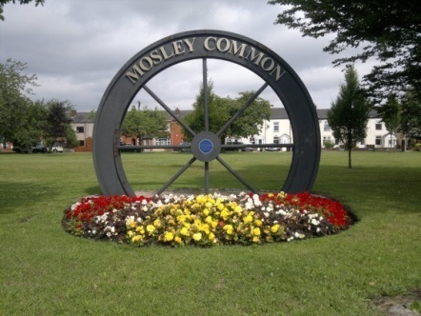
Mosley Common is a village with 3 areas of common land at its centre used for recreation and leisure by local residents. In the past the village was dependent on the local coal mines and mills for its employment and consequent terraced housing and council estates were built to house the workers. This industry has now all disappeared and most residents commute to surrounding urban areas for employment. Up until 2018 the village was surrounded by farmed fields but all this is gradually being covered by new housing. The oldest building in the parish is Garret Hall, mainly Tudor but with medieval origins, which was the home of the local Lords of the Manor.
Mosley Common is situated 10 miles from Wigan and from Manchester in opposite directions.
It has good access to motorway networks making beautiful places such as the Peak District, Yorkshire Dales, Snowdonia and North Wales, and the Lake District easily accessible. Southport and Blackpool are within an hour's distance by car. Easy access is also provided by the new Guided Busway into Manchester and Leigh, Atherton and Tyldesley.

