Parish Profile
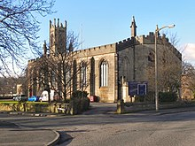

The Parish of St. James with St. Ambrose, Oldham

In the beginning was the Word and the Word was with God and the Word was God. John 1:1
The Word was made flesh, He lived among us, and we saw His glory. John 1:14

2018

Contents

Welcome…………………………………………………………………….1
Introduction…………………………………………………………......2
Basic Information and Statistics……………………………….3
House of Bishops Declaration 2014………………………….6
Local Community……………………………………………………….7
Schools and Voluntary Groups…………………………………10
Worship and Worshippers…………………………………………11
Church-Based Organizations and Groups………………..12
Our Patronal Festival…………………………………………………14
Neighbouring Anglican Churches and Parishes………..15
Ecumenism…………………………………………………………………15
Ministry………………………………………………………………………15
Mission……………………………………………………………………….16
Finance and Stewardship………………………………………….17
Our Next Parish Priest……………………………………………….18

Welcome

Welcome to our Parish Profile. Thank you for taking the time to read it. Our aim is to give you an understanding of our parish and a taste of what it might be like to be a part of our family here at St. James with St. Ambrose, Oldham.

We hope that it will enable you to consider prayerfully our vacancy for a new Parish Priest and we look forward to meeting you should you choose to apply.

David Hughes and Janet Taylor
Churchwardens

1
Introduction

This Parish has previously had the same Priest for over 35 years but since his retirement has been in Interregnum for over a year. During his incumbency Father Paul Plumpton developed the Grade II listed church building from being in an extremely poor state to one which is an excellent position to continue the tradition of Anglo-Catholic worship in the Parish.
The Parish is under the Extended Episcopal care of the Bishop of Beverley. The church has been financially prudent regarding giving and fundraising and continues to meet its responsibilities to the Diocese through consistently meeting its Quota and also regular outward giving to charities. We are therefore looking for someone who is a member of the Society of Saint Wilfrid and Saint Hilda and who will work with the PCC to continue to develop the life of the parish within the sacramental assurance of catholic order and practice.

2
Basic Information and Statistics

Full name of Parish | St. James with St Ambrose, Oldham
Title of Vacant Post | Incumbent
Name and address of Patron | Bishop  Rector of St. Mary’s Prestwich
Archdeacon | Ven Cherry Vann  Tel 0161 678 1454  archrochdale@manchester.anglican.org
Area Dean | Rev Lyn Woodall  lyn.woodall@gmail.com
Vicarage | Yates Street, Derker, Oldham OL1 4AR  (Please see photograph below)
Official Population | The population as of the 2011 census is 5000, but this will now be a little higher due to the repopulation of areas following the Housing Market Renewal Scheme.
Number on the Electoral Roll | 57
Average weekly attendance for the last 3 years | 45
Average weekly attendance of children and young people under 16 | 3

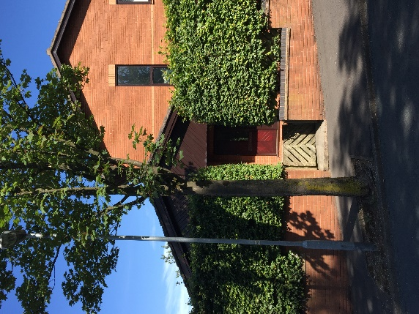
Our Vicarage is on Yates Street, Derker, Oldham OL1 4AR. It is currently occupied by the Curate from St. Paul’s Church, Royton.

3
In the last twelve months

Baptisms | 14
Admitted to Holy Communion before Confirmation | 0
Confirmed | 0
Marriages | 2
Funerals in Church | 5
Funerals not in Church | 1
Christmas Communicants (all services) | 50
Easter Communicants (all services) | 110

The principal church is Saint James the Great. The building commenced in 1827 and it was finished and consecrated on 19th September 1829. The seating capacity including the Lady Chapel and Gallery is approximately 350.

The latest Quinquennial Inspection was undertaken on 8/12/16 and the report was completed on 10/01/17. This highlighted no ‘works of upmost urgency’ were needed. ‘Works within 18 months’ were minor pointing on one window which has now been completed and repainting of a steel door panel. ‘Works within 5 years’ were the boundary wall which has been completed and minor repairs to the gallery floor where holes remain after the removal of some pews. A letter from the Archdeacon
4
agrees with the Architect that ‘the church is kept to an exceptional standard’. The cost of the minor works still outstanding was not identified but will be relatively low. The maintenance of the Grade II listed building is ongoing and other possible improvements have been identified for the future.

The Narthex, Parish Room, Kitchen and Disabled Facilities are available for hire.

The other church in the joint benefice is St Mark with Christ Church, Glodwick and they are submitting a separate profile.

The parish produces a Sunday Bulletin Leaflet each week containing the service time and details, events and notices. We also produce leaflets for the Summer and Christmas Fairs and a Christmas Card, all of these are distributed widely throughout the parish.

Our church can be found at https:/achurchnearyou.com/church/15926/

The Churchwardens are David Hughes and Janet Taylor

The representatives are Janet Taylor and Sue Boswell

5

Priests (Ordination of Women) Measure 1993
House of Bishops Declaration on the Ministry of Bishops and Priests 2014

A Resolution under the House of Bishops Declaration was passed by the PCC in July 2016 on the grounds of theological conviction and this is still in place.

6
Local Community

Oldham is a town in Greater Manchester amid the Pennines and between the rivers Irk and Medlock, 5.3 miles southeast of Rochdale and 6.9 miles northeast of Manchester. It is the administrative centre of the Metropolitan Borough of Oldham, which had a population of 230,800 in 2015. The town has a population of 103,544 and an area of around 26 square miles. Oldham rose to prominence in the 19th century as an international centre of textile manufacture. It was a boomtown of the Industrial Revolution, and among the first ever industrialised towns, rapidly becoming "one of the most important centres of cotton and textile industries in England". At its zenith it was the most productive cotton spinning mill town in the world, producing more cotton than France and Germany combined. Oldham's textile industry fell into decline in the mid-20th century and the town's last mill closed in 1998. The demise of textile processing in Oldham depressed the local economy.

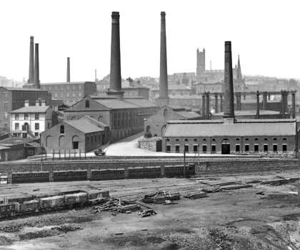

Today Oldham is a predominantly residential town, and the improvement of the town centre is the focus of a project for transforming Oldham into a centre for further education and the performing arts. There are many notable persons with Oldham connections including the composer Sir William Walton, former British Prime Minister Sir Winston Churchill and Louise Brown, the world's first baby to be conceived by in vitro fertilisation. Notable media personalities from Oldham include presenter
7
Nick Grimshaw, actors Eric Sykes, Bernard Cribbins and Christopher Biggins, TV host Phillip Schofield, actresses Shobna Gulati, Dora Bryan Anne Kirkbride, physicist and science educator Brian Cox and comedy double act Tommy Cannon and Bobby Ball. Notable musicians from Oldham include the Inspiral Carpets, N-Trance and Mark Owen of boyband Take That as well as the founding members of the rock band Barclay James Harvest. One person from Oldham of particular Christian interest is Laurence Chadderton, one of the original translators of the Authorized King James Version of the Bible.
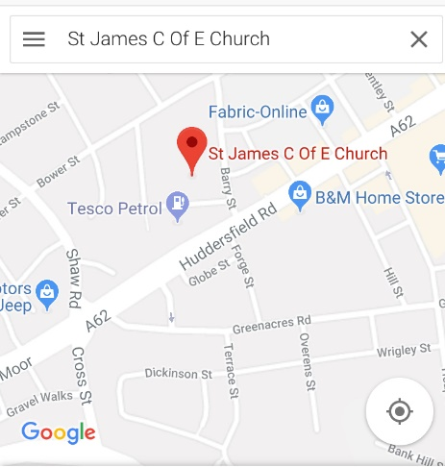
The parish is located on the outskirts of the town centre of Oldham but also ‘has a dramatic sense of connection with the wider landscape and spectacular views to the north and west’ of the High Pennine hills. Derker originally contained ‘Dirt Car House which lay in the historic estate of Horsedge. The estate had originally belonged to the Knights of Saint John of Malta but it was subdivided at the Dissolution in 1536. In 1620 the estate was notable for being surrounded by 7 crosses which defined its boundaries’. Although Derker is recorded as a place of residence as early as 1604, Saint James Church (opened in 1829) predates all of the Victorian terraced housing which was built to service the many cotton mills which existed in Oldham but most of which have been demolished in the last 30 years and the council estate which was constructed in the 1920s. Saint James is a Commissioners' church by Francis Goodwin, with the chancel added in 1883. It is in stone, with a Welsh slate roof, and consists of a nave, north and south aisles, a shallow canted apse at the east end, a west tower, and vestries flanking the tower which are now used as the Parish Lounge and the Kitchen. The present vestry is at the east end of the Church. The tower has clasping buttresses, a parapet above the second stage, and flying buttresses to the octagonal belfry stage that contains clock faces. At the top is an embattled parapet with corner pinnacles.

8
As well as housing the parish contains a variety of industrial, commercial and retail premises, a park and a Metrolink station together with good bus routes.
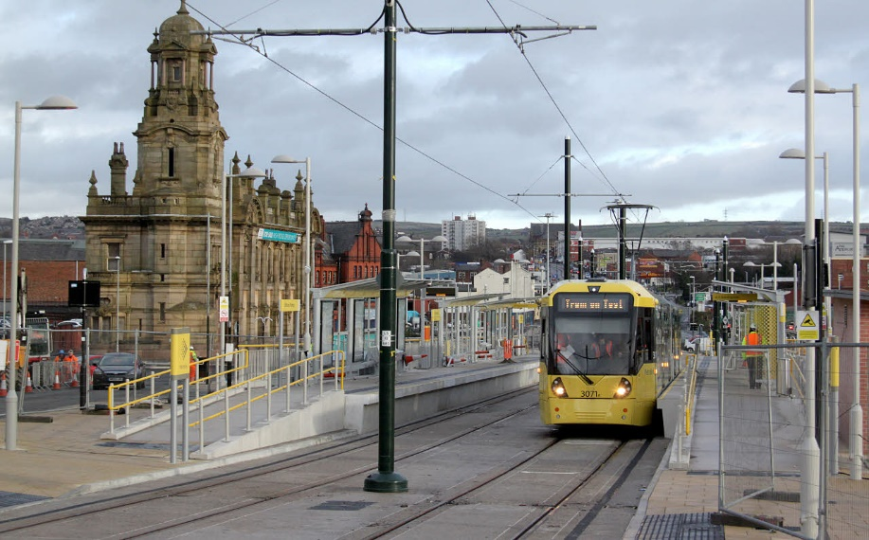

According to Research Statistics provided by the Diocese for 2011, demographically the Parish has a population which is overwhelmingly White British (90%) with Other White (3%), Asian (2%), Black (2%) and Mixed Race (3%). 94% were born in the UK and only 1% have difficulties with speaking English. 65% described themselves as Christian.
Statistics present a picture of a parish with a predominately white, low income, low educational achievement population working long hours in lower grade occupations and generally having good health. There is a large proportion of single people and lone parents. The proportion of rented properties (59%) may indicate shorter-term periods of residence in the Parish and it is of note that a large proportion of the people on the Electoral Roll and regular weekly attenders live outside the Parish.
A large part of the parish area has previously been subject to the Housing Market Renewal Programme which has resulted in the demolition of many of the Victorian terraces and their replacement with more modern accommodation. However, this has resulted in the dissolution of many existing community ties and areas of undeveloped land since the halting of the Scheme. The church provides a valuable community resource in an area which has limited local facilities and, apart from the provision of christenings, marriage and funerals, the main contacts with the wider community are through the extremely well attended fairs and hire of the Narthex.

9
Schools and Voluntary Groups

Mayfield and Stoneleigh Primary Schools, neither of which is a church school, are within the parish but there are no formal links with these. However, classes of children have been brought into the church as part of their school studies.

The church does host concerts by Crompton House, which is a Church of England Secondary School and other schools and the Rotary Club also hold their annual Carol Concert in the church.

10
Worship and Worshippers

There is a Sung Mass every Sunday at 11.15am and said masses on Tuesdays, Thursdays and Fridays at 11am and Saturdays at 10am. Major Feast Days and Solemnities are also observed, usually with a Sung Mass and Sermon.

The English Hymnal and Ancient & Modern New Standard Hymn Books, Common Worship and the Roman Missal are used. The Priest wears full traditional vestments. The congregation tends to be aged over 45, approximately 75% female and, although mixed, having a larger proportion of people from higher socio-economic groups than the parish population. The majority of worshippers live outside the parish boundary and the churchmanship is in the modern Anglo-Catholic tradition.

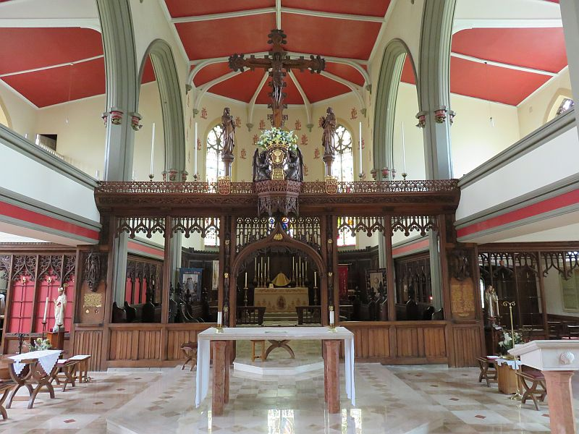

11
Church-Based Organizations and Groups

We do not have any regular church-based organisations at the moment but the parish does have an annual pilgrimage to Walsingham. A small group of willing helpers meet quite regularly to arrange flowers for Sunday masses and special occasions. Members of the congregation can request a flower arrangement in memory of a loved one and these are included on the date requested wherever possible.

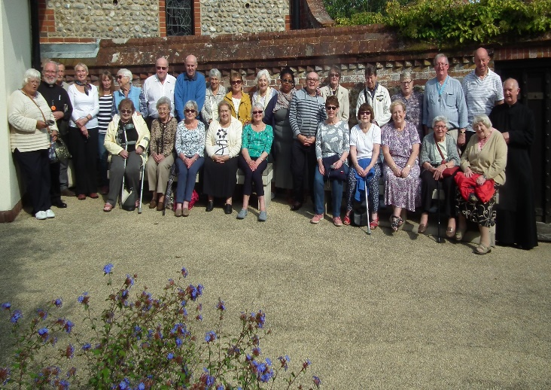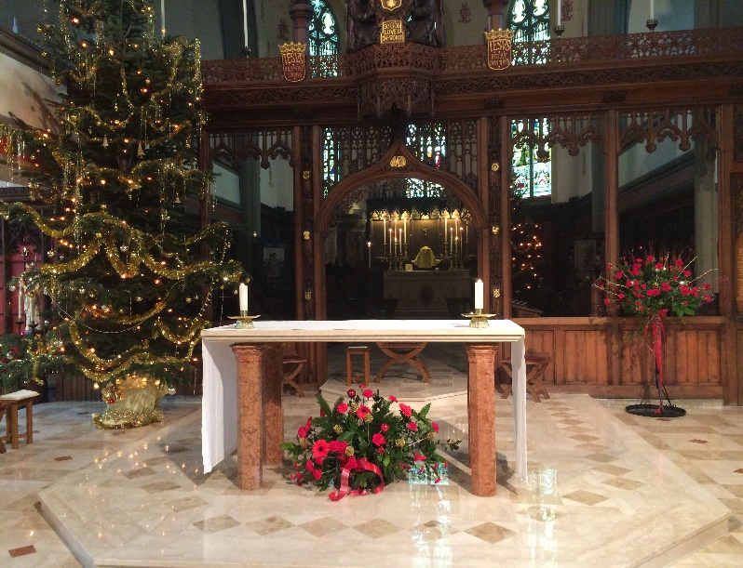

12
The church has several social events including a Parish Lunch and holds Summer and Christmas Fairs which are very well attended by the parishioners.

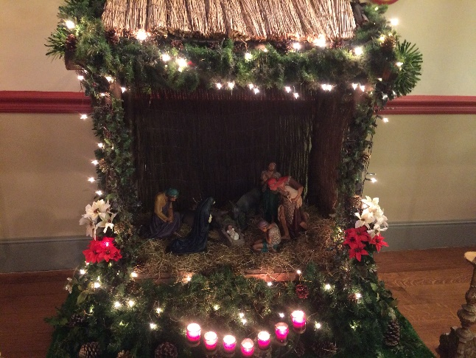

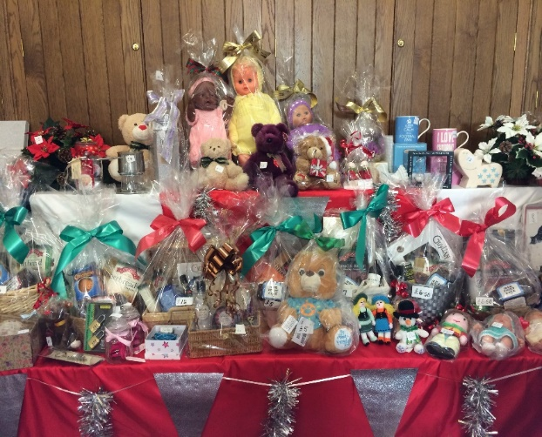

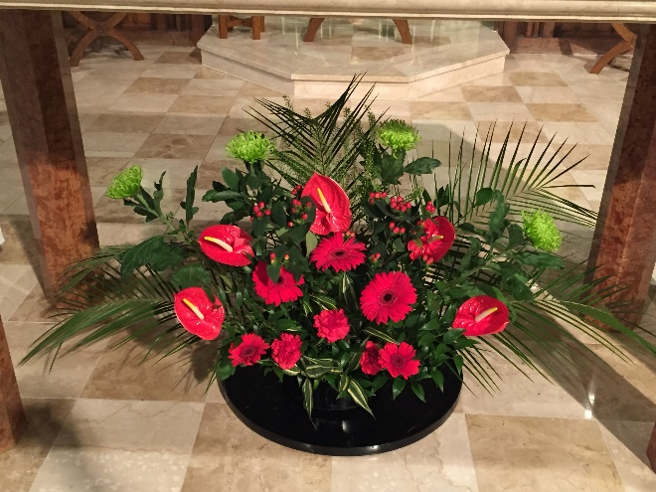

13

Our Patronal Festival – 25th July 2018

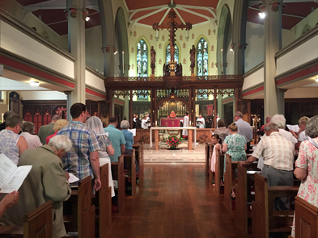

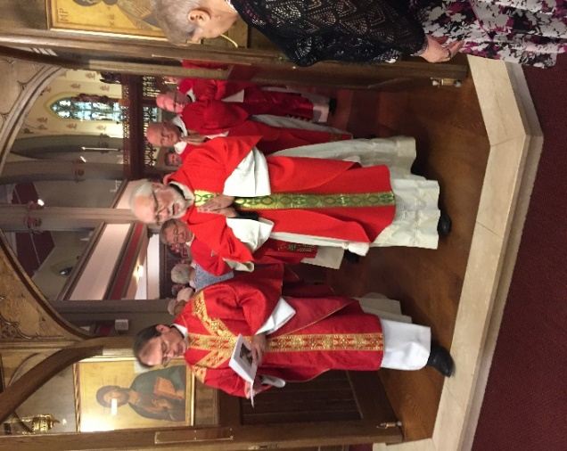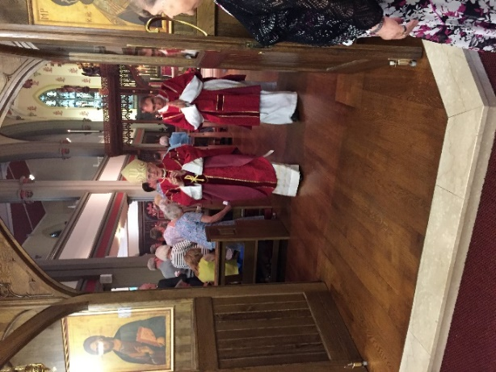

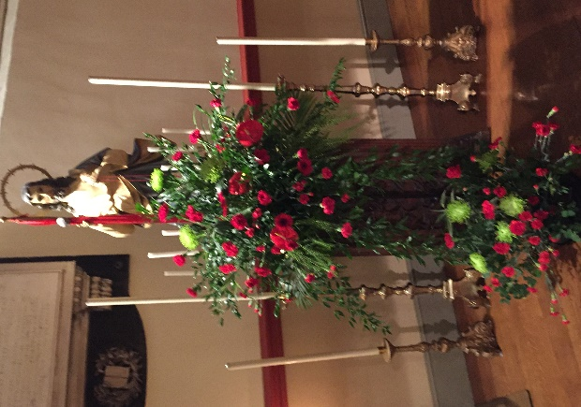

14
Neighbouring Anglican Churches and Parishes
The Deanery Mission and Pastoral Plan is still in development. The benefice is joint with Saint Mark and Christ Church, Glodwick and joint bible studies have recently begun. Saint James is a member of the Society of Saint Wilfrid and Saint Hilda which represents traditional Anglo-Catholic practice and order.

Ecumenism
East Oldham Methodist Church borders the parish but there are no formal links.

Ministry
During the interregnum we have been very fortunate to have had the ministrations of a retired priest Father John Hilton and some support from the former Area Dean, Father Graham Hollowood. There are no assistant curates, NSMs or OLMs officiating but we would be happy to support their ministries if they became available and were suitable.

15
Mission
Plans have been in place to become a joint benefice with the neighbouring parish of Saint Mark with Christ Church Glodwick since before the departure of our previous incumbent but, at the time of writing, this is still awaiting the legal process to be completed. The parish of St. Mark with Christ Church is of a significantly different demographic having a large proportion of African-Caribbean and Muslim residents of Pakistani or Bangladeshi origin. However, the tradition of the church is of a similar churchmanship. In the meantime, we have been extremely fortunate to have had the ministrations of a retired priest. Now that the incumbent of Saint Mark’s has moved on, they too are in Interregnum. This clearly will affect our congregation’s capacity to develop and respond to the challenges posed by the recent changes caused by the HMR Scheme. However, we intend to continue in the future to:

1) Provide opportunities for all members of the congregation, including young people, to grow in discipleship and worship (on a daily basis in conjunction with Saint Mark’s) in the catholic tradition of the Church of England and to encourage vocations.

2) Provide the visible witness of a worshipping Christian presence in the community. Serve the local community by providing a valuable building resource in an area which can lack suitable facilities.

3) Promote good relationships and opportunities for outreach to the community in contacts through christenings, marriages and funerals together with community events such as the very well attended Fairs and hosting concerts.

16
Finance and Stewardship

Christian Stewardship is practised through the use of gift aid envelopes for regular giving from both tax and non-tax payers. On 1st July 2018 the Gift Aid Lite scheme started to be implemented and this is now used each week by the Gift Aid Secretary. One-off donations can be given using the envelopes located on the end of the pews. This enables visitors to contribute to our church and also for regular donors to contribute to special appeals.

Members of the congregation take their financial responsibilities seriously and the church has always been committed to paying its Parish Share in full. The previous Incumbent only claimed expenses on an ad hoc basis however the Priest’s claimed expenses have always been paid in full.

The parish supports 12 charities per year chosen by the PCC, 4 charities in its Lenten appeal and one charity in its Harvest appeal which totalled £8,169 in 2017.

17
The Next Parish Priest

1. a. We therefore would look for a Priest who has the experience and skills to lead worship in the catholic tradition including sound teaching which equips and encourages members (including young people) to grow spiritually and live out their calling as baptised Christians to be disciples of Jesus.
b. As the benefice will be joint with Saint Mark’s the Priest will need the skill to serve and synergise the two parishes to make best use of the strengths of each.
c. We have strong links with other Anglo-Catholic parishes which we would wish to maintain however the church has not participated much in the wider Anglican Church or promoted ecumenism with other denominations in the vicinity. It would be enriching for all if the new Priest has the vision to promote the unity in the Holy Spirit and develop mutual understanding and respect through building relationships whenever possible whilst remaining true to our catholic heritage and beliefs.

2. a. The previous Incumbent and congregation have spent a great
deal of effort and money to restore the building to an excellent
condition so we would look for a Priest who will continue to care
for the building and an ability to promote and develop its use by
the community.

b. Although we have been very successful in fundraising through events and regular giving it may well be necessary to find new sources of income so the experience and vision to identify and access these is also necessary.

18

3. a. We have good links with parishioners for our community
events so we would look for a Priest who can build on these
relationships to encourage participation in the life of the church.

b. We would wish to further serve the community by our Priest forging new links such as possibly through contacting organisations within the Parish such as care homes, schools etc.

c. The parish would like ‘a priest who is a man of prayer and pastoral zeal’ with a special ability to encourage young people and children in the faith.

We would like to thank you for taking the time to read our Parish Profile and look forward to receiving your application should you wish to apply.

19

